# Title

## Abstract

## Introduction

First paragraph text with references. (Dietrich et al., 2014; Ellenbroek and Youn, 2016; Hedrich et al., 2004; Houdebine, 2004)

Second paragraph and remaining text body.

## Results

### Results sub-heading

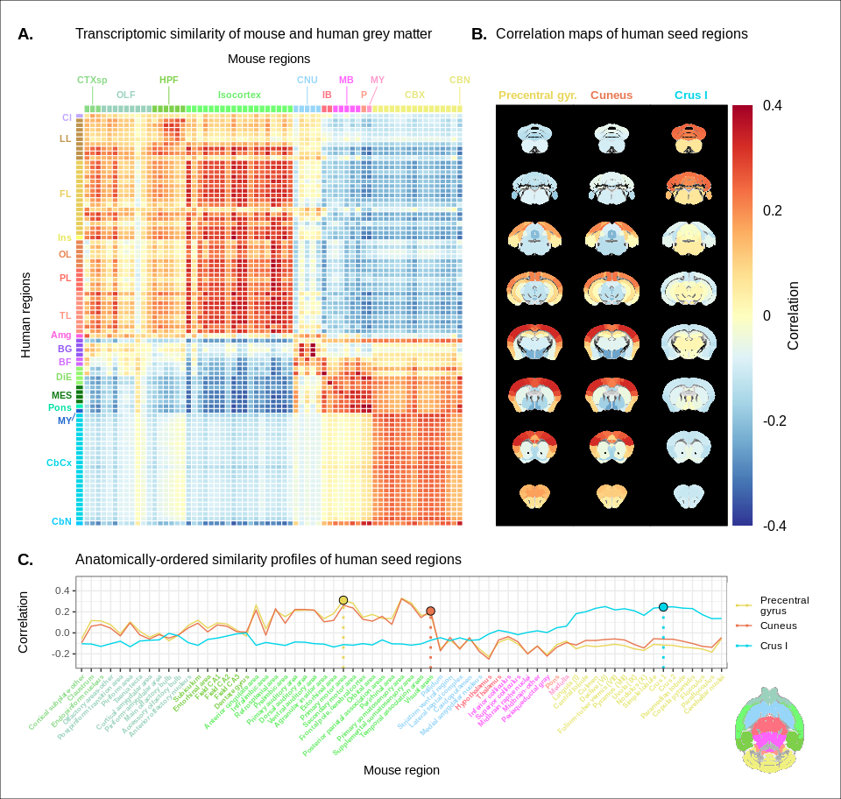

Transcriptomic similarity in the mouse and human brains. () Similarity matrix displaying the correlation between 67 mouse regions and 88 human regions based on the expression of 2835 homologous genes. Columns are annotated with 11 broad mouse regions: Cortical subplate (CTXsp), olfactory areas (OLF), hippocampal formation (HPF), isocortex, cerebral nuclei (CNU), interbrain (IB), midbrain (MB), pons (P), medulla (MY), cerebellar cortex (CBX), cerebellar nuclei (CBN). Rows are annotated with 16 broad human regions: Claustrum (Cl), limbic lobe (LL), frontal lobe (FL), insula (Ins), occipital lobe (OL), parietal lobe (PL), temporal lobe (TL), amygdala (Amg), basal ganglia (BG), basal forebrain (BF), diencephalon (DIE), mesencephalon (MES), pons, myelencephalon (MY), cerebellar cortex (CbCx), cerebellar nuclei (CbN). Broad patterns of similarity are evident between coarsely defined brain regions, while correlation patterns are mostly homogeneous within these regions. () Mouse brain coronal slices showing similarity profiles for the human precentral gyrus, cuneus and crus I. Correlation patterns for the precentral gyrus and cuneus are highly similar to one another and broadly similar to most isocortical regions. The crus I is homogeneously similar to the mouse cerebellum. () Anatomically-ordered line charts displaying the similarity profiles for the seed regions in (B). Dashed vertical lines indicate the canonical mouse homologue for each human seed. Annotation colours correspond to atlas colours from the AMBA and AHBA for mouse and human regions respectively.

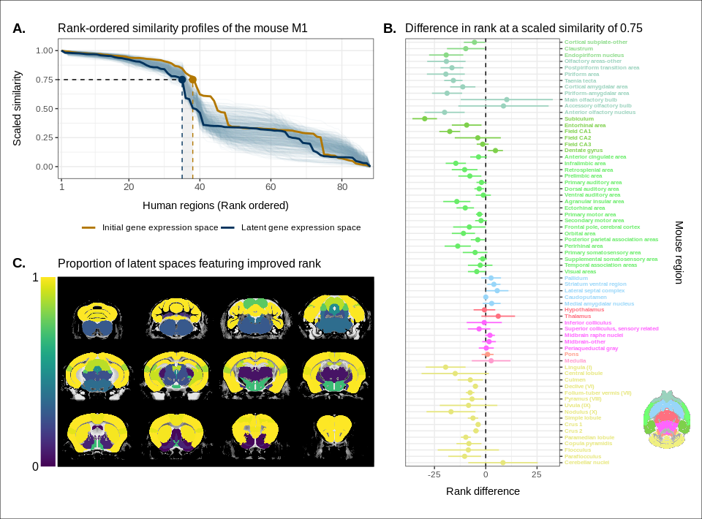

Quantifying improvement in locality in gene expression latent space. () The amount of local signal within a broadly similar region of the brain for a finer seed region’s (e.g. primary motor area) similarity profile can be quantified by the decay rate of the head of the rank-ordered profile. Decay rate was quantified by computing the rank at a similarity of 0.75. This metric was compared between the initial gene expression space (orange line) and every gene expression latent space resulting from repeated training of the neural network (every blue line is a training outcome, heavy blue line serves as an example). A negative difference between these rank metrics indicates an improvement in locality in the latent space. () Structure-wise distributions of differences in rank at a similarity of 0.75 between the initial gene expression space and the gene expression latent spaces. Points and error bars represent mean and 95% confidence interval. Dashed black line at 0 indicates the threshold for improvement in one space over the other. Colours correspond to AMBA annotations as in Figures 1 and 2. Binomial likelihood (logistic regression) estimate of $p_{\text{B}}=0.78$ with %95 CI [0.66, 0.86]. The probability of obtaining at least this many successes under the null binomial distribution, $B\left(67,0.5\right)$, is $p=8.64⋅{10}^{-7}$. () Proportion of perceptron training runs resulting in an improvement or null difference in the gene expression latent space compared with the initial space, estimated using region-wise logistic regressions. Cortical and cerebellar regions exhibit high proportions of improvement, while subcortical regions are less likely to be improved by the classification process.

## Discussion

## Materials and Methods

## References

Dietrich MR, Ankeny RA, Chen PM. 2014. Publication Trends in Model Organism Research. *Genetics* **198**:787–794. doi:[10.1534/genetics.114.169714](https://doi.org/10.1534/genetics.114.169714)

Ellenbroek B, Youn J. 2016. Rodent models in neuroscience research: Is it a rat race? *Disease Models & Mechanisms* **9**:1079–1087. doi:[10.1242/dmm.026120](https://doi.org/10.1242/dmm.026120)

Hedrich HJ, Mossmann H, Nicklas W. 2004. Chapter 24: Housing and maintenanceThe Laboratory Mouse. Elsevier Academic Press. pp. 395–408.

Houdebine L-M. 2004. Chapter 6: The mouse as an animal model for human diseasesThe Laboratory Mouse. Elsevier Academic Press. pp. 97–107.

## Acknowledgements