# FRONT MATTER

## Title

## Authors

## Affiliations

## Abstract

## Teaser

# MAIN TEXT

## Introduction

## Results

### Results sub-heading

## Discussion

## Materials and Methods

## References

## Acknowledgements

## Figures and Tables

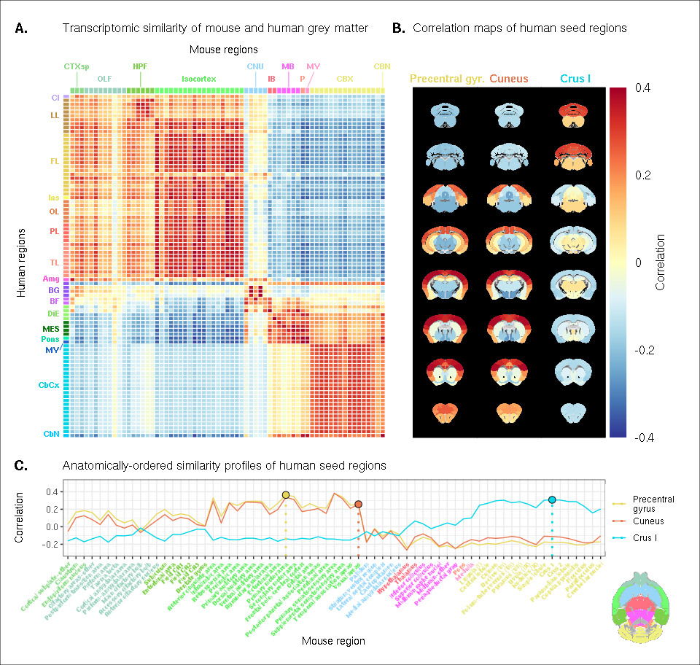

Figure caption

## Supplementary Materials