Dev: AAbitew
Course: BIDD 330 – Business Intelligence & Data Design
Date: 04/12/2026
Wiki: https://github.com/abebe953/BIDD330_PowerBI_Project

Technical Documentation: Power BI Application, AI Reverse Engineering (DAX to SQL), and GitHub Wiki Submission Process

1. Introduction
This document explains the end-to-end process used to build a Power BI reporting solution, connect it to a cloud-based database server, use AI tools to translate DAX into SQL, and publish supporting documentation in a GitHub Wiki.
The purpose of this guide is to help new developers and analysts understand the workflow, troubleshoot common issues, and reproduce the same setup in a business intelligence environment.

2. Power BI Application Development

2.1 Tool Used
The application was developed using Microsoft Power BI Desktop.

2.2 Data Source
Data was accessed from an Azure-hosted relational database using Microsoft Azure SQL Server.
Instead of using multiple CSV files, a direct database connection was created. This ensures:
- Real-time or near real-time data updates
- Reduced manual file handling
- Centralized data management
- Improved data consistency

2.3 Steps to Build the Power BI Report

Step 1: Connect to SQL Server
- Open Power BI Desktop
- Click Get Data → SQL Server
- Enter server name and database credentials
- Choose Import or DirectQuery

Step 2: Load Tables
- Select required tables (Fact and Dimension tables)
- Load data into Power BI model

Step 3: Data Modeling
- Establish relationships between tables (Star Schema)
- Ensure proper key mapping (Primary Key → Foreign Key)

Step 4: Create Measures (DAX)
Example measures created:
State Distinct Count = DISTINCTCOUNT(DimState[State])
Month Distinct Count = DISTINCTCOUNT(DimDate[Month])

Step 5: Build Visualizations
- Bar charts for state-level analysis
- Card visuals for KPIs
- Slicers for filtering by time and geography

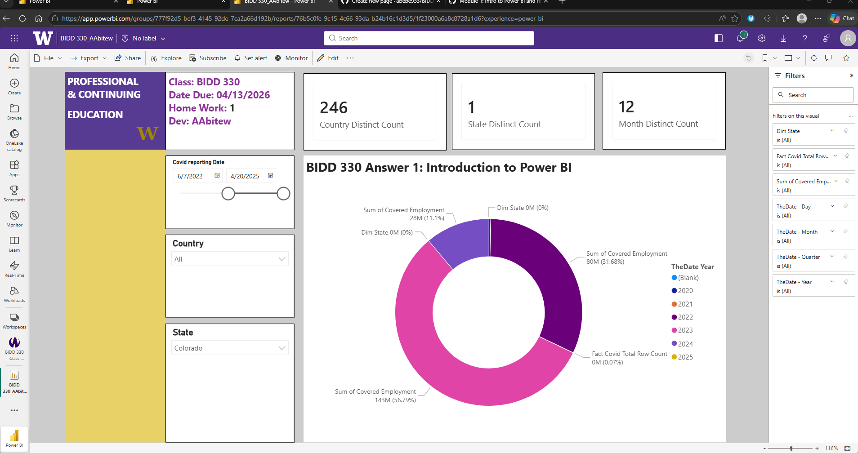
Power BI Data Model View or Report Dashboard

3. AI Tool Usage: Reverse Engineering DAX to SQL

3.1 Objective
The goal of using AI was to translate Power BI DAX measures into equivalent SQL queries for validation and backend replication.

3.2 Process

Step 1: Identify DAX Measure
Example:
State Distinct Count = DISTINCTCOUNT(DimState[State])

Step 2: AI Conversion Output (SQL Equivalent)
SELECT COUNT(DISTINCT State)
FROM DimState;

Step 3: Validation
- Run SQL query in database environment
- Compare results with Power BI visuals
- Ensure both outputs match

3.3 Benefits of AI Assistance
- Faster translation between BI and database logic
- Improved understanding of query behavior
- Reduced manual SQL writing errors
- Better debugging and validation workflow

4. Connecting Power BI to a Server (Not CSV Files)

4.1 Why Server Connection Was Used
Instead of using static CSV files, a live database connection was used to:
- Maintain data integrity
- Avoid manual updates
- Enable scalable analytics
- Support enterprise BI architecture

4.2 Connection Steps
- Open Power BI Desktop
- Select Get Data → SQL Server Database
- Enter:
  - Server Name
  - Database Name
- Choose authentication method:
  - Windows / Database login
- Select tables and load data

4.3 Troubleshooting Tips
- Ensure VPN is enabled if required
- Verify server credentials
- Confirm firewall access to Azure SQL
- Check dataset permissions

5. GitHub Wiki Submission Process
The documentation was published using GitHub Wiki for version control and sharing.
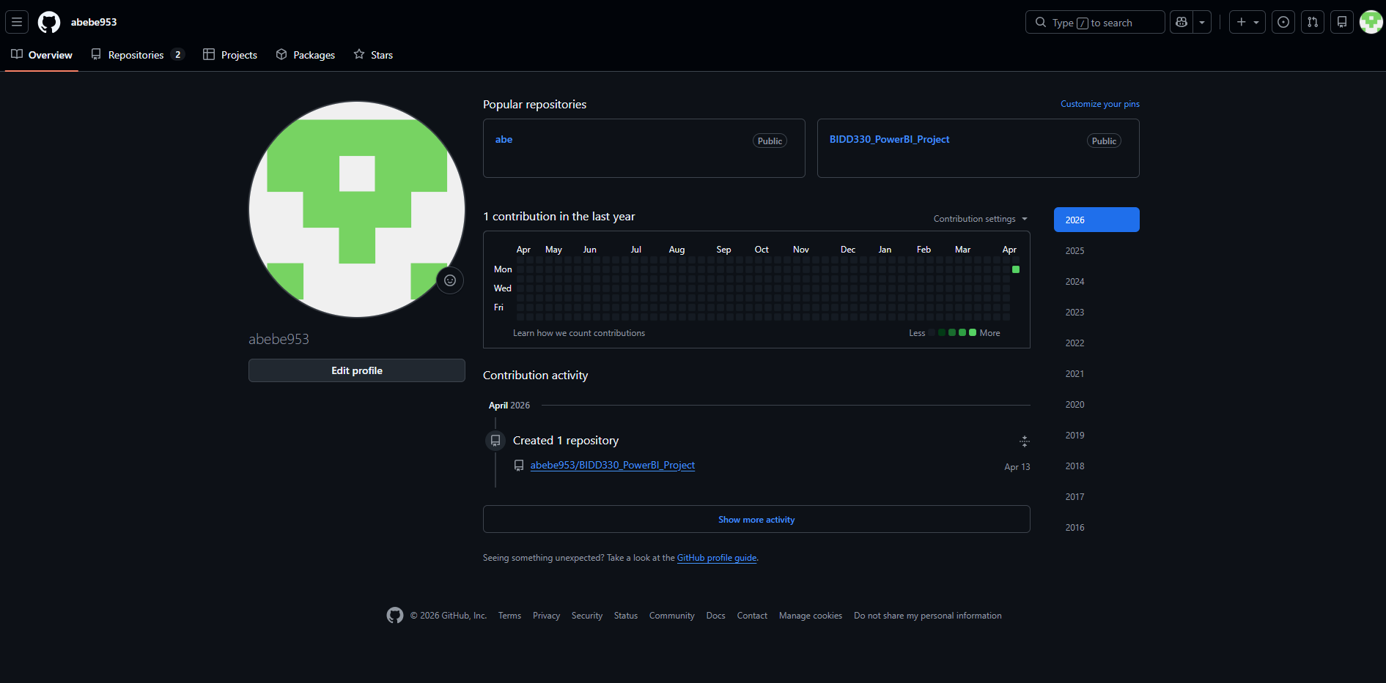

5.1 Repository Setup Steps

Step 1: Create GitHub Account
- Sign up using a personal email address

Step 2: Create Repository
- Click New Repository
- Set visibility (Public or Private depending on requirement)

Step 3: Name Repository
Example: BIDD330_PowerBI_Project

5.2 Wiki Setup

Step 4: Enable Wiki
- Go to repository settings
- Enable Wiki feature

Step 5: Create Wiki Page
- Click Create New Page
- Title:
- Module 1: Power BI, Data Modeling, and AI Tooling
- Paste this Word document content into wiki page
- Upload screenshots
- Click Save Page
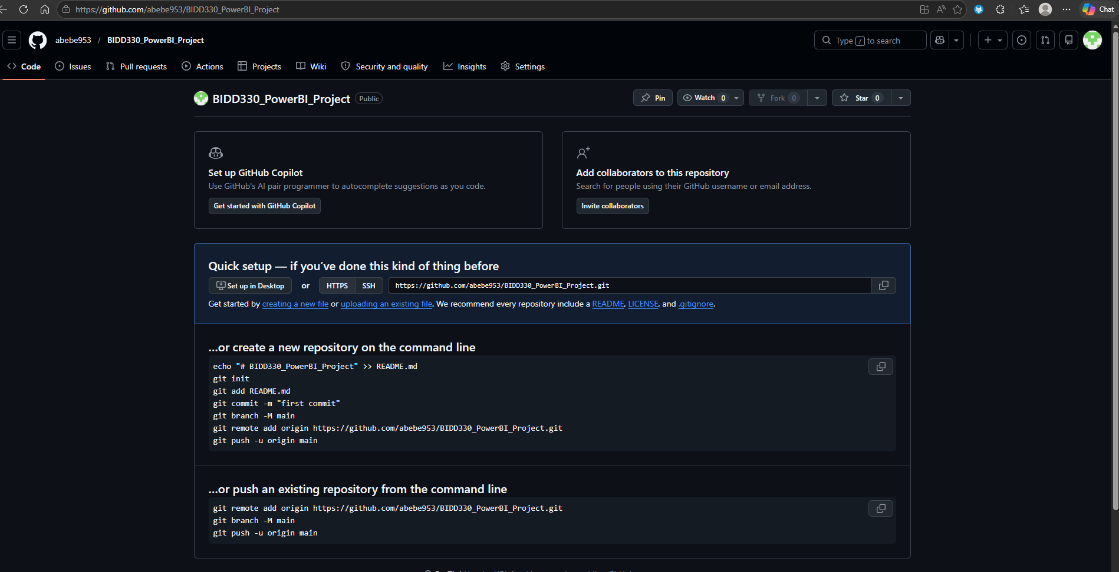

6. Conclusion
This project demonstrates how to:
- Build a Power BI dashboard connected to a live SQL Server database
- Create DAX measures for analytical reporting
- Translate DAX logic into SQL using AI tools
- Document and publish work using GitHub Wiki for collaboration and version control
This workflow reflects real-world Business Intelligence practices used in enterprise environments.

