SmartRail
Seat occupancy sensing and platform guidance for shorter boarding
Research document — stage 3
Yazan Rabea · Abed Azem · Samar Khatib
Mentor: Itai Dabran
236333 Project in Internet of Things · Interdisciplinary Center for Smart Technologies (ICST)
Taub Faculty of Computer Science, Technion · October 2026

General description
SmartRail senses which seats on a train are free and puts that information in front of passengers waiting on the platform, so that they spread along the platform instead of crowding at a few doors. A train cannot leave until its slowest door has finished boarding, so the time it spends standing at a station is set by the busiest door rather than the average one. Spreading the crowd lowers that maximum, and dwell overruns are what accumulate into delay across a journey.
The prototype has four parts. An infrared distance sensor above each seat reports whether the seat is occupied [1]. An ESP32 microcontroller turns those readings into a stable empty or occupied decision [2]. A laptop groups the seat states into carriages. Two passenger-facing interfaces then present them: a platform entrance screen that draws the train as a positional map, showing each carriage's own free-seat count in the place that carriage will stop, and a phone application that acts as a dispatcher, giving each passenger who asks a different carriage so that the waiting crowd divides itself. Two seats are physically sensed; the remaining 1,294 of a twelve-carriage train are simulated, which lets a whole train be demonstrated without instrumenting it.
Headline result. On a twelve-carriage train taking 240 boarding passengers a stop, the positional map cuts mean dwell from 143 to 111 seconds, a saving of 22 percent, and the screen and the application together reach 32 percent. The simulation also showed that a display naming the best carriages makes boarding worse than no display at all, and both interfaces were built around that finding.

Introduction
Passengers do not spread evenly along a platform. They gather near the entrances, the stairs and the exits they will want at their destination. A few carriages receive most of the boarders while others leave with empty seats, and because the train waits for its slowest door, those crowded doors set the dwell time for the whole train. The information that would fix this already exists on the train, namely which seats are free; it is simply not visible to the person standing on the platform, who must decide where to wait before the train arrives.
Operators have reached the same conclusion. Deutsche Bahn publishes real-time occupancy per carriage in its passenger app, on the vehicle and on platform displays, using door counters and light sensors, and states the purpose as helping passengers find a seat quickly and helping trains depart on time [8]. Arriva Rail London trialled a system in 2017 that derives how many passengers are in each carriage from train loading data and shows it to station staff, who then direct waiting passengers towards the less crowded carriages [9]. Both confirm that the concept works in service; what neither publishes is a measurement of how much dwell time the guidance actually saves, which is the gap this project addresses.
SmartRail closes the loop at seat level rather than at door or vehicle level. Seat-level sensing on the train feeds two passenger-facing interfaces, and a simulation estimates what they are worth in seconds of dwell time. The interfaces are deliberately shaped differently because they are read by different numbers of people at once: the platform screen is read by everybody waiting at the same moment, so it carries only positional facts and names no carriage, while the phone application is read by one passenger and may give one instruction precisely because it remembers what it told the previous passenger. Section 5 shows why that asymmetry is the whole design.

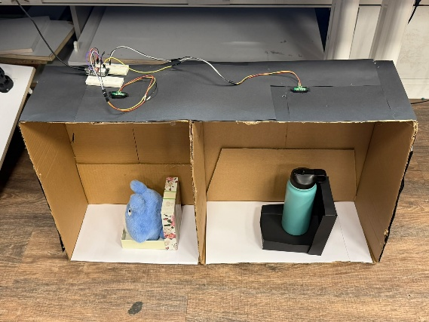

Work in the field
Counting passengers automatically is not a new idea. A 1979 technical report for the US transit industry evaluated three commercial passenger counters fitted to service buses: one used treadle mats in the door steps and two used infrared beams across the doorway, and the treadle mats performed slightly better under almost all test conditions [12]. The beam-break counter at the door survived that comparison and is still the industry baseline four decades later; the bus fleet studied by Madsen and colleagues in 2022 used exactly that, on twenty-two vehicles [11].
The limitation of door counting is structural rather than technological. A door counter measures a flow, not a state, so its estimate of how many people are aboard is an accumulated sum, and any per-event bias accumulates with it. Madsen and colleagues measured a mean drift of about −0.12 passengers per stop against manual ground truth, enough for the running estimate to go negative by the end of a trip, and noted that bicycles, prams and suitcases are counted as people [11]. A door counter also cannot say where the free seats are inside the carriage.
Four approaches are in use or under study, and they differ in what they actually measure:
- Optical counting at the door. Time-of-flight cameras with active infrared illumination produce a 3D image that a neural network interprets; one manufacturer claims better than 98 percent accuracy independent of ambient light [10]. These are the successors to the 1979 beam counters and inherit the same accumulation problem.
- Load weighing. The vehicle weighs itself and infers how many people are aboard. Arriva Rail London's 2017 trial on Class 378 units derived a per-carriage count this way and gave it to station staff, who redirected waiting passengers [9]. It measures a state rather than a flow, so it does not drift, but it cannot tell a heavy passenger from two light ones and says nothing about which seats are free.
- Wireless device counting. A receiver counts Wi-Fi probe requests from passengers' phones. It needs a device-per-person conversion factor, derived by Madsen and colleagues from 86 boarding passengers, and thresholds recalibrated for each placement and route [11]: cheap, non-intrusive and correspondingly noisy.
- Seat-level sensing, which is what this project does. A sensor per seat measures occupancy directly as a state, so it does not drift and needs no conversion factor, and it is the only approach that answers the question a boarding passenger actually asks: is there a seat in that carriage. The cost is one sensor per seat and the wiring to match, which is why it is rare in service.

The sensor
Each seat is sensed with a Sharp GP2Y0A21YK0F infrared distance sensor [1]. It emits an infrared pulse and measures the angle at which the reflection returns, so it measures distance by triangulation rather than by reflected intensity. That matters here: the reading barely changes between a light and a dark surface above roughly 20 cm, so clothing colour has little effect, which is the weakness that disqualifies a simple reflective sensor for this job.
Three properties of the device shaped the design. Its output is not linear, so the firmware converts voltage to distance with the datasheet fit d = 29.988 · V^−1.173 centimetres [1]. It is non-monotonic below about 8 cm, where an object pressed close returns the same voltage as one far away, so the mounting must keep every real reading above roughly 15 cm. Its emitter fires in bursts, which makes the supply sag through breadboard wiring, and the datasheet asks for a bypass capacitor next to the sensor for that reason [1]. The usable range is 10 to 80 cm while a seated person measures about 85 to 90 cm from cushion to head, so the sensor is mounted above the seat and aimed forward at the lap rather than down at the head, putting both the empty and the occupied reading inside the usable range.

Project description

Components and assembly
Part | Qty | Role
ESP32 DevKit V1, 30-pin, CP2102 [2] | 1 | Reads both sensors and decides seat state
Sharp GP2Y0A21YK0F IR sensor [1] | 2 | Seat occupancy, 10–80 cm range
NeoPixel LED strip | 1 | Platform sign stand-in, one segment per carriage
Breadboard, jumper wires, USB cable | — | Prototype wiring and power

Each sensor takes its supply from VIN, which carries about 5 V while the board is powered over USB, and its signal goes to GPIO34 and GPIO35. Those two pins are on ADC1, which continues to work when Wi-Fi is enabled [2]. The sensor's output peaks at about 3.1 V, inside the 3.3 V limit of an ESP32 input, so no divider is needed, but its 5 V supply must never touch a GPIO pin.

Algorithms
The firmware decides occupancy on the board rather than sending raw readings to the laptop. The threshold is relative to each seat's own measured baseline, which tolerates differences between sensors and mountings better than one fixed distance for every seat, and the later wireless stage needs the decision made on the train. Three mechanisms act together:
- Baseline calibration. At power-on the firmware measures the empty seat for about 0.9 seconds and stores that distance as the seat's baseline.
- Median filtering. It samples every 40 ms, matching the sensor's own update period, and takes the median of the last eleven samples. A running median rejects isolated spikes without smearing a genuine step change, which is the property a mean does not have [3].
- Hysteresis. A seat becomes occupied when the filtered distance drops more than 20 cm below its baseline, and returns to empty only when it rises back above baseline minus 12 cm. Two separate thresholds stop the state flickering when a seated passenger shifts; this is the two-threshold switching principle described by Schmitt in 1938 [4]. Any change must then hold for a full second before it is accepted, so somebody walking past a seat never registers.
Detection therefore lags a real movement by about 1.5 seconds, which is well inside the two-second requirement.

Communication
The board prints a status line twice a second and an event line on every change. These lines are a contract rather than debug output: the laptop parses them, so changing a print format breaks the display. Train and platform are presently joined by the USB cable at 115200 baud. The wireless link a real deployment needs, whether ESP-NOW or Wi-Fi with a cloud database, has not been selected or built, and neither has the platform display hardware; these are the two decisions that gate deployment.

The two passenger interfaces
A Python program on a laptop reads the serial stream, groups seats into twelve carriages of 108 seats and serves both interfaces over a local HTTP server. The platform screen is a positional map and nothing else: it draws the train in plan view along the platform edge, each carriage in the place it will stop, with the zone letters beneath it. Carriages are published front to back and never sorted by availability, so the layout holds no ordering a passenger could read as a ranking. A seat whose sensor has stopped reporting is shown as unknown rather than free, and a carriage holding any unknown seat states only what it can evidence, as “at least 3 free, 7 of 108 seats unknown”. Below a fifth of the train's seats free, the screen stops grading carriages by seat count altogether and shows one instruction to spread out.
The phone application answers one passenger at a time. It keeps the carriages within walking range of where that passenger is standing, prefers those with a confirmed free seat, and among them picks the carriage it has routed the fewest passengers to so far. Because it records each answer, two people standing side by side are given different carriages and the crowd divides itself before the train arrives.
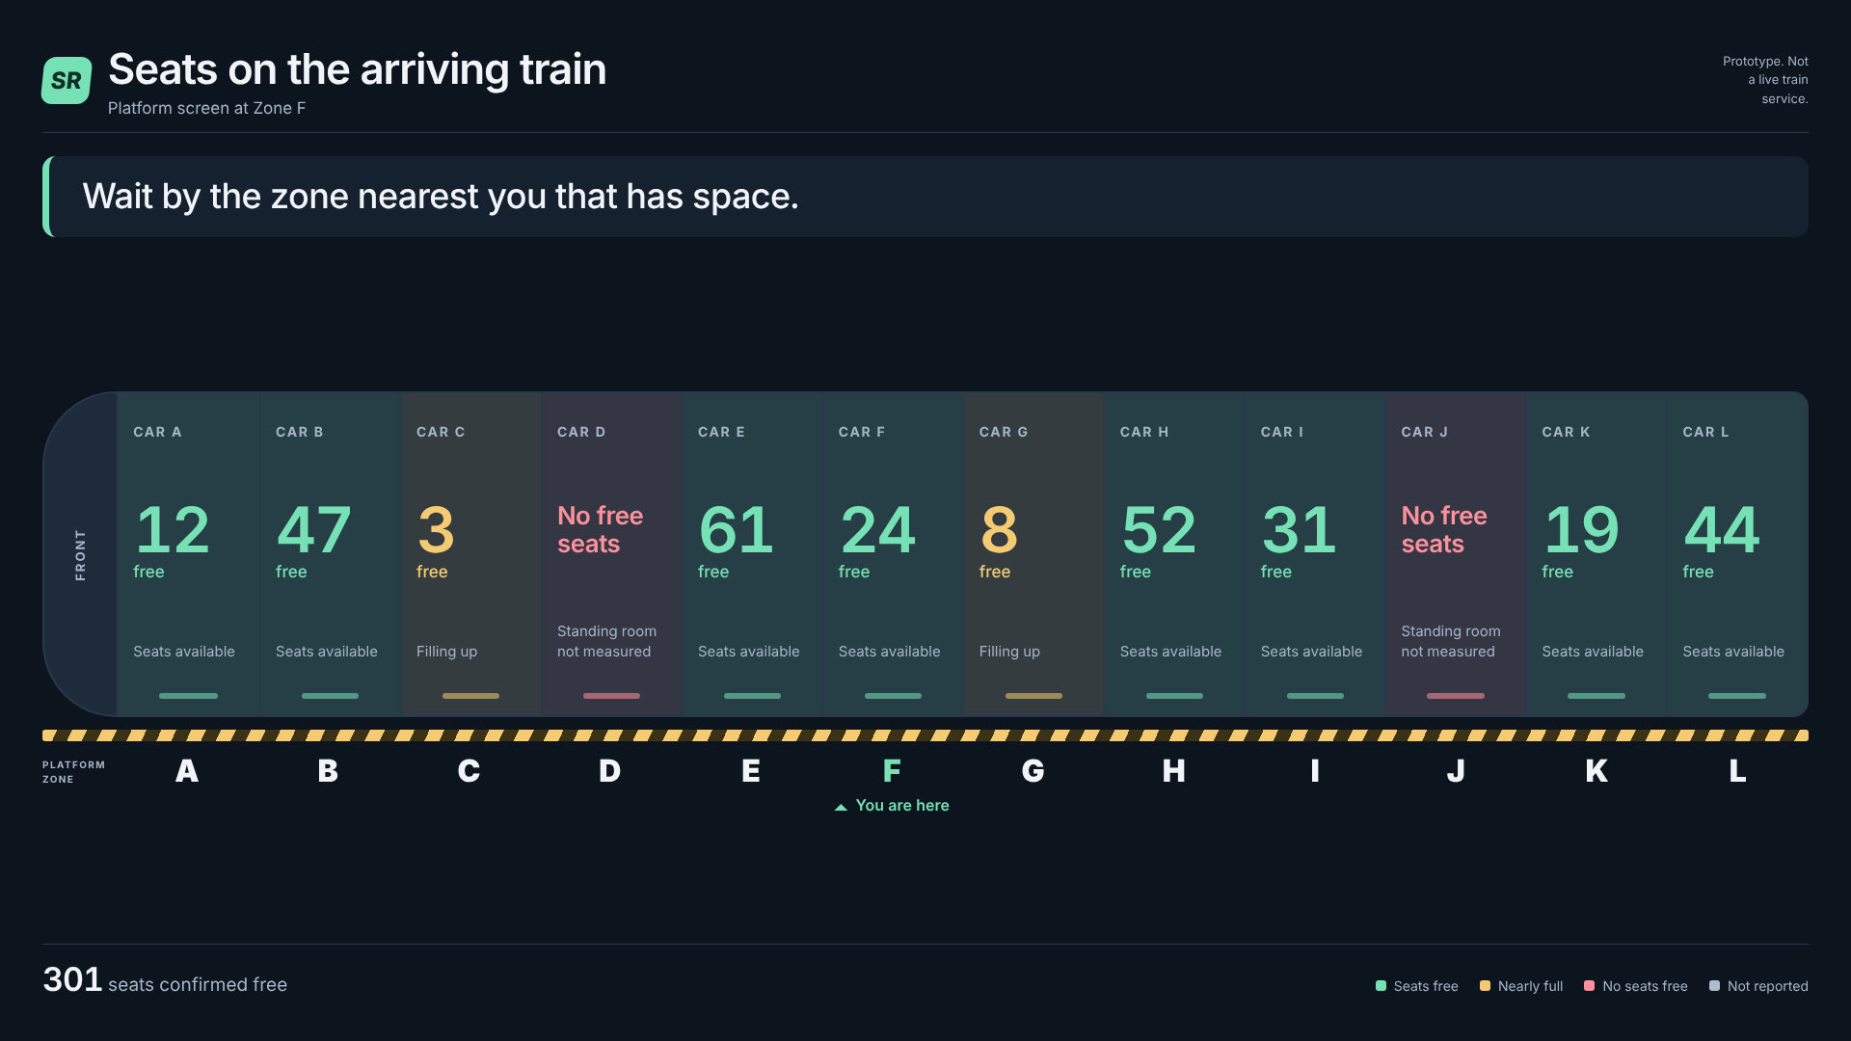
Figure 2. The platform entrance screen. Each carriage is drawn where it will stop, with its own count and zone letter. Nothing is ranked and no carriage is named.

Bibliography for this section
Sensor and microcontroller: [1] Sharp GP2Y0A21YK0F datasheet; [2] Espressif ESP32 series datasheet. Algorithms: [3] Tukey, Exploratory Data Analysis (1977), for the running median; [4] Schmitt, A thermionic trigger, Journal of Scientific Instruments 15 (1938), for two-threshold hysteresis; [5] Ross, Introduction to Probability Models, for the Poisson process and its thinning property, used in Section 5. Full entries are in the References.

Simulation description
Sensing a free seat is the easy half of this project. The half that carries the claim is whether telling passengers about it shortens boarding, and the prototype cannot answer that, so it is answered by simulation. Passengers arrive at a station as a Poisson process and each chooses a carriage independently; because the choices are independent, the thinning property makes the number boarding each carriage Poisson as well, with a mean equal to the arrival rate times that carriage's share [5]. The model never draws a per-carriage Poisson variable directly, so this is a property that emerges rather than one built in. Dwell follows the standard formulation [6][7]: a fixed term, a term per alighting passenger and a term per boarding passenger with a crowding penalty, taken at the busiest door rather than averaged. The generic experiments use one twelve-carriage train of 108 seats a carriage over 500 simulated stops.
What guidance changes is not the shape of the distribution but its means. Without guidance those means are bunched around the platform access points. With the display, the passengers who act on it choose again among the carriages within reach, weighted by the free seats each is showing. That pushes the means towards uniform: the busiest carriage, measured against the average carriage, falls from 1.89 to 1.37, where 1.00 would be perfectly uniform.
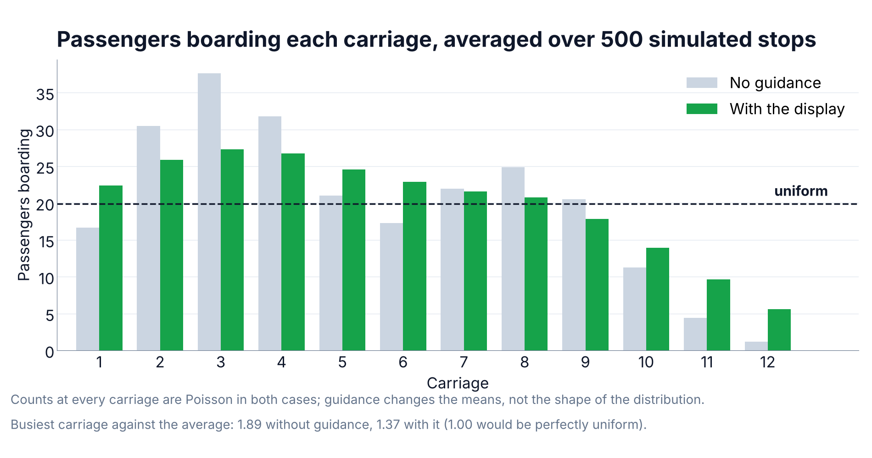
Figure 3. Passengers boarding each carriage, averaged over 500 simulated stops. “With the display” is one shared platform screen showing each carriage's own free-seat count, read by 60 percent of passengers.
The share of passengers who act on the display is one parameter; what they then do is a separate one, and the second matters more. Two designs were compared at the same 60 percent compliance: the one demonstrated at the end of stage 2, which ranked the carriages and named the best three, and the positional map built for stage 3.

Design | Mean dwell | Against no display | Busiest door | Busiest / average
Nothing | 142.7 s | — | 39 | 1.89
Stage 2: name the three best carriages | 200.9 s | 41% slower | 76 | 1.58
Stage 3: each carriage shows its own state | 110.8 s | 22% faster | 33 | 1.37

The stage 2 design does make the distribution more uniform, and still makes boarding slower. It pulls the busiest-to-average ratio from 1.89 down to 1.58, so passengers really are spread more evenly than with no display. Dwell nevertheless rises from 143 to 201 seconds. The averages improve because the three named carriages change from stop to stop, so over many stops every carriage takes a turn; within any single stop the crowd is in one place, because everybody reads the same three names at the same moment and walks to the same three doors. The busiest door nearly doubles, from 39 to 76. Dwell is set by that door at every stop and never by the long-run average, which is why a more uniform average can accompany a worse journey. That is what ended the stage 2 approach.
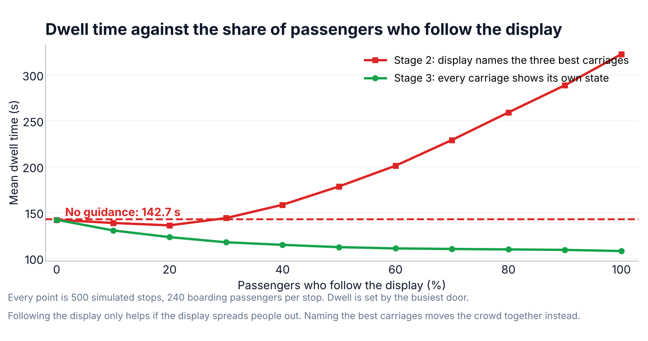
Figure 4. Dwell time against the share of passengers who act on the display, from nobody to everybody, under the two designs. Which rule the display implements matters more than how many passengers follow it.
Under the stage 3 rule most of the benefit arrives early: going from nobody to thirty percent compliance captures 25 of the eventual 35 seconds, so the system does not depend on universal compliance. Under the stage 2 rule the curve turns the other way once more than about a quarter of passengers obey it, because the more people act on a shared recommendation the harder they converge.

When seats run short
Free seats are only a proxy for where there is room, and the proxy breaks down on a nearly full train. Re-running the model at a crush operating point, where about 12 percent of the train’s seats are free at the doors and every stop falls below the 20 percent threshold, shows what happens to a display that still grades carriages by their seat counts:

At a crush load, 12% of seats free | Mean dwell | Against no display
Nothing | 146.0 s | —
Grade the carriages by free seats | 161.6 s | 11% slower
Stop grading, show one instruction to spread out | 148.4 s | 2% slower

With so few seats left, the counts are small, noisy and nearly equal, and grading them funnels everyone into the two or three carriages that still have any: the display becomes 11 percent worse than showing nothing. Switching the screen to a single instruction to spread out recovers 13 of those 16 seconds. That is the fallback described in Section 4, and this is the measurement behind it. Appendix C sets out the rest of the simulation: the walking-time assumption and its lead-time requirement, what happens when the display cannot foresee who is about to alight, the per-person application measured on its own, and the remaining figures.

Conclusions
The sensing chain works. An infrared sensor above a seat, a calibrated relative threshold, a median filter and a one-second confirmation produce a stable occupied or empty decision in about 1.5 seconds, and the per-carriage aggregation and both passenger interfaces are built and demonstrable on a laptop. The simulation then answers the project's central question affirmatively, with two qualifications more useful than the headline: a positional map read by 60 percent of passengers cuts mean dwell by 22 percent, the application and the screen together reach 32 percent, and most of that benefit arrives by the time thirty percent of passengers act on it.
The first qualification is that a display naming the best carriages makes boarding worse than no display at all, by about two-fifths, even though it flattens the long-run distribution. Showing each carriage's own state and letting passengers choose locally is what produces the benefit, so the passenger display was rebuilt as a positional map and the banner and badges were removed from it. The second is that free seats are only a proxy for where there is room, and on a nearly full train that proxy breaks down: at a crush load, grading carriages by seat count is 11 percent slower than showing nothing, which is why the screen falls back to a single instruction to spread out below a fifth of seats free. At the crush loads where this system would matter most, the right measurement is crowding rather than seats.
What remains is to replace assumptions with measurements: a platform count of boarders per carriage, a stopwatch survey of dwell times, and a compliance estimate from showing the display to real passengers. The wireless train-to-platform link and the platform display hardware remain to be chosen, and are the decisions that gate a deployment.

Appendix A — User guide for the simulation
The simulation is a command-line program. It needs Python 3.10 or later with numpy and matplotlib installed.
pip install numpy matplotlib

Running it
From the simulation folder, the comparison and all charts:
python boarding_sim.py

Options worth changing
Option | Default | What it changes
--compliance | 0.6 | Share of passengers who act on the display
--strategy | proportional / adaptive | What a passenger who follows the display does
--stops | 500 | Simulated station stops per scenario
--arrivals | 240 | Mean passengers boarding per stop
--t-board | 1.5 | Seconds per boarding passenger at one door
--seed | 12345 | Random seed; the same seed reproduces a run exactly
--no-charts | off | Print the numbers without drawing figures

What it produces
Everything is written to the results folder: summary.json with every number, boarders_per_car.csv, compliance_sweep.csv, and the figures used in this document. Running the same command twice with the same seed produces identical output.

Reading the output
- Dwell time is the mean seconds the train stands at a station, set by its busiest door.
- Busiest door is the number of passengers boarding through the most loaded carriage; it is what dwell is driven by.
- Busiest carriage against the average is the evenness measure: 1.00 is perfectly uniform, 1.89 is the modelled situation with no display.
- Variance over mean near 1.0 confirms the per-carriage counts are Poisson, as the model's structure implies.

Appendix B — Programmer guide for the simulation

Files
File | Responsibility
boarding_sim.py | The model, the experiments and the console report
charts.py | Every figure; no model logic
README.md | Assumptions, results and sources

How one stop is simulated
- Alighting passengers are drawn per carriage in proportion to who is aboard.
- The number of waiting passengers is drawn from a Poisson distribution.
- Each passenger is assigned the carriage they would naturally walk to, drawn from the baseline profile, which is a mixture of Gaussians centred on the platform access points.
- A compliance share of them then act on the display, according to the chosen strategy, limited by how far they will walk.
- Dwell is computed as the fixed term plus the maximum over carriages of the alighting and boarding terms.
- Occupancy carries forward to the next stop.

Key functions
Function | What it does
baseline_profile(p) | Probability of choosing each carriage with no guidance
choose_cars(...) | Turns a passenger count into boarders per carriage; all behaviour rules live here
dwell_seconds(...) | The dwell equation, taken at the busiest door
run(p, guided) | One scenario over p.stops stops, with separate random streams
compare(p) | Paired guided and unguided comparison plus the summary numbers
sweep_compliance(p) | Dwell against compliance, for one behaviour rule
compare_strategies(p) | The behaviour rules at one compliance level

Changing the model
- Every tunable value is a field of the Params dataclass at the top of boarding_sim.py, with a comment giving its basis.
- To add a behaviour rule, add a branch in choose_cars and a label in compare_strategies. Nothing else needs to change.
- Arrivals, alighting and behaviour draw from separate random streams, so the guided and unguided runs face the same sequence of arrivals. The comparison is paired; keep it that way when adding experiments.

Appendix C — Supporting simulation detail

Model parameters
Parameter | Value | Basis
Carriages × seats | 12 × 108 | Matches the SmartRail display
Boarding passengers per stop | 240, Poisson | Estimate for a busy suburban stop
Passengers acting on the display | 60% | Unmeasured; Figure 4 sweeps it from 0 to 100%
Furthest a passenger will walk | 3 carriages | About 78 m, roughly 60 s on foot
Fixed dwell term | 11.0 s | Within the 10.4–13.5 s range reported in [7]
Seconds per boarding passenger, per door | 1.5 s | See the note below on per-door versus per-vehicle
Seconds per alighting passenger, per door | 1.0 s | Same basis
Crowding penalty at a full carriage | +45% | Congestion term of the standard model [6]
Stops simulated | 500 per scenario | Enough for the means to settle

Per-door against per-vehicle rates. The published regressions give a combined boarding-and-alighting coefficient of 0.26 to 0.28 seconds per passenger [7]. That figure is per vehicle: it is fitted against the total number of passengers using the vehicle, whose doors work in parallel. This model works per door, because dwell is set by the busiest one, so its coefficient must be larger by roughly the number of door streams. At 1.5 seconds per boarding passenger per door, the implied vehicle has about five or six door streams, which is typical of the light rail vehicles those regressions were fitted on. The fixed term is quoted per vehicle in both cases, which is why 11.0 s is used directly and sits inside the reported 10.4–13.5 s range.

That the per-carriage counts really are Poisson
The model draws a total and assigns passengers one at a time, so nothing forces the per-carriage counts to be Poisson. They are anyway, which is the thinning property at work [5]: over 500 stops the busiest carriage has a variance of 37.4 against a mean of 37.6, and for a Poisson variable the two are equal.
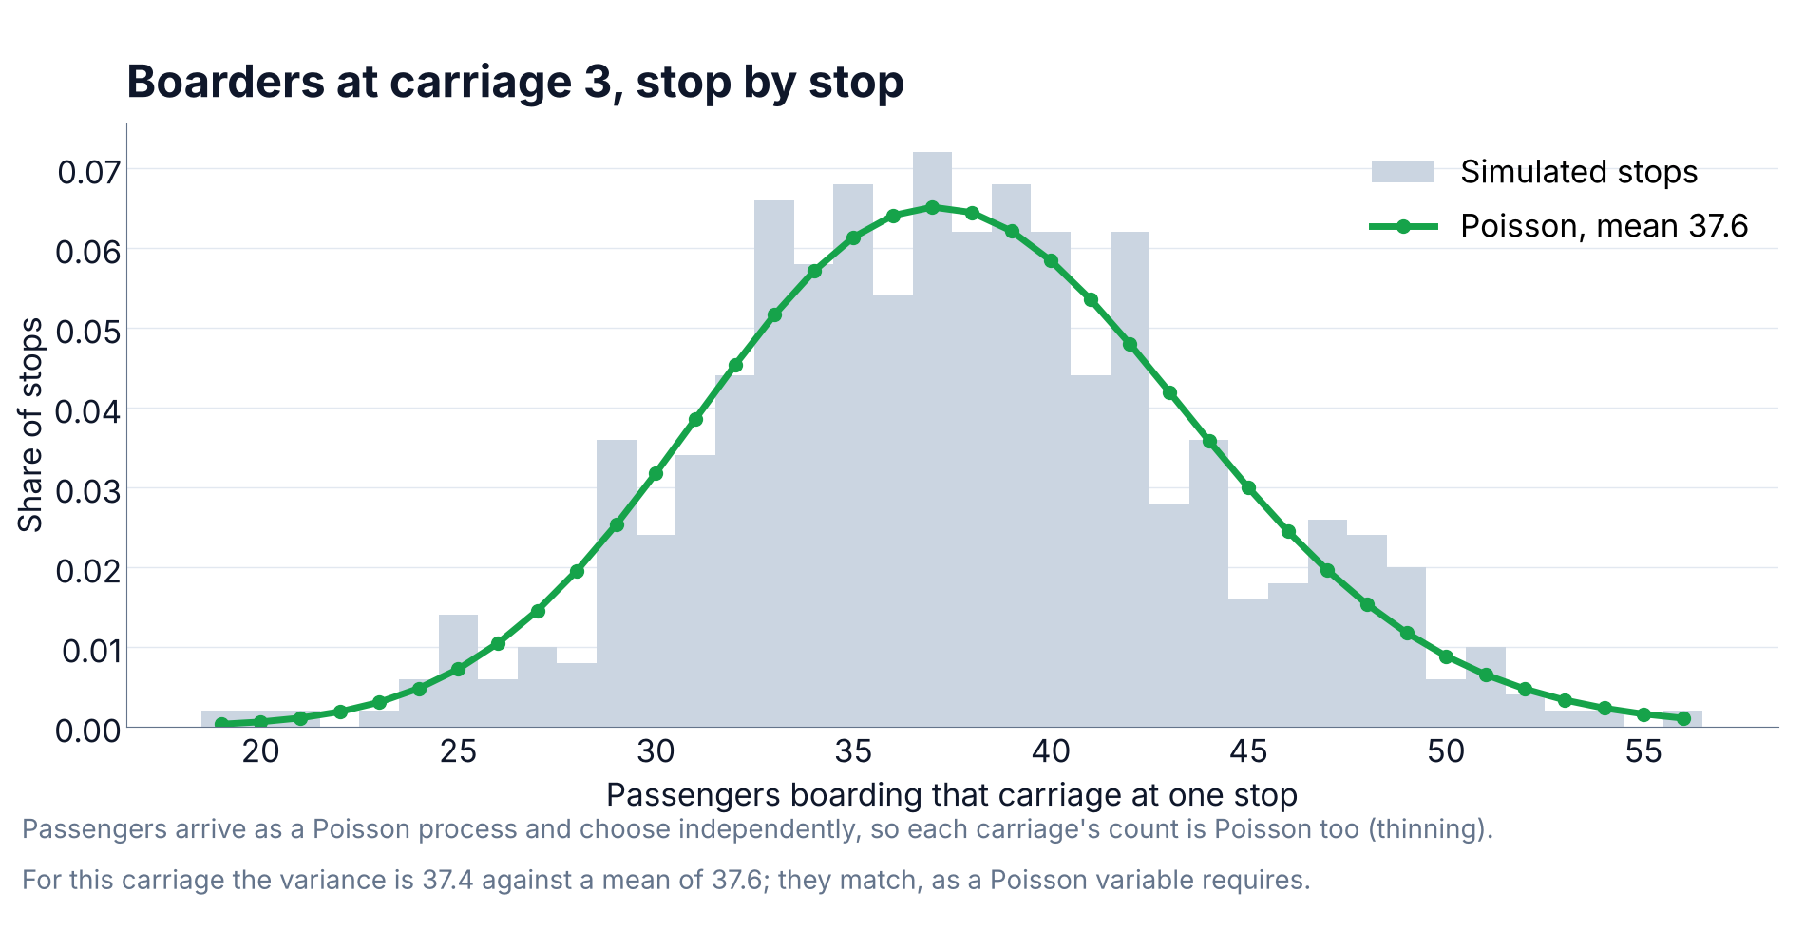
Figure 5. Boarders at the busiest carriage over 500 simulated stops with no display, against the Poisson distribution with the same mean.

Why the long-run average is the wrong measure
Dwell is set at every stop by the busiest door, so what matters is the whole spread of that number and not its average. Two consecutive stops under each design show it as boarders per carriage:

Design | Boarders per carriage at one stop | Busiest door
Stage 3 map | 15 26 27 24 30 20 26 13 18 16 9 3 | 30
Stage 3 map | 25 20 41 38 26 25 27 21 9 9 10 4 | 41
Stage 2 ranking | 5 10 100 11 11 7 12 5 8 55 2 1 | 100
Stage 2 ranking | 20 41 40 11 9 7 87 9 23 4 1 3 | 87

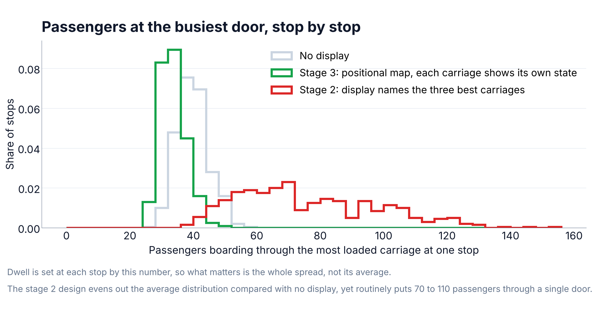
Figure 6. Passengers boarding through the most loaded carriage at a single stop, over 500 stops, under both designs.
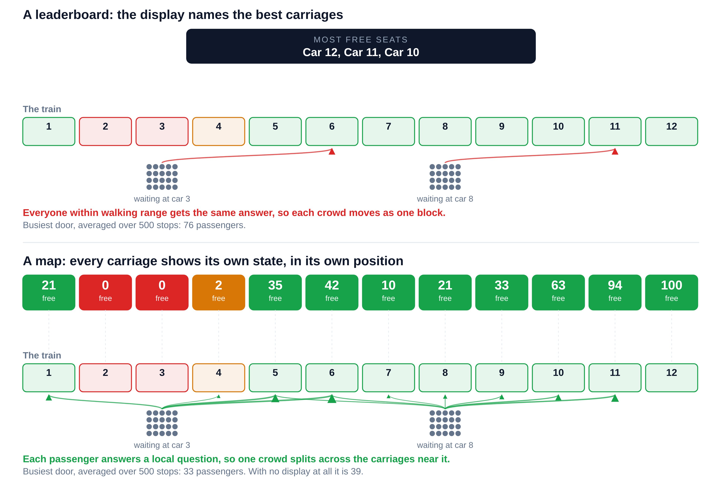
Figure 7. The same train and the same two waiting crowds under both designs. The free-seat numbers are one real moment from the simulation; the arrows show where passengers would walk, given a three-carriage limit.

Walking is not free
The model charges nothing for the walk along the platform: it assumes a passenger reads the display while waiting, walks to the suggested carriage before the train arrives, and is standing there when the doors open. That is defensible but carries a requirement. A double-deck coach is about 26 m and a platform walking pace about 1.3 m/s, so the three-carriage limit is roughly 78 m or 60 seconds. The display must therefore show the approaching train's state at least a minute before it arrives, and the whole sensing chain has to fit inside that minute. A passenger who does not make it boards where they stand, which is arithmetically identical to not having followed the display, and the compliance sweep already covers that case.

Furthest a passenger will walk | Distance | Notice needed | Screen | App
2 carriages | 52 m | 40 s | 19% | 39%
3 carriages | 78 m | 60 s | 22% | 43%
4 carriages | 104 m | 80 s | 25% | 45%
6 carriages | 156 m | 120 s | 29% | 45%

Even one carriage of movement and twenty seconds of notice recovers 14 percent on a screen and 32 percent through an application. The application saturates at about four carriages, because beyond that the balancing is limited by where passengers start rather than by how far they will go.

The display cannot see who is about to get off
The figures quoted so far let the display show free seats as they will be once the passengers leaving at this station have gone. No sensor can know that in advance. A waiting passenger chooses where to stand before the train arrives, so what they can actually be shown is what the sensors see on approach, with the alighting still to come. Re-running every scenario on that basis is the honest test:

Design | If the display could foresee alighting | Sensors only
Screen, map | 22% | 20%
App, per-person advice | 43% | 44%

The cost is two percentage points for the screen and none for the application. Passengers leaving are spread across the carriages roughly in proportion to how full each one is, so alighting changes every carriage's count in much the same direction and leaves their order largely intact. This is reassuring for a sensing system: the quantity the sensors can actually measure is good enough, and a per-station alighting prediction would be a refinement rather than a prerequisite.

The application measured on its own
A screen shows one picture to everybody, so everyone reading it works from the same data and their choices are correlated. An application can tell different passengers different things and can account for what it has already told the previous ones. Taken alone, with no platform screens at all, its benefit scales with how many people carry it:

Phones with the app | Mean dwell | Saving | Busiest door
5% | 134 s | 6% | 37
10% | 127 s | 11% | 36
20% | 112 s | 22% | 32
30% | 98 s | 31% | 28
50% | 84 s | 41% | 23
70% | 79 s | 45% | 21
100% | 78 s | 45% | 21

The benefit saturates near 70 percent, beyond which the walking limit rather than the advice constrains the spreading. A realistic application reach of 10 to 20 percent sits at the lower end, saving 11 to 22 percent on its own, which is why the platform screen remains worth building alongside it. Combining the two gives 32 percent, against 22 percent for either alone.

How much to trust these numbers
The percentage saving is robust to the parameter most likely to be wrong: across boarding rates from 0.8 to 2.5 seconds per passenger the saving stays between 21 and 23 percent, because the guided and unguided cases scale together. The absolute saving in seconds is not robust, and neither is anything that depends on how passengers bunch today. Three measurements would turn this from a plausible model into evidence: counting boarders per carriage on a real platform, timing thirty to forty stops, and showing the display to passengers to estimate compliance.

Appendix D — Stage 2 programmer guide
Reproduced from Presentation/PROGRAMMER_MANUAL.md as submitted for stage 2. Its car ranking now feeds only the retained stage 2 page; the stage 3 interfaces (Section 4, Appendix E) never read it.
https://github.com/abedazem13/SmartRail

SmartRail — programmer manual
Purpose: let another developer understand, reproduce and safely extend the presentation implementation.
Source baseline: 0883d93, inspected 13 October 2026. No code changes, new test execution or physical validation were performed to produce this manual. Use the actual tested commit in the final report.

1. Architecture and responsibilities
The ESP32 owns the calibrated sensor-to-occupancy decision. Python receives that decision, adds unknown/data-age handling, combines it with simulated seats, and exposes shared snapshots to browser views. One serial thread serves all tabs.
File | Responsibility
ESP32.ino (../ESP32/ESP32.ino) | ADC sampling, calibration, median filtering, occupancy state machine, serial output
parameters.h (../ESP32/parameters.h) | Firmware pin mapping, thresholds, timing and sensor conversion constants
seat_live.py (../PC_software/seat_live.py) | Existing Board/Seat parser, regular expressions, stale logic; also a standalone console program
dashboard_model.py (../PC_software/dashboard_model.py) | DemoModel, logical seats, source protection, counts/ranking, simulated stations
dashboard_serial.py (../PC_software/dashboard_serial.py) | SerialWorker, bounded LineBuffer, serial ownership, retry and shutdown
dashboard.py (../PC_software/dashboard.py) | Flask create_app(), API validation, local/network access checks, Waitress entry point
app.js (../PC_software/dashboard_web/app.js) | Shared passenger/control rendering, compact-state decoding, polling, operations and offline UI
index.html (../PC_software/dashboard_web/index.html) | Both views' structure and controls
style.css (../PC_software/dashboard_web/style.css) | Responsive visual design, status colors and seat map
test_dashboard.py (../PC_software/tests/test_dashboard.py) | Model, HTTP and fake-serial regression tests
browser_dashboard_check.py (../PC_software/tests/browser_dashboard_check.py) | Browser integration checks using synthetic firmware input

The older guidance.py (../PC_software/guidance.py) passenger-assignment demo is imported by the console software but is not the dashboard's recommendation algorithm. Dashboard recommendations are computed in DemoModel.snapshot().

2. Dependencies and operation
- Python 3.10+; Flask 3.1.2, pyserial 3.5, Waitress 3.0.2, pinned in requirements.txt (../PC_software/requirements.txt).
- Optional browser checks: Playwright 1.63.0 from requirements-dev.txt (../PC_software/requirements-dev.txt), plus Chromium or installed Edge.
- Vanilla HTML/CSS/JS: no Node toolchain, CDN or external font dependency.
- Firmware: Arduino IDE 2.x with ESP32 core. The newer setup documentation reports 3.0.7; record actual installed version/build output rather than relying on older TODOs.
Follow USER_MANUAL.md (USER_MANUAL.md) for setup. Launchers assume a repository-root virtual environment. The server defaults to localhost:8765; CLI options are --http-port, --serial-port and --host. Source paths for web assets are resolved relative to the server file, not the shell's current directory.

3. Model and source mapping
Current constants in dashboard_model.py:
Constant | Value / role
NUM_CARS | 12; IDs A–L
SEATS_PER_CAR | 108; seat IDs A1–A108 through L1–L108
TOTAL_SEATS | 1,296
REAL_SENSORS | 2; asserted against map length
SENSOR_MAP | A1→firmware 0, B1→firmware 1
AVAILABLE_FREE_MIN | 10 confirmed free seats for green
RECOMMEND_CARS | 3
STOP_ANIMATION_S | 2.4
STOP_MIN_FRACTION / STOP_MAX_FRACTION | 0.05 / 0.20
AUTO_INTERVAL_MIN / AUTO_INTERVAL_MAX | 3 / 300 s; zero disables

simulated stores EMPTY/OCCUPIED for every logical ID. In hybrid mode, _seat_view() substitutes the two real states from the Board; stored simulated values never fill gaps in real data. Switching back to simulation intentionally shows the last software values, not physical readings.
Simulation starts from a deterministic example: free counts (12, 3, 0, 25, 48, 7, 36, 18, 1, 60, 29, 72). Seat placement uses (number * 37) % 108 < free_count. A1/B1 are occupied in that example. Total free = 311; occupied = 985. In hybrid mode those two values depend on hardware, so do not assert the software-only total unconditionally.
All public operations use an RLock. configure() increments a generation and resets the board state. The serial worker tags transport/data callbacks with that generation; late callbacks from an old mode or port cannot overwrite the current model.

4. State invariants and aggregation
- EMPTY = confirmed free; OCCUPIED = confirmed occupied; UNKNOWN = not currently established.
- A1/B1 cannot be edited through set_seat() in hybrid mode. Presets and simulated stops exclude them too.
- Per car: free + occupied + unknown == total.
- Unknown seats do not increase free and do not count as occupied in the occupancy percentage.
- Car status: unknown if any unknowns; otherwise full if free=0, available if free≥10, else filling.
- Occupancy percentage is confirmed occupied / total × 100, rounded to one decimal. Do not use 100 - occupancy_pct as a guaranteed free percentage if unknowns exist.
- Suggestions rank cars with confirmed free seats by descending free, then alphabetical ID. Take at most three. Unlike the old nine-seat implementation, ties do not retain a previous preference.
- Ranking does not mutate seat states, reserve seats, count waiting passengers or quantify boarding-time benefit.

5. Firmware behavior and protocol
Current parameters (../ESP32/parameters.h): two ADC1 sensor pins GPIO34/35, LED GPIO2/4, 40 ms sample interval, 11-sample median window, 500 ms status interval. Calibration waits 3 s and fills each sensor's window twice to establish an empty baseline. The team must keep physical seats empty throughout.
Distance conversion uses 29.988 * V^-1.173, with low-voltage handling and 10–90 cm output clamps. These are firmware values, not a guarantee of valid physical sensing across that entire interval. Very close targets can produce misleading readings; use the sensor datasheet and measured mounting geometry.
Occupancy compares filtered distance with baseline-relative margins: enter at baseline−20 cm; exit when the occupied condition at baseline−12 cm ceases. A changed condition must persist for 1,000 ms. Noise above 150 mV or baseline outside 20–75 cm triggers a calibration warning. Do not infer actual accuracy/latency from these constants alone.
Serial is 115200 baud. Examples below are illustrative protocol values, not measured evidence:
SmartRail seat occupancy - GP2Y0A21YK0F
--- CALIBRATION: keep all seats EMPTY. starting in 3 s ---
CAL seat=0 baseline=58.4cm mv=566 noise=38mV
--- calibration done ---
S0 dist= 58.3cm base= 58.4cm noise= 52mV EMPTY S1 dist= 27.5cm base= 59.0cm noise= 30mV OCCUPIED
EVENT seat=0 state=OCCUPIED dist=23.6cm
The full two-seat calibration emits a CAL entry for each sensor. Status may include a ? pending-confirmation marker and optional raw-voltage diagnostics. c requests recalibration and d toggles raw debug output through serial; the dashboard does not provide these as control endpoints. To use another serial tool, release the dashboard's port first.
seat_live.py regular expressions define the parser contract. Changing firmware print formats requires corresponding parser and test updates. Consult communication documentation (../Documentation/08_COMMUNICATION_AND_DATA.md) for serial fields, but use this manual for the current HTTP/train model.

6. Calibration, stale data and serial lifecycle
- Opening the port may reset the ESP32. Real seats start unknown.
- Boot/calibration-start resets the tracked board and sets calibrating.
- CAL messages supply baseline/diagnostic information but do not make seats passenger-visible as free during calibration.
- After calibration-done, the dashboard explicitly waits for a fresh status/event before establishing occupancy.
- Per-seat stale threshold is more than 2 s (STALE_S in seat_live.py). Status normally arrives every 0.5 s; one missing seat can age out independently.
- Detected transport disconnect resets both real seat values immediately. SerialWorker retries opening/reading roughly every second. It does not switch to simulation on failure.
- One serial handle is shared through the server, not one per browser tab. Closing a tab does not release hybrid mode; switching to simulation or shutting down does.
- LineBuffer handles partial reads/CRLF, replaces invalid UTF-8 and discards lines longer than its 4,096-byte limit including their tails.
- WARN messages are retained visibly, bounded in number, until a new boot/calibration or mode setup clears them. They are not a complete sensor-fault diagnosis.
- Sensor disconnection that still produces plausible firmware messages is not automatically detectable. USB/stream stale handling is not full FR-009 health monitoring.

7. Simulated station state machine
next_stop() applies currently due changes and schedules a new stop. _run_stop() samples only editable simulated IDs:
- Select a rounded random 5–20% of currently occupied simulated seats to alight, at least one if nonempty, capped at population size.
- Select a rounded random 5–20% from previously free seats plus newly alighted seats to board, with the same minimum/cap rules.
- Spread alighting over the first 1.2 s, boarding over the second 1.2 s.
- Increment the station counter immediately; boarding reflects whether pending changes remain.
These fractions apply to the eligible population across cars, not to exactly that fraction in each individual car. Rounding/minimum-one matters for small populations. Selection is random; the deterministic example preset does not make later stops deterministic.
snapshot() advances due changes and automatic stops using a monotonic clock. Automatic operation is request/poll-driven, not a background simulation timer. A long gap in polling does not replay every missed station at real-time frequency.
Operation | Pending changes | Station counter | Auto setting
Click one seat | Cancels pending changes for that seat only | Preserved | Preserved
Scenario preset | Clears all | Resets to 1 | Preserved
Mode/port configuration | Clears all | Preserved | Preserved
Stop auto (0) | Existing pending changes can finish | Preserved | Disabled
Restart server | New model | 1 | Disabled

For clean demonstrations, explicitly stop auto and wait/apply a preset. Do not rapidly queue manual Next stop calls while another animation is active; the UI normally prevents this. The backend is a demo mechanism, not a validated railway event scheduler.

8. HTTP API
JSON input is required for mutations. Body size is limited to 4,096 bytes. String fields are validated by the route helper; invalid operations produce an error rather than silently changing mode/source. Some framework errors return HTML, so callers should not assume every failure body is JSON.
Method / path | Body / purpose
GET / | Passenger page
GET /controls | Local operator page
GET /api/state | Shared compact snapshot; also advances due simulated events
GET /api/ports | Local serial port list; does not open a port
POST /api/mode | {"mode":"simulation","port":""} or {"mode":"hybrid","port":"COM5"}
POST /api/seats/A2 | {"state":"EMPTY"} or {"state":"OCCUPIED"}
POST /api/preset | {"name":"example"}, {"name":"empty"}, {"name":"occupied"}
POST /api/next_stop | {}; schedule a simulated stop
POST /api/auto | {"interval":"10"} or {"interval":"0"}; route expects a string, model parses seconds

Top-level snapshot contains mode, generation, station, auto_interval, boarding, train dimensions, totals, recommended (list), message, connection, warnings and stale_s.
Each car contains id, zone, free, occupied, unknown, total, occupancy_pct, status, states and seats:
- states is a 108-character string: E, O or U per seat in numeric order; character 0 = seat 1.
- seats contains detailed records only for the mapped sensor positions, not every seat. It can include A1/B1 as simulated records in simulation mode; always inspect source, not just sensor_id.
- Detailed records include source/state/editability, reason, distance in cm, noise in mV, pending flag and age in seconds; diagnostics can be null.
Clients must not interpret len(car.seats) as the car's capacity or treat a gray car's known-free count as zero. UI code decodes the compact state strings for the large control map.

9. Frontend and network behavior
The same HTML/JS bundle serves both views; pathname selects the control UI. Browser polling occurs around every 500 ms with a 2.5 s request timeout. Shared server state synchronizes tabs/devices; request sequencing protects the UI against outdated in-flight responses. Failed state polls hide old counts and display offline; successful polls restore the display.
The server defaults to 127.0.0.1. --host 0.0.0.0 exposes viewing to the local network and prints a detected LAN address. Flask Host checks, same-origin JSON mutation checks, no-store responses and a content security policy are present. Remote clients are denied the controls route, port list and non-GET requests; local controls require access from loopback, not the host's LAN URL.
This is not authentication, encryption or a production security design. Network viewers can access state snapshots, so use only a trusted network, never a public tunnel. Do not put a reverse proxy in front without redesigning/testing trust checks: a proxy can make remote requests appear local. No credentials or personal passenger identities are needed for the demo.

10. Build and test workflow
Firmware: open ESP32.ino (../ESP32/ESP32.ino) in Arduino IDE, select the actual ESP32 board/COM port, compile/upload, and record toolchain versions. Do not assume an old binary corresponds to current source or guess a flashing offset. Preserve the tested build's provenance.
Software tests, from SmartRail root after installing dependencies:
Push-Location .\PC_software
..\.venv\Scripts\python.exe -m unittest discover -s tests -p "test_*.py" -v
Pop-Location
Optional actual-browser checks (fake serial inputs, still not hardware tests):
.\.venv\Scripts\python.exe -m pip install -r .\PC_software\requirements-dev.txt
.\.venv\Scripts\python.exe -m playwright install chromium
Push-Location .\PC_software
..\.venv\Scripts\python.exe .\tests\browser_dashboard_check.py
Pop-Location
Alternatively use installed Edge: set $env:SMARTRAIL_BROWSER_CHANNEL = 'msedge' before the browser test and omit the Chromium download. Record the actual interpreter, browser version, test count, exit result and revision. Do not hardcode an old reported test count as current proof.
Visible test coverage includes dimensions/example, ranking, simulated stop bounds/timing, auto stops, real-input protection, stale/calibration handling, generation guards, validation/network access, framing and fake reconnects. Browser tests cover both views and synthetic events. Physical tests remain a separate human/device procedure in TEST_RESULTS_TEMPLATE.md (TEST_RESULTS_TEMPLATE.md).

11. Changing or extending the implementation

Change train size
Review NUM_CARS, SEATS_PER_CAR, the example tuple length, SENSOR_MAP, and the scatter rule. The current scatter multiplier is coprime with 108; another seat count may need a different permutation to preserve exact totals. Also update hardcoded UI text, labels, thresholds, tests and manuals. Changing one constant is not guaranteed to produce a consistent presentation.

Add real sensors
Update wiring and firmware NUM_SEATS/pin arrays with safe ADC choices. Update the parser's tracked board mapping, SENSOR_MAP, REAL_SENSORS, model and UI assumptions, diagnostics, tests and docs. Adding only a display mapping is insufficient if the Board still tracks just two firmware IDs. Hardware acceptance is required.

Change recommendation policy
Keep it separate from measured availability. Add deterministic tests, document tie handling/unknowns, and do not reduce free counts merely because a passenger was advised to go somewhere. A passenger-flow study needs a defined model, equal comparison conditions, repeated trials and a mentor-approved metric.

Introduce wireless transport
Define an explicit message schema, device/car/seat identifiers, freshness, reconnection, authentication and trust boundaries first. Preserve unknown-on-missing semantics. Viewing the laptop page over Wi-Fi is not this feature.

Change serial messages or persistence
Modify producer/parser/tests together. The current server is memory-only; session restart resets data. If adding a database/log, define retention, privacy and timestamps. The latest-message UI is not a raw session recorder.

12. Known boundaries
No accepted dwell-time performance claim, no full sensor-health guarantee, no real train location feed, no complete wireless deployment, no reservations, no production authentication, no persistent dashboard sessions. The proposed requirements remain subject to mentor confirmation. Use READINESS_CHECKLIST.md (READINESS_CHECKLIST.md) and TEST_RESULTS_TEMPLATE.md (TEST_RESULTS_TEMPLATE.md) to close acceptance/evidence gaps rather than claiming success from source inspection.

Appendix E — Stage 3 user guide
Updated for stage 3 from Presentation/USER_MANUAL.md and PC_software/PASSENGER_INTERFACES.md in the project repository.

SmartRail — user manual
Audience: demonstrator/operator, and passengers using the platform screen or phone app.
Version described: source b549083 (stage 3), reviewed 25 October 2026.
Scope: current 12-car prototype. Physical testing must be completed with the board; this manual does not certify the hardware.

1. What the system does
Seat states for 12 cars, A–L, of 108 seats each reach passengers through two interfaces:
- Platform screen: a positional map of the arriving train for everyone waiting. Each carriage shows its own state where it stops; nothing is ranked or named.
- Phone app: a dispatcher for one passenger. You enter your platform zone and receive a single assigned carriage; the next person is sent elsewhere.
The operator's Controls page changes simulated seats, runs simulated stops and connects two real sensors (hybrid mode: A1 and B1 real, 1,294 seats simulated). Counts and assignments are guidance, not reservations; stations are simulated, not live train tracking.

2. What you need
- Software: Windows laptop with Python 3.10 or newer, a web browser, this repository and a virtual environment with the project dependencies. Phones also need a trusted private network shared with the laptop.
- Hybrid: ESP32 DevKit V1 with current firmware; two mounted Sharp analog IR sensors on GPIO34 and GPIO35; USB data cable and CP210x driver; working power, common ground and supply decoupling per ../Documentation/04_HARDWARE.md and 05_WIRING_AND_PINOUT.md.
Power down before changing wires. Never apply 5 V to an ESP32 signal pin or combine external power with PC USB without an approved arrangement.

3. One-time Windows setup
In PowerShell, from the repository root (the folder containing ESP32 and PC_software):
if (-not (Test-Path .venv)) { py -3 -m venv .venv }
.\.venv\Scripts\python.exe -m pip install -r .\PC_software\requirements.txt
Use python if py is unavailable; install and launch with the same interpreter. For hardware, upload ESP32.ino (../ESP32/ESP32.ino) from Arduino IDE 2.x with the ESP32 core (record the version used), keeping the seats empty through calibration.

4. Start and stop
Passenger interfaces, from the repository root:
.\.venv\Scripts\python.exe .\PC_software\passenger_routes.py
Operator controls: start_dashboard.bat (../start_dashboard.bat) or .\PC_software\dashboard.py. Keep both consoles open.
View | Address | Purpose
Platform screen | http://127.0.0.1:8766/platform | Positional map; add ?zone=F to mark the screen's own zone
Phone app | http://127.0.0.1:8766/app | Zone picker and one assigned carriage
Controls | http://127.0.0.1:8765/controls | Seats, scenarios, stops, hardware connection

As submitted, the passenger server simulates its own train (the example scenario) and ignores Controls and the sensors, and start_dashboard.bat still opens the stage 2 display at port 8765. Registering the passenger routes in dashboard.py (PC_software/PASSENGER_INTERFACES.md) fixes both: the screen and app are then served on port 8765, / shows the map, and the stage 2 display is kept at /baseline for comparison only.
Press F11 for a full-screen platform display. Stop a server with Ctrl+C; restarting resets its seats, station and assignments. If a port is busy, add --http-port 8767 and use that port. dashboard.py --serial-port COM5 starts hybrid mode directly.

5. Read the platform screen
Carriages are drawn in stopping order from the FRONT marker, each above its zone letter. The order never changes with availability, and no carriage is badged or named.
Display | Meaning
“N free”, Seats available (green) | 10 or more confirmed free seats
“N free”, Filling up (yellow) | 1–9 confirmed free seats
“No free seats” (red) | None free with complete data; standing room is not measured, so boarding is still allowed
“Some seats not reported” (gray) | A sensor is silent; only proven seats are stated, e.g. “At least 3 free, 7 of 108 seats unknown”
“Space here” on every carriage with room | Under 20% of seats free: counts are hidden and the banner asks everyone to spread out and use all doors
“You are here” | This screen's zone, set by ?zone= in its address
“Lost contact with the train” | Counts are out of date

Passengers wait by the nearest carriage with space, as the banner says. Zones are logical labels matching car letters; no real stopping-position feed exists.

6. Use the phone app
- Open http://127.0.0.1:8766/app, or the network address from Section 9 on a phone. The app lists the twelve platform zones, front to back.
- Tap the zone you are standing at. This is the only input.
- Read the single assignment: the zone to wait at, “Car X stops here”, the walk (e.g. “2 carriages towards the back”) and the seats confirmed free when you asked.
- Walk there. The carriage is held for 3 minutes, shown as a countdown; at zero it expires, and you reload or tap Change my zone to ask again.
- Once aboard, tap I have boarded. This, like Change my zone, hands the carriage back for the next passenger.
Dispatcher rules:
- A repeated request within the 3 minutes (a reload, or reopening the app) returns the same carriage and is not counted twice. The on-screen countdown restarts, but the hold still ends 3 minutes after the first request.
- Passengers at the same zone get different carriages: within 3 carriages, the app picks the one with a confirmed free seat that the fewest waiting passengers have been sent to. Unknown seats never count as free.
- If nothing within reach confirms a free seat, it still assigns a carriage away from the busiest door, and says so.
- All assignments clear when the train departs (the station counter advances). The app never lists carriages or shows other carriages' counts.

7. Simulation controls
Controls reach the screen and app only once the routes are registered (Section 4).
- Choose Use simulation if needed, and press Stop auto stops before preparing a static scene.
- Example scenario · station 1 restores the example; Empty simulated seats and Occupy simulated seats set every editable seat (A1/B1 are skipped in hybrid mode). Presets reset the station to 1 but do not stop automatic stops.
- Click a seat in the car maps to toggle it between empty and occupied.
- Next stop: over about 2.4 seconds simulated passengers leave, then others board, at random. The station advances, which clears all phone assignments. Physical seats never change.
- Automatic stops (5, 10, 15 or 30 s) are advanced by page polling, so keep Controls or the platform screen open. A running stop may finish after Stop auto stops.
Example free counts: A12, B3, C0, D25, E48, F7, G36, H18, I1, J60, K29, L72; total 311 (24%), so the screen shows counts. At 259 or fewer (under 20%) it shows “Space here”. Stops are synthetic activity, not a passenger-flow model.

8. Connect physical sensors
- Confirm firmware, wiring and mounting with the hardware operator. Sensor 0/GPIO34 is A1; sensor 1/GPIO35 is B1.
- Close Arduino Serial Monitor/Plotter and any other program using the port; only one reader can own it.
- In Controls, choose Refresh ports, select the actual port and click Connect hardware · hybrid mode.
- Keep both seats empty through calibration (typically about five seconds; connecting may reset the ESP32). A1/B1 then show sensor sources and cannot be clicked.
- A target in the validated range occupies the seat after firmware confirmation; removing it restores empty.
Demonstration: stop auto, connect with both real seats empty, then choose Occupy simulated seats. Controls shows one free seat in A and in B; the platform screen marks both “Space here” because the train is under 20% free. Covering one sensor turns its carriage to “No free seats”.
If the ESP32 disconnects, A1/B1 become unknown (“Some seats not reported”) and are never filled with simulated values. The worker retries the same port; if Windows renames it, select it and reconnect with the seats empty. Hardware diagnostics & mapping shows distance, noise, state age and the latest board message.

9. Phone access over the network (optional)
- Put the laptop and phones on a trusted private network or hotspot; campus Wi-Fi may isolate devices.
- Add --host 0.0.0.0 to the passenger command in Section 4 (once integrated, use start_dashboard_network.bat instead).
- On the phone, open http://<laptop IPv4 address>:8766/app (8765 once integrated); ipconfig shows the address. 127.0.0.1 on a phone is the phone itself.
- If Windows asks, allow the program on private networks only; do not disable the firewall.
Phones can only request and hand back assignments, never change seats, modes or ports. There is no password: do not expose the service to the internet or a public tunnel.

10. Common problems
Symptom | Action
Missing Flask, serial or Waitress | Install requirements with the interpreter that launches the server
Page unavailable | Check the console, address and port
Port already in use | Stop the old server or choose another --http-port
Screen ignores Controls or sensors | Expected from the standalone passenger server; register its routes (Section 4)
Phone cannot load or shows an error | Check network, address, port, firewall and client isolation; once integrated, confirm the guard change in PASSENGER_INTERFACES.md
No COM device | Check USB data cable, driver and actual port
COM access denied | Close every other serial reader, then retry
A1/B1 not reported after connecting | Wait for calibration; verify firmware, 115200 baud and two sensor entries
Wrong physical seat changes | Verify sensor index/GPIO mapping with the operator
False readings | Check range, mounting, noise, supply and capacitors before changing thresholds
Preset changes by itself | Stop automatic stops first

11. Evidence and limits
Capture screenshots of both interfaces, a hardware video and completed test results (TEST_RESULTS_TEMPLATE.md). There is no database, reservation, live train feed or measured dwell-time optimization; assignments live in server memory and the phone keeps only a random ticket. Source-based descriptions must not be relabeled as physical test results.

References

Sensors and hardware
[1] Sharp Corporation. GP2Y0A21YK0F distance measuring sensor unit, datasheet. Analogue output, 10–80 cm measuring range.
[2] Espressif Systems. ESP32 series datasheet. ADC1 and ADC2 behaviour with Wi-Fi enabled, GPIO input limits.

Algorithms
[3] Tukey, J. W. Exploratory Data Analysis. Addison-Wesley, 1977. Running-median smoothing.
[4] Schmitt, O. H. A thermionic trigger. Journal of Scientific Instruments, 15(1), 1938, pp. 24–26. Two-threshold switching, the basis of hysteresis.
[5] Ross, S. M. Introduction to Probability Models. Academic Press. The Poisson process and its thinning property.

Dwell time
[6] Public Transportation Systems, lecture 9: dwell-time models. MIT OpenCourseWare, Spring 2017. https://live.ocw.mit.edu/courses/1-258j-public-transportation-systems-spring-2017/79e5b6b5a78002efdf3ec1697b7573c2_MIT1_258JS17_lec09.pdf
[7] Modelling dwell time in light rail systems: regression coefficients and fixed minimum dwell. University of Southampton. https://eprints.soton.ac.uk/414364/1/4_50.pdf

Occupancy sensing and deployed systems
[8] Deutsche Bahn improves regional passenger experience with real-time capacity information. Railway News. https://railway-news.com/db-improves-regional-passenger-experience-with-real-time-capacity-information
[9] UK premiere: Arriva Rail London app from Hacon shows loadweigh information in real time, 26 September 2017. Per-carriage loading given to station staff on Class 378 units. https://www.hacon.de/en/news/press/uk-premiere-arriva-rail-london-app-from-hacon-shows-loadweigh-information-in-real-time/
[10] VisualCounter Transit TOF: time-of-flight 3D passenger counting, manufacturer product brochure, APTA 2023. Accuracy figure is manufacturer-stated. https://www.aptaexpo.com/apta2023//custom/PDFs/APTA23PR/VisualCounter.Transit.TOF_MK-BR-030.06-EN%20(1).pdf
[11] Madsen, T. et al. Comparison and fusion of WLAN-probe and infrared door-counter occupancy estimation on buses. Sensors, 22, 2022, article 4111. https://vbn.aau.dk/files/492069003/sensors_22_04111_v2.pdf
[12] Evaluation of passenger counter system for an AVM experiment, volume I: technical report, 1979. Treadle-mat and infrared-beam counters compared on transit buses. https://trid.trb.org/View/88777

Project repository
[13] SmartRail: firmware, PC software, simulation and documentation. https://github.com/abedazem13/SmartRail

