SmartRail
Seat occupancy sensing and platform guidance
Research document — stage 3
Yazan Rabea · Abed Azem · Samar Khatib
Mentor: Itai Dabran
236333 — Project in Internet of Things
Interdisciplinary Center for Smart Technologies (ICST)
Taub Faculty of Computer Science, Technion
22 October 2026

1. General description
SmartRail senses which seats on a train are free and shows that information to passengers waiting on the platform, so that they spread along the platform instead of crowding at a few doors. A train cannot leave until its slowest door has finished boarding, so the time it spends standing at a station is set by the busiest door rather than the average one. Spreading the crowd lowers that maximum.
The prototype has four parts. An infrared distance sensor above each seat reports whether the seat is occupied. An ESP32 microcontroller turns those readings into a stable empty or occupied decision. A laptop groups the seat states into carriages. Two passenger-facing interfaces then present them: a platform entrance screen that draws the train as a positional map, showing each carriage’s own free-seat count in the place that carriage will stop, and a phone application that acts as a dispatcher, giving each passenger who asks a different carriage so that the waiting crowd divides itself.
Two seats are physically sensed. The remaining 1,294 seats of a twelve-carriage train are simulated in software, which lets a whole train be demonstrated without instrumenting it. A separate simulation answers the question the project exists to answer: whether this kind of guidance actually shortens boarding.
Headline result. On a model of a ten-station morning service on the Israel Railways coastal line, the train stands still for 12.4 minutes today and 11.0 minutes with the display, recovering 83 seconds per journey and 63 seconds of accumulated delay. The simulation also showed that a display naming the best carriages makes boarding worse than no display at all. Both interfaces were built around that finding: the screen ranks nothing, and the application coordinates passengers one at a time rather than broadcasting a single answer to all of them.

2. Introduction

The problem
Passengers do not spread evenly along a platform. They gather near the entrances, the stairs and the exits they will want at their destination. The result is that a few carriages receive most of the boarders while others leave with empty seats. Because the train waits for its slowest door, those few crowded doors set the dwell time for the whole train, and dwell overruns accumulate into delay across a journey.
The information that would fix this already exists on the train: which seats are free. It is simply not visible to the person standing on the platform, who must decide where to wait before the train arrives.

What SmartRail does
SmartRail closes that loop. Seat-level sensing on the train feeds a platform display that shows, carriage by carriage, how many seats are confirmed free and which platform zone each carriage will stop at. A passenger reading it can move a short distance along the platform before the train arrives.
Two interfaces deliver that information, and they are shaped differently because they are read by different numbers of people at once. The platform entrance screen is read by everybody waiting at the same moment, so it carries only positional facts: this carriage, in this place, has this many confirmed free seats. It names no carriage as a better choice, because a recommendation read simultaneously by a whole crowd moves that crowd to the same doors. The phone application is read by one passenger, so it may give one instruction — go to that carriage — precisely because it remembers what it told the previous passenger and sends this one somewhere else. Section 5 measures both, and the asymmetry between them is the project’s main design finding.
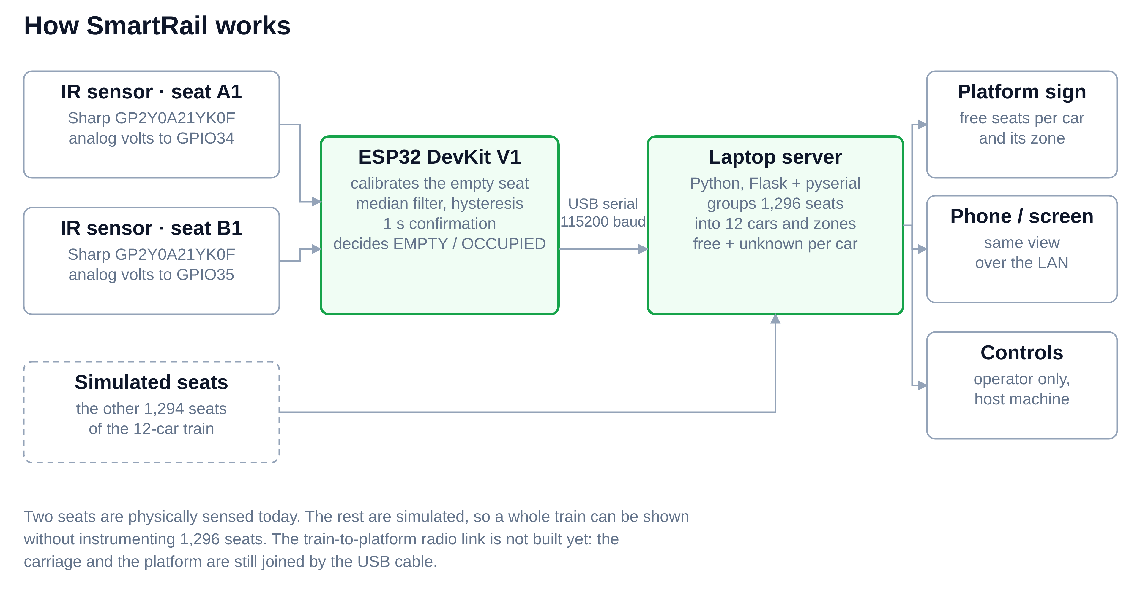
Figure 1. The parts of the system and what each one sends to the next. Two seats are physically sensed today; the train-to-platform radio link is not yet built.

Scope of this document
Section 3 reviews comparable systems and the measurement literature the simulation relies on. Section 4 describes what was built. Section 5 describes the simulation and its results, including a calibration to a real Israel Railways service. Section 6 draws conclusions. The appendices are the user and programmer guides for the simulation, and pointers to the stage-2 guides and the repository.

3. Work in the field

Occupancy displays already in service
Deutsche Bahn (DB) successfully operates a similar real-time occupancy system, using sensors to display red, yellow, and green capacity indicators for individual carriages on platforms and apps. This proves the concept's real-world feasibility and removes significant project risk.
Crucially, DB displays the state of every carriage rather than recommending a single "best" one which is a design distinction that Section 5's simulations demonstrate is essential.

How dwell time is modelled
The dwell-time literature gives this project both its equation and its parameters. The standard formulation expresses the time a door is open as a fixed term plus a term for each boarding passenger, a term for each alighting passenger, and a congestion term that grows with the number of standees. For a vehicle or a train, dwell is taken as the maximum over its doors and carriages, not the average, which is exactly the property SmartRail tries to exploit.
Published regressions on real services give the scale of those coefficients. A study of three light rail lines reports a combined boarding-and-alighting coefficient of 0.26 to 0.28 seconds per passenger and a fixed minimum dwell of 10.4 to 13.5 seconds that cannot be undercut. The simulation in Section 5 uses values in this range and reports how sensitive its conclusion is to them.

The sensors
Each seat is sensed with a Sharp GP2Y0A21YK0F infrared distance sensor. It emits an infrared pulse and measures the angle at which the reflection returns, so it measures distance by triangulation rather than by reflected intensity. That matters for this application: the reading barely changes between a light and a dark surface above roughly 20 cm, so clothing colour has little effect.
Three properties of the sensor shaped the design:
- Its output is not linear. The firmware converts voltage to distance with the datasheet fit d = 29.988 · V^-1.173 centimetres.
- It is non-monotonic below about 8 cm: an object pressed close gives the same voltage as one far away. The mounting must keep every real reading above roughly 15 cm.
- Its infrared emitter fires in bursts, which makes the supply sag through breadboard wiring. The datasheet asks for a bypass capacitor next to the sensor for this reason.
The sensor's usable range is 10 to 80 cm, while a seated person measures about 85 to 90 cm from cushion to head. The sensor is therefore mounted above the seat and aimed forward at the lap rather than down at the head, so that both the empty and the occupied reading fall inside the usable range.

4. The project

Hardware
Part | Quantity | Role
ESP32 DevKit V1, 30-pin, CP2102 | 1 | Reads both sensors and decides seat state
Sharp GP2Y0A21YK0F IR sensor | 2 | Seat occupancy, 10-80 cm range
NeoPixel LED strip | 1 | Platform sign stand-in, one segment per carriage
Breadboard, jumper wires, USB cable | - | Prototype wiring and power

Each sensor takes its supply from VIN, which carries about 5 V while the board is powered over USB, and its signal goes to GPIO34 and GPIO35. Those two pins are on ADC1, which continues to work when WiFi is enabled. The sensor's output peaks at about 3.1 V, inside the 3.3 V limit of an ESP32 input, so no divider is needed, but its 5 V supply must never touch a GPIO pin.

Firmware: deciding whether a seat is occupied
The firmware makes the decision on the board rather than sending raw readings to the laptop. This was a deliberate choice: the threshold is relative to each seat's own measured baseline, which tolerates differences between sensors and mountings better than one fixed distance for every seat, and the later wireless stage needs the decision to be made on the train.
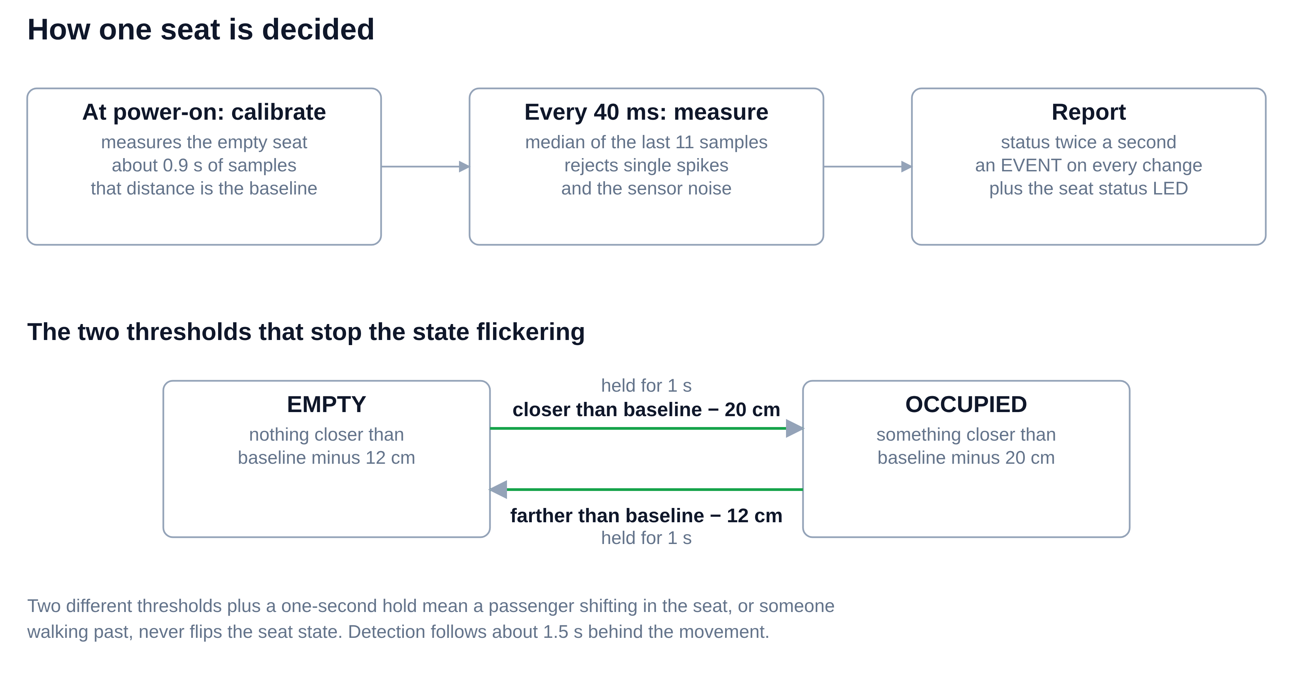
Figure 2. How one seat is decided. Three mechanisms act together: a calibrated baseline, two thresholds, and a one-second confirmation.
At power-on the firmware measures the empty seat for about 0.9 seconds and stores that distance as the seat's baseline. It then samples every 40 ms, matching the sensor's own update period, and takes the median of the last eleven samples, which rejects single spikes without smearing a real change. A seat becomes occupied when the filtered distance drops more than 20 cm below its baseline, and returns to empty only when it rises back above baseline minus 12 cm.
The two different thresholds stop the state flickering when a seated passenger shifts. Finally, any change must hold for a full second before it is accepted, so somebody walking past a seat never registers. Detection therefore lags a real movement by about 1.5 seconds, which is well inside the two-second requirement.
The board prints a status line twice a second and an event line on every change. These lines are a contract, not debug output: the laptop software parses them, so changing a print format breaks the display.

Passenger display: a positional map
A Python program on a laptop reads the serial stream, groups seats into twelve carriages of 108 seats, and serves the two passenger-facing interfaces over a local HTTP server. Two seats are real; the remaining 1,294 are simulated, which is what makes a whole-train demonstration possible.
The display is a positional map and nothing else. It draws the train in plan view along the platform edge, each carriage in the place it will actually stop, with the platform zone letters beneath it. Every carriage shows its own confirmed free-seat count and its own state. The carriages are published front to back and are never sorted by availability, so the layout holds no ordering that a passenger could read as a ranking, and no position a badge could occupy.
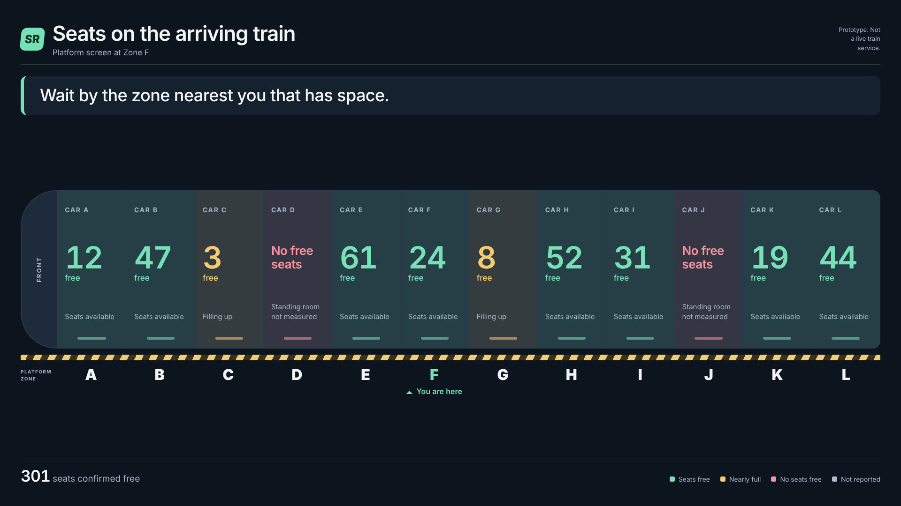
Figure 3. The platform entrance screen. Each carriage is drawn where it will stop, with its own count and zone letter. A screen also marks the zone it is installed at, so two screens at opposite ends of one platform show identical counts and send their readers in different directions.
The “most confirmed free seats” banner and the “best choice” and “good choice” badges were removed from this display. Section 5 shows why. A screen that names winning carriages is read by everyone at the same moment, so it moves the crowd rather than spreading it, and in the model it makes boarding 49 percent worse than showing nothing at all. The ranked version was not deleted, because it is the control case those measurements are compared against. It is retained unmodified at the /baseline address, where it remains the only place in the system that still names a carriage as a recommendation, and it is put back in front of passengers only if an environment variable is deliberately set to it.
A seat whose sensor has stopped reporting is shown as unknown rather than free, and a carriage containing any unknown seat is never counted as having more availability than it can prove: it states only what it can evidence, in the form “at least 3 free, 7 of 108 seats unknown”. This is a deliberate safety property, since a system that silently reported a failed sensor as an empty seat would send passengers to a carriage that is in fact full. For the same reason a carriage with no free seats reads “no free seats” rather than “full”: standing room is not sensed, and a passenger may still legitimately board there.

What the screen does when the train is nearly full
Below a fifth of the train’s seats free, the screen stops grading carriages by seat count altogether. Every carriage with room reads identically, the counts disappear, and the banner becomes one instruction to spread along the platform and use all the doors. Nothing on the screen can then be compared, so nothing on it can funnel a crowd.
The rule exists because of a failure the calibration exposed, described in Section 5. On a nearly full train, ranking by free seats sends everybody to the two or three carriages that still have any, and one station on the modelled journey came out 20 seconds worse with the display than without it. With the fallback in place that regression disappears and the modelled journey saving rises from 61 to 83 seconds.
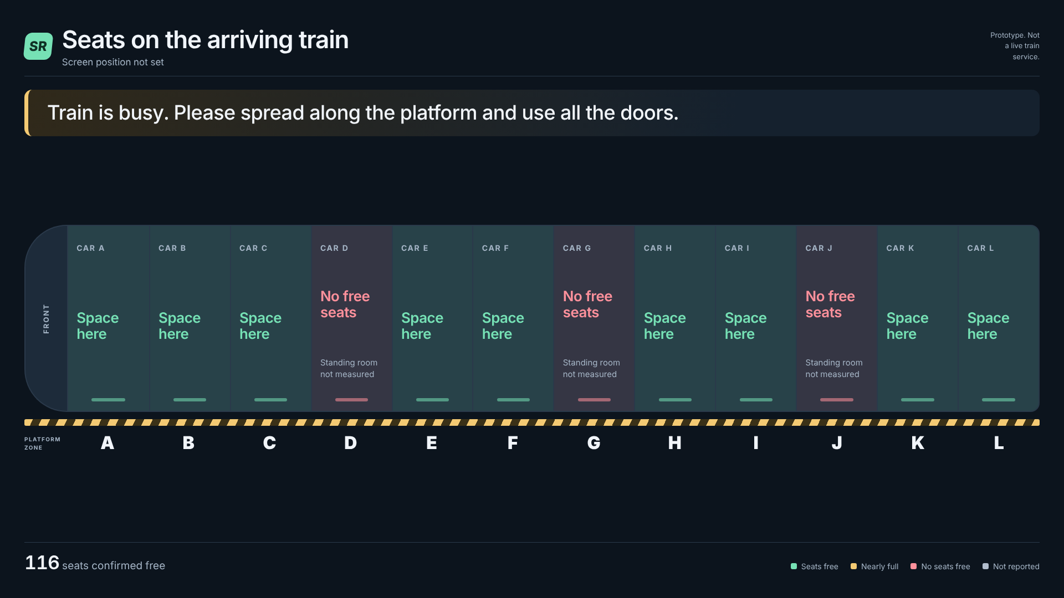
Figure 4. The same screen below the 20 percent threshold. The per-carriage counts are gone and every carriage with room reads the same, so no ranking can be inferred from the tiles.

Phone application: a stateful dispatcher
The second interface answers one passenger at a time. A passenger opens it, says which platform zone they are standing at, and is given one carriage. The application keeps the carriages within walking range of that zone, prefers the ones with a confirmed free seat, and among those picks the carriage it has routed the fewest passengers to so far, breaking ties on free seats and then on walking distance.
Because it records each answer, the next passenger asking from the same zone is sent somewhere else. Two people standing side by side are given different carriages, and the crowd divides itself before the train arrives. This is the one thing a shared screen cannot do, and Section 5 measures what it is worth.
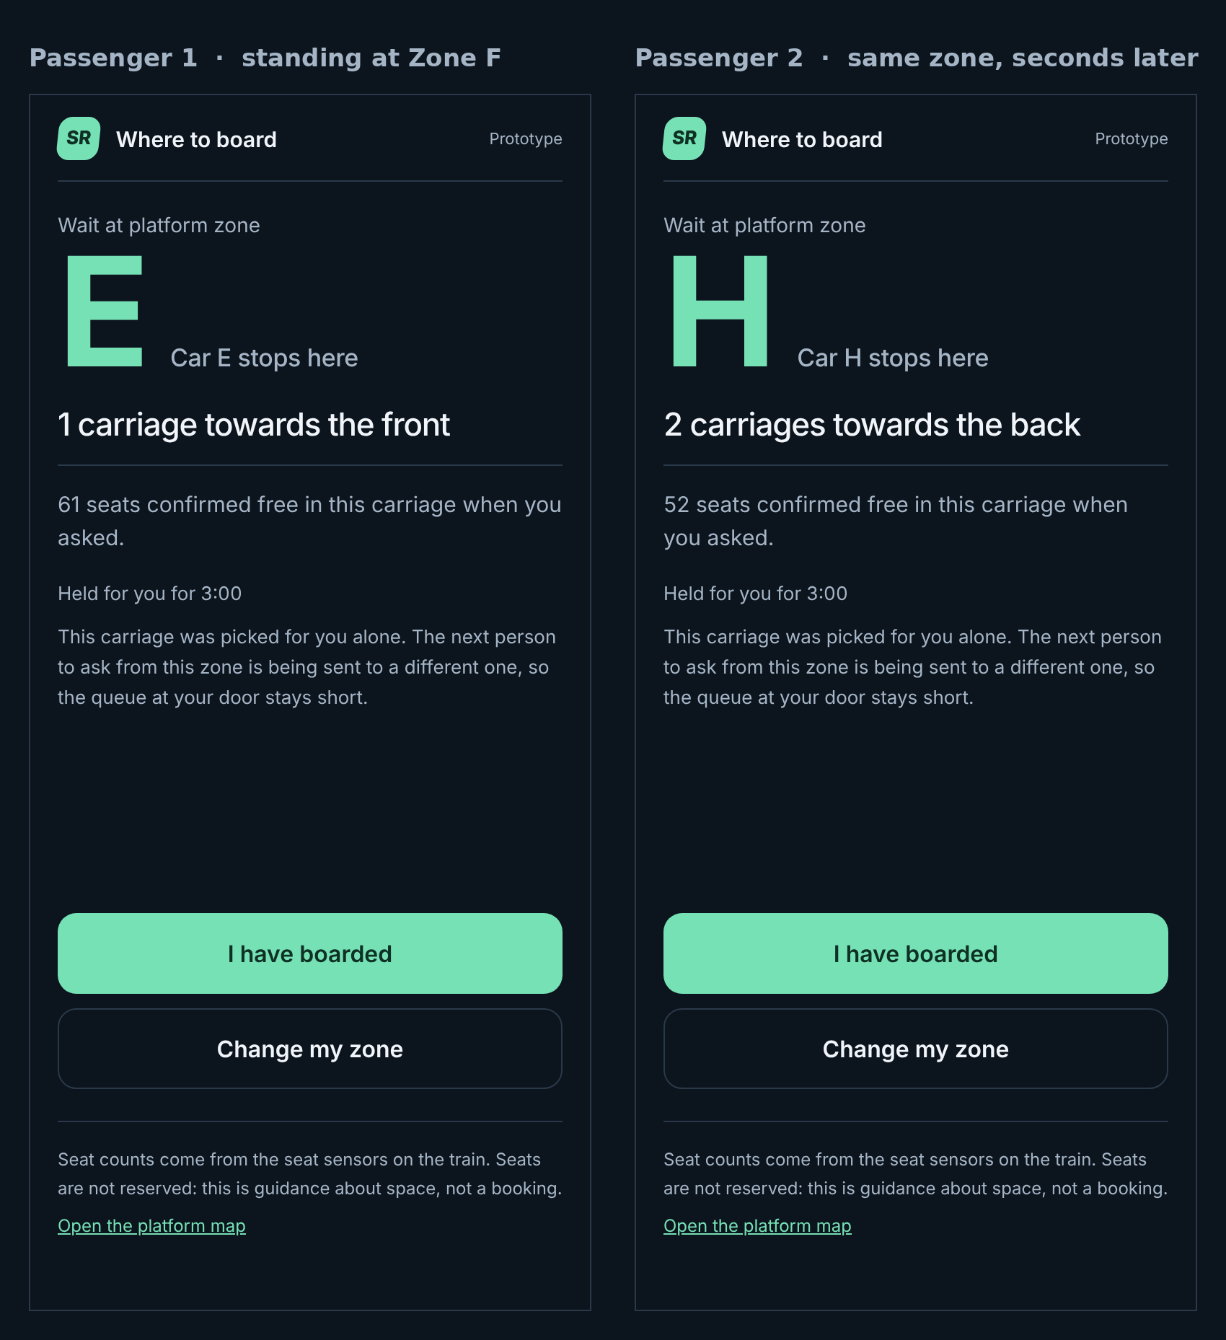
Figure 5. Two passengers standing at the same platform zone, asking seconds apart. The dispatcher remembers the first answer, so the second passenger is sent to a different carriage.
Three behaviours the interface needs that are not part of the routing rule itself: an assignment expires after three minutes, so the routing counts describe the passengers currently waiting rather than everyone who has ever asked; a repeated request carrying the same ticket returns the same carriage instead of being counted as a second passenger, so a refresh does not distort the division; and the counts are cleared when the train departs, because the next train’s crowd is a different population.

Communication, and what is not built
The train and the platform are presently joined by the USB cable, at 115200 baud. The wireless link that a real deployment needs, whether ESP-NOW or WiFi with a cloud database, has not been selected or built, and neither has the platform display hardware. These are the two decisions that gate the rest of the system.

5. The simulation
Sensing a free seat is the easy half of this project. The half that carries the claim is whether telling passengers about it shortens boarding. That cannot be answered by the prototype, so it is answered by simulation.

How passengers are modelled
Passengers arrive at a station as a Poisson process, which is the standard assumption for passenger arrivals. Each arriving passenger then chooses a carriage independently. Because the choices are independent, the thinning property of a Poisson process means the number boarding each carriage is itself Poisson, with a mean equal to the arrival rate multiplied by that carriage's share. The simulation never draws a per-carriage Poisson variable directly: it draws the total and assigns passengers one at a time, so this is a property that emerges from the model rather than one built into it.

Parameters of the generic simulation
Figures 6 to 8 use one twelve-carriage train of 108 seats a carriage, matching the SmartRail display. The values below are the model's inputs. Those marked as estimates are the ones a platform measurement would replace.

Parameter | Value | Where it comes from
Carriages x seats | 12 x 108 | The SmartRail display
Boarders per stop | 240, Poisson | Our estimate of a busy station
Alighting per stop | 25% of seated passengers | Our estimate; sets the train's steady load at about 80 of 108 seats a carriage
Waiting profile | Gaussians at carriages 3 and 8, sigma 1.6 carriages | Our estimate of an entrance and a staircase; the weakest input
Passengers acting on the display | 60% | Unmeasured; Figure 8 sweeps it from 0 to 100%
Walking limit | 3 carriages | Our estimate; nobody walks the length of a platform for a seat
Fixed dwell term | 11 s | Published fixed terms run about 10 to 14 s
Boarding | 1.5 s per passenger per door | Within the published range
Alighting | 1.0 s per passenger per door | Alighting is normally faster than boarding
Crowding penalty | +45% boarding time at a full carriage | Standard in dwell models
Stops simulated | 500 per scenario | Enough for the means to settle

Arrivals, alighting and passenger behaviour are drawn from three separate random streams, so the guided and unguided runs face an identical sequence of arrivals. The comparison is therefore paired: any difference between them comes from where passengers choose to stand, not from different demand.
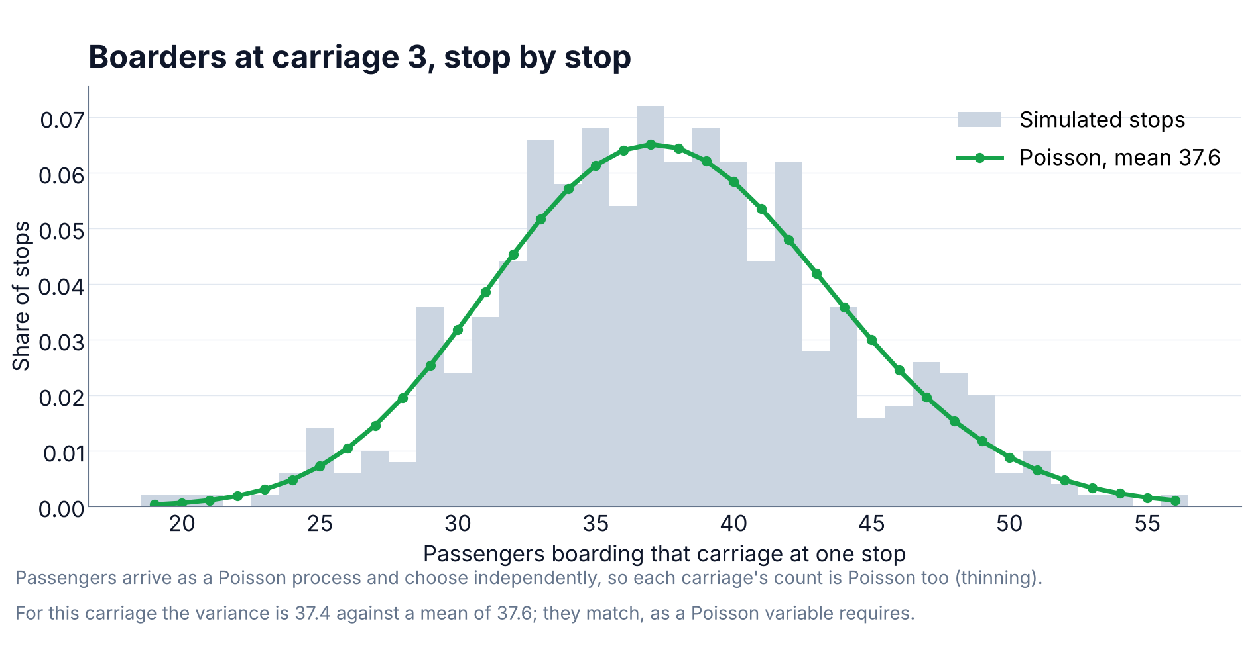
Figure 6. Boarders at the busiest carriage over 500 simulated stops in the no-display case, against the Poisson distribution with the same mean. The variance is 37.4 against a mean of 37.6; for a Poisson variable the two are equal.
What guidance changes is therefore not the shape of the distribution but its means. Without guidance those means are bunched around the platform access points, which is what Figure 6 shows at the busiest carriage. With the display, the 60 percent of passengers who act on it choose again among the carriages within three of where they stand, each carriage weighted by the free seats it is showing. A carriage advertising forty free seats is twice as likely to be chosen as one advertising twenty, and a carriage out of walking range is not considered at all. That pushes the means towards uniform: the busiest carriage, measured against the average carriage, falls from 1.89 to 1.37, where 1.00 would be perfectly uniform.
This is one of several ways a passenger might read a display, and the choice is not neutral. The rule above, weighting carriages by their free seats, is the one behind Figures 7 and 8. The next subsection compares it against four alternatives, including the one the current SmartRail screen implements, and shows that the rule matters more than the compliance rate does. The Israel Railways section later uses a refinement of it that also handles a nearly full train.
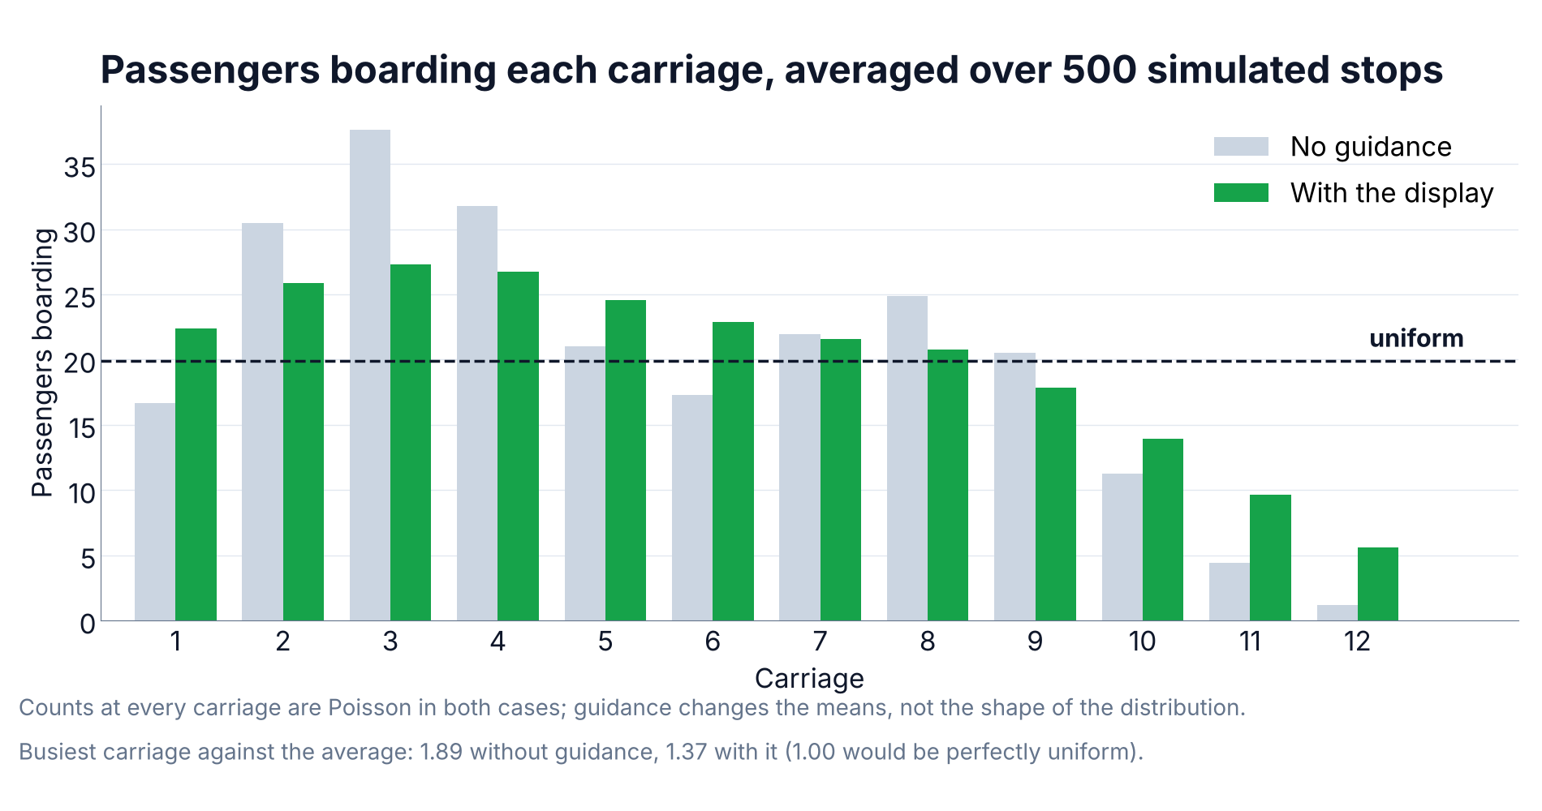
Figure 7. Passengers boarding each carriage, averaged over 500 simulated stops. “With the display” here means one shared platform screen showing each carriage's own free-seat count, read by 60 percent of passengers. No application is involved: the per-person application is a separate design, compared later.
Dwell time follows the standard formulation described in Section 3: a fixed term, a term per alighting passenger and a term per boarding passenger with a crowding penalty, taken at the busiest door rather than averaged.

What the display says matters more than how many obey it
The share of passengers who act on the display is one parameter. What they then do is a separate one, and the simulation shows that the second matters more. Five rules were compared at the same 60 percent compliance:

What the display tells passengers | Mean dwell | Against no display
Nothing | 142.7 s | —
Weight carriages by their free seats | 110.8 s | 22% faster
Avoid the carriages marked full | 120.4 s | 16% faster
Spread out, ignoring the counts | 121.6 s | 15% faster
Name the three best carriages | 200.9 s | 41% slower
Send everyone to the emptiest carriage | 212.6 s | 49% slower

The two rules at the bottom of that table are the important finding. Everyone waiting reads the same screen at the same moment, so naming winners moves the crowd rather than spreading it: the busiest door grows from 39 passengers to 76 and dwell rises by two-fifths. This is not an artefact of how ties were broken. Sending passengers to a random recommended carriage instead of the nearest is still 24 percent slower, and badging eight of the twelve carriages is still slightly worse than showing nothing. The reason is that a recommendation is global while the passenger's problem is local: every rule that helps lets somebody weigh the carriages near where they already stand.
The display the project started with did both. Its per-carriage cards were the safe part; its “good choice” badges and its “most confirmed free seats” banner were the pattern this table warns about. They were removed from the passenger display, and the ranked version is retained only as the control case these figures are measured against.
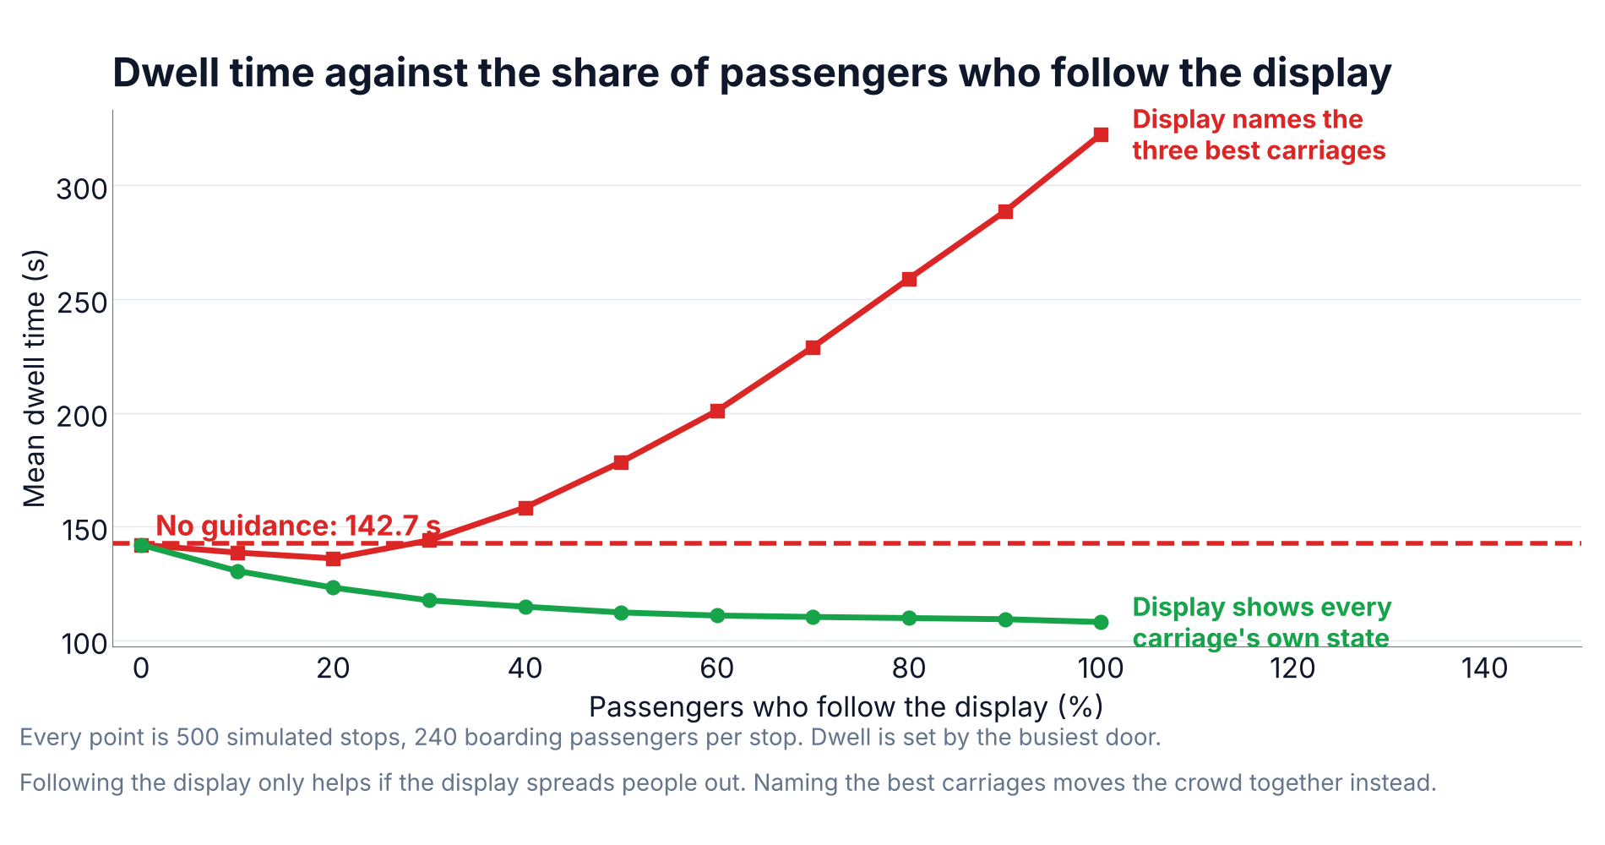
Figure 8. Dwell time against the share of passengers who act on the display, under the two rules. The benefit depends on which rule the display implements, not only on how many passengers follow it.
Under the rule that works, most of the benefit arrives early: going from nobody to thirty percent compliance captures 25 of the eventual 35 seconds. The system does not need everyone to obey.

What the model assumes about time
The simulation charges nothing for the walk along the platform. It assumes a passenger reads the display while waiting, walks to the recommended carriage before the train arrives, and is standing there when the doors open. Only the boarding itself consumes dwell. That assumption is defensible, but it carries a requirement and it needs testing, so both are set out here.
The requirement is lead time. A double-deck coach is about 26 metres, and a platform walking pace is about 1.3 metres a second, so the three-carriage limit used throughout is roughly 78 metres or 60 seconds. The display must therefore show the approaching train's state at least a minute before it arrives, and the whole sensing chain, from seat to carriage controller to platform, has to fit inside that minute. A passenger who does not make it simply boards where they are standing, which is arithmetically identical to that passenger not having followed the display at all, and the compliance sweep already covers that case.
Shorter walks still pay. The benefit does not depend on passengers crossing the platform:

Furthest a passenger will walk | Distance | Notice needed | Screen | App
1 carriage | 26 m | 20 s | 14% | 32%
2 carriages | 52 m | 40 s | 19% | 39%
3 carriages | 78 m | 60 s | 22% | 43%
4 carriages | 104 m | 80 s | 25% | 45%
6 carriages | 156 m | 120 s | 29% | 45%

Even one carriage of movement, twenty seconds of notice, recovers 14 percent on a screen and 32 percent through an application. The application saturates by four carriages, because beyond that the balancing is limited by where passengers start rather than by how far they will go.

A second optimism: the display cannot see who is about to get off
The figures quoted so far let the display show free seats as they will be once the passengers leaving at this station have gone. No sensor can know that in advance. A waiting passenger chooses where to stand before the train arrives, so what they can actually be shown is what the sensors see on approach, with the alighting still to come. Re-running every scenario on that basis is the honest test:

Design | If the display could foresee alighting | Sensors only
Screen, map | 22% | 20%
App, per-person advice | 43% | 44%

The cost is two percentage points for the screen and none for the application. The reason is that passengers leaving are spread across the carriages roughly in proportion to how full each one is, so alighting changes every carriage's count in much the same direction and leaves their order largely intact. The carriage with the most free seats on approach is usually still the one with the most free seats once the doors close. This is reassuring for a sensing system, because it means the quantity the sensors can actually measure is good enough, and a per-station alighting prediction would be a refinement rather than a prerequisite.

Why a ranked list is the wrong design
A natural reading of these results is that the display should rank the carriages from emptiest to fullest. The simulation says the opposite, and the reason is worth setting out because the averages in Figure 7 invite exactly that conclusion.
A ranked list is read as “go to the best carriage I can reach”. Averaged over 500 stops it produces the most uniform distribution of the three designs tested, with a busiest-to-average ratio of 1.23 against 1.37 for the per-carriage map. By that measure it looks like the best design. Its dwell is 213 seconds against the map's 111, and against 143 seconds for no display at all.
The averages are uniform because the top of the ranking moves from stop to stop: a different carriage leads each time, so over many stops every carriage takes a turn. Within any single stop the crowd is in one place. Four consecutive stops under each design show it plainly, as boarders per carriage:

Design | Boarders per carriage at one stop | Busiest door
Map | 15 26 27 24 30 20 26 13 18 16 9 3 | 30
Map | 25 20 41 38 26 25 27 21 9 9 10 4 | 41
Ranked list | 5 10 100 11 11 7 12 5 8 56 2 0 | 100
Ranked list | 6 15 13 97 10 7 3 41 7 8 13 24 | 97

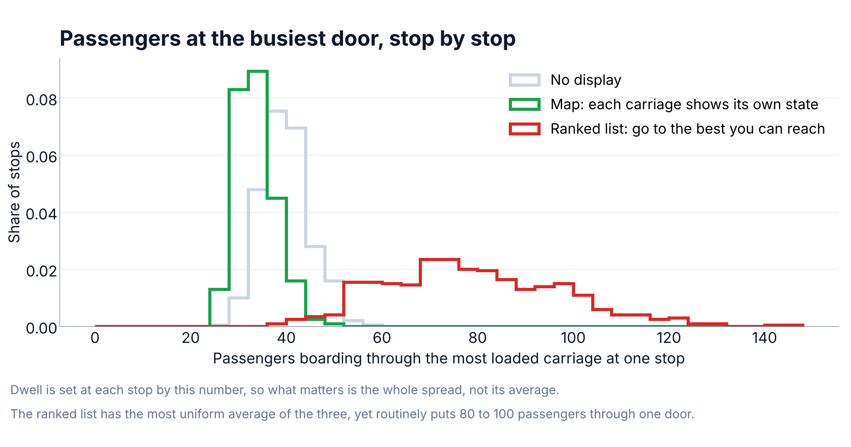
Figure 9. How many passengers board through the most loaded carriage at a single stop, over 500 stops. Dwell is set by this number at every stop, so the whole spread matters, not its average.
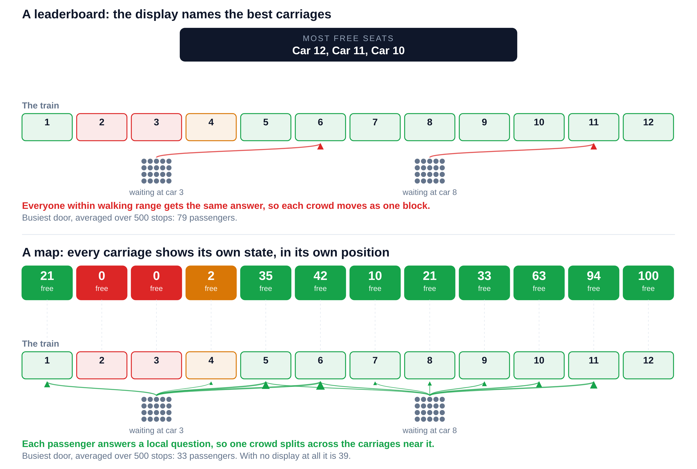
Figure 10. The same train and the same two waiting crowds under both designs. The free-seat numbers are one real moment from the simulation; the arrows show where passengers would walk, given a three-carriage limit.
The design principle that follows is that the display should be a map, not a leaderboard. Showing each carriage's own state in its physical position lets each passenger solve a local problem: which of the carriages near me has room. Ranking them poses one global question to everybody at once, and a crowd that all receives the same answer moves together. This is why the delivered screen is a positional map of the whole train, and why the badges that named winners were removed from it.

Does a platform display make the app redundant?
The map design raises a fair objection. If the information has to be positional and has to reach the passenger before the train arrives, a screen on the platform delivers it, and the phone application looks unnecessary. Two things answer that, one of which the simulation can test.
The first is a matter of timing rather than design. A sign fixed to each carriage, showing that carriage's own count, would satisfy the positional requirement and be useless for this purpose: it is only readable once the train has arrived, by which time the passenger has already chosen where to stand and the dwell is already determined. Whatever the channel, the information has to arrive while the passenger can still act on it.
The second is a real capability that no shared screen has. A screen shows one picture to everybody, so everyone reading it works from the same data and their choices are correlated. An application can tell different passengers different things, and can take account of what it has already told the previous ones. The simulation models this as each complying passenger being assigned a carriage within walking range that evens out the load, rather than choosing independently from a common picture.

How the information reaches passengers | Mean dwell | Against no display
Nothing | 143 s | —
Shared screen, ranked list | 213 s | 49% worse
Shared screen, map, at 60% reach | 111 s | 22% better
App, per-person advice, at 20% reach | 112 s | 22% better
Both together | 96 s | 32% better

The application works as a dispatcher rather than a noticeboard. A passenger waiting on the platform opens it and it answers that one passenger:
- It takes the carriages within walking range of where that passenger is standing.
- Of those, it picks the one it has sent the fewest people to so far, breaking ties on free seats.
- It records that answer, so the next passenger to ask gets a different carriage.
Because it remembers what it has already handed out, two passengers standing side by side are sent to different carriages. The crowd divides itself as it is served, before the train arrives. That is what a screen cannot do: everyone looking at a screen sees the same picture and draws the same conclusion.
The timing improves because dwell is set by the busiest door. Spreading the same passengers over more carriages drops the busiest door from 39 boarders to 22, and the train is held for the longest door, not the average one.
Taken on its own, with no platform screens at all, the application's benefit scales with how many people carry it:

Phones with the app | Mean dwell | Saving | Busiest door
5% | 134 s | 6% | 37
10% | 127 s | 11% | 36
20% | 112 s | 22% | 32
30% | 98 s | 31% | 28
50% | 84 s | 41% | 23
70% | 79 s | 45% | 21
100% | 78 s | 45% | 21

The benefit saturates near 70 percent, beyond which the walking limit rather than the advice is what constrains the spreading. A realistic application reach of 10 to 20 percent sits at the lower end, saving 11 to 22 percent on its own, which is why the platform screen remains worth building alongside it.
This settled an open question in the project’s scope, namely whether a phone application belonged in the final system. It does, provided it gives each user its own answer, and the application described in Section 4 was built on that basis. An application that simply reproduced the platform screen, or worse displayed a ranked list of the best carriages, would have added reach without adding coordination, and would have forfeited the advantage that justifies building it.

What the code does now
The rule at the bottom of that comparison is the one the system implements. `PC_software/dispatcher.py` holds it, and `PC_software/guidance.py`, which used to carry a rule of its own, now delegates to it, so the console tools, the simulator and the phone application all route by one policy and cannot drift apart.
Two things changed, and the simulation identified both. The first is reach. The allocator is no longer a console-only component that nothing passenger-facing called: it is what the phone application serves to passengers, one answer at a time, and `guidance.py` is the module that provides it. The console programs that already imported it are unchanged and keep working.
The second is the objective. The previous rule assigned each passenger to the nearest carriage that still had a confirmed free seat. With 108 seats to a carriage, a carriage showing forty free seats absorbs forty passengers before anyone is sent past it, so that rule filled carriages one at a time rather than balancing across them, and left the distribution almost as bunched as no guidance at all. It now assigns each passenger to the carriage within walking range that it has routed the fewest passengers to, breaking ties on free seats. Simulated at the same 60 percent compliance, the two rules compare like this:

Rule | Mean dwell | Saving | Busiest door
No guidance | 143 s | — | 39
Ranked display: name the three best carriages | 201 s | 41% worse | 76
Previous rule: nearest carriage with a free seat | 125 s | 13% | 36
Implemented rule: least-loaded within walking range | 81 s | 43% | 22

Under the implemented rule the mean boarders per carriage run from 21 down to 17 across the twelve carriages, against 30 down to 1 under the previous one. The change was one of policy rather than a new component: the existing structure, a loop over passengers holding state between them, already supported it. One further change came with it. An unsensed seat is no longer a reason to send a passenger anywhere; the previous rule preferred a carriage whose sensors had failed over spreading the load, which amounted to guessing, and a seat now counts as free only when a sensor says so.

Calibrated to an Israel Railways service
The figures above use generic parameters, which makes the percentages comparable but the seconds meaningless. To put the result in context, the model was re-run on a service this project would actually serve: a southbound morning-peak train on the coastal line, calling at ten stations from Haifa-Hof HaCarmel to Tel Aviv Savidor Center, formed of an eight-car Bombardier Twindexx Vario double-deck set of the type Israel Railways runs on this line, with about 1,000 seats.
The line, the station order and the train are real. The relative size of the stations is anchored on published annual passenger counts: Tel Aviv HaShalom handled 15.3 million passengers in 2019, the busiest station in the country; Haifa-Hof HaCarmel 4.6 million, fifth; Herzliya 3.0 million, fourteenth. How those annual totals divide into one peak train is our estimate for a busy morning service, and is the first thing a platform count should replace.

Where the per-station figures come from
Every dwell figure in this section is computed by the model. None of them is a measurement, and Israel Railways publishes none. The check described below established that the national timetable contains no dwell times at all, so there is no published figure for this section to report. What the simulation does instead is calculate dwell from the passenger numbers, using the equation from Section 3:
door time = t_alight x alighters + t_board x boarders x crowding
dwell = t_fixed + the largest door time of the eight carriages
Each station's bar is the mean of 300 simulated stops. At Haifa-Hof HaCarmel, for example, one such stop puts 36 boarders and 3 alighters through the busiest carriage, giving that door 71 seconds of work; adding the 8-second fixed term gives a dwell of 79 seconds for that draw, and the average over 300 draws is the 100 seconds shown.
Three kinds of input feed that calculation, and they differ in how well founded they are. The line, the station order, the eight-car train and its 1,000 seats are real. The rate constants, 1.5 seconds per boarding passenger, 1.0 per alighting passenger, an 8-second fixed term and a 45 percent crowding penalty, are taken from the ranges in the published studies cited in Section 3, but are not fitted to this operator. The passenger numbers per station are our own estimates for a busy morning service, scaled by the relative size of the stations; they are the weakest input and the first that a platform count should replace.
The consequence is that the absolute heights of the bars should not be quoted as Israel Railways dwell times. What the comparison supports is the difference between the two bars at each station, because both are computed from the same passenger numbers with the same constants, and only the passengers' choice of carriage differs between them.
The one-minute reference line in Figure 11 is our assumption, not an Israel Railways figure. No per-station dwell allowance is published, and we checked rather than assumed. The national GTFS feed, issued by the Ministry of Transport and covering rail, carries an arrival time and a departure time for every stop, so the difference between them would be the scheduled dwell. We downloaded the feed, kept the rail trips and compared the two timestamps at every stop: they are identical at every one. Israel Railways therefore does not publish dwell at all, absorbing it into the run time between stations. One minute is the usual order of magnitude for an intermediate stop, and timing thirty stops with a stopwatch would replace it with a measured value. Until then the overrun figures below should be read as relative, not absolute. The script that performs this check is in the simulation folder as gtfs_dwell.py.
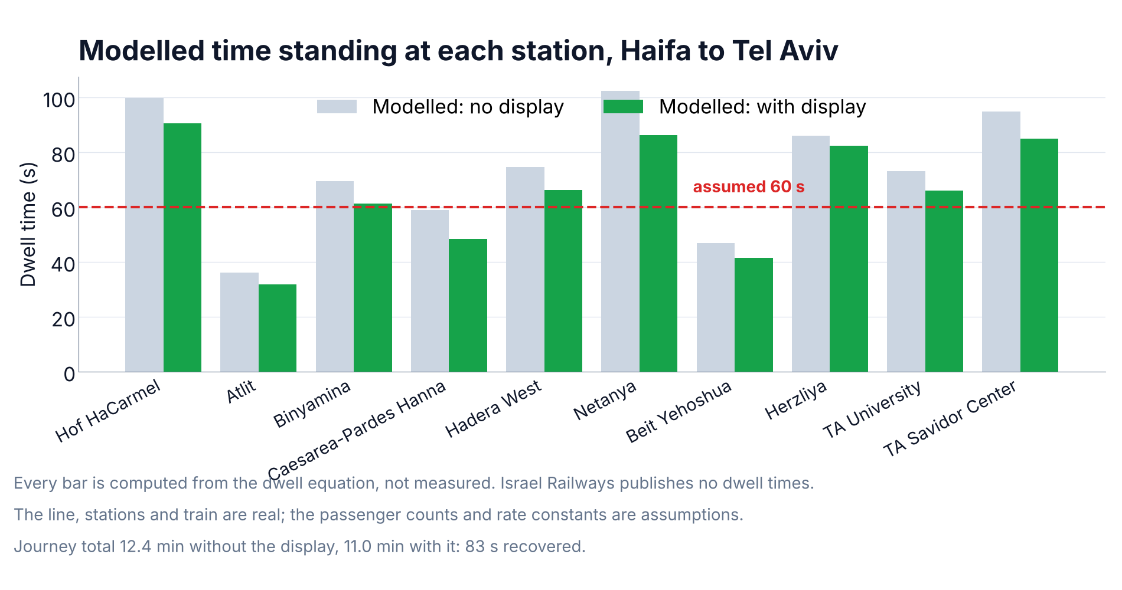
Figure 11. Modelled time standing at each of ten stations on the coastal line, with and without the display. Every bar is computed from the dwell equation; none is measured. The 60-second line is an assumed reference, not a published allowance.

Station | Boarding | No display | With display | Saved
Haifa-Hof HaCarmel | 220 | 100 s | 91 s | 9 s
Atlit | 40 | 36 s | 32 s | 4 s
Binyamina | 120 | 70 s | 61 s | 8 s
Caesarea-Pardes Hanna | 70 | 59 s | 48 s | 11 s
Hadera West | 130 | 75 s | 66 s | 9 s
Netanya | 180 | 103 s | 86 s | 16 s
Beit Yehoshua | 50 | 47 s | 42 s | 6 s
Herzliya | 150 | 86 s | 83 s | 4 s
Tel Aviv University | 40 | 73 s | 66 s | 7 s
Tel Aviv Savidor Center | 20 | 95 s | 85 s | 10 s
Whole journey | 1,020 | 743 s | 660 s | 83 s

In the model the train stands still for 12.4 minutes across the ten stops without the display and 11.0 minutes with it, a saving of 83 seconds, or 11 percent of the time spent stationary. Measured against the assumed one-minute reference, seven of the ten stops overrun it either way, but the accumulated overrun falls from 185 seconds to 122 seconds: a minute of delay recovered over one journey, on one train. The 83-second saving does not depend on that reference line; only the overrun figures do.
The calibrated saving is smaller than the generic 22 percent, and the reason is instructive. The boarding load on this service is spread over eight carriages and most of its stations are moderate, so the busiest door is less dominant than in the generic case. A result quoted without calibration would have overstated the benefit by a factor of two.

Which part of the display the 83 seconds comes from
The SmartRail screen carries two kinds of information at once: a card for each carriage showing its own free-seat count and zone, and a recommendation naming the three carriages with the most seats. The simulation treats these as two different pieces of advice, because a passenger acts on one or the other. Run on the same ten-station journey, they do not merely differ in size; they differ in sign.

What the passenger acts on | Journey standing time | Against today
Nothing: no display | 743 s | —
The per-carriage cards | 660 s | 83 s saved
The per-carriage free-seat counts | 681 s | 62 s saved
The “good choice” badges and banner | 1,026 s | 283 s lost
A single best carriage | 1,007 s | 264 s lost

The 83 seconds reported above is the per-carriage reading. It is the right one to quote because it is what the layout leads with and what occupies most of the screen, but the figure belongs to that element, not to the screen as a whole. The information the system collects is sound; it is one element of how that information is presented that carries the risk, and removing or rewording the badges is a small change with a large effect in the model.

A limit the calibration exposed
The journey revealed a failure mode that the generic model had hidden. By Herzliya the train is carrying 941 passengers in 1,000 seats and several carriages have no free seats at all. Guidance that ranks carriages by free seats then funnels everyone into the two or three carriages that still have any, and that stop became 20 seconds worse with the display than without it.
The display therefore changes what it optimises when seats run short. Below a fifth of the seats free it stops ranking carriages by seat count and shows one instruction to spread out, which is the fallback described in Section 4. With that rule in place the Herzliya regression disappears and the journey saving rises from 61 to 83 seconds. The requirement came out of the simulation and is now implemented, but the limitation behind it stands, and it is the one identified early in the project: at the crush loads where the system would be most valuable, free seats stop being the right thing to measure, and crowding takes their place.

How much to trust these numbers
The percentage saving is robust to the parameter most likely to be wrong. Across boarding rates from 0.8 to 2.5 seconds per passenger, the saving stays between 21 and 23 percent, because both the guided and unguided cases scale together. The absolute saving in seconds is not robust, and neither is anything that depends on how passengers bunch today.
Three measurements would turn this from a plausible model into evidence. Counting boarders per carriage on a real platform would replace the assumed bunching profile, which is the assumption the whole result rests on. Timing thirty to forty stops would replace the literature coefficients with ones fitted to Israel Railways. Showing the display to passengers and asking where they would stand would estimate compliance, and would settle which of the behaviour rules in the table above real people actually follow.

6. Conclusions
The sensing chain works. An infrared sensor above a seat, a calibrated relative threshold, a median filter and a one-second confirmation produce a stable occupied or empty decision in about 1.5 seconds, and the per-carriage aggregation and both passenger-facing interfaces are built and demonstrable on a laptop.
The simulation answers the project's central question affirmatively, but with two qualifications that are more useful than the headline. On a realistic Israel Railways service, the display recovers 83 seconds of standing time and 63 seconds of accumulated delay over ten stations, roughly 11 percent of the time the train spends stationary. Most of that benefit arrives by the time thirty percent of passengers act on it, so the system does not depend on universal compliance.
The first qualification is that a display which names the best carriages makes boarding worse than no display at all, by about two-fifths. Showing each carriage’s own state and letting passengers choose locally is what produces the benefit. The passenger display was rebuilt on that basis. It is now a positional map of the whole train, and the “most confirmed free seats” banner and the “best choice” and “good choice” badges were removed from it; the ranked version is retained, unmodified, only as the control case the measurements are compared against.
The second is that the benefit comes from spreading passengers, and free seats are only a proxy for where there is room. On a nearly full train that proxy breaks down and can actively mislead, which is why the display falls back to encouraging spreading once seats are scarce. That fallback is implemented: below a fifth of the train’s seats free, the screen stops grading carriages by seat count and shows a single instruction to spread along the platform. At the crush loads where this system would matter most, the right measurement is still crowding rather than seats.
Both changes were made in the project’s own code. `PC_software/guidance.py` already allocated per passenger and held state between them, which is the structure the result depends on; what it lacked was reach and the right objective. It now delegates to `PC_software/dispatcher.py`, routes each passenger to the least-loaded carriage within walking range rather than the nearest one with a seat, and is what the phone application serves to passengers rather than a tool reachable only from the console.
On the scope question of whether a phone application belongs in the system, the simulation gave a clear answer provided the application does something a screen cannot, and the application was built on that basis. Telling each user a different carriage, chosen to even out the load, is about three times as effective per passenger reached as a shared picture, because it coordinates instead of broadcasting. An application on a fifth of phones matches a platform screen seen by three fifths of passengers, and the two together save just under a third of the standing time rather than the fifth that either manages alone. That is why both were built rather than one instead of the other, and why an application that merely mirrored the platform screen would not have earned its place.
What remains is to replace assumptions with measurements: a platform count of boarders per carriage, a stopwatch survey of dwell times, and a compliance estimate from showing the display to real passengers. The wireless train-to-platform link and the platform display hardware remain to be chosen, and are the decisions that gate a deployment.

Appendix A — User guide for the simulation
The simulation is a command-line program. It needs Python 3.10 or later with numpy and matplotlib installed.
pip install numpy matplotlib

Running it
From the Simulation folder, the generic comparison and all charts:
python boarding_sim.py
The Israel Railways journey over ten stations:
python israel_journey.py

Options worth changing
Option | Default | What it changes
--compliance | 0.6 | Share of passengers who act on the display
--strategy | proportional / adaptive | What a passenger who follows the display does
--stops | 300 | Simulated station stops per scenario
--runs | 300 | Simulated journeys (Israel script)
--arrivals | 240 | Mean passengers boarding per stop
--t-board | 1.5 | Seconds per boarding passenger at one door
--seed | 12345 | Random seed; the same seed reproduces a run exactly
--no-charts | off | Print the numbers without drawing figures

What it produces
Everything is written to the results folder: summary.json with every number, boarders_per_car.csv, compliance_sweep.csv, israel_journey.csv, and the figures used in this document. Running the same command twice with the same seed produces identical output.

Reading the output
- Dwell time is the mean seconds the train stands at a station, set by its busiest door.
- Busiest door is the number of passengers boarding through the most loaded carriage; it is what dwell is driven by.
- Busiest carriage against the average is the evenness measure: 1.00 is perfectly uniform, 1.89 is the modelled situation today.
- Variance over mean near 1.0 confirms the per-carriage counts are Poisson, as the model's structure implies.

Appendix B — Programmer guide for the simulation

Files
File | Responsibility
boarding_sim.py | The model, the experiments and the console report
israel_journey.py | The ten-station Israel Railways service, built on the same model
charts.py | Every figure; no model logic
README.md | Assumptions, results and sources

How one stop is simulated
- Alighting passengers are drawn per carriage in proportion to who is aboard.
- The number of waiting passengers is drawn from a Poisson distribution.
- Each passenger is assigned the carriage they would naturally walk to, drawn from the baseline profile, which is a mixture of Gaussians centred on the platform access points.
- A compliance share of them then act on the display, according to the chosen strategy, limited by how far they will walk.
- Dwell is computed as the fixed term plus the maximum over carriages of the alighting and boarding terms.
- Occupancy carries forward to the next stop.

Key functions
Function | What it does
baseline_profile(p) | Probability of choosing each carriage with no guidance
choose_cars(...) | Turns a passenger count into boarders per carriage; all behaviour rules live here
dwell_seconds(...) | The dwell equation, taken at the busiest door
run(p, guided) | One scenario over p.stops stops, with separate random streams
compare(p) | Paired guided and unguided comparison plus the summary numbers
sweep_compliance(p) | Dwell against compliance, for one behaviour rule
compare_strategies(p) | The five behaviour rules at one compliance level
run_journey(...) | One Israel Railways journey over the ten stations

Changing the model
- Every tunable value is a field of the Params dataclass at the top of boarding_sim.py, with a comment giving its basis.
- To add a behaviour rule, add a branch in choose_cars and a label in compare_strategies. Nothing else needs to change.
- To model a different service, edit the JOURNEY list in israel_journey.py: each stop carries its boarding and alighting counts and its platform access points.
- Arrivals, alighting and behaviour draw from separate random streams, so the guided and unguided runs face the same sequence of arrivals. The comparison is paired; keep it that way when adding experiments.

Appendix C — Repository and stage-2 guides
The project repository, including the firmware, the PC software, this simulation and the full documentation set:
https://github.com/abedazem13/SmartRail
The stage-2 user and programmer guides for the hardware and the passenger display are in the repository rather than reproduced here:
- Presentation/USER_MANUAL.md — running the passenger display and the demo controls.
- Presentation/PROGRAMMER_MANUAL.md — firmware and PC software for a developer taking the project on.
- Documentation/06_ESP32_FIRMWARE.md — the firmware in detail, including every parameter.
- Documentation/08_COMMUNICATION_AND_DATA.md — the serial line format the display depends on.
- Documentation/05_WIRING_AND_PINOUT.md — the pin map and assembly order.
- Unit Tests/ — the sensor bring-up test and its pass criteria.

Sources
- Deutsche Bahn real-time capacity information for regional passengers (Railway News). https://railway-news.com/db-improves-regional-passenger-experience-with-real-time-capacity-information
- Public Transportation Systems, lecture 9, dwell-time models (MIT OpenCourseWare). https://live.ocw.mit.edu/courses/1-258j-public-transportation-systems-spring-2017/79e5b6b5a78002efdf3ec1697b7573c2_MIT1_258JS17_lec09.pdf
- Modelling dwell time in light rail systems, regression coefficients (University of Southampton). https://eprints.soton.ac.uk/414364/1/4_50.pdf
- Israel Railways Twindexx Vario double-deck coaches, eight-car sets of about 1,000 seats (Railway News). https://railway-news.com/israel-railways-double-deck-coaches-electrified-line/
- Tel Aviv HaShalom railway station, annual passenger figures and national rank (Wikipedia). https://en.wikipedia.org/wiki/Tel_Aviv%E2%80%93HaShalom_railway_station
- Haifa-Hof HaCarmel railway station, annual passenger figures and national rank (Wikipedia). https://en.wikipedia.org/wiki/Haifa%E2%80%93Hof_HaCarmel_railway_station
- Herzliya railway station, annual passenger figures and national rank (Wikipedia). https://en.wikipedia.org/wiki/Herzliya_railway_station
- Israel Railways network, lines and journey times (Seat 61). https://www.seat61.com/Israel.htm

