Clustering Analysis
Customer Churn Analysis, Stage 2 Deliverable
Prepared by: Abed, Data Analyst, Clustering Analysis
Deliverable | Files in this folder
Clustering_Analysis | This document (documentation + insights); Clustering_Analysis.ipynb and .py (code); kmeans_model.pkl (trained model); elbow_method.png; cluster_visualization.png; cluster_assignments.csv

1. Objective
Segment telecommunications customers by similarity in tenure and monthly charges, in order to identify behavioural patterns linked to churn and support targeted retention recommendations.

2. Method
K-Means was selected as the clustering algorithm. It scales well to this dataset's size (6,741 customers after deduplication) and both features used, tenure and MonthlyCharges, are continuous variables that suit a distance-based method. Both features were standardised (mean 0, standard deviation 1) before clustering, since K-Means relies on Euclidean distance and unscaled features would let the larger-range variable dominate the result.
Parameter | Value / Setting
Algorithm | K-Means (scikit-learn)
Features used | tenure, MonthlyCharges (standardised)
Initialisation | k-means++
n_init | 10 (best of 10 runs by inertia)
random_state | 42 (reproducibility)
Dataset size | 6,741 customers (5,392 train / 1,349 test)

3. Optimal Number of Clusters
The optimal number of clusters, k, was determined using two independent methods, so the choice is not based on a single, subjective read of a chart.
3.1 Elbow Method
WCSS (within-cluster sum of squares) was computed for k = 1 to 10. WCSS always decreases as k increases, so the goal is to find the point of diminishing returns rather than the lowest value.
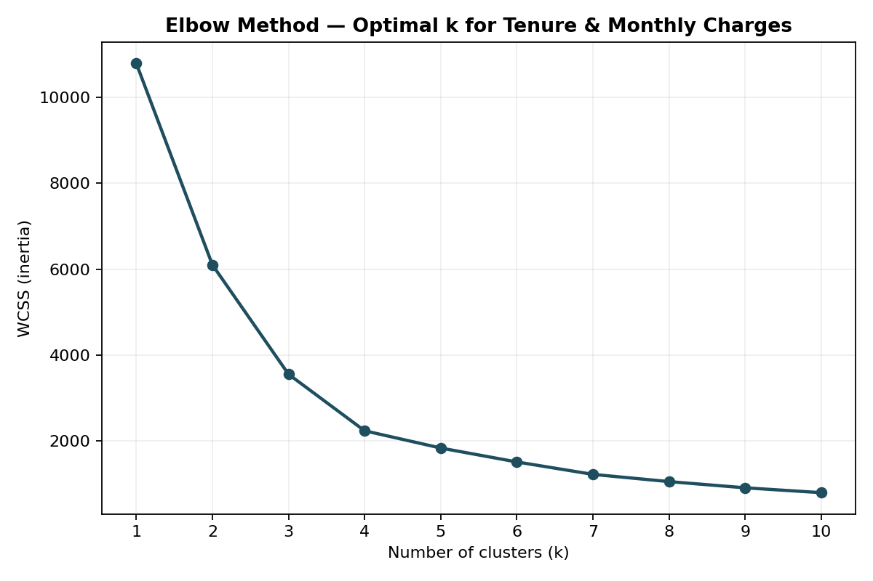
Figure 1. Elbow method, WCSS by number of clusters.
k | WCSS | % Drop from Previous k
1 | 10784.00 | —
2 | 6099.30 | 43.4%
3 | 3556.66 | 41.7%
4 | 2242.08 | 37.0%
5 | 1841.15 | 17.9% ← sharp fall-off begins
6 | 1517.29 | 17.6%
The improvement remains substantial through k=4 (37%+), then drops sharply to under 18% from k=5 onward. This flattening, the “elbow”, indicates k=4 is where additional clusters stop being worth the added complexity.
3.2 Silhouette Score (validation check)
Silhouette score was computed for k = 2 to 7 as an independent, more objective check. It measures how well-separated and internally cohesive the clusters are, on a scale of -1 to 1 (higher is better).
k | Silhouette Score
2 | 0.4063
3 | 0.4431
4 | 0.4593 ← peak
5 | 0.4167
6 | 0.4176
7 | 0.4223
The silhouette score peaks at k=4 and declines for k=5 and beyond, independently confirming the elbow method's result.
Conclusion: k = 4 was selected as the optimal number of clusters, supported by two independent methods rather than a single visual judgement.

4. Trained K-Means Model
The final model was trained with k=4 on the full standardised training set. Resulting cluster centroids (in standardised tenure, MonthlyCharges space):
Cluster | Tenure (std.) | Monthly Charges (std.) | Size | Churn Rate
0 | +0.855 | −1.050 | 918 | 5.0%
1 | +1.054 | +0.925 | 1,521 | 15.6%
2 | −0.746 | +0.527 | 1,705 | 48.9%
3 | −0.894 | −1.078 | 1,248 | 25.4%
The trained model is saved as kmeans_model.pkl in this folder. The full training code, including data loading, the elbow and silhouette analysis, model training, and visualisation, is provided in Clustering_Analysis.ipynb (with an equivalent Clustering_Analysis.py script version). Cluster numbering from K-Means is arbitrary and not guaranteed to be stable across environments; labels in this document and in the code are derived programmatically from each cluster's actual centroid values and churn rate, not from a fixed lookup by cluster number.

5. Visualisation and Labelling of Clusters
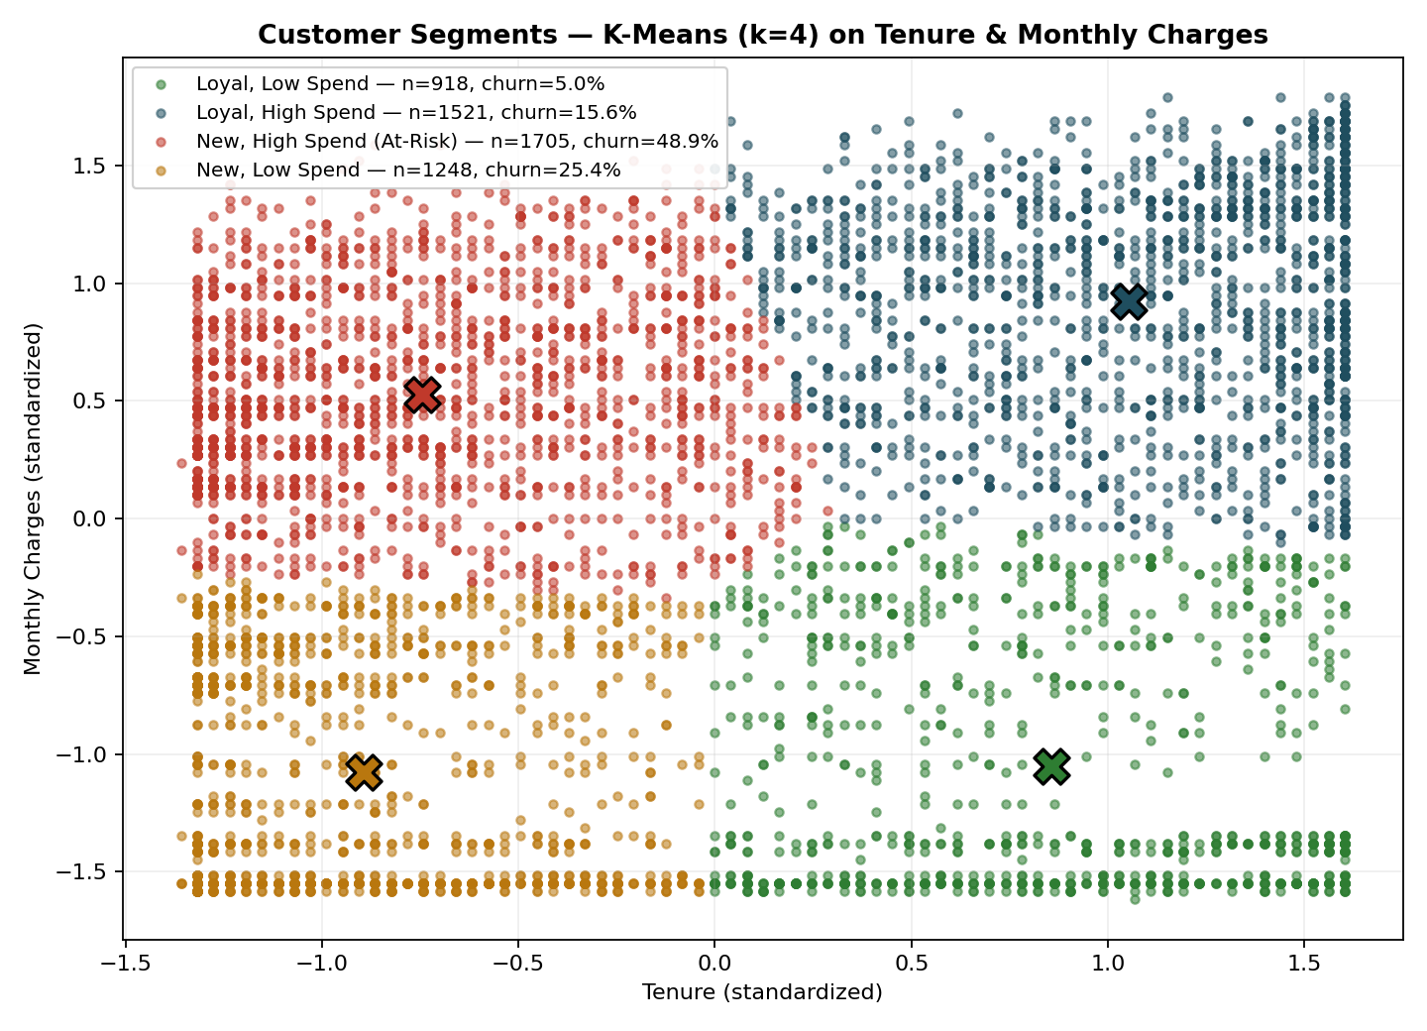
Figure 2. Labelled customer segments: tenure vs. Monthly Charges, with cluster centroids marked.
Segment | Profile | Size | Churn Rate
Loyal, Low Spend | High tenure, low monthly charges | 918 | 5.0%
Loyal, High Spend | High tenure, high monthly charges | 1,521 | 15.6%
New, High Spend (At-Risk) | Low tenure, high monthly charges | 1,705 | 48.9%
New, Low Spend | Low tenure, low monthly charges | 1,248 | 25.4%

6. Interpretation and Actionable Insight
Clustering itself uses only tenure and MonthlyCharges and has no knowledge of churn. Churn rate was calculated per segment after clustering, to interrogate whether the discovered groups relate meaningfully to churn behaviour.
The New, High Spend (At-Risk) segment stands out clearly: it churns at 48.9%, roughly 3–10x higher than every other segment, and is not a small edge case: at 1,705 customers, it is the largest of the four segments (about 25% of the customer base). New customers who are already paying high monthly charges are the clearest, highest-priority retention target identified in this analysis, and this finding is recommended as a central input to the project's retention strategy in the final report.

7. Files in This Folder
- Clustering_Analysis_Documentation.docx: this document
- Clustering_Analysis.ipynb: full annotated code (Jupyter Notebook)
- Clustering_Analysis.py: equivalent plain Python script
- kmeans_model.pkl: trained K-Means model (k=4)
- elbow_method.png: elbow method chart (Figure 1)
- cluster_visualization.png: labelled cluster scatter plot (Figure 2)
- cluster_assignments.csv: per-customer cluster assignment and churn label

