**Data Science pre-selection survey/interview**

Full Name:

Graduation place, year and last degree:

Current work (location and title):

Nature of Tasks (if employed):

Previous Work (location and title):

Nature of tasks (if applicable):

Any data related work (if yes, specify):

How you learned about this Training:

Objectives/Purpose from attending training:

Expected Outcome:

Readiness level (skills and time, incl. top programming skills and technologies):

Familiarity with the training subject:

Attended edX MOOC?

Expected level of effort during training (# hours/week):

Nature of effort (expected):

Why do you qualify for this training (up to 3 reasons in 30 sec)?

Sample 1 (page 2):

Sample 2 (page 3):

Sample 3 (page 4):

Future trends in data science (what do you expect):

Project suggestion (end of training):

Do you have active (a) Twitter (b) LinkedIn (c) GitHub accounts?

Comments and suggestions for training:

S1: explain this and expect output of last section (2 min)  
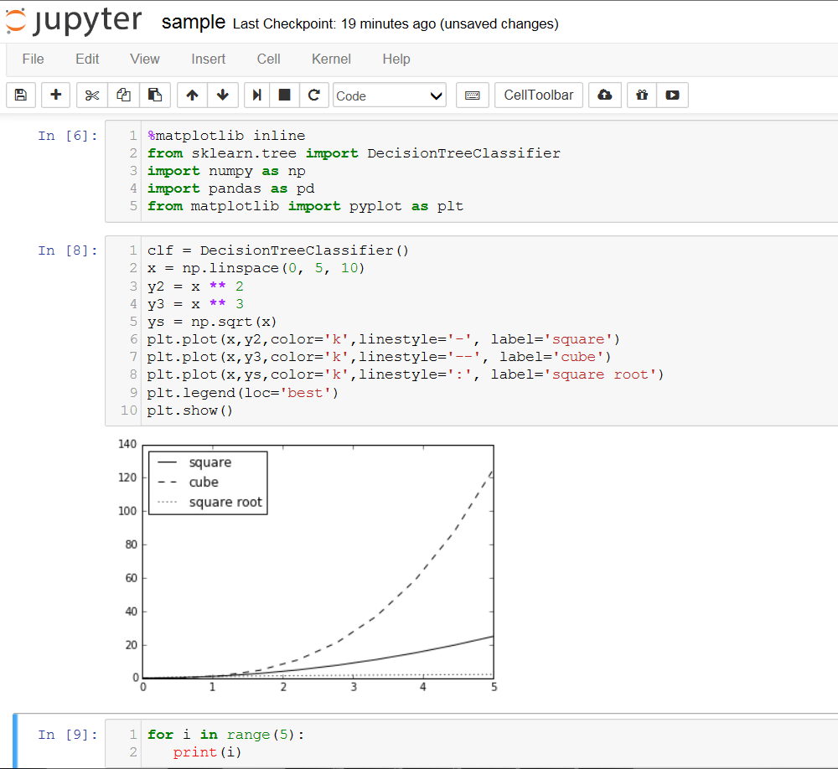

S2: examine this script and output. Provide general comment. What do you expect the area under curve from X=0 to X=4? What does SD measure? (2m)

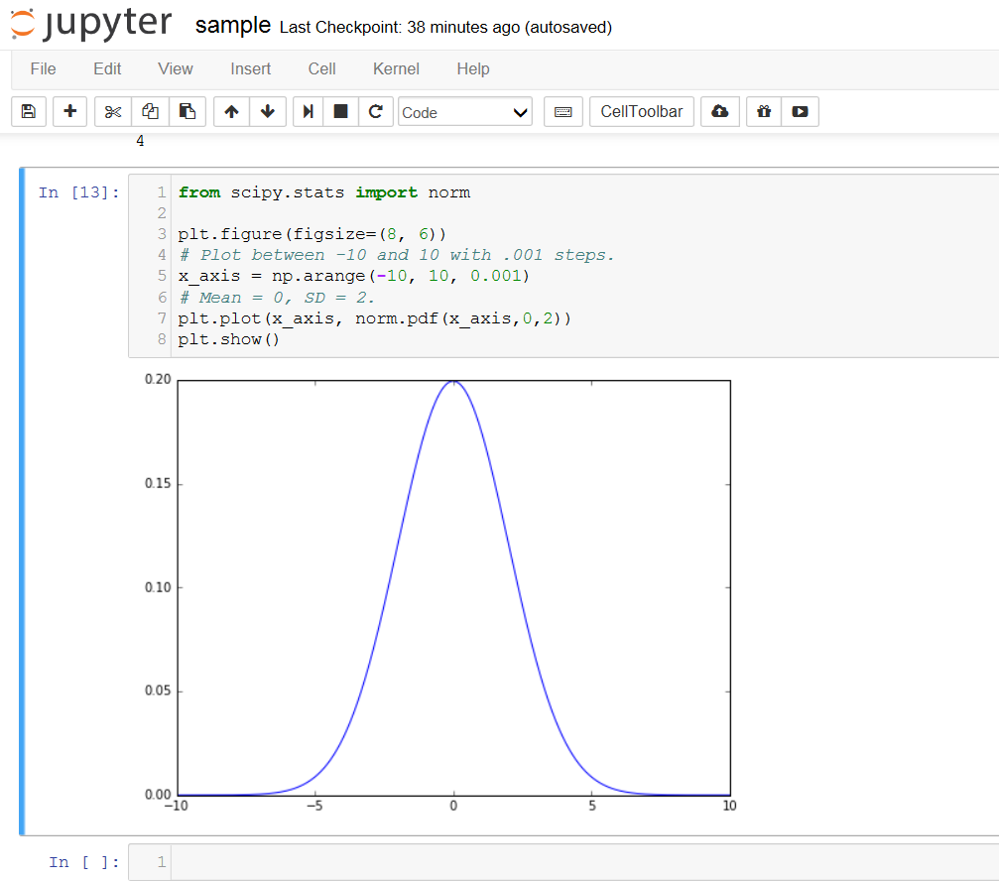

S3: Examine the following code and graph. What is going on here? Do you think the line is the best fit for the dots? If you were to draw one, how do you determine the parameters? (3 min)  
