Why Do Some People React to the Same Drugs Differently Than Others?
Md Abedur Rahman
University of the Cumberlands

Data Science & Big Data Analy (ITS-836-A01)

Jess Schwartz, Oludotun Oni
October 4, 2026

Abstract
People can experience different therapeutic effects and adverse reactions even when they receive the same medication. Drug response is influenced by multiple interacting factors, including genetics, age, sex, organ function, co-medications, environmental exposures, and disease characteristics. This project uses a 200-record drug-classification dataset to examine whether routinely measured patient characteristics can predict drug category. The predictors are age, sex, blood-pressure category, cholesterol category, and sodium-to-potassium (Na-to-K) ratio; the outcome contains five drug classes (drugA, drugB, drugC, drugX, and drugY). Data were inspected for completeness, summarized descriptively, encoded for machine learning, and divided into stratified training and testing sets. Decision tree, random forest, and multinomial logistic regression classifiers were evaluated using accuracy, weighted precision, weighted recall, weighted F1 score, and confusion matrices. Decision tree and random forest models each achieved 97.5% test accuracy, while logistic regression achieved 95.0%. Na-to-K ratio showed especially clear separation for drugY, whose mean ratio was 22.37 compared with approximately 10.63 to 11.52 for the other drug classes. The findings demonstrate that patient characteristics can contain strong predictive information for treatment classification. However, the dataset does not contain genetic variants, medication doses, actual adverse-event outcomes, or longitudinal clinical follow-up, so the results should be interpreted as a classroom demonstration of individualized drug selection rather than direct evidence of pharmacogenomic causation.
Keywords: drug response, pharmacogenomics, personalized medicine, classification, machine learning
Introduction
A medication that works well for one patient may be ineffective or poorly tolerated by another. This interindividual variability is a central challenge in clinical pharmacology because drug response reflects both pharmacokinetics, what the body does to a drug, and pharmacodynamics, what the drug does to the body. Patient-level characteristics such as age, sex, body composition, kidney and liver function, concurrent medications, smoking, diet, disease state, and genetic variation can change drug exposure or sensitivity. Pharmacogenomics focuses specifically on how genomic variation contributes to differences in medication efficacy and toxicity (Pirmohamed, 2014; Relling & Evans, 2015; Weinshilboum & Wang, 2017).
The clinical importance of individualized drug response is increasingly recognized in precision medicine. The U.S. Food and Drug Administration (FDA) maintains information about pharmacogenomic biomarkers in drug labeling and pharmacogenetic associations that may affect drug metabolism, therapeutic response, dosage, or adverse-event risk. Examples include variants in CYP2C19, CYP2D6, CYP2C9, HLA genes, and drug transporter genes. These examples show that biological differences between patients can sometimes have actionable implications for treatment selection or monitoring (U.S. Food and Drug Administration, 2026).
Drug-response variability is nevertheless more complex than genetics alone. Reviews of pharmacogenomics in primary care emphasize contributions from age, sex, body mass index, renal and hepatic impairment, co-medications, environmental exposures, and genetics. Sex-related physiological and hormonal differences can also influence pharmacokinetic and pharmacodynamic processes (Swen et al., 2023). Consequently, individualized prescribing requires consideration of multiple sources of variation rather than a single patient attribute.
Data science provides a useful framework for examining this problem. Classification algorithms can learn patterns linking patient characteristics with categorical treatment outcomes. Decision trees are particularly interpretable because they represent prediction rules as sequential splits. Random forests combine many trees to improve stability and predictive performance. Multinomial logistic regression provides a comparatively simple statistical baseline for modeling a multi-class outcome. Comparing these approaches can show whether the available patient variables contain enough information to distinguish treatment classes reliably.
The present project asks: (1) How are age, sex, blood pressure, cholesterol, and Na-to-K ratio distributed across the five drug classes? (2) Can these patient characteristics accurately predict drug class? (3) Which observable patterns appear most important for differentiating the classes? The primary hypothesis is that patient characteristics are associated with drug classification and that supervised machine-learning models can predict the drug class with high accuracy. A secondary expectation is that Na-to-K ratio and blood-pressure category will show particularly strong separation among classes.
Methods
Data Source and Study Design. The analysis used the uploaded drug200.csv dataset, a small cross-sectional classification dataset containing 200 observations and six columns. Each row represents a patient record. Five columns were used as predictors: Age, Sex, BP, Cholesterol, and Na_to_K. Drug was treated as the categorical target variable. Age and Na_to_K are numeric variables. Sex has two categories, BP has three categories (HIGH, LOW, NORMAL), Cholesterol has two categories (HIGH, NORMAL), and Drug contains five classes. The dataset was analyzed locally in Python; no API calls or web scraping were required for the analytic dataset.
Data Wrangling and Preprocessing. The CSV file was loaded with pandas and checked for dimensions, data types, missing values, and class frequencies. The dataset contained 200 rows and no missing values in any of the six columns, so imputation and record deletion were unnecessary. Categorical predictors were transformed using one-hot encoding with handling for previously unseen categories. Age and Na-to-K ratio were standardized so that the logistic regression model would not be disproportionately influenced by differences in measurement scale. Preprocessing was placed inside a scikit-learn ColumnTransformer and Pipeline to reduce the risk of applying transformations inconsistently between training and testing data.
Exploratory Analysis. Descriptive statistics were calculated for Age and Na_to_K. Frequencies and cross-tabulations were used to examine drug class by sex, blood pressure, and cholesterol. Drug-specific means, standard deviations, minima, and maxima were calculated for age and Na-to-K ratio. Bar charts and boxplots were created with Matplotlib to visualize class distribution and differences in Na-to-K ratio.
Predictive Modeling. The predictors and target were separated, and the observations were divided into 80% training data and 20% testing data using random_state=42. Stratification by Drug preserved the class distribution across the split. Three classifiers were trained: a decision tree with maximum depth 5, a random forest with 300 trees, and multinomial logistic regression implemented through scikit-learn's LogisticRegression. The random seed was fixed where applicable to support reproducibility.
Evaluation. Models were compared using test-set accuracy, weighted precision, weighted recall, and weighted F1 score. Weighted metrics were reported because the outcome classes were imbalanced. Confusion matrices were also examined to identify the specific classes involved in errors. Because the outcome is categorical, regression metrics such as R-squared and mean absolute error are not appropriate for this analysis. All code used to reproduce the analysis is supplied separately in drug_response_analysis.py.
Table 1
Dataset Variables
Variable | Type | Role | Description
Age | Numeric | Predictor | Patient age in years
Sex | Categorical | Predictor | F or M
BP | Categorical | Predictor | HIGH, LOW, or NORMAL
Cholesterol | Categorical | Predictor | HIGH or NORMAL
Na_to_K | Numeric | Predictor | Sodium-to-potassium ratio
Drug | Categorical | Outcome | drugA, drugB, drugC, drugX, or drugY
Results
Descriptive Findings. The sample contained 200 records. Mean age was 44.32 years (SD = 16.54), with ages ranging from 15 to 74. The mean Na-to-K ratio was 16.08 (SD = 7.22), with a range from 6.27 to 38.25. There were 104 male and 96 female records. DrugY was the most frequent outcome (n = 91, 45.5%), followed by drugX (n = 54, 27.0%), drugA (n = 23, 11.5%), drugB (n = 16, 8.0%), and drugC (n = 16, 8.0%).
Clear class patterns were visible in the categorical variables. All drugA and drugB observations occurred among patients with HIGH blood pressure. DrugC appeared only among patients with LOW blood pressure and HIGH cholesterol. DrugX appeared among LOW or NORMAL blood-pressure observations, whereas drugY appeared in all three blood-pressure categories. Sex was more evenly distributed across classes and did not show the same degree of visual separation.
The strongest numerical separation involved Na-to-K ratio. DrugY records had a mean Na-to-K ratio of 22.37 (SD = 6.06), with a minimum of 15.02. In contrast, the mean ratios for drugA, drugB, drugC, and drugX ranged only from 10.63 to 11.52, and their maxima were below 14.65. This near-separation explains why Na-to-K ratio is highly informative for identifying drugY in this dataset. Age also distinguished some classes: the mean age for drugB was 62.50 years, compared with 35.87 years for drugA.
Table 2
Descriptive Statistics by Drug Class
Drug | n | Mean Age | Mean Na-to-K | Na-to-K Range
drugA | 23 | 35.87 | 10.92 | 6.27-13.97
drugB | 16 | 62.50 | 11.52 | 8.62-14.24
drugC | 16 | 42.50 | 10.63 | 6.77-14.16
drugX | 54 | 44.02 | 10.65 | 6.68-14.64
drugY | 91 | 43.75 | 22.37 | 15.02-38.25
Figure 1
Distribution of Drug Classes
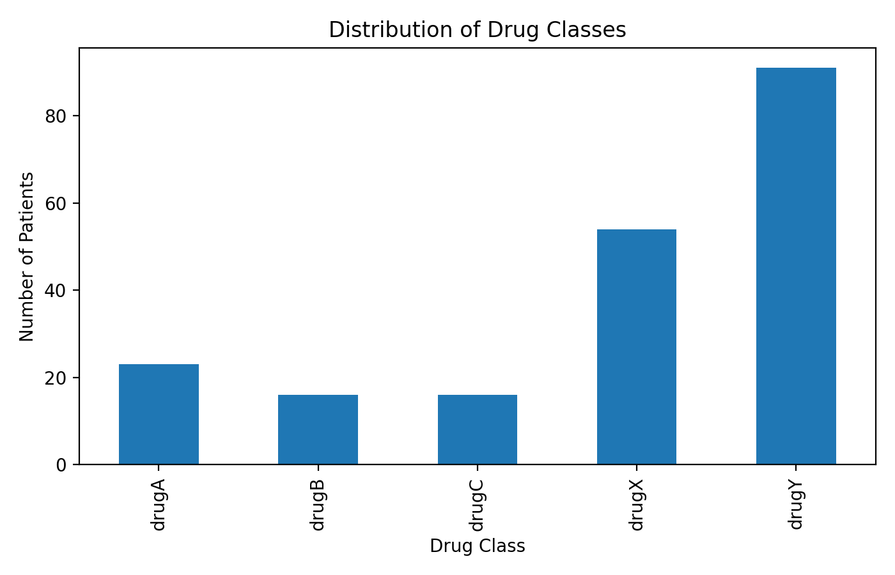
Figure 2
Sodium-to-Potassium Ratio by Drug Class
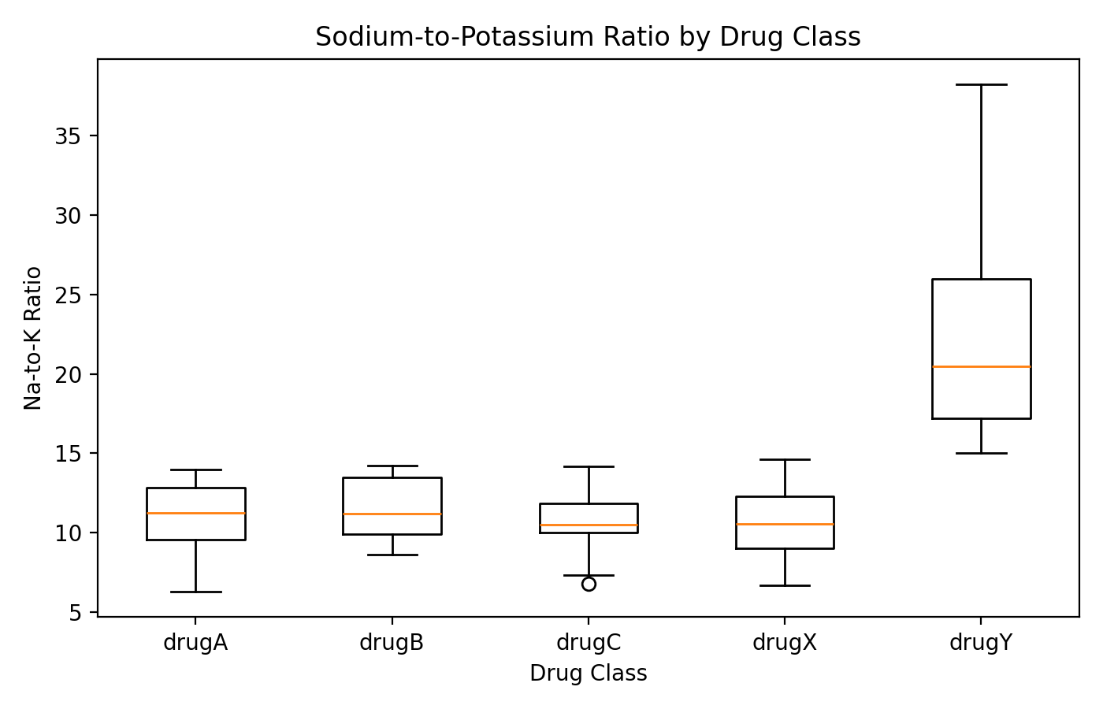
Model Performance. Both the decision tree and random forest correctly classified 39 of the 40 test observations, producing an accuracy of 97.5%. Their weighted precision was 97.9%, weighted recall was 97.5%, and weighted F1 score was 97.4%. Logistic regression correctly classified 38 of 40 observations, for 95.0% accuracy, 95.5% weighted precision, 95.0% weighted recall, and a 94.8% weighted F1 score.
The decision tree and random forest made the same single error in the held-out test set: one drugB observation was predicted as drugA. Both models correctly classified all test observations from drugC, drugX, and drugY. Logistic regression made two errors: one drugB observation was predicted as drugA and one drugX observation was predicted as drugY. The high performance across three different algorithms suggests that the dataset contains strong, relatively simple boundaries between the five classes.
Table 3
Classification Model Performance on the 20% Test Set
Model | Accuracy | Weighted Precision | Weighted Recall | Weighted F1
Decision Tree | 0.975 | 0.979 | 0.975 | 0.974
Random Forest | 0.975 | 0.979 | 0.975 | 0.974
Logistic Regression | 0.950 | 0.955 | 0.950 | 0.948
Figure 3
Random Forest Confusion Matrix
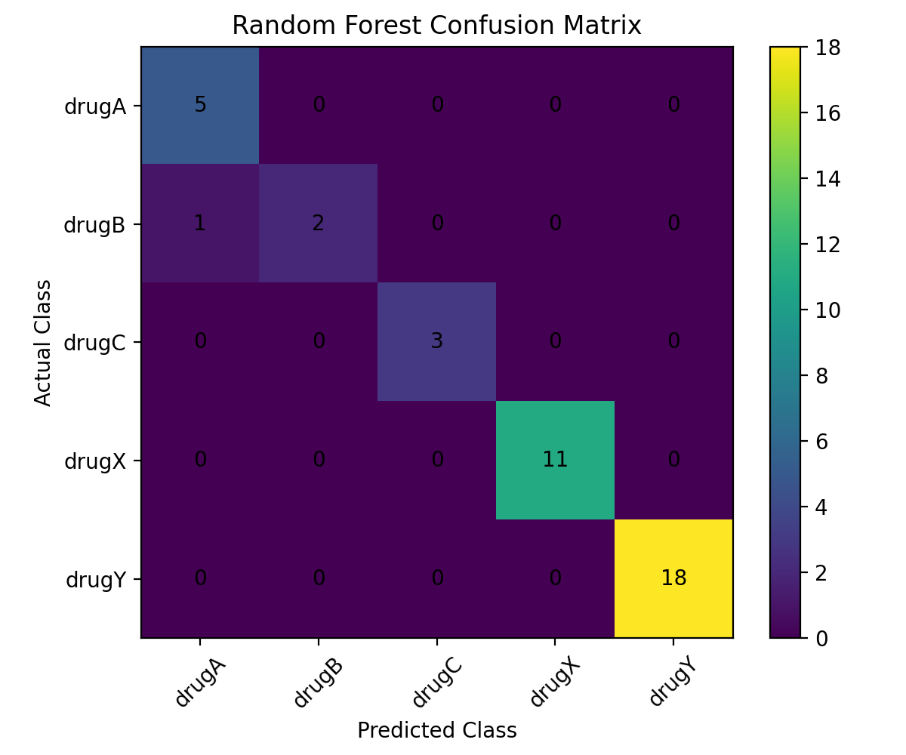
Discussion
The results support the primary hypothesis that patient characteristics in this dataset are strongly associated with drug classification. All three models achieved at least 95% test accuracy, and two models achieved 97.5%. The most obvious explanatory pattern was the separation of drugY by Na-to-K ratio. Every drugY observation had a ratio above approximately 15, while all observations assigned to the other four drug classes had ratios below approximately 14.7. Blood-pressure and cholesterol categories then provided additional separation among the non-drugY classes, while age helped distinguish drugA and drugB among high-blood-pressure observations.
These findings are conceptually consistent with precision-medicine research showing that medication response can depend on multiple patient characteristics. Pharmacogenomics demonstrates that inherited differences in drug-metabolizing enzymes, transporters, immune-related genes, and drug targets can alter systemic drug concentrations, efficacy, or toxicity. The FDA likewise recognizes pharmacogenetic associations for numerous medications, although it cautions that genotype is only one of many factors affecting drug concentrations and response. The present dataset does not measure genotype, but its strong associations among clinical characteristics and treatment class illustrate the broader principle that uniform treatment rules may not fit all patients.
The results also illustrate why interpretable machine learning can be valuable in healthcare analytics. A decision tree can express clinically understandable threshold and category rules, while a random forest can capture interactions without requiring the analyst to specify them in advance. Logistic regression performed only slightly worse, indicating that the classification problem is not dependent on a highly complex model. In practice, predictive accuracy alone is insufficient for clinical deployment. A model would also require external validation, calibration, fairness assessment, clinical interpretation, and evaluation of the consequences of incorrect recommendations.
The very high accuracy should therefore be interpreted cautiously. The dataset is small, with only 200 observations, and the test set contains only 40 records. Several classes have few observations, including only 16 total cases each for drugB and drugC. A single additional error would noticeably change class-specific metrics. The data also contain unusually clean decision boundaries, especially for Na-to-K ratio, which makes the prediction task easier than many real clinical problems. Performance on a larger, independent population could be lower.
A second limitation is that the target variable represents a drug class rather than a measured biological response such as symptom improvement, drug concentration, toxicity, hospitalization, or adverse drug reaction. Therefore, the analysis cannot establish that age, blood pressure, cholesterol, sex, or Na-to-K ratio caused a person to respond differently to the same medication. It is more accurate to interpret the project as predicting individualized drug assignment from patient characteristics. The dataset also lacks dosage, diagnoses, kidney and liver function, medication interactions, ancestry, genetic variants, adherence, and longitudinal outcomes.
Future research should use larger clinical or pharmacogenomic datasets that include actual treatment outcomes and genomic information. Such studies could evaluate gene-drug interactions alongside demographic, laboratory, and clinical variables; use cross-validation and external validation cohorts; compare additional algorithms; examine model calibration; and assess performance across population subgroups. Explainability techniques could also be used to quantify how each feature contributes to predictions. These extensions would move the analysis closer to the real question of why the same drug produces different effects in different people.
Conclusion
This project examined whether patient characteristics can help explain and predict differences in drug classification. In the 200-record dataset, age, sex, blood pressure, cholesterol, and Na-to-K ratio provided enough information for three supervised-learning models to classify five drug categories with 95.0% to 97.5% accuracy on a held-out test set. Na-to-K ratio was particularly informative for drugY, while blood pressure, cholesterol, and age helped distinguish the remaining classes.
The analysis supports the project hypothesis within the boundaries of this dataset: patient characteristics were strongly associated with drug category, and machine-learning models could predict the category with high accuracy. The broader scientific literature shows that real medication response is influenced by a much wider set of factors, including genetics, physiology, co-medications, environment, and disease characteristics. Thus, the project demonstrates the value of data-driven personalized treatment while also showing why richer clinical and pharmacogenomic data are necessary before drawing conclusions about actual efficacy, toxicity, or prescribing decisions.

References
Pirmohamed, M. (2014). Personalized pharmacogenomics: Predicting efficacy and adverse drug reactions. Annual Review of Genomics and Human Genetics, 15, 349-370. https://doi.org/10.1146/annurev-genom-090413-025419
Relling, M. V., & Evans, W. E. (2015). Pharmacogenomics in the clinic. Nature, 526, 343-350. https://doi.org/10.1038/nature15817
U.S. Food and Drug Administration. (2026). Table of pharmacogenetic associations. https://www.fda.gov/medical-devices/precision-medicine/table-pharmacogenetic-associations
U.S. Food and Drug Administration. (n.d.). Table of pharmacogenomic biomarkers in drug labeling. https://www.fda.gov/drugs/science-and-research-drugs/table-pharmacogenomic-biomarkers-drug-labeling
Weinshilboum, R. M., & Wang, L. (2017). Pharmacogenomics: Precision medicine and drug response. Mayo Clinic Proceedings, 92(11), 1711-1722. https://doi.org/10.1016/j.mayocp.2017.09.001
Swen, J. J., van der Wouden, C. H., Manson, L. E., et al. (2023). A 12-gene pharmacogenetic panel to prevent adverse drug reactions: An open-label, multicentre, controlled, cluster-randomised crossover implementation study. The Lancet, 401(10374), 347-356. https://doi.org/10.1016/S0140-6736(22)01841-4

