SPU
GRADUATION PROJECT REPORT

Multimodal RAG System
for Clinical Healthcare Advice
and Medical Report Parsing
OCR-free report understanding • Vector retrieval • Local grounded generation
Student | Andallah Wali Agha
Supervisors | Dr. Assef Jafar  Eng. Wessam Alsohle
Semester | First Semester, 2026/2027
Part 1: Project Overview | Chapter 1: Theoretical Foundations

Contents
Part 1 Project Overview
1 Scientific Problem and Project Objective
2 State of the Art
3 Proposed Solution: Idea, Block Diagram and Flowchart
4 Project Scope and Evaluation Plan
Chapter 1 Theoretical Foundations
1.1 Visual Document Understanding and OCR-Free Parsing
1.2 Dense Vector Spaces and Similarity Search
1.3 Language Models and Optimization
1.4 Retrieval-Augmented Generation
1.5 Technical Implementation Stack
References
PART 1

Project Overview

1. Scientific Problem and Project Objective

1.1 Scientific Problem
Clinical decision-making depends on heterogeneous data: narrative medical records, scanned lab reports and prescriptions, and clinical guidelines. In practice a patient often brings a photographed or scanned lab sheet, and both the patient and a small clinic need to understand what the numbers mean. Extracting structured information and giving evidence-based advice from such sources raises three problems:
- OCR error propagation. Classic pipelines run OCR first and parse the text afterwards. On noisy, skewed or low-quality scans, OCR mistakes (for example a misread lab value or unit) propagate to every later stage and can change the medical meaning.
- Hallucination and weak domain grounding. General-purpose LLMs can produce confident but unsupported medical statements when they answer without retrieved evidence.
- Modality gap in retrieval. Text-only retrieval cannot directly use the layout and visual structure of forms and diagnostic sheets, where meaning depends on table position and headings.

1.2 Project Objective
The goal is an end-to-end multimodal Retrieval-Augmented Generation (RAG) system that parses medical report images and returns grounded healthcare guidance. The specific objectives are:
- OCR-free document understanding: convert report images directly into structured JSON using a vision-language transformer (Donut).
- Semantic retrieval: embed and index chunked clinical text in a FAISS vector database for fast, accurate context retrieval.
- Grounded local generation: use a small local LLM (Qwen2.5-1.5B-Instruct) to write recommendations supported by the retrieved passages.
- Integration: combine parsing, retrieval and generation into one working pipeline that runs on a single T4 GPU.

2. State of the Art
The project builds on work in visual document understanding, vector search, retrieval-augmented generation and compact instruction-tuned LLMs.
Study | Domain | Method | Contribution | Limitation
Kim et al. (2022), Donut | Visual document understanding | Swin encoder + BART decoder, end to end | Removes the OCR engine and its error propagation | High-resolution input needs much GPU memory
Liu et al. (2021), Swin Transformer | Vision backbone | Shifted-window self-attention | Linear complexity in image size | Window design adds implementation complexity
Lewis et al. (2020), RAG | Knowledge-grounded generation | Retriever + generator | Reduces hallucination by conditioning on retrieved text | Quality depends on retrieval quality
Reimers & Gurevych (2019), Sentence-BERT | Sentence embeddings | Siamese BERT networks | Fast semantic similarity via cosine distance | General-domain training; limited medical specificity
Johnson et al. (2017), FAISS | Vector search | IVFADC, GPU k-selection | Billion-scale search, large speedup over CPU | Needs memory tuning; quantization loses some accuracy
Qwen Team (2024), Qwen2.5 | Foundation LLMs | Large-scale pre-training, SFT, preference optimization | Strong small instruct models | Long context increases compute cost
Yang et al. (2024), Qwen2.5-Math | Reasoning LLMs | SFT, reward modeling, GRPO | Strong reasoning at 1.5B to 7B scale | Depends on execution feedback
Chu et al. (2024), Causal Guardrails | LLM safety | Causal analysis, debias LoRA | Reduces bias and jailbreak risk | Extra training overhead

2.1 Research Gap
Donut removes OCR dependence and FAISS enables fast lookup, but no common pipeline joins OCR-free report extraction with a local, vector-grounded medical RAG model. Most RAG systems start from OCR text and inherit its errors. This project fills that gap, and keeps all processing on local hardware, which also protects patient privacy.

3. Proposed Solution

3.1 Idea of the Solution
The system reads the report image directly, turns it into structured JSON, uses that JSON (plus the user's question) to retrieve relevant clinical passages, and lets a local LLM write advice grounded in those passages. An example of the intermediate JSON produced by the parsing stage:
{
"patient": {"age": 45, "sex": "F"},
"tests": [
{"name": "Hemoglobin", "value": 10.2, "unit": "g/dL"},
{"name": "Fasting glucose", "value": 131, "unit": "mg/dL"}
]
}
Figure 1. Illustrative structured output of the Donut parsing stage

3.2 Block Diagram
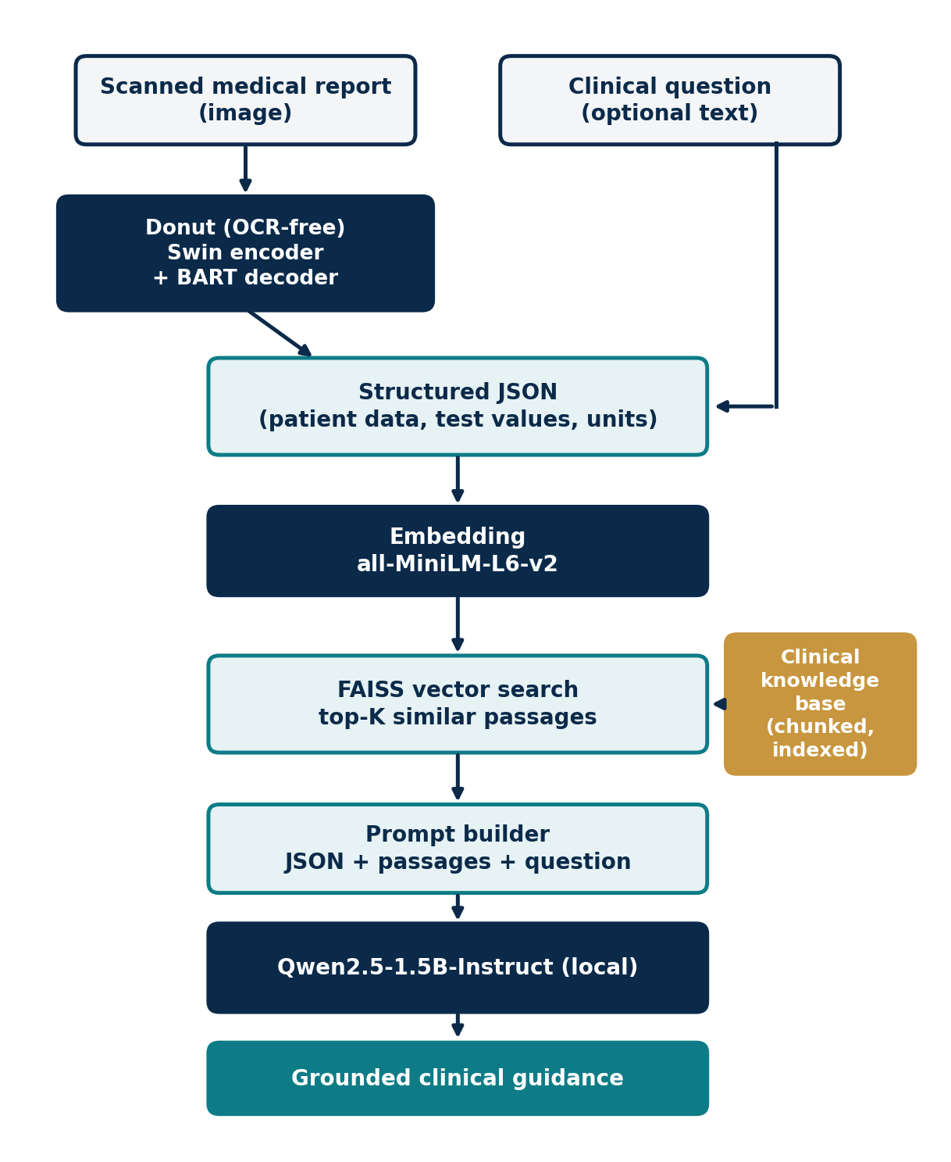
Figure 2. System block diagram

3.3 Flowchart
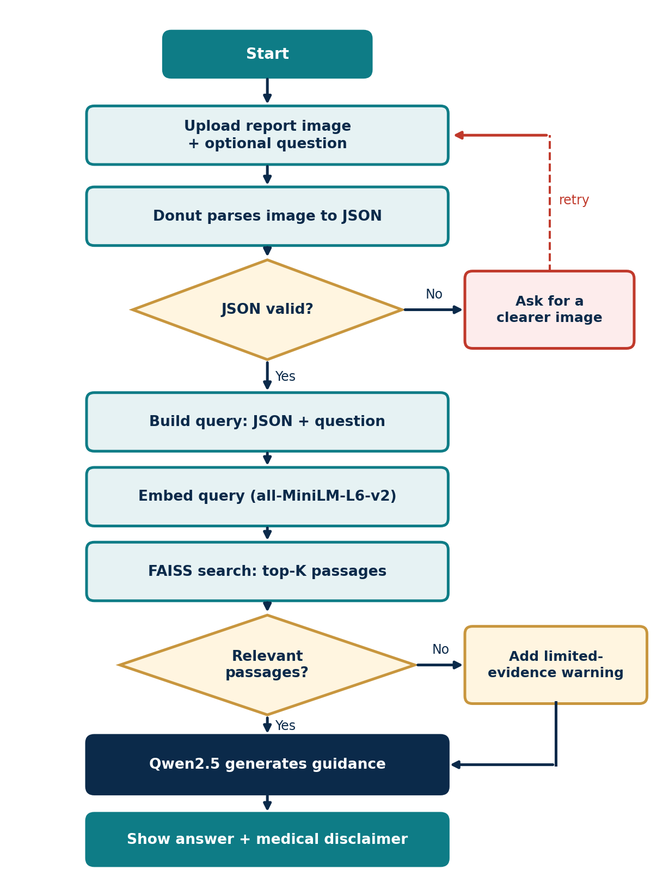
Figure 3. Operational flowchart with validity and relevance checks

3.4 Operational Workflow
- Input: the user submits a report image and optionally a question.
- Parsing: Donut converts the image to JSON of key parameters, with no external OCR.
- Retrieval: the JSON and question are embedded and matched against the FAISS index to get the top-K passages.
- Generation: a prompt combining report data and passages is sent to Qwen2.5-1.5B-Instruct, which writes the guidance together with a medical disclaimer.

4. Project Scope and Evaluation Plan
The system gives informational guidance only and does not replace a physician. The planned evaluation covers each stage and the whole pipeline:
Stage | Metric | What it shows
Parsing (Donut) | Field-level F1, exact match on values and units | Whether report numbers are read correctly
Retrieval (FAISS) | Recall@K, MRR | Whether the right passages are found
Generation (Qwen2.5) | Faithfulness to retrieved context, expert review | Whether advice is supported by evidence
System | Latency and GPU memory on a T4 | Whether it runs on modest hardware
CHAPTER 1

Theoretical Foundations
This chapter presents the theory the project relies on, in the order of the pipeline: image understanding, retrieval, and generation.

1.1 Visual Document Understanding and OCR-Free Parsing

Swin Transformer encoding
Standard Vision Transformers use global self-attention, whose cost grows quadratically with the number of image patches. The Swin Transformer restricts attention to local windows of size M × M and shifts the windows between layers, so cost grows linearly with image size while information still flows across windows. Inside a window:
Attention(Q, K, V) = Softmax( QKᵀ / √d + B ) V
where Q, K, V are the query, key and value matrices, d is the per-head dimension, and B is the relative position bias.

Autoregressive decoding
The encoder's visual features feed a BART decoder that generates the JSON token by token. Training minimizes the cross-entropy over target tokens Y = (y₁, …, y_T):
L(θ) = − Σₜ log Pθ( yₜ | y<ₜ , X_img )

1.2 Dense Vector Spaces and Similarity Search

Sentence embeddings
Text chunks and queries are mapped to vectors in ℝᴰ. Similarity is measured with cosine similarity; for unit-normalized vectors it is tied to Euclidean distance:
Sim(u, v) = u · v / (‖u‖ ‖v‖) d²(u, v) = 2 − 2 (u · v)
So ranking by highest cosine similarity equals ranking by smallest Euclidean distance. The model all-MiniLM-L6-v2 produces 384-dimensional embeddings.

FAISS indexing (IVF-PQ)
The index partitions the space into K coarse Voronoi cells with k-means (inverted file, IVF). At query time only the nearest cells are searched. Product Quantization (PQ) splits each vector into m sub-vectors and replaces each with its nearest sub-centroid, giving q(y) = [q₁(y₁), …, q_m(y_m)]. This saves memory and speeds up search at the cost of a small approximation error.

1.3 Language Models and Optimization

Causal language modeling
The response R given context C is generated with the factorization:
P(R | C) = Π i=1..n P( rᵢ | C, r₁, …, rᵢ₋₁ )
In RAG, C contains the parsed report and the retrieved passages, which anchors the answer to evidence.

Group Relative Policy Optimization (GRPO)
GRPO is used in training reasoning models such as Qwen2.5-Math. For each prompt it samples a group of G outputs and computes advantages relative to the group, with no separate value network:
Âᵢ = ( rᵢ − mean(r) ) / std(r)
The policy is updated with a clipped probability-ratio objective plus a KL penalty β·D_KL(π_θ ‖ π_ref) that keeps it close to a reference model. This project uses a model already trained this way rather than running GRPO itself.

1.4 Retrieval-Augmented Generation
RAG combines a retriever (embeddings + FAISS) with a generator (LLM). Instead of relying only on knowledge stored in the model's weights, the generator receives retrieved text at inference time. This lowers hallucination and lets the knowledge base be updated without retraining, which matters in medicine where guidelines change.

1.5 Technical Implementation Stack
Layer | Technology
Deep learning framework | PyTorch 2.x with CUDA acceleration
Vision and language models | HuggingFace transformers: Donut, Qwen2.5-1.5B-Instruct
Vector indexing | FAISS (CPU or GPU) for k-NN search
Text embeddings | sentence-transformers, all-MiniLM-L6-v2
Execution environment | Kaggle Notebooks with NVIDIA T4 GPU

References
- Kim, G. et al. (2022). OCR-free Document Understanding Transformer (Donut). ECCV.
- Liu, Z. et al. (2021). Swin Transformer: Hierarchical Vision Transformer using Shifted Windows. ICCV.
- Lewis, P. et al. (2020). Retrieval-Augmented Generation for Knowledge-Intensive NLP Tasks. NeurIPS.
- Reimers, N. and Gurevych, I. (2019). Sentence-BERT: Sentence Embeddings using Siamese BERT-Networks. EMNLP.
- Johnson, J., Douze, M. and Jégou, H. (2017). Billion-scale similarity search with GPUs.
- Qwen Team (2024). Qwen2.5 Technical Report.
- Yang, A. et al. (2024). Qwen2.5-Math Technical Report.
- Chu, Z. et al. (2024). Causal Guardrails for LLM safety.

