Trust Registry - Architecture & API Specification
This document provides a comprehensive technical overview of the Trust Registry, an authoritative trust anchor infrastructure designed for the Aadhaar ecosystem. The Trust Registry acts as the single source of truth for authenticating, onboarding, querying, and revoking ecosystem participants (Verifiers and Wallets).

1. System Architecture
The Trust Registry is a Next.js 16 (App Router) project built with React 19, TypeScript, and Tailwind/Vanilla CSS. It serves as a lightweight, cryptographically secure PKI (Public Key Infrastructure) engine.

1.1 High-Level Component Architecture
The following diagram illustrates how the trust registry components interact:
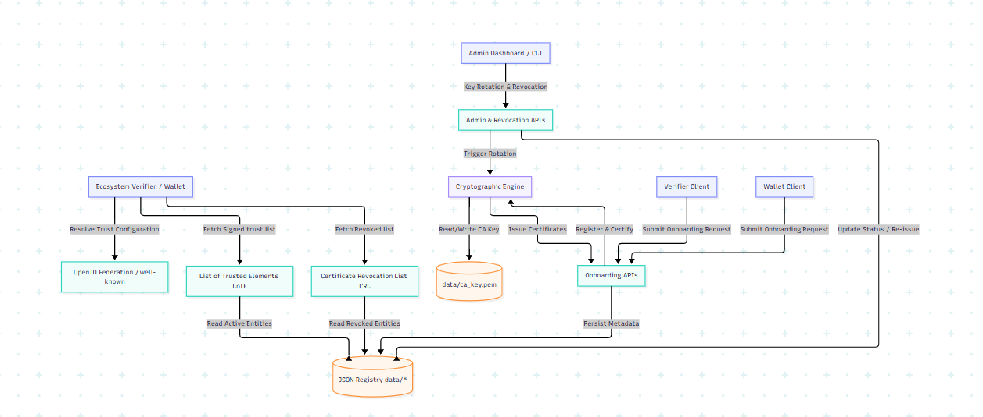

1.2 Trust & Integration Profiles
The system supports three integration methods for participants to accommodate varying levels of cryptographic sophistication:
1.2.1 Proprietary Profile
The Proprietary Profile is intended for relying parties that wish to integrate exclusively with the Aadhaar App and do not require interoperability with other wallets or trust ecosystems.
Under this model, relying parties establish trust through a one-time onboarding process by submitting their entity name, logo, and a valid Class 2 or Class 3 X.509 public certificate to UIDAI. Upon successful onboarding, UIDAI registers the certificate and issues a unique Client ID to the relying party.
For every transaction, the Aadhaar App validates the request signature against the pre-registered Class 2 or Class 3 public certificate associated with the Client ID. Successful signature validation establishes trust and authorizes the transaction.
Key characteristics of this profile are:
- Utilizes static, direct configuration mapping.
- Intended for closed-loop deployments that exclusively use the Aadhaar App.
- Trust is established through pre-registered Class 2 or Class 3 X.509 public certificates and a UIDAI-issued Client ID.
- Requires one-time onboarding and certificate registration with UIDAI.
- Request authentication is performed by validating transaction signatures against the registered public certificate.
- Does not require a Trust Registry download, dynamic trust resolution, or OpenID Federation mechanisms.

    - OpenID Offline Profile
The Offline OpenID4VP profile is intended for wallet ecosystems that require offline verification capabilities. Participating wallets may periodically download the signed List of Trusted Elements (LoTE) and use the locally cached copy for subsequent trust evaluation without requiring real-time connectivity to the Trust Registry. Participating relying parties shall be provisioned with short-lived X.509 certificates (2–4 weeks validity), and UIDAI shall provide APIs for automated certificate refresh and rotation.
Standardized deployment using X.509 certificates.
  - The Trust Registry issues short-lived/long-lived X.509 certificates to clients. The public certificate is compiled and hosted inside the centralized List of Trusted Elements (LoTE).

1.2.3 OpenID Federation Profile
The Federated OpenID4VP profile is intended for ecosystems that prefer dynamic trust establishment and do not wish to periodically download the complete trust registry.
Under this model, wallets and verifiers establish trust on demand by querying the Trust Registry for the status of a participating entity. The Trust Registry provides a signed response indicating whether the requested entity is currently trusted and authorized to participate in the Aadhaar ecosystem.
The Trust Registry acts as a Trust Anchor and exposes JWS-signed Entity Statements that allow participants to dynamically resolve and validate trust chains. Participants may optionally query lightweight status APIs for operational optimization; however, trust decisions shall be based on validation of signed federation metadata and trust chains. Participants dynamically retrieve the entity's metadata and public key material through its OpenID Federation Entity Configuration endpoint (/.well-known/openid-federation). Trust is established by validating the JWS-signed Entity Statements and resolving the authority chain from the participating entity back to the UIDAI Trust Anchor.
Key characteristics of this profile are:
- Utilizes the OpenID Federation 1.0 standard.
- Eliminates the need for periodic download and storage of the complete trusted participant list.
- Enables dynamic, real-time trust discovery and verification of wallets, verifiers, and issuers.
- Uses JWS-signed Entity Statements to communicate entity metadata, public keys, and trust marks.
- Establishes trust by validating the chain of authority from the participating entity to the UIDAI Trust Anchor.
- Supports scalable interoperability and simplifies onboarding and lifecycle management of ecosystem participants.

2. Cryptographic Foundations & Management

2.1 The Trust Anchor (CA) Private Key
- Algorithm: RSA 2048-bit.
- Storage: Persisted securely in data/ca_key.pem.
- Initialization: Automatically generated on system startup if missing, or loaded from the UIDAI_PRIVATE_KEY environment variable.
- Caching: The PEM is parsed into a Node.js KeyObject and cached in-memory.

2.2 Certificate Generation & Issuance
Onboarding processes generate an X.509 certificate for the participant:
- The public key is supplied by the onboarding participant.
- The certificate is generated using node-forge.
- Validity: 1 year (from the exact time of onboarding) for federated flows and 2-4 weeks validity for offline flows
- Key Usages: digitalSignature, nonRepudiation, keyEncipherment, dataEncipherment (CA constraint is set to false).
- Signature: Signed by the active Trust Anchor private key using SHA-256.

2.3 Dynamic Key Rotation Flow
The system supports zero-downtime, programmatic Trust Anchor key rotation.
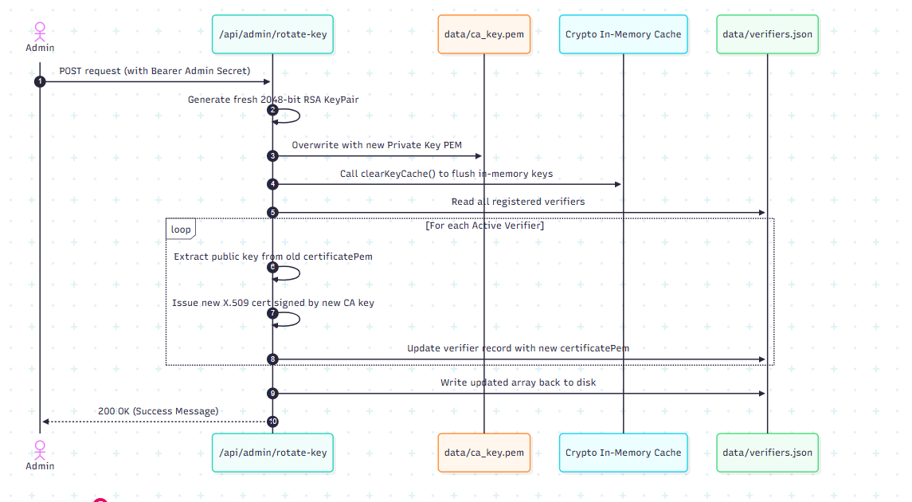

3. Data Persistence Layer
The database consists of flat-file JSON datastores and PEM directories under the /data folder:
- data/ca_key.pem: The PEM-encoded trust anchor private key.
- data/verifiers.json:
json
[
{
"id": "1719134567890",
"name": "State Hospital Network",
"domain": "hospital.gov.in",
"status": "Active",
"integrationMethod": "OpenID4VP (Centralized)",
"logoUrl": "/logos/1719134567890-xyz.png",
"contactInfo": "admin@hospital.gov.in",
"certificatePem": "-----BEGIN CERTIFICATE-----\n...",
"createdAt": "2026-06-23T10:00:00.000Z"
}
]
- data/wallets.json:
json
[
{
"id": "1719134987654",
"name": "E-Gov Wallet",
"domain": "wallet.egov.gov.in",
"status": "Active",
"integrationMethod": "OpenID4VP (Federated)",
"logoUrl": null,
"androidPackageName": "in.gov.egov.wallet",
"callbackUrl": "https://wallet.egov.gov.in/api/callback",
"contactInfo": "tech@egov.gov.in",
"encryptionKey": "pem-encoded-encryption-public-key",
"certificatePem": "-----BEGIN CERTIFICATE-----\n...",
"createdAt": "2026-06-23T10:05:00.000Z"
}
]

4. API Specification

4.1 Authentication
- Administrative endpoints (Revocation, Key Rotation) require authentication.
- Authentication type: Bearer Token.
- Secret Token: Specified by the ADMIN_SECRET environment variable (defaults to trust-admin for development).

4.2 Onboarding Endpoints

4.2.1 Onboard Verifier
Registers a new verifier in the system and issues a signed X.509 certificate.
- URL: /api/onboard
- Method: POST
- Content-Type: multipart/form-data
- Request Parameters:
- Response:
  - Status: 200 OK
  - Headers:
    - Content-Type: application/zip
    - Content-Disposition: attachment; filename="verifier_certificate.zip"
  - Body: A ZIP archive containing certificate.pem (the issued X.509 certificate signed by the Trust Anchor).
- Error Responses:
  - Status: 400 Bad Request if missing required parameters.
  - Status: 500 Internal Server Error if certificate creation fails.

4.2.2 Onboard Wallet
Registers a new wallet in the system and issues a signed X.509 certificate.
- URL: /api/wallets/onboard
- Method: POST
- Content-Type: multipart/form-data
- Request Parameters:
- Response:
  - Status: 200 OK
  - Headers:
    - Content-Type: application/zip
    - Content-Disposition: attachment; filename="wallet_certificate.zip"
  - Body: A ZIP archive containing certificate.pem (the issued X.509 certificate signed by the Trust Anchor).

4.3 Query & Discovery Endpoints

4.3.1 Get All Registered Verifiers
Retrieves the raw list of all registered verifiers.
- URL: /api/verifiers
- Method: GET
- Response:
  - Status: 200 OK
  - Headers: Content-Type: application/json
  - Body: Array of verifier metadata objects.
  - Sample Payload:
json
[
{
"id": "1719134567890",
"name": "State Hospital Network",
"domain": "hospital.gov.in",
"status": "Active",
"integrationMethod": "OpenID4VP (Centralized)",
"logoUrl": "/logos/1719134567890-xyz.png",
"contactInfo": "admin@hospital.gov.in",
"certificatePem": "-----BEGIN CERTIFICATE-----\n...",
"createdAt": "2026-06-23T10:00:00.000Z"
}
]

4.3.2 Get All Registered Wallets
Retrieves the raw list of all registered wallets.
- URL: /api/wallets
- Method: GET
- Response:
  - Status: 200 OK
  - Headers: Content-Type: application/json
  - Body: Array of wallet metadata objects.

4.4 Trust Infrastructure & Protocol Endpoints

4.4.1 List of Trusted Elements (LoTE)
Returns the JWS-signed trust list complying with the ETSI TS 119 612 structure.
- URL: /api/lote
- Method: GET
- Query Parameters:
  - type (String, Optional): The participant type to fetch. Must be verifier or wallet. Defaults to verifier.
- Response:
  - Status: 200 OK
  - Headers: Content-Type: application/json
  - Body:
json
{
"trust_list_jwt": "eyJhbGciOiJSUzI1NiIsImtpZCI6InVpZGFpLXRydXN0LWFuY2hvci1rZXktMSIsInR5cCI6IkpXUyJ9.ey...",
"trust_anchor_key": {
"kty": "RSA",
"n": "v5g7k...",
"e": "AQAB",
"kid": "uidai-trust-anchor-key-1",
"alg": "RS256",
"use": "sig"
}
}
- JWT Payload Structure (Decoded trust_list_jwt):
json
{
"iss": "https://trust.aadhaar.gov.in",
"iat": 1719159000,
"list_type": "https://trust.aadhaar.gov.in/Trst/Type/aadhaar",
"sequence_number": 1,
"issue_date": "2026-06-23T10:50:00.000Z",
"next_update": "2026-06-24T10:50:00.000Z",
"trust_service_providers": [
{
"tsp_name": "State Hospital Network",
"tsp_information": {
"id": "1719134567890",
"domain": "hospital.gov.in"
},
"services": [
{
"service_name": "Aadhaar Verifier (OpenID4VP (Centralized))",
"service_type": "https://trust.aadhaar.gov.in/Trst/Svctype/IdV",
"status": "https://trust.aadhaar.gov.in/Trst/Svcstatus/granted",
"service_digital_identity": {
"x509_certificate": "-----BEGIN CERTIFICATE-----\n..."
}
}
]
}
]
}

4.4.2 Certificate Revocation List (CRL)
Returns a JWS-signed representation of all revoked participants.
- URL: /api/crl
- Method: GET
- Query Parameters:
  - type (String, Optional): The participant type to fetch. Must be verifier or wallet. Defaults to verifier.
- Response:
  - Status: 200 OK
  - Headers: Content-Type: application/json
  - Body:
json
{
"crl_jwt": "eyJhbGciOiJSUzI1NiIsImtpZCI6InVpZGFpLXRydXN0LWFuY2hvci1rZXktMSIsInR5cCI6IkpXUyJ9.ey...",
"trust_anchor_key": {
"kty": "RSA",
"n": "v5g7k...",
"e": "AQAB",
"kid": "uidai-trust-anchor-key-1",
"alg": "RS256",
"use": "sig"
}
}
- JWT Payload Structure (Decoded crl_jwt):
json
{
"iss": "https://trust.aadhaar.gov.in",
"iat": 1719159000,
"list_type": "https://trust.aadhaar.gov.in/Trst/Type/crl",
"lastUpdated": "2026-06-23T10:50:00.000Z",
"revoked": [
{
"id": "1719134000000",
"name": "Revoked Partner Inc",
"domain": "revokedpartner.com",
"revokedAt": "2026-06-23T10:45:00.000Z",
"certificatePem": "-----BEGIN CERTIFICATE-----\n..."
}
]
}

4.4.3 OpenID Federation Entity Configuration
Serves the self-signed Entity Configuration of the Trust Anchor in accordance with OpenID Federation 1.0. The Entity Configuration contains the Trust Anchor's metadata, public signing keys, federation capabilities, and trust mark information required for dynamic trust resolution.
- URL: /.well-known/openid-federation
- Method: GET
- Response:
  - Status: 200 OK
  - Headers: Content-Type: application/entity-statement+jwt
  - Body: A signed JWT string containing the entity statement.
- JWT Payload Structure (Decoded):
json
{
"iss": "https://trust.aadhaar.gov.in",
"sub": "https://trust.aadhaar.gov.in",
"iat": 1719159000,
"jwks": {
"keys": [
{
"kty": "RSA",
"n": "v5g7k...",
"e": "AQAB",
"kid": "uidai-trust-anchor-key-1",
"alg": "RS256",
"use": "sig"
}
]
},
"metadata": {
"federation_entity": {
"organization_name": "Aadhaar Trust Registry Anchor",
"homepage_uri": "https://trust.aadhaar.gov.in",
"policy_uri": "https://trust.aadhaar.gov.in/policy",
"contacts": ["admin@uidai.gov.in"]
},
"trust_mark_issuer": {}
},
"authority_hints": []
}

4.4.4 OpenID Federation Fetch (Subordinate Statements)
Allows dynamic trust resolution by serving subordinate entity configuration statements.
- URL: /api/federation/fetch/ovse/{ovse id}
- Method: GET
- Query Parameters:
  - sub (String, Required): The identifier of the subordinate verifier (e.g. urn:uidai:client:infoque-solution:189374790).
- Response:
{
"entityId": "sbi.co.in",
"status": "active",
"entityType": "verifier",
"integrationMethod": "OpenID Federation",
"entityConfiguration":
"https://sbi.co.in/.well-known/openid-federation"
}
  - Status: 200 OK
  - Headers: Content-Type: application/entity-statement+jwt
  - Body: A signed JWT string containing the subordinate entity statement.
- JWT Payload Structure (Decoded):
json
{
"iss": "https://trust.aadhaar.gov.in",
"sub": "https://sbi.co.in",
"iat": 1719159000,
"exp": 1719162600,
"jwks": {
"keys": [
{
"kty": "RSA",
"e": "AQAB",
"n": "mock_sbi_modulus...",
"alg": "RS256"
}
]
},
"metadata_policy": {
"openid_relying_party": {
"client_name": { "value": "State Bank of India" },
"logo_uri": {},
“redirect uris”:{“value”:”https://sbi.co.in/callback”},
“Contacts”:{“value”:abee@sbi.co.in},
}
},
"trust_marks": [
{
"id": " urn:uidai:client:infoque-solution:18062025453",
"trust_mark": "signed_trust_mark_jwt..."
},
{ "authority_hints": [ "https://trust.aadhaar.gov.in"]
}
]
}
- Error Responses:
  - Status: 400 Bad Request if sub parameter is missing.
  - Status: 404 Not Found if subordinate is not recognized (currently mock resolves only https://sbi.co.in).

4.5 Administrative & Control Endpoints

4.5.1 Revoke Verifier
Revokes a verifier's status and updates the active registry database.
- URL: /api/verifiers/revoke
- Method: POST
- Headers:
  - Content-Type: application/json
  - Authorization: Bearer <ADMIN_SECRET>
- Request Body:
json
{
"verifierId": "1719134567890"
}
- Response:
  - Status: 200 OK
  - Body:
json
{
"success": true,
"message": "Verifier successfully revoked"
}
- Error Responses:
  - Status: 401 Unauthorized if Authorization header is missing.
  - Status: 403 Forbidden if Bearer token is incorrect.
  - Status: 404 Not Found if the verifier is not found in the database.
  - Status: 400 Bad Request if the verifier is already revoked.

4.5.2 Revoke Wallet
Revokes a wallet's status and updates the active registry database.
- URL: /api/wallets/revoke
- Method: POST
- Headers:
  - Content-Type: application/json
  - Authorization: Bearer <ADMIN_SECRET>
- Request Body:
json
{
"walletId": "1719134987654"
}
- Response:
  - Status: 200 OK
  - Body:
json
{
"success": true,
"message": "Wallet successfully revoked"
}

4.5.3 Rotate Trust Anchor Private Key
Triggers key rotation on the Trust Anchor. Overwrites the root private key, invalidates cryptographic caches, and automatically updates and re-signs all X.509 certificates for all active verifiers.
- URL: /api/admin/rotate-key
- Method: POST
- Headers:
  - Authorization: Bearer <ADMIN_SECRET>
- Response:
  - Status: 200 OK
  - Body:
json
{
"success": true,
"message": "CA Key Rotated and Certificates Regenerated"
}
- Error Responses:
  - Status: 401 Unauthorized if Bearer token is incorrect or missing.
  - Status: 500 Internal Server Error if dynamic generation or re-issuance logic fails.

