Trust Registry - Architecture & API Specification
This document provides a comprehensive technical overview of the Trust Registry, an authoritative trust anchor infrastructure designed for the Aadhaar ecosystem. The Trust Registry acts as the single source of truth for authenticating, onboarding, querying, and revoking ecosystem participants (Verifiers and Wallets).

1. System Architecture
The Trust Registry is suggested to be hosted by a neutral central agency like Digilocker or NIC or CDAC for being compliant with Aadhaar Act.

1.1 High-Level Component Architecture
The following diagram illustrates how the trust registry components interact within the proposed architecture:
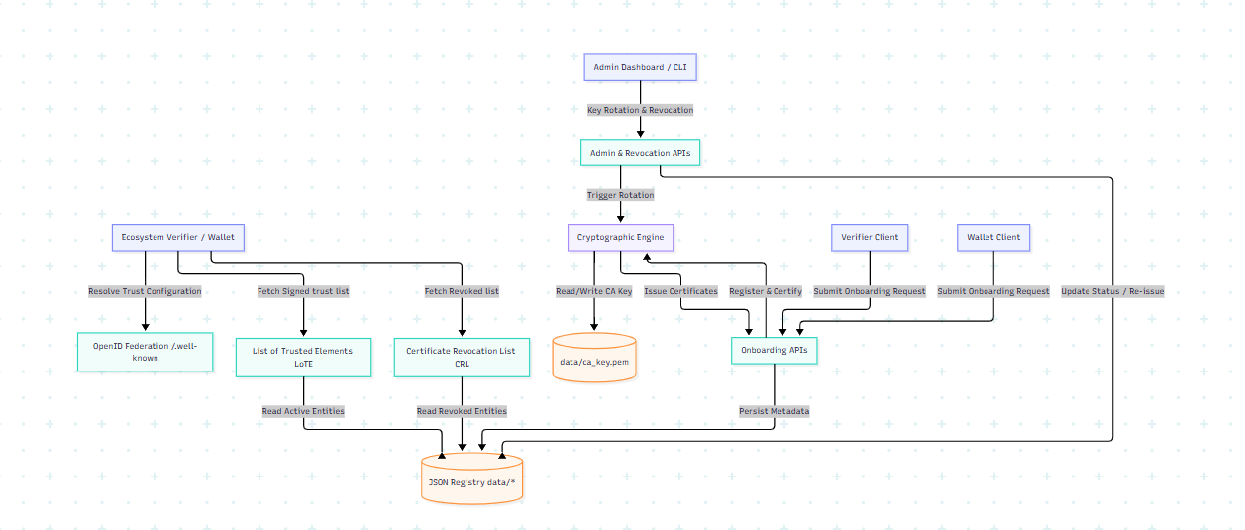

1.2 Trust & Integration Profiles
The system supports three integration methods for participants to accommodate varying levels of cryptographic sophistication:
- Proprietary Profile
- Utilizes static, direct configuration mapping.
- Trust is established through pre-registered public class 2/3 certificates submitted with UIDAI during the onboarding process.
- OpenID4VP (Offline) Profile
- Standardized deployment using X.509 certificates.
- The Trust Registry issues short-lived/long-lived X.509 certificates to clients. The public certificate is compiled and hosted inside the centralized List of Trusted Elements (LoTE).
- In offline mode, participating wallets periodically download the signed LoTE and use it for local trust evaluation. Relying parties are provisioned with short-lived X.509 certificates (2–4 weeks validity) with automated rotation.
- OpenID Federation Profile
- Utilizes the OpenID Federation 1.0 standard.
- The Trust Registry acts as a Trust Anchor and exposes JWS-signed Entity Statements that allow participants to dynamically resolve and validate trust chains. Participants may optionally query lightweight status APIs for operational optimization; however, trust decisions shall be based on validation of signed federation metadata and trust chains.
- Participants dynamically retrieve the entity's metadata and public key material through its OpenID Federation Entity Configuration endpoint (/.well-known/openid-federation). Trust is established by validating the JWS-signed Entity Statements and resolving the authority chain from the participating entity back to the UIDAI Trust Anchor.
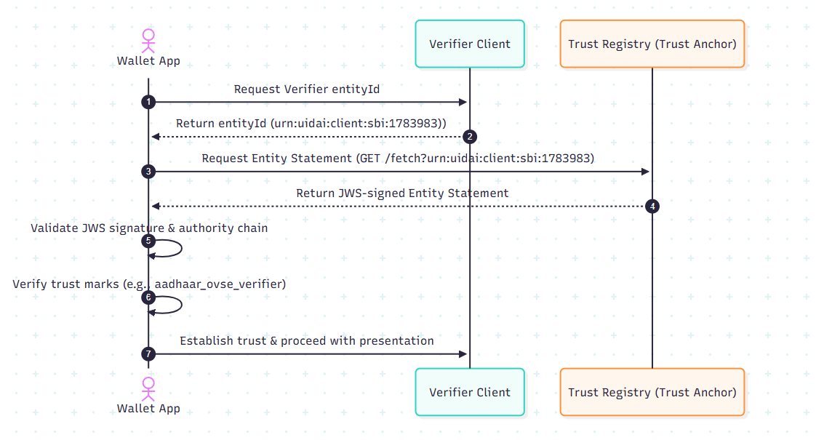
fig: Federated trust architecture

2. Cryptographic Foundations & Management

2.1 The Trust Anchor (CA) Private Key
- Algorithm: RSA 2048-bit.
- Storage: Persisted securely in data/ca_key.pem.
- Initialization: Automatically generated on system startup if missing, or loaded from the UIDAI_PRIVATE_KEY environment variable.
- Caching: The PEM is parsed into a Node.js KeyObject and cached in-memory.

2.2 Certificate Generation & Issuance
Onboarding processes generate an X.509 certificate for the participant:
- The public key is supplied by the onboarding participant.
- The certificate is generated using node-forge.
- Validity: 1 year (from the exact time of onboarding).
- Key Usages: digitalSignature, nonRepudiation, keyEncipherment, dataEncipherment (CA constraint is set to false).
- Signature: Signed by the active Trust Anchor private key using SHA-256.

2.3 Dynamic Key Rotation Flow
The system supports zero-downtime, programmatic Trust Anchor key rotation.
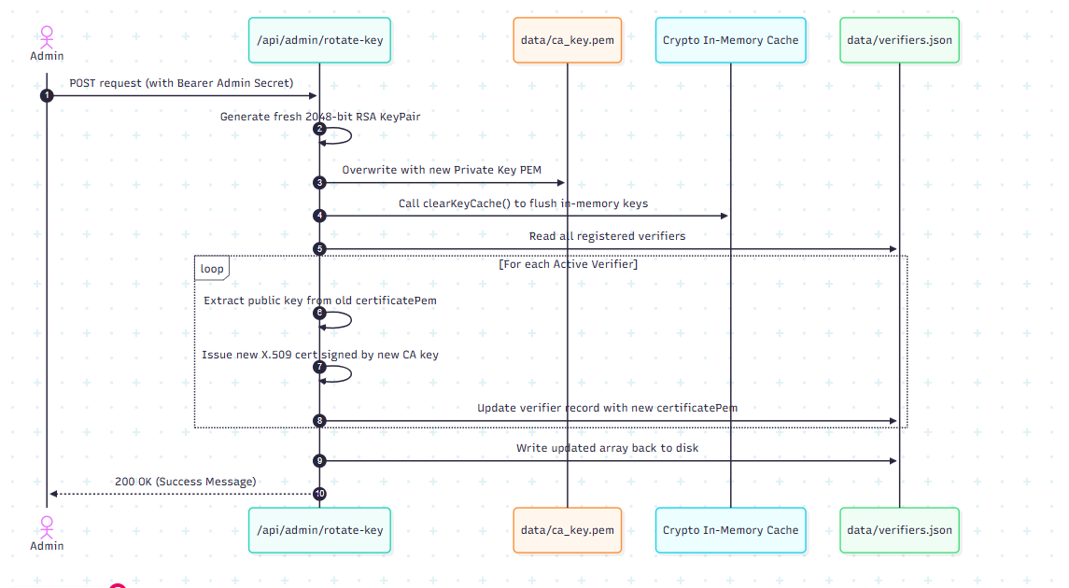

3. Data Persistence Layer
The database consists of flat-file JSON datastores and PEM directories under the /data folder:
- `data/ca_key.pem`: The PEM-encoded trust anchor private key.
- `data/verifiers.json`:
[
{
"id": "1719134567890",
"name": "State Hospital Network",
"domain": "hospital.gov.in",
"status": "Active",
"integrationMethod": "OpenID4VP (Offline)",
"logoUrl": "/logos/1719134567890-xyz.png",
"contactInfo": "admin@hospital.gov.in",
"certificatePem": "-----BEGIN CERTIFICATE-----\n...",
"createdAt": "2026-06-23T10:00:00.000Z"
}
]
- `data/wallets.json`:
[
{
"id": "1719134987654",
"name": "E-Gov Wallet",
"domain": "wallet.egov.gov.in",
"status": "Active",
"integrationMethod": "OpenID Federation",
"logoUrl": null,
"androidPackageName": "in.gov.egov.wallet",
"callbackUrl": "https://wallet.egov.gov.in/api/callback",
"contactInfo": "tech@egov.gov.in",
"encryptionKey": "pem-encoded-encryption-public-key",
"certificatePem": "-----BEGIN CERTIFICATE-----\n...",
"createdAt": "2026-06-23T10:05:00.000Z"
}
]

4. API Specification

4.1 Authentication
- Administrative endpoints (Revocation, Key Rotation) require authentication.
- Authentication type: Bearer Token.
- Secret Token: Specified by the ADMIN_SECRET environment variable (defaults to trust-admin for development).

4.2 Onboarding Endpoints

4.2.1 Onboard Verifier
Registers a new verifier in the system and issues a signed X.509 certificate.
- URL: /api/onboard
- Method: POST
- Content-Type: multipart/form-data
- Request Parameters:
Name | Type | Required | Description
verifierName | String | Yes | Friendly name of the Verifier organization
domainName | String | Yes | Verified domain of the Verifier
publicKey | String | Yes | PEM-formatted RSA Public Key of the Verifier
integrationMethod | String | Yes | Proprietary, OpenID4VP (Offline), or OpenID Federation
logo | File | No | Image file (png/jpg) representing the corporate logo
contactInfo | String | No | Contact information or email address

- Response:
- Status: 200 OK
- Headers:
- Content-Type: application/zip
- Content-Disposition: attachment; filename="verifier_certificate.zip"
- Body: A ZIP archive containing certificate.pem (the issued X.509 certificate signed by the Trust Anchor).
- Error Responses:
- Status: 400 Bad Request if missing required parameters.
- Status: 500 Internal Server Error if certificate creation fails.

4.2.2 Onboard Wallet
Registers a new wallet in the system and issues a signed X.509 certificate.
- URL: /api/wallets/onboard
- Method: POST
- Content-Type: multipart/form-data
- Request Parameters:
Name | Type | Required | Description
walletName | String | Yes | Friendly name of the Wallet application
domainName | String | Yes | Domain name hosted by the wallet issuer
publicKey | String | Yes | PEM-formatted RSA Public Key of the Wallet
integrationMethod | String | Yes | Proprietary, OpenID4VP (Offline), or OpenID Federation
logo | File | No | Image file representing the wallet logo
androidPackageName | String | No | Android application package name (e.g. com.wallet.app)
callbackUrl | String | No | Intent redirection callback URL
contactInfo | String | No | Contact details for security or operations
encryptionKey | String | No | Public key used for response encryption

- Response:
- Status: 200 OK
- Headers:
- Content-Type: application/zip
- Content-Disposition: attachment; filename="wallet_certificate.zip"
- Body: A ZIP archive containing certificate.pem (the issued X.509 certificate signed by the Trust Anchor).

4.3 Query & Discovery Endpoints

4.3.1 Get All Registered Verifiers
Retrieves the raw list of all registered verifiers.
- URL: /api/verifiers
- Method: GET
- Response:
- Status: 200 OK
- Headers: Content-Type: application/json
- Body: Array of verifier metadata objects.
- Sample Payload:
[
{
"id": "1719134567890",
"name": "State Hospital Network",
"domain": "hospital.gov.in",
"status": "Active",
"integrationMethod": "OpenID4VP (Offline)",
"logoUrl": "/logos/1719134567890-xyz.png",
"contactInfo": "admin@hospital.gov.in",
"certificatePem": "-----BEGIN CERTIFICATE-----\n...",
"createdAt": "2026-06-23T10:00:00.000Z"
}
]

4.3.2 Get All Registered Wallets
Retrieves the raw list of all registered wallets.
- URL: /api/wallets
- Method: GET
- Response:
- Status: 200 OK
- Headers: Content-Type: application/json
- Body: Array of wallet metadata objects.

4.4 Trust Infrastructure & Protocol Endpoints

4.4.1 List of Trusted Elements (LoTE)
Returns the JWS-signed trust list complying with the ETSI TS 119 612 structure.
- URL: /api/lote
- Method: GET
- Query Parameters:
- type (String, Optional): The participant type to fetch. Must be verifier or wallet. Defaults to verifier.
- Response:
- Status: 200 OK
- Headers: Content-Type: application/json
- Body:
{
"trust_list_jwt": "eyJhbGciOiJSUzI1NiIsImtpZCI6InVpZGFpLXRydXN0LWFuY2hvci1rZXktMSIsInR5cCI6IkpXUyJ9.ey...",
"trust_anchor_key": {
"kty": "RSA",
"n": "v5g7k...",
"e": "AQAB",
"kid": "uidai-trust-anchor-key-1",
"alg": "RS256",
"use": "sig"
}
}
- JWT Payload Structure (Decoded `trust_list_jwt`):
{
"iss": "https://trust.aadhaar.gov.in",
"iat": 1719159000,
"list_type": "https://trust.aadhaar.gov.in/Trst/Type/aadhaar",
"sequence_number": 1,
"issue_date": "2026-06-23T10:50:00.000Z",
"next_update": "2026-06-24T10:50:00.000Z",
"trust_service_providers": [
{
"tsp_name": "State Hospital Network",
"tsp_information": {
"id": "1719134567890",
"domain": "hospital.gov.in"
},
"services": [
{
"service_name": "Aadhaar Verifier (OpenID4VP (Offline))",
"service_type": "https://trust.aadhaar.gov.in/Trst/Svctype/IdV",
"status": "https://trust.aadhaar.gov.in/Trst/Svcstatus/granted",
"service_digital_identity": {
"x509_certificate": "-----BEGIN CERTIFICATE-----\n..."
}
}
]
}
]
}

4.4.2 Certificate Revocation List (CRL)
Returns a JWS-signed representation of all revoked participants.
- URL: /api/crl
- Method: GET
- Query Parameters:
- type (String, Optional): The participant type to fetch. Must be verifier or wallet. Defaults to verifier.
- Response:
- Status: 200 OK
- Headers: Content-Type: application/json
- Body:
{
"crl_jwt": "eyJhbGciOiJSUzI1NiIsImtpZCI6InVpZGFpLXRydXN0LWFuY2hvci1rZXktMSIsInR5cCI6IkpXUyJ9.ey...",
"trust_anchor_key": {
"kty": "RSA",
"n": "v5g7k...",
"e": "AQAB",
"kid": "uidai-trust-anchor-key-1",
"alg": "RS256",
"use": "sig"
}
}
- JWT Payload Structure (Decoded `crl_jwt`):
{
"iss": "https://trust.aadhaar.gov.in",
"iat": 1719159000,
"list_type": "https://trust.aadhaar.gov.in/Trst/Type/crl",
"lastUpdated": "2026-06-23T10:50:00.000Z",
"revoked": [
{
"id": "1719134000000",
"name": "Revoked Partner Inc",
"domain": "revokedpartner.com",
"revokedAt": "2026-06-23T10:45:00.000Z",
"certificatePem": "-----BEGIN CERTIFICATE-----\n..."
}
]
}

4.4.3 OpenID Federation Entity Configuration
Serves the self-signed Entity Configuration of the Trust Anchor in accordance with OpenID Federation 1.0. The Entity Configuration contains the Trust Anchor's metadata, public signing keys, federation capabilities, and trust mark information required for dynamic trust resolution.
- URL: /.well-known/openid-federation
- Method: GET
- Response:
- Status: 200 OK
- Headers: Content-Type: application/entity-statement+jwt
- Body: A signed JWT string containing the entity statement.
- JWT Payload Structure (Decoded):
{
"iss": "https://trust.aadhaar.gov.in",
"sub": "https://trust.aadhaar.gov.in",
"iat": 1719159000,
"jwks": {
"keys": [
{
"kty": "RSA",
"n": "v5g7k...",
"e": "AQAB",
"kid": "uidai-trust-anchor-key-1",
"alg": "RS256",
"use": "sig"
}
]
},
"metadata": {
"federation_entity": {
"organization_name": "Aadhaar Trust Registry Anchor",
"homepage_uri": "https://trust.aadhaar.gov.in",
"policy_uri": "https://trust.aadhaar.gov.in/policy",
"contacts": ["admin@uidai.gov.in"]
},
"trust_mark_issuer": {}
},
"authority_hints": []
}

4.4.4 OpenID Federation Fetch (Subordinate Statements)
Allows dynamic trust resolution by serving subordinate entity configuration statements.
- URL: /fetch
- Method: GET
- Query Parameters:
Name | Type | Required | Description
sub | String | Yes | Identifier of subordinate entity
iss | String | No | Issuer whose entity statement is requested

- Response:
- Status: 200 OK
- Headers: Content-Type: application/entity-statement+jwt
- Body: A signed JWT string containing the subordinate entity statement.
- JWT Payload Structure (Decoded):
{
"iss": "https://trust.aadhaar.gov.in",
"sub": "https://sbi.co.in",
"iat": 1719159000,
"exp": 1719162600,
"jwks": {
"keys": [
{
"kty": "RSA",
"e": "AQAB",
"n": "mock_sbi_modulus...",
"alg": "RS256"
}
]
},
"metadata_policy": {
"openid_relying_party": {
"client_name": { "value": "State Bank of India" },
"logo_uri": {},
"redirect_uris": { "value": "https://sbi.co.in/callback" },
"contacts": { "value": "abee@sbi.co.in" }
}
},
"trust_marks": [
{
"id": "aadhaar_ovse_verifier",
"trust_mark": "signed_trust_mark_jwt...",
"type": "verifier"
}
],
"authority_hints": [
"https://trust.aadhaar.gov.in"
]
}
- Error Responses:
- Status: 400 Bad Request if sub parameter is missing.
- Status: 404 Not Found if subordinate is not recognized (currently mock resolves only https://sbi.co.in).

4.4.5 Verify Entity Status
Allows dynamic operational status query of an entity by its identifier.
- URL: /api/entities/{entityId}
- Method: GET
- Response:
- Status: 200 OK
- Headers: Content-Type: application/json
- Body:
{
"entityId": "sbi.co.in",
"status": "active",
"entityType": "verifier",
"integrationMethod": "OpenID Federation",
"entityConfiguration": "https://sbi.co.in/.well-known/openid-federation"
}

4.5 Administrative & Control Endpoints

4.5.1 Revoke Verifier
Revokes a verifier's status and updates the active registry database.
- URL: /api/verifiers/revoke
- Method: POST
- Headers:
- Content-Type: application/json
- Authorization: Bearer <ADMIN_SECRET>
- Request Body:
{
"verifierId": "1719134567890"
}
- Response:
- Status: 200 OK
- Body:
{
"success": true,
"message": "Verifier successfully revoked"
}
- Error Responses:
- Status: 401 Unauthorized if Authorization header is missing.
- Status: 403 Forbidden if Bearer token is incorrect.
- Status: 404 Not Found if the verifier is not found in the database.
- Status: 400 Bad Request if the verifier is already revoked.

4.5.2 Revoke Wallet
Revokes a wallet's status and updates the active registry database.
- URL: /api/wallets/revoke
- Method: POST
- Headers:
- Content-Type: application/json
- Authorization: Bearer <ADMIN_SECRET>
- Request Body:
{
"walletId": "1719134987654"
}
- Response:
- Status: 200 OK
- Body:
{
"success": true,
"message": "Wallet successfully revoked"
}

4.5.3 Rotate Trust Anchor Private Key
Triggers key rotation on the Trust Anchor. Overwrites the root private key, invalidates cryptographic caches, and automatically updates and re-signs all X.509 certificates for all active verifiers.
- URL: /api/admin/rotate-key
- Method: POST
- Headers:
- Authorization: Bearer <ADMIN_SECRET>
- Response:
- Status: 200 OK
- Body:
{
"success": true,
"message": "CA Key Rotated and Certificates Regenerated"
}
- Error Responses:
- Status: 401 Unauthorized if Bearer token is incorrect or missing.
- Status: 500 Internal Server Error if dynamic generation or re-issuance logic fails.

