**MD. ABID AZAM KHAN** 

(Software algorithm and architecture designer)

983/1 (1st Floor), East Shewrapara, Kafrul, Dhaka- 1216.

Cell: 01866454466

E-mail: unipixar@hotmail.com

**Career Objective**

I can provide all kinds of web , desktop and mobile solutions with ASP.net , c# , Node.js, Angular , Ionic , PHP (including LaravelFramework), MYSQL, MongoDB,HTML,CSS, JAVA SCRIPT, AJAX and CMS(Joomla! , Wordpress, Opencart and others) .

I am also expert in Graphics Designing (Web Graphics -Photoshop, Illustrator, Fireworks, Indesign, Corel Draw, Quark Xpress, UleadPhotoimpact) and Video Editing (Adobe After Effects, Adobe Premiere Pro).

With my honesty, skill, integrity and creativity, I can provide much kind of solutions like Community Portal,  
e-Commerce, Social Network, Resuscitate to take employer firm to the next level.

**Skills**

|  |  |  |  |
| --- | --- | --- | --- |
| **no** | **Topic** | | **Years of**  **working**  **experience** |
| 1 | Typescript Developer | | 3 Years+ |
| 2 | Angular  version 1 (angularJs) and version 2 , 3, 4 , 5 , 6 ,7 | | 3 years+ |
| 3 | Ionic [all versions] | | 2 years+ |
| 4 | Node.Js [version : 6.* , 8.* , 9.*]: | | 3 years+ |
| 5 | Nodebots [javascript robotics] | | ​​​​​1 year |
| 6 | Browser Extension [chrome , firefox , safari , Edge] | | 3 years+ |
| 7 | Web Scraping:[with node.js and browser extension]: | | 2 years+ |
| 8 | API Development: PHP, Javascript[Node.js] and Python: | | |
|  | i | PHP:[laravel, CodeIgniter and other MVC frameworks] | 5 Years+ |
|  | ii | Node.Js [version : 6.* , 8.* , 9.*] | 3 years+ |
|  | iii | ASP.net | 2 years+ |
|  | iv | Python:[Django] | 1 year |
| 9 | Database:  [SQL: Oracle, MySQL , sqlite .  NoSQL:MongoDB , firebase] | | 5 years+ |
|  |  | |  |
| 10 | UI & UX Skills: | |  |
|  | i | graphics design: photoshop & Illustrator | 6 Years+ |
|  | ii | HTML5 and CSS3 | 5 years+ |
|  | iii | SASS | 3 years+ |
|  | iv | Javascript | 5 year |
|  | v | Responsive  {​​​​​last 4 years I designed every project fully responsive}​​​​​ | 4 Years+ |
| 11 | c#[WPF and Winforms] | | 2 years+ |

**Professional Experience**

**[Personal]**

|  |  |  |
| --- | --- | --- |
| **Website** | **Description** | **Used Codes** |
| barisalbarassociation.com  (Government Project) | [100% developed by me(including graphics)]  For developing this website, I didn't use any CMS and it is based on Caode. | Codes used for this site: PHP, html, java script, ajax.  Database used for this site: MYsql |
| fireflybd.com | [100% developed by me (including graphics)]  For developing this website, I didn't use any CMS but I make CMS for my client. | Codes used for this site: PHP, html, java script.  Database used for this site: MYsql |
| barisalpharmacy.com | [100% developed by me (including graphics)] | Node.js , Mongo |

**[As A Employer]**

|  |  |  |
| --- | --- | --- |
| **Website** | **Description** | **Used Codes** |
| Shoplanyard | URL: <http://lw.shoplanyard.com/>  [template and module and production machine  API development] | Opencart  [php php cURL , Cron Job] |
| deshgori.net | URL: <http://deshgori.net/>  [Frontend and Backend both are designed and  developed by me] | Laravel Framework  And  Bootstrap Frontend Framework |
| deepurple.net | URL: <http://deepurple.net/>  [Frontend and Backend both are designed and  developed by me] | Bootstrap , fresh PHP and  Javascript |
| Albijadi | url : [0502677779.com](http://0502677779.com/)  [CUSTOM extension development: component , module and plugin] | JOOMLA! |
| shunirmangroup | URL: <http://shunirmangroup.com>  [the template of the site is developed by me,  Some custom module was needed to develop  That site  ]. | JOOMLA! |
| sanimexgroup.com | URL: <http://sanimexgroup.com/> | JOOMLA! |
| others | Many other projects are done by me as employer such as’ Hotel Management System’ , ‘Accounting Apps’ and ‘Directory Apps’. | |

**job experiences**

|  |  |  |
| --- | --- | --- |
| **Company** | **Position** | **Status** |
| Upwork | Typescript , Angular ,  Redux , React , Node.js ,  Ionic,Browser Extension  & App developer | 2017-running |
| Shieldox (https://shieldox.com) | Node.js, browser extension developer | 2016-2017 |
| Window it solution | Web Developer | 2014-2016 |
| FIREFLYBD**LTD** | Web + Soft: Developer And Trainer | 2012-2014 |

**Certificates**

|  |  |  |
| --- | --- | --- |
| **Title** | **Institution** | **Description** |
| Graphics Design | Al-Hera Multimedia | a |
| HTML5 | Odesk | Mark:86 [top:20%] |
| CSS | Odesk | Mark:89 [top:20%] |
| Adobe Photoshop CS5 Extended Test | Upwork | Mark::88[top:20%] |
| Node.js Test | Upwork | Mark::79[top:30%] |
|  |  |  |

**Academic Qualification**

|  |  |  |  |  |
| --- | --- | --- | --- | --- |
| Degree | Institute | Concentration | Graduation Year | Result |
| Bachelor of Science | Daffodil Institute of IT (DIIT) | BIT  (Business Information Technology) | Running | Studying |
| Higher Secondary Certificate | Gvot. Sayad Hatemali College, Barisal | Business Studies | 2011 | CGPA- 4.40 |
| Secondary School Certificate | Barisal Zilla School | Business Studies | 2008 | CGPA- 4.88 |

**Personal data**

Name : Md. Abid Azam Khan

Father’s Name : Md. Rashedul Azam Khan

Mother’s Name : Monowara Begum.

Date of Birth : 15-06-1993

Nationality : Male Citizen of Bangladesh.

Religion : Islam

Marital Status : Single

Present Address : Md. AbidAzam Khan,

C/O: Md. AshiqAzam Khan

983/01(1st Floor), East Shewrapara,

Kafrul, Dhaka- 1216.

Permanent Address : Md. AbidAzam Khan,

C/O:

Contact Number : 01866454466

E-mail : unipixar@hotmail.com

**Functional Skills& Achievements**

* Well conversant in oral & written English and Bengali languages.
* Can deliver report & analysis to audience using multimedia presentations.
* Can allocate company resources based on priority and time.
* Staying productive even in time constraint deadlines and difficult challenges.

I'm not afraid of overtime and working under high pressure, but I prefer a balanced and productive workflow

I hereby declare that all information provided is true, and understand that any falsification and misrepresentation may lead to disqualification of my application.

Sincerely Yours,

MD. ABID AZAM KHAN

**Attachments:**

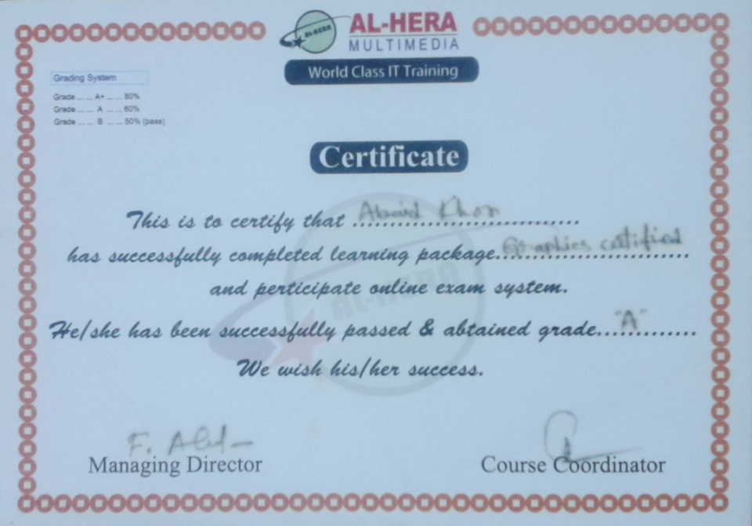

**Upwork Tests**

**upwork Profile:** [**Abid Khan**](https://www.odesk.com/o/profiles/users/_~01612184ca6e39b462/)

https://www.upwork.com/freelancers/~01612184ca6e39b462

**Php Tutorials Made By me:** <https://www.youtube.com/watch?v=b8hmd62t4T0&list=PLReJI-lpLsP-Mefhon49xtfvexCP1enFI>

**Upwork Client FeedBack**

