Advanced Database Management
Phase 01
Group 39
Members:
Taiba Ali BSCS24116
Abeeha BSCS24010

ERD and normalization
ERD(1NF):
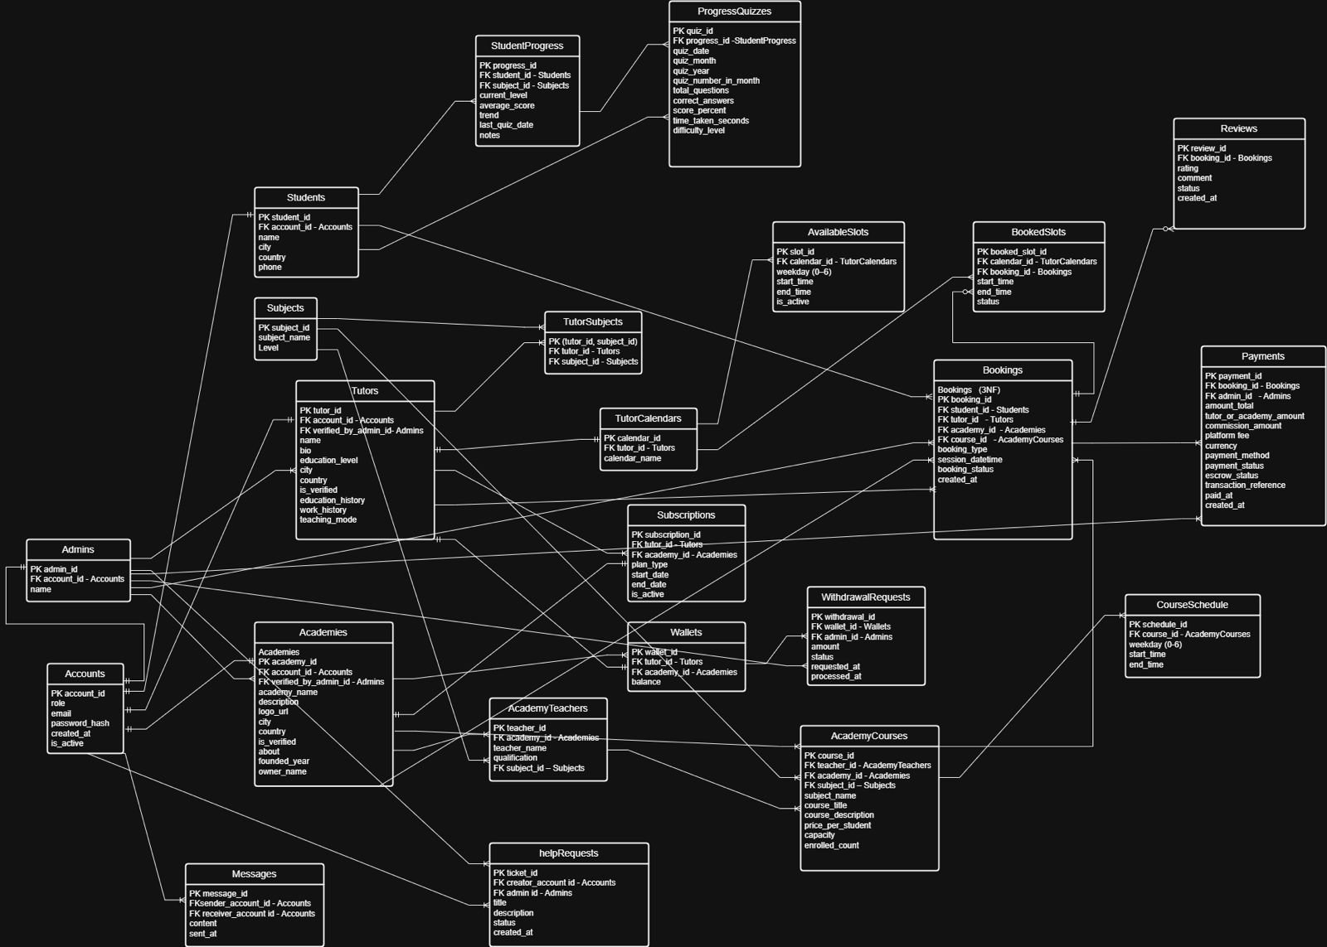
Justification for 1NF:
In our 1NF design, all tables were structured with primary keys and each attribute stored atomic values without repeating groups or multi-valued fields. Many-to-many relationships, such as between Tutors and Subjects, were resolved using a bridge table (Tutor Subjects). Scheduling was structured through Tutor Calendars, which further separated availability and bookings into Available Slots and Booked Slots tables to avoid repeating time-slot data. Profile-related information for Tutors and Academies was stored in clearly defined attributes, including education_history and work_history, while administrative verification was handled through foreign key references.Although the design satisfied 1NF requirements, some redundancy and indirect dependencies still existed. For that we did normalization till third normal form.
Normalization:
To achieve 3NF, we eliminated transitive dependencies and reduced redundancy while preserving the logical flow of the system. In AcademyTeachers, subject_name created a transitive dependency and was replaced with subject_id as a foreign key referencing the Subjects table. Similarly, in AcademyCourses, subject_name was removed and replaced with subject_id to prevent redundancy. Additionally, city and country were removed from AcademyCourses because location depends on academy_id, meaning it belongs to the Academies entity rather than individual courses. In Bookings, payment-related attributes (such as tutor_or_academy_amount, commission_amount, escrow_status, and transaction details) represented a separate entity. These were moved into a dedicated Payments table linked through booking_id. Furthermore, the scheduling structure was clearly separated into TutorCalendars, AvailableSlots, and BookedSlots, ensuring that time-slot data is not redundantly stored within bookings. In the Reviews table, redundant foreign keys student_id and tutor_id were removed because they can be derived from the related booking. Now each review depends solely on booking_id, removing transitive dependencies. For the progress tracking feature, quiz attempts are stored in ProgressQuizzes with a foreign key to StudentProgress. StudentProgress links each student to a subject, so ProgressQuizzes no longer duplicates student_id or subject_id, keeping it in 3NF.
ERD (3NF):
