METHODOLOGICAL RATIONALE: DERIVING THE 902 BUILT-MONUMENT DATASET
A 4-Stage Screening Protocol Filtering 972 Candidate UNESCO Cultural World Heritage Sites into the 902 Built Heritage Target Universe
Initial Candidate Pool | Excluded Sites | Target Built Universe | Derivation Ratio
972 Cultural Sites | 70 Sites (4 Stages) | 902 Built Monuments | 92.8% Inclusion Rate

1. Executive Rationale & Selection Baseline
A foundational requirement of any rigorous heritage data science project is establishing a well-defined target universe. When constructing a global geological database of heritage stones, assessing built monuments requires isolating sites that contain physical architecture, masonry, rock-cut excavations, or structural earth/stone materials from sites inscribed purely for natural ecosystems, agricultural practices, or intangible social memories.
SELECTION PROTOCOL EXECUTIVE SUMMARY
Out of 972 candidate UNESCO Cultural World Heritage Sites inscribed under Criteria (i) through (vi), exactly 902 sites (92.8%) contain constructed physical architecture, rock-cut excavations, or structural masonry materials. The remaining 70 sites (7.2%) were systematically excluded through a 4-stage screening protocol because their Outstanding Universal Value (OUV) is derived entirely from non-structural agricultural landscapes, pure timber frame architecture lacking stone foundations, submerged marine archaeological sediments, or intangible living traditions.

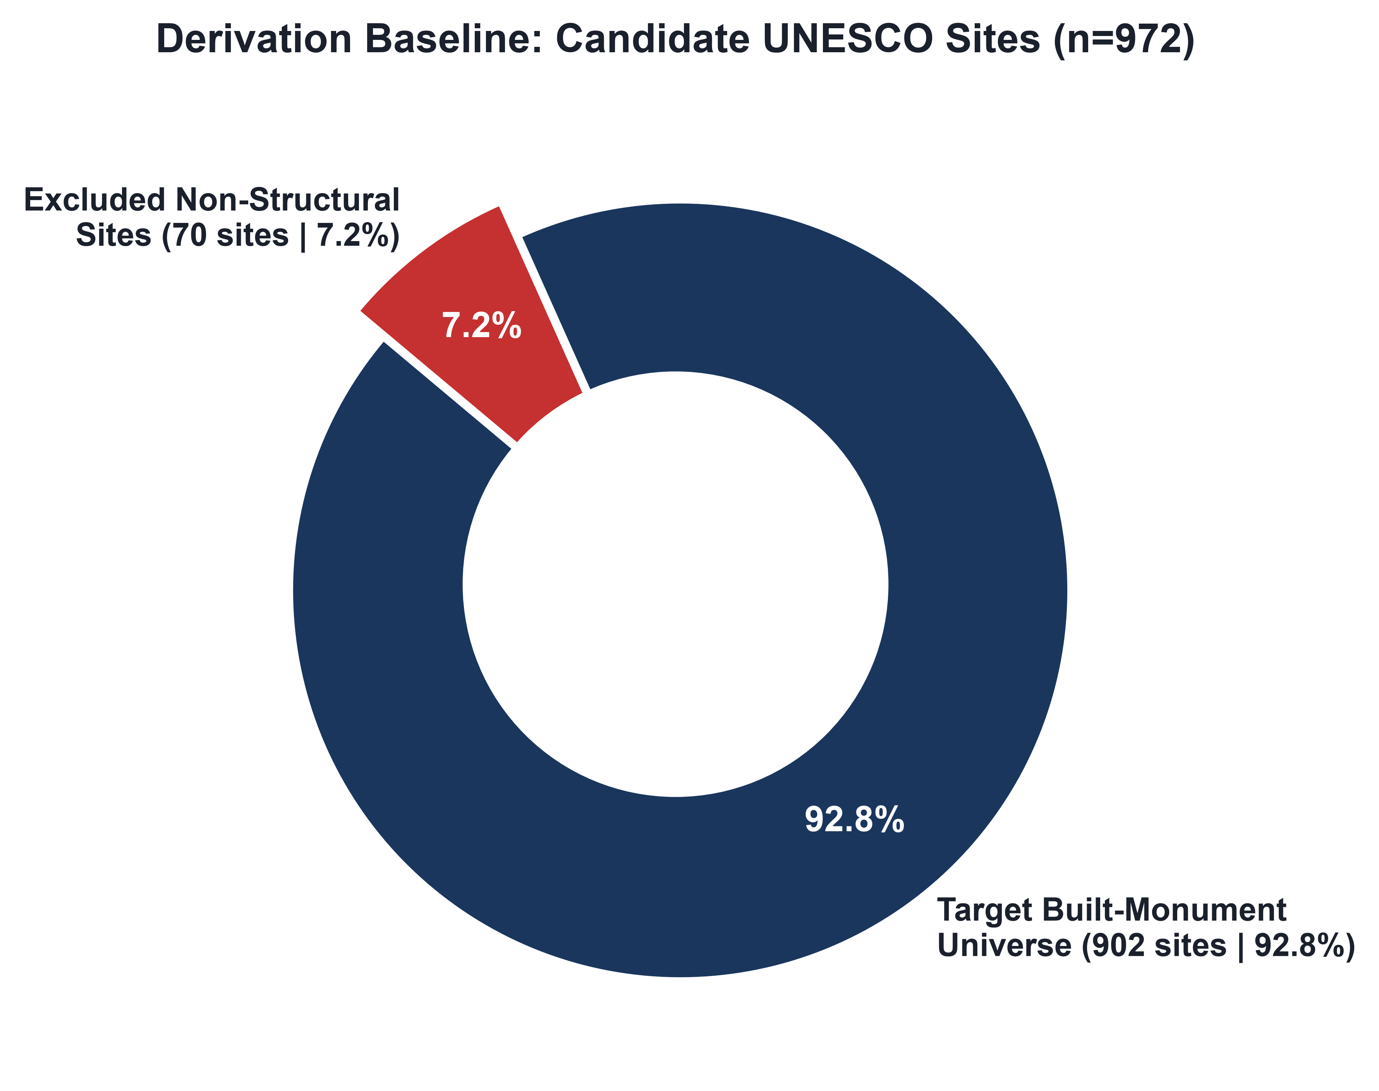
Figure 1: Ratio of Target Built-Monument Universe (n=902) to Excluded Non-Structural Sites (n=70).
2. The 4-Stage Screening Pipeline
To ensure scientific reproducibility, candidate sites underwent sequential filtering across four operational stages:
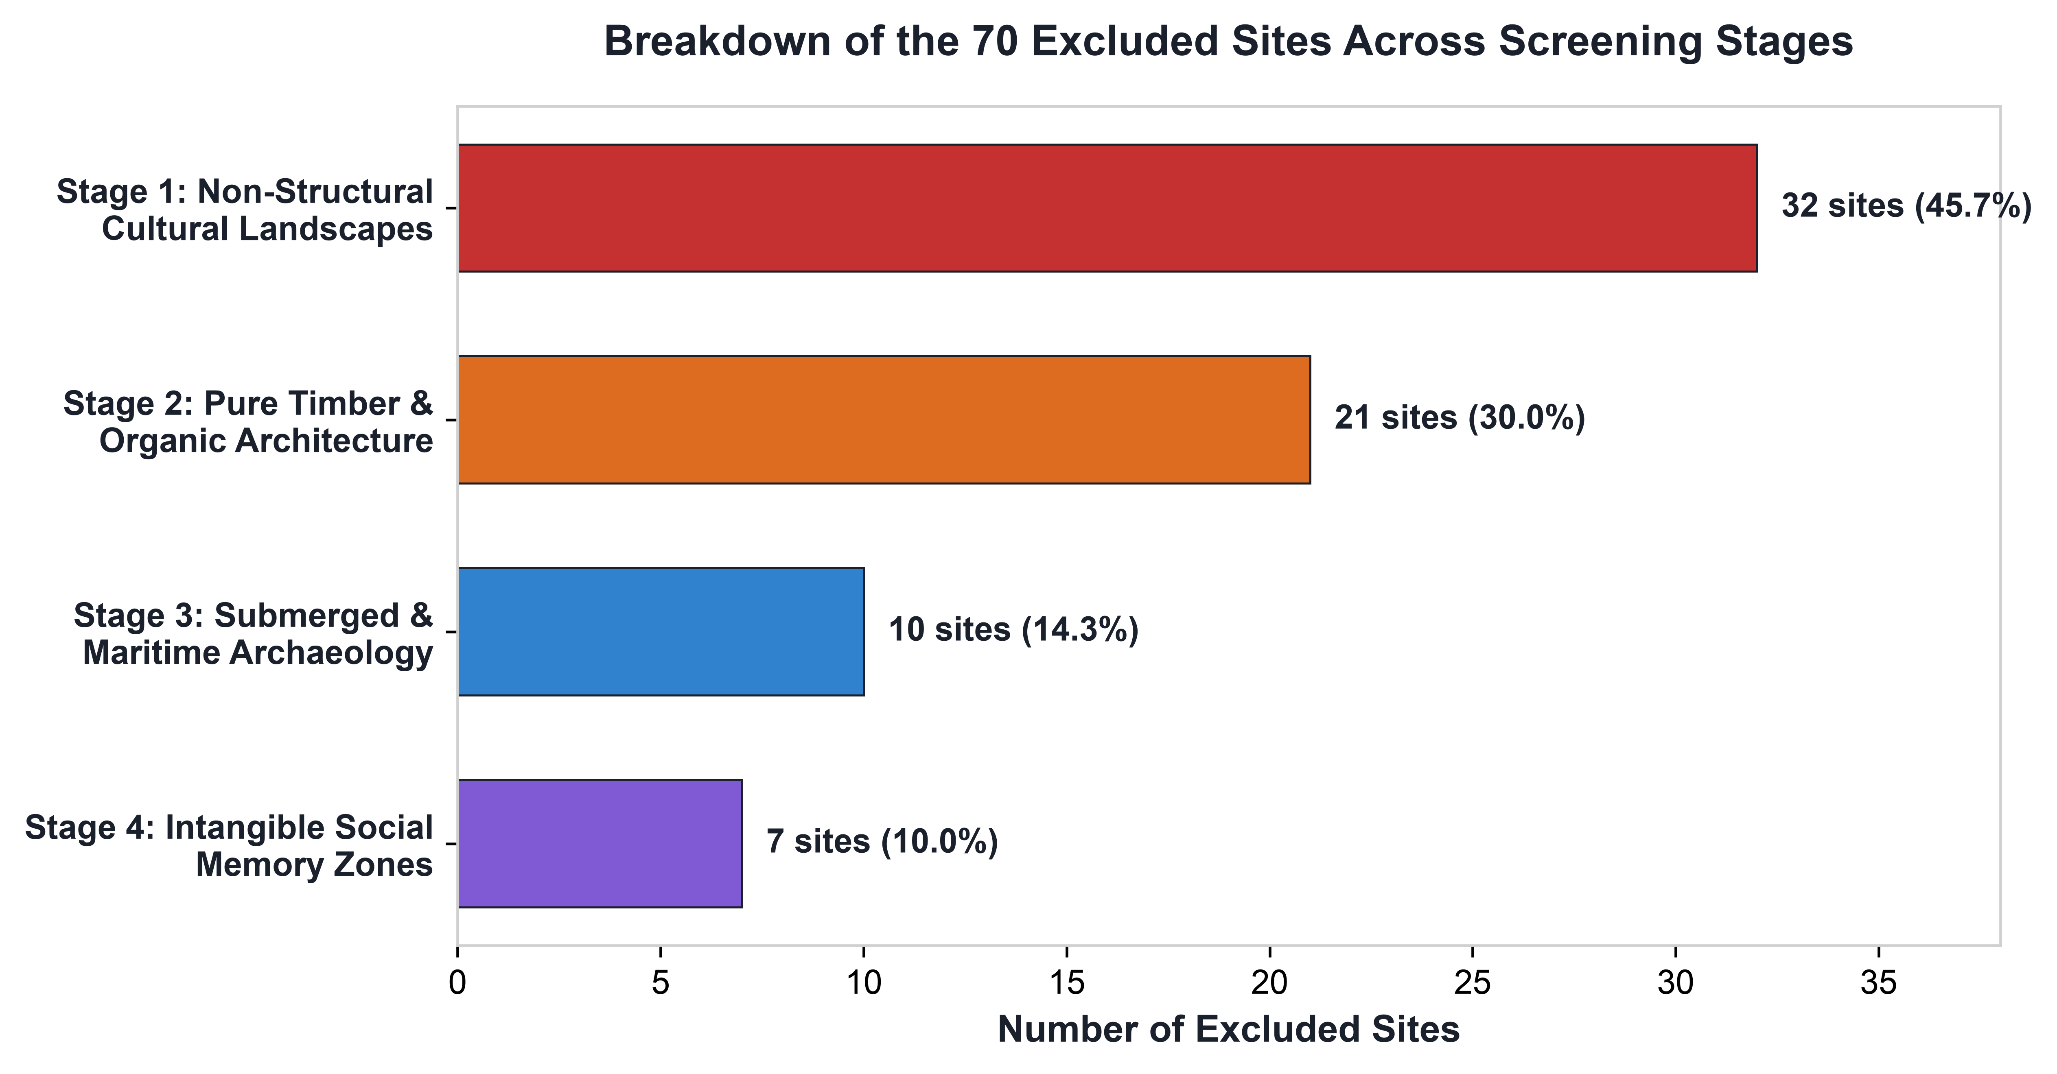
Figure 2: Distribution of the 70 excluded sites across the four screening stages.
Screening Stage | Exclusion Category | Sites Excluded | % of Exclusions
Stage 1 | Non-Structural Cultural Landscapes | 32 Sites | 45.7%
Stage 2 | Pure Timber & Organic Architecture | 21 Sites | 30.0%
Stage 3 | Submerged & Maritime Archaeology | 10 Sites | 14.3%
Stage 4 | Intangible Social Memory Zones | 7 Sites | 10.0%

3. Stage 1: Non-Structural Cultural Landscapes (32 Sites)
Stage 1 evaluates agricultural landscapes, vineyard terraces, agro-ecological coffee farming domains, and sacred mountain groves. While these sites represent outstanding human adaptation to natural environments, their primary Outstanding Universal Value (OUV) is derived from living land management, crop cultivation, or natural aesthetics rather than permanent stone masonry architecture.
Representative exclusions in Stage 1 include the Rice Terraces of the Philippine Cordilleras (un-walled earthen agricultural paddies), the Coffee Cultural Landscape of Colombia (agro-forestry crop land), the Lavaux Vineyard Terraces in Switzerland (soil-retaining agricultural slopes), and the Agave Landscape of Tequila in Mexico.
4. Stage 2: Pure Timber & Organic Architecture (21 Sites)
Stage 2 filters out monuments built entirely of timber framing, horizontal log carpentry, reed thatch, or bark without structural stone foundations, ashlar cladding, or rock-cut elements.
Notable exclusions in Stage 2 include Urnes Stave Church in Norway (constructed completely of timber framing and wood shingles), Kizhi Pogost in Russia (log-built multi-domed timber churches assembled without nails or stone foundations), the Wooden Churches of Maramureş in Romania, the Churches of Chiloé in Chile, and the Kasubi Tombs of Buganda Kings in Uganda (constructed of circular timber poles, reed, and thatch).
5. Stage 3: Submerged & Maritime Archaeology (10 Sites)
Stage 3 excludes submerged prehistoric pile dwellings, sunken ancient harbor installations, and underwater shipwreck reserves located beneath current sea or lake levels. These sites are governed by marine archaeology protocols and underwater conservation science, where terrestrial stone quarrying, masonry decay, and atmospheric weathering analysis do not apply.
Key exclusions include the Prehistoric Pile Dwellings around the Alps (submerged wooden stilt settlements in lakebed sediments across 6 countries), the Port Royal Submerged City in Jamaica, the Submerged Royal Quarter of Alexandria in Egypt, and Baiae Submerged Roman Park in Italy.
6. Stage 4: Intangible Social Memory Zones (7 Sites)
Stage 4 filters out sites inscribed primarily under UNESCO Criterion (vi) for universal symbolic memory, human rights, or historical events rather than discrete physical stone architecture.
Examples include Robben Island in South Africa (inscribed for the memory of the anti-apartheid struggle), Bikini Atoll Nuclear Test Site in the Marshall Islands (commemorative Cold War landscape), Hiroshima Peace Memorial Genbaku Dome in Japan (universal symbol of peace and nuclear destruction), Auschwitz Birkenau Concentration Camp in Poland, and the Island of Gorée in Senegal.
7. Formal Materials & Methods Text for Publication
For academic manuscripts, thesis chapters, or journal submissions, the following standardized text provides the formal methodological justification:
MANUSCRIPT TEXT (READY FOR PUBLICATION)
The dataset selection protocol evaluated 972 candidate Cultural World Heritage Sites inscribed under UNESCO Criteria (i) through (vi). To ensure petrographic and structural relevance, a 4-stage screening protocol filtered out 70 sites whose primary heritage significance does not involve constructed geological materials. Specifically, we excluded: (a) non-structural agricultural landscapes lacking stone masonry terraces (n=32), (b) pure timber or organic structures built without stone or brick foundations (n=21), (c) submerged prehistoric pile dwellings and maritime archaeological zones (n=10), and (d) commemorative living zones lacking discrete structural monuments (n=7). The resulting 902 sites constitute the definitive global universe of UNESCO-inscribed built monuments, rock-cut excavations, and structural masonry heritage.

