# Game Design & Development Final Project

Group Partners: Abeeq Jafar (164253), Saad Tayyab (164083)

## Experiment:

Practical 14.1 Proving V=IR Ohms Law, Chapter 14, 9th & 10th Physics practical book.

## Background:

Ohms Law: Ohm's law states that the current through a conductor between two points is directly proportional to the voltage across the two points. Introducing the constant of proportionality, the resistance, one arrives at the usual mathematical equation that describes this relationship:

I= V/R, where I is the current through the conductor in units of amperes, V is the voltage measured across the conductor in units of volts, and R is the resistance of the conductor in units of ohms.

Material Required:

* Nichrome wire (>10ohm)
* Voltmeter (0 – 15V)
* Ammeter (0 – 0.6A)
* Rheostat (50 ohm)
* Power supply (0 -12V, 1A)
* Switch

Circuit connecting these components:

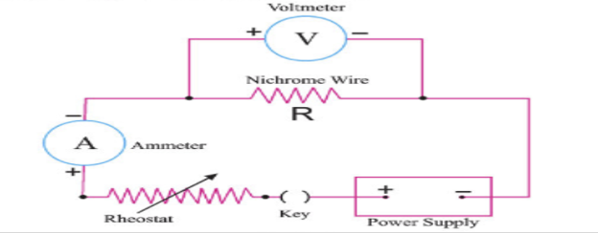

## Practical:

We made the assets for ammeter & voltmeter in 3DS Max and used standard unity 3D objects to complete the circuit. Battery & resistance modes were taken from the asset store.

We setup the circuit on the table because it was difficult for the user to manually set up the circuit and connect everything. We made a top view camera that renders their view of the table from the top that is useful for easy access to the circuit and provides the same view of the circuit as in the experiment.

There is an input field on the battery that allows the user to manually enter the battery voltages. Once the user has entered the battery voltage, he can press enter to activate the circuit and the readings on the voltmeter an ammeter will update according to the value enter by the user. The user can then use the arrow keys to move the rheostat left and right to control the flow of the current this will change the readings on the voltmeter & ammeter no match those of the rheostat.

The user can note down these readings and then plot a graph with V on the X axis and I on the Y axis. This plotted line should be a straight line indicating the directly proportional voltage and current.

## After experiment questions:

We have added these questions for learning outcomes

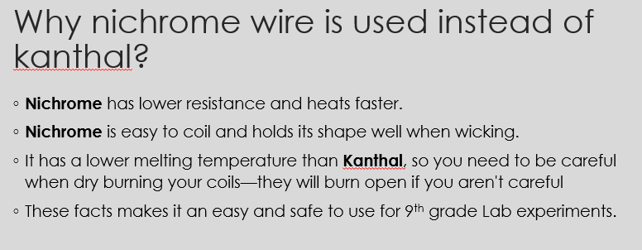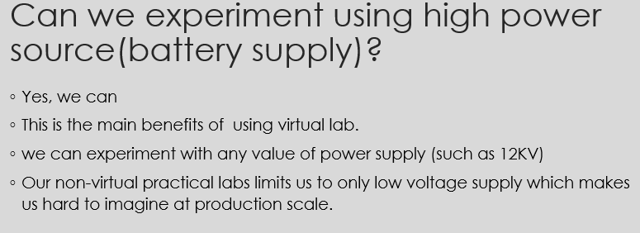

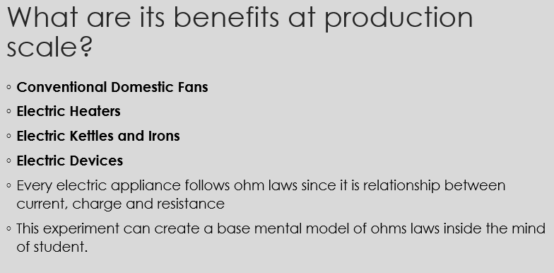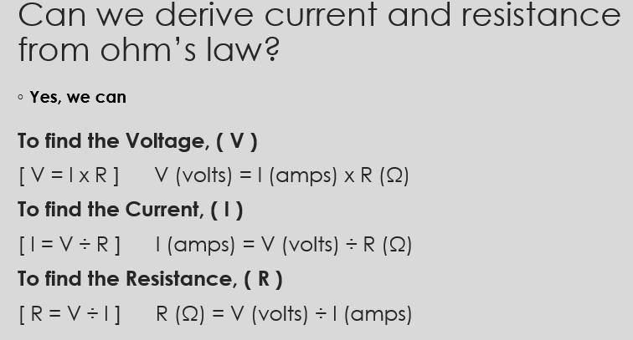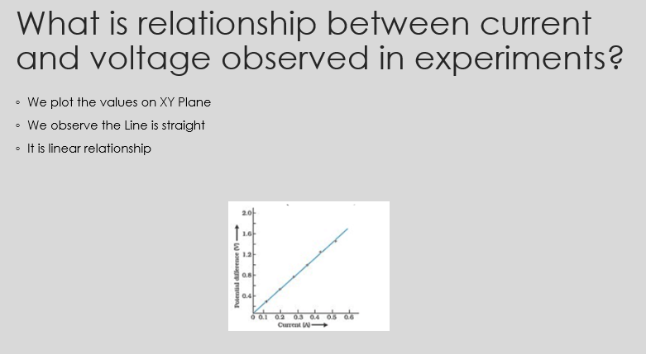

## Not able to do:

We were not able to find or make an accurate model of rheostat ourselves so we made a very basic model using the standard unity 3D assets.

We did not use the toolbar from the experiment because we thought it would be easier for the user if we set up the experiment on the table ourselves because there were too many wires and connections in the experiment.

Initially we planned to do another scene in the experiment in which the user will also be able to plot the graph by the values that he finds indeed experiment but we could not complete that part in time.

## Abeeq’s contribution:

I did most of the scripting and the working of the experiment, camera views, rheostat functionality etc.

## Saad’s contribution:

Arranged and made most assets used in the experiment, scene setup, post experiment questions, practical study etc.