Business Data Analysis and Reporting Project
Retail Sales Performance Analysis

Executive Summary
This report demonstrates a professional business analysis workflow using a simulated retail sales dataset. After removing the duplicate order and filling missing categorical values, the analysis covers 360 unique orders, with total revenue of 104,458.38, total profit of 53,730.38, and an overall profit margin of 51.4%. The average order value is 290.16. The results help illustrate how managers can use KPIs, category comparisons, regional performance, channel analysis, and monthly trends to support business decisions. The dataset is simulated for training and does not represent a real company.

1. Business Objective and Questions
The business objective is to understand sales performance and identify areas that may need management attention. The analysis addresses five questions: How much revenue and profit were generated? Which product categories contribute most? Which regions perform strongly? Which sales channel contributes the most revenue? How does revenue change month by month?

2. Dataset and Preparation
The project uses a simulated retail dataset containing order ID, order date, region, sales channel, product category, product, units sold, unit price, revenue, cost, and profit. The raw file contains a small number of intentional data quality issues for practice, including missing region and channel values and a duplicate order. Exact duplicate order IDs were removed. Missing categorical values were filled using the most frequent category. Dates were converted to a date format and a month field was created for trend analysis.

3. Key Performance Indicators
- Total revenue: 104,458.38
- Total profit: 53,730.38
- Unique orders: 360
- Units sold: 2,293
- Average order value: 290.16
- Overall profit margin: 51.4%

4. Category and Regional Findings
The highest revenue category in this simulated sample is Clothing, while the highest revenue region is North. Category and region rankings help decision makers identify where demand is concentrated. Revenue should be reviewed alongside profit, costs, and stock availability before making investment decisions.
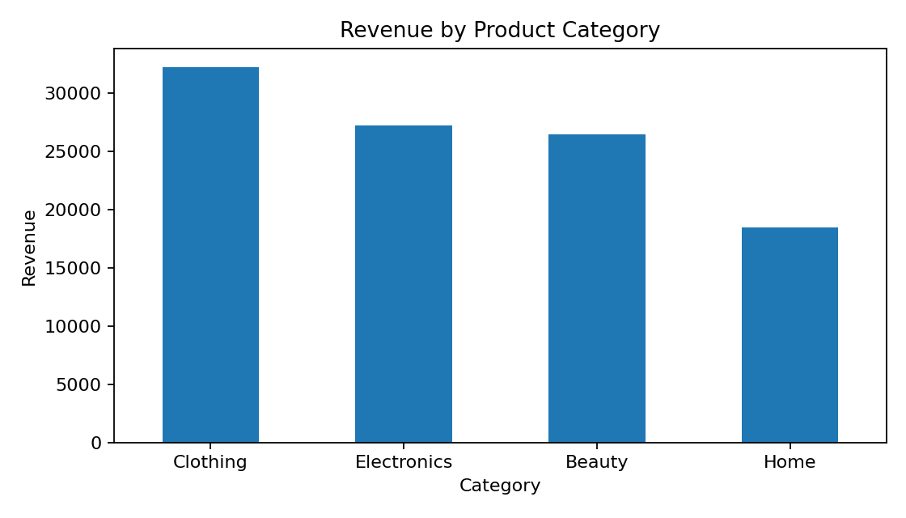
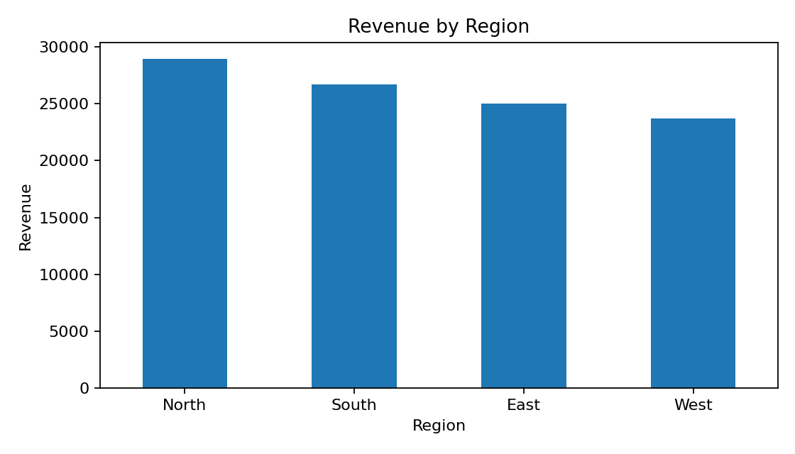

5. Channel and Monthly Performance
The channel with the highest revenue is Online. Monthly revenue analysis helps identify stronger and weaker periods, which can support inventory planning, staffing, and promotional calendars.
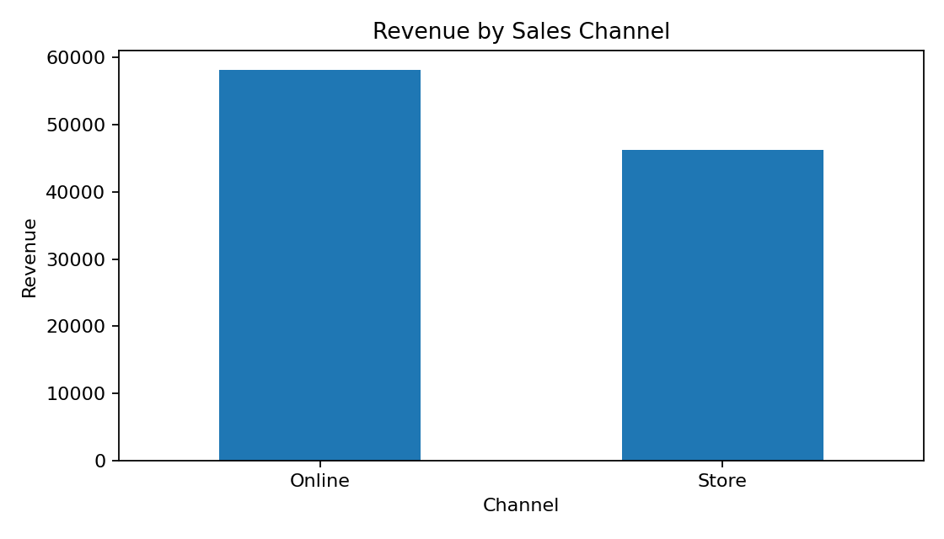
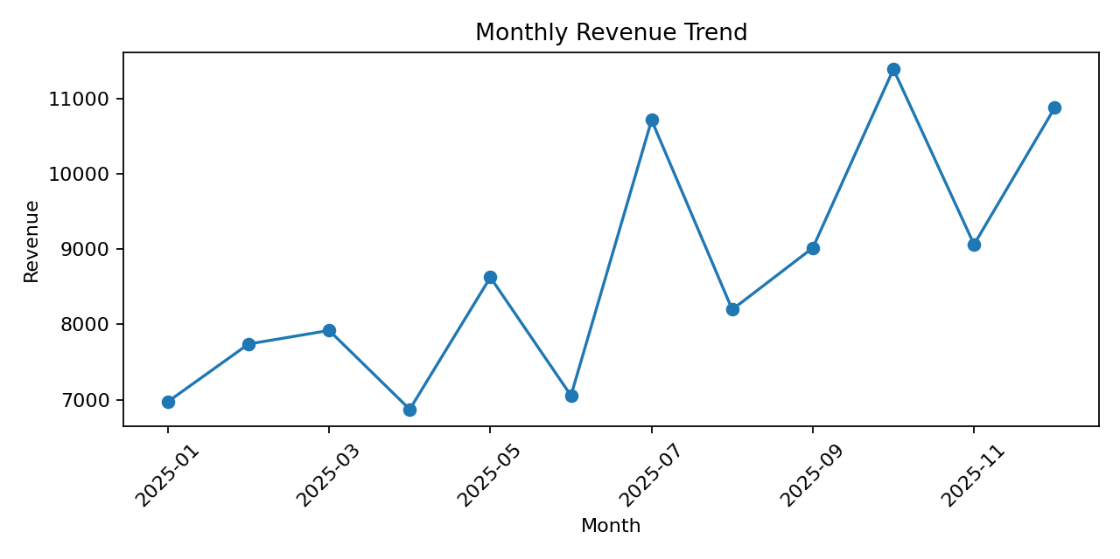

6. Business Insights
The KPI summary provides a concise view of overall performance. Category and regional comparisons identify where sales are concentrated. The channel comparison shows how customers are purchasing, while the monthly trend gives context about timing. Because the dataset is simulated, these observations demonstrate how to interpret business reports rather than describe actual market performance.

7. Actionable Recommendations
- Review inventory levels for the highest revenue categories while monitoring their profit margins.
- Investigate lower performing regions by comparing local product mix, order volume, and channel availability.
- Evaluate sales channels using both revenue and profit so that marketing decisions are not based on sales alone.
- Use monthly revenue trends to plan promotions, staffing, and inventory ahead of stronger periods.
- Introduce routine data quality checks for duplicate order IDs, missing values, and inconsistent formats.
- Refresh the KPI dashboard regularly and compare results with business targets once real company data is available.

8. Conclusion
This project demonstrates how data analysis can support business reporting and decision making. It defines a business objective, prepares data, calculates key performance indicators, identifies patterns, creates visualizations, and translates findings into actionable recommendations. The notebook and dataset are included so the analysis can be reproduced and extended. For real business use, the simulated dataset should be replaced with approved company data and the findings should be checked against business context.

