## FINAL PROJECT DOCUMENTATION

**Dressify**



### Submitted By

|  |  |
| --- | --- |
| Abeera Noor | 22-Arid-4405 |
| Bismah Arshad | 22-Arid-4410 |
| Eman Mustafa | | 22-Arid-4413 |
|  |  |

**Supervisor**

#### Mr. Bilal Arshad

#### Lecturer

**2025**

**Gujrat Institute of Management Sciences**

**PMAS-Arid Agriculture University, Rawalpindi**

**‘‘**

Project submitted to Department of Computer Science

Gujrat Institute of Management Sciences

### By

|  |  |
| --- | --- |
| Abeera Noor | 22-Arid-4405 |
| Bismah Arshad | 22-Arid-4410 |
| Eman Mustafa | 22-Arid-4413 |

#### In partial fulfillment of the requirements for the degree of (BSSE)

**Gujrat Institute of Management Sciences**

**PMAS-Arid Agriculture University, Rawalpindi**

## Members’ Detail

|  |  |
| --- | --- |
| **Project ID** | GIMS-BSSE-202015 |

|  |  |  |  |
| --- | --- | --- | --- |
| Dressify | | | |
| **Group Leader:** Bismah Arshad  **Group Members:**3 | | | |
| Name | Registration # | Email Address | Class |
| Abeera Noor | 22-Arid-4405 | Abeeranoor2202@mail.com | BSSE |
| Bismah Arshad | 22-Arid-4410 | Abismah@gmail.com | BSSE |
| Eman Mustafa | 22-Arid-4413 | Manomugal2807@gmail.com | BSSE |

##### Mr. Awais Illyas

PMO, GIMS

**Dated:**

## Dedication

### To our Fathers,

“To My Guiding Light, My Source of Strength -My Beloved Father”

### To our Mothers,

“To the One Whose Unwavering Support And Kindness guided Me Through Life’s Melodies. Thank You Being My Rock, Mom”

### To our Loved Ones,

“For Their Understanding, Tenderness For Keeping Us Motivated To Our Dreams”

### To our Teacher,

“To Sir Bilal Arshad, Who Kindled Wisdom's Flame Within Us, Guiding My Path With Unwavering Grace and Insight, I Dedicate My Deepest Gratitude and Eternal Appreciation”

~Abeera Noor, Eman Mustafa, Bismah Arshad ~

## Project Summary

|  |  |
| --- | --- |
| **Project Title** | Dressify |
| **Project ID** | GIMS-BSSE-F202025 |
| **Organization** | Gujrat Institute of Management Sciences |
| **Objective** | Write the objectives of project here   * Supervisor and Students can track the progress of their projects. * PMO can generate reports of entire groups i.e., to check the progress of entire group. * Meeting time will be managed easy for student and supervisor. * Supervisor can generate the report of the entire group ad check the progress. * PMO can generate reports of entire groups i.e., to check the progress of the entire group. |
| **Undertaken By** | Abeera Noor 22-Arid-4405, Bismah Arshad 22-Arid-4410 and Eman Mustafa 22-Arid-4413 |
| **Supervised By** | Mr. Bilal Arshad |
| **Date started** | May 10 ,2025 |
| **Date Completed** | June 22, 2025 |
| **Technologies Used** | Android Studio, Java, XML, Firebase |
| **System Used** | Window 10 |

**Proofreading Certificate**

##### This is to acknowledge that the project entitled

**Dressify [**GIMS-BSSE-F202025**]**

**has been proofread By**

**Mr. Bilal Arshad**

#### Lecturer, Computer Science/GIMS

**Dated:**

## Declaration

We hereby declare that we developed this project and this report entirely on the basis of our personal efforts made under the sincere guidance of our project supervisor. We further declare that, the titled project and all associated documents, reports are submitted as partial requirements for the degree of “BS (Hons.) in Computer Sciences’’

|  |  |  |
| --- | --- | --- |
| **Members’ Name** | **Registration #** | **Signature** |
| Abeera Noor | 22-Arid-4405 |  |
| Bismah Arshad | 22-Arid-4410 |  |
| Eman Mustafa | 22-Arid-4413 |  |

**Dated:**

## Acknowledgement

"In the name of guidance and unwavering support, I extend my heartfelt gratitude to the esteemed mentor, Mr. Bilal Arshad, whose wisdom and encouragement steered this final project's completion. Dr. Amir Nabi Rana, the Director, deserves my sincere thanks for invaluable guidance. I am truly appreciative of the collective inspiration and unwavering encouragement received from the revered teachers of the Computer Science Department throughout this enriching journey."

## Certificate

This is to certify that Abeera Noor 22-Arid-4405, Bismah Arshad 22-arid-4410 and Eman Mustafa 22-Arid-4413 have successfully completed the final project titled: “E-Commerce System”, accepted by the Department of Computer Science and find satisfactory for the requirement of:

**Gujrat Institute of Management Sciences PMAS-Arid Agriculture University Rawalpindi**

**For Award of the Degree**

**BSSE**

|  |  |
| --- | --- |
| Supervisor  Mr. Bilal Arshad  Lecturer, GIMS | |
| Examiner 1 Sir Awais | |
| Examiner 2 Sir Sami-ullah | |
| Examiner 3 Sir Ashar | |
| HOD/CS-IT GIMS | Director General  GIMS |

**Dated:**

## Abstract

Smartphones have revolutionized the e-commerce industry, enabling consumers to shop conveniently through intuitive mobile applications. This project details the design and development of an Android-based e-commerce platform, crafted to deliver a comprehensive and user-centric online shopping experience. Developed using Java in Android Studio and integrated with Firebase for robust backend functionality, the application supports key features such as user authentication, product browsing, shopping cart management, secure checkout, and order tracking. Firebase’s real-time database, authentication services, and cloud storage ensure seamless data synchronization and scalability, while Android’s versatile ecosystem guarantees compatibility across a wide range of devices. The development process adheres to a systematic software engineering methodology, encompassing requirements specification, system architecture design, implementation, and rigorous testing to ensure functionality, performance, and usability. This project not only demonstrates technical proficiency in mobile application development and backend integration but also lays the groundwork for future enhancements, such as advanced product search algorithms, personalized recommendations, and integration of secure payment gateways. By addressing the growing demand for efficient and accessible e-commerce solutions, this application contributes to the evolving digital marketplace, offering a scalable and user-friendly platform for modern retail needs.

## Table of Contents

Dedication iii

Project Summary iv

Declaration vi

Acknowledgement vii

Abstract ix

Table of Contents x

List of Tables xvii

List of Figures xx

List of Abbreviations xxiii

Chapter 1 Introduction 2

* 1. Problem Statement 3
  2. Significance 3
  3. Objectives 4
  4. Limitations and Restrictions 4
  5. Overview 5
  6. System Architecture 7
  7. Software/Hardware Requirements 7
  8. Implementation Tools and Technology 7
  9. Implementation Plan 8
     1. Deliverable Items 8
     2. Milestone Chart 8

Chapter 2 Requirement Analysis 10

* 1. Functional Requirements 10
     1. For User 10
     2. For Admin 12
  2. Non-Functional Requirement 15
  3. Use Cases 16
     1. Login Use Case 16
     2. All Groups for PMO Use Case 17
     3. Add supervisor again for PMO Use Case 18
     4. View Groups for PMO Use Case 19
     5. PMO Update Group Use Case 20
     6. View Forms Use Case 21
     7. Share File Use Case 22
     8. Delete Shared File Use Case 23
     9. PMO Create Group Login Use Case 24
     10. Add Student Use Case 25
     11. Add Student by uploading Excel sheet Use Case 26
     12. PMO View All Students Use Case 27
     13. Add New PMO Use Case 28
     14. Update PMO Use Case 29
     15. Delete PMO Use Case 30
     16. Update Student Details Use Case 31
     17. Delete Student Use Case 32
     18. Update Group Login Use Case 33
     19. Delete Group Login Use Case 34
     20. Add Supervisor Use Case 35
     21. View All Supervisor Use Case 36
     22. PMO Update Supervisor Details Use Case 37
     23. PMO Delete Supervisor Use Case 38
     24. Delete Message Form Chat Box For PMO 39
     25. Logout Use Case 40
     26. Student Proposal Form Use Case 41
     27. Student Project Status Use Case 42
     28. View Meeting Time Slots Use Case 43
     29. Select Group Members Use Case 44
     30. Group Proposal Forms Use Case 45
     31. View Progress Of Groups Use Case 46
     32. View Group Details Use Case 47
     33. View Share File Use Case 48
     34. PMO View Group Members Use Case 49
     35. PMO Delete Group Use Case 50
     36. Set Meeting Time Use Case 51
     37. View Announcement Use Case 52
     38. PMO Create Session Use Case 53
     39. PMO View All Session Use Case 54
     40. PMO Delete Session Use Case 55
     41. PMO View All Group Logins Use Case 56
     42. PMO Group Proposal Use Case 57
     43. Forget Password for PMO Use Case 58
     44. PMO D-Activate Group Login Use Case 59
     45. Admin D-Activate New Group Login Use Case 60
     46. View Students that are not in Group Use Case 61
     47. Delete Student that not in Group use case 62
     48. Update Student Details that are not in Group Use Case 63

Chapter 3 DESIGN 65

* 1. UML Diagrams 65
  2. Use-Case Diagram 65
     1. Supervisor 65
     2. Student 66
     3. PMO 67
     4. Complete System 68
  3. Class Diagram 69
  4. Sequence Diagram 70
     1. Login for PMO, Supervisor, Groups 70
     2. Add group logins 71
     3. All group details 72
     4. Add PMO 73
     5. Add Student 74
     6. Add supervisor 75
     7. PMO Session 76
     8. Share file 77
     9. Preliminary Proposal form 78
     10. Check status 79
     11. Select Group Member 80
     12. Meting Time table 81
     13. View Meeting Timetable 82
     14. Send Message in Chat Box 83
     15. View chat 84
     16. Upload Marks 85
     17. View marks 86
  5. ERD 87

Chapter 4 Testing 89

* 1. Login Test Case 89
  2. View All Group Test Case 90
  3. View Chat Box Test Case 91
  4. Log-out Test Case 92
  5. Forget Password for PMO Test Case 93
  6. PMO Add Group Login Test Case 94
  7. PMO Add Student Test Case 95
  8. PMO Add Student by Excel Test Case 96
  9. PMO View All Student Test Case 97
  10. PMO Update Student in All Student Test Case 98
  11. PMO View Student that are not in Group Test Case 99
  12. PMO Update Student that are not in Group Test Case 100
  13. PMO View All Group Login Test Case 101
  14. PMO Delete Group Login Test Case 102
  15. PMO Update Group Login Test Case 103
  16. PMO D-Activate Group Login Test Case 104
  17. PMO View All Group Test Case 105
  18. PMO Update Proposal Form Test Case 106
  19. PMO Delete Group Test Case 107
  20. PMO Download Form Test Case 108
  21. PMO Check the Submitted Items Test Case 109
  22. Update Student Record Test Case 110
  23. PMO Delete Student Test Case 111
  24. PMO Share Files Test Case 112
  25. PMO View All Files Test Case 113
  26. PMO Delete File Test Case 114
  27. PMO Add New Admin Test Case 115
  28. Admin Delete PMO Test Case 116
  29. PMO D-Activate PMO Login Test Case 117
  30. PMO Update PMO Test Case 118
  31. PMO Add Supervisor Test Case 119
  32. PMO Create Session Test Case 120
  33. Admin Delete Session Test Case 121
  34. PMO View All Supervisors Test Case 122
  35. PMO Update Supervisor Test Case 123
  36. PMO D-Activate Supervisor Test Case 124
  37. PMO Send Massage test Case 125
  38. PMO Delete Send Message Test Case 126
  39. Student Select Group Member Test Case 127
  40. Student View Members Test Case 128
  41. Student Submit Preliminary Proposal Test Case 129
  42. Student Check Project status Test Case 130
  43. View Meeting Timeslots for Student Test Case 131
  44. Student Share Files Test Case 132
  45. Student View All Files Test Case 133
  46. Supervisor View Group Proposal Forms Test Case 134
  47. Supervisor of Groups Test Case 135
  48. Supervisor Share Files Test Case 136
  49. Supervisor View All Files Test Case 137
  50. Supervisor Set Meeting Time Test Case 138

Chapter 5 User Manual 140

* 1. PMO Login 140
  2. Dashboard 140
  3. Add group login 141
  4. Add Student 141
  5. Add Student by Excel Sheet 142
  6. View All Student 142
  7. Update Student 143
  8. Delete Student 143
  9. All Group Login 144
  10. Update Group Login 144
  11. Delete Group Login 145
  12. View all group 145
  13. Delete Group Member 146
  14. Update Proposal 146
  15. Download Form 147
  16. Submitted items 147
  17. Add Supervisor 148
  18. View all Supervisor 148
  19. Update Supervisor 149
  20. D-Activate supervisor 149
  21. Delete Supervisor 150
  22. PMO Share File 150
  23. View Share File 151
  24. Delete file 151
  25. Create Session 152
  26. Delete Session 152
  27. Add new PMO 153
  28. View All PMO 153
  29. Update PMO 154
  30. D-Activate PMO 154
  31. Delete PMO 155
  32. Supervisor Login 155
  33. View Proposal Forms 156
  34. Accept or Reject Proposal form 156
  35. Supervisor of Groups 157
  36. Assign Weightage 157
  37. Delete Weightage 158
  38. Add Progress 158
  39. View Group Details 159
  40. Download Uploaded Files 159
  41. Delete Group from Supervision 160
  42. Share File 160
  43. View My Share File 161
  44. Delete My Share File 161
  45. View Another Share File 162
  46. Set Meeting Time 162
  47. Student Login 163
  48. Student Dashboard 163
  49. Select Group Members 164
  50. Submitted Proposal Form 164
  51. Check Project Status 165
  52. Check Meeting Slots 165
  53. Chat Box 166
  54. Send Message 166

References 167

## List of Tables

Table 2.1 login use case 16

Table 2.2 All Group for PMO Use Case 17

Table 2.3 Add supervisor again for PMO Use Case 18

Table 2.4 View Groups for PMO Use Case 19

Table 2.5 PMO Update Group Use Case 20

Table 2.6 View Forms Use Case 21

Table 2.7 Share File Use Case 22

Table 2.8 Delete Shared File Use Case 23

Table 2.9 PMO Create Group Login Use Case 24

Table 2.10 Add Student Use Case 25

Table 2.11 Add Student by uploading Excel sheet Use Case 26

Table 2.12 PMO View All Students Use Case 27

Table 2.13 Add new PMO Use Case 28

Table 2.14 Update PMO Use Case 29

Table 2.15 Delete PMO Use Case 30

Table 2.16 Update Student Details Use Case 31

Table 2.17 Delete Student Use Case 32

Table 2.18 Update Group Login Use Case 33

Table 2.19 Delete Group Login Use Case 34

Table 2.20 Add Supervisor Use Case 35

Table 2.21 View All Supervisor Use Case 36

Table 2.22 PMO Update Supervisor Details Use Case 37

Table 2.23 PMO Delete Supervisor Use Case 38

Table 2.24 Delete Message Form Chat Box For PMO 39

Table 2.25 Logout Use Case 40

Table 2.26 Student Proposal Form Use Case 41

Table 2.27 Student Project Status Use Case 42

Table 2.28 View Meeting Time Slots Use Case 43

Table 2.29 Select Group Members Use Case 44

Table 2.30 Group Proposal Forms Use Case 45

Table 2.31 View Progress Of Groups Use Case 46

Table 2.32 View Group Details Use Case 47

Table 2.33 View Share File Use Case 48

Table 2.34 PMO View Group Members 49

Table 2.35 PMO Delete Group Use Case 50

Table 2.36 Set Meeting Time Use Case 51

Table 2.37 View Announcement Use Case 52

Table 2.38 PMO Create Session Use Case 53

Table 2.39 PMO View All Session Use Case 54

Table 2.40 PMO Delete Session Use Case 55

Table 2.41 PMO View All Group Logins Use Case 56

Table 2.42 PMO Group Proposal Use Case 57

Table 2.43 Forget Password for PMO Use Case 58

Table 2.44 PMO D-Activate Group Login Use Case 59

Table 2.45 Admin D-Activate New Group Login Use Case 60

Table 2.46 View Students that are not in Group Use Case 61

Table 2.47 Delete Student that not in Group use case 62

Table 2.48 Update Student Details that are not in Group Use Case 63

Table 4.1 Login Test Case 89

Table 4.2 View All Group Test Case 90

Table 4.3 View Chat Box Test Case 91

Table 4.4 Log-out Test Case 92

Table 4.5 Forget Password for PMO 93

Table 4.6 PMO Add Group Login Test Case 94

Table 4.7 PMO Add Student Test Case 95

Table 4.8 PMO Add Student by Excel Test Case 96

Table 4.9 PMO View All Student Test Case 97

Table 4.10 PMO Update Student in All Student Test Case 98

Table 4.11 PMO View Student that are not in Group Test Case 99

Table 4.12 PMO Update Student that are not in Group Test Case 100

Table 4.13 PMO View All Group Login Test Case 101

Table 4.14 PMO Delete Group Login Test Case 102

Table 4.15 PMO Update Group Login Test Case 103

Table 4.16 PMO D-Activate Group Login Test Case 104

Table 4.17 PMO View All Group Test Case 105

Table 4.18 PMO Update Proposal Form Test Case 106

Table 4.19 PMO Delete Group Test Case 107

Table 4.20 PMO Download Form Test Case 108

Table 4.21 PMO Check the Submitted Items Test Case 109

Table 4.22 Update Student Record Test Case 110

Table 4.23 PMO Delete Student Test Case 111

Table 4.24 PMO Share Files Test Case 112

Table 4.25 PMO View All Files Test Case 113

Table 4.26 PMO Delete File Test Case 114

Table 4.27 PMO Add New Admin Test Case 115

Table 4.28 Admin Delete PMO Test Case 116

Table 4.29 PMO D-Activate PMO Login Test Case 117

Table 4.30 PMO Update PMO Test Case 118

Table 4.31 PMO Add Supervisor Test Case 119

Table 4.32 PMO Create Session Test Case 120

Table 4.33 Admin Delete Session Test Case 121

Table 4.34 PMO View All Supervisors Test Case 122

Table 4.35 PMO Update Supervisor Test Case 123

Table 4.36 PMO D-Activate Supervisor Test Case 124

Table 4.37 Send Massage test Case 125

Table 4.38 Delete Send Message Test Case 126

Table 4.39 Student Select Group Member Test Case 127

Table 4.40 Student View Members Test Case 128

Table 4.41 Student Submit Preliminary Proposal Test Case 129

Table 4.42 Student Check Project status Test Case 130

Table 4.43 Meeting Timeslots For Student Test Case 131

Table 4.44 Student Share Files Test Case 132

Table 4.45 Student View All Files Test Case 133

Table 4.46 Supervisor View Group Proposal Forms Test Case 134

Table 4.47 Supervisor of Groups Test Case 135

Table 4.48 Supervisor Share Files Test Case 136

Table 4.49 Supervisor View All Files Test Case 137

Table 4.50 Supervisor Set Meeting Time Test Case 138

##### List of Figures

Figure 1.1: Model-View-Controller 7

Figure 1.2: Gantt chart for milestones 8

Figure 3.1 Use-Case Diagram for supervisor 65

Figure 3.2 Use-Case Diagram for student 66

Figure 3.3 Use-Case Diagram for PMO 67

Figure 3.4 Use-Case Diagram for complete system 68

Figure 3.5 Class Diagram 69

Figure 3.6 Login for PMO, Supervisor, Students 70

Figure 3.7 Add groups logins 71

Figure 3.8 All groups details 72

Figure 3.9 Add PMO 73

Figure 3.10 Add Student 74

Figure 3.11 Add Supervisor 75

Figure 3.12 PMO Session 76

Figure 3.13 Share File 77

Figure 3.14 Preliminary proposal form 78

Figure 3.15 Check status 79

Figure 3.16 Select Group Members 80

Figure 3.17 Meeting Time Table 81

Figure 3.18 View Meeting Timetable 82

Figure 3.19 Send Message in Chat Box 83

Figure 3.20 View Chat 84

Figure 3.21 Upload Marks 85

Figure 3.22 View Marks 86

Figure 3.23 ERD of PMO 87

Figure 5.1 PMO Login 140

Figure 5.2 PMO Dashboard 140

Figure 5.3 Add Group Login 141

Figure 5.4 Add Student 141

Figure 5.5 Add Student by Excel Sheet 142

Figure 5.6 View All Students 142

Figure 5.7 Update Student 143

Figure 5.8 Delete Student 143

Figure 5.9 All Group Logins 144

Figure 5.10 Update Group Login 144

Figure 5.11 Delete Group Login 145

Figure 5.12 View All Group 145

Figure 5.13 Delete Group Member 146

Figure 5.14 Update Proposal 146

Figure 5.15 Download Form 147

Figure 5.16 Submitted Items 147

Figure 5.17 Add Supervisor 148

Figure 5.18 View All Supervisors 148

Figure 5.19 Update Supervisor 149

Figure 5.20 D-Activate Supervisor 149

Figure 5.21 Delete Supervisor 150

Figure 5.22 PMO Share File 150

Figure 5.23 View File 151

Figure 5.24 Delete File 151

Figure 5.25 Create Session 152

Figure 5.26 Delete Session 152

Figure 5.27 Add New PMO 153

Figure 5.28 View Al PMO 153

Figure 5.29 Update PMO 154

Figure 5.30 D-Activate PMO 154

Figure 5.31 Delete PMO 155

Figure 5.32 Supervisor Login 155

Figure 5.33 View Proposal Forms 156

Figure 5.34 Accept or Reject Proposal Form 156

Figure 5.35 Supervisor of Groups 157

Figure 5.36 Assign Weightage 157

Figure 5.37 Delete Weightage 158

Figure 5.38 Add Progress 158

Figure 5.39 View Group Details 159

Figure 5.40 Download Uploaded Files 159

Figure 5.41 Delete Group from Supervision 160

Figure 5.42 Share File 160

Figure 5.43 View My File Share 161

Figure 5.44 Delete My Share File 161

Figure 5.45 View Another Share File 162

Figure 5.46 Set Meeting Time 162

Figure 5.47 Student Login 163

Figure 5.48 Student Dashboard 163

Figure 5.49 Select Group Members 164

Figure 5.50 Submitted Proposal Form 164

Figure 5.51 Check Project Status 165

Figure 5.52 Check Meeting Slots 165

Figure 5.53 Chat Box 166

Figure 5.54 Send Massage 166

## List of Abbreviations

|  |  |
| --- | --- |
| PMO | Project Management Office |
| PMS | Project Management System |

# Chapter 1 Introduction

## Chapter 1 Introduction

The advent of mobile technology has fundamentally reshaped the retail landscape, with e-commerce applications becoming essential tools for consumers seeking convenience, accessibility, and efficiency in their shopping experiences. As smartphones continue to dominate daily life, the demand for robust, user-friendly mobile applications has surged, prompting developers to create innovative solutions that cater to modern consumer needs. This project focuses on the development of an Android-based e-commerce application, designed to provide a seamless and intuitive platform for online shopping. Built using Java in Android Studio and integrated with Firebase for backend services, the application aims to deliver core functionalities such as user authentication, product browsing, shopping cart management, and secure order processing, aligning with industry standards set by leading platforms like Amazon and eBay.

The motivation for Dressify stems from the growing significance of mobile e-commerce in the global market, where businesses increasingly rely on mobile apps to connect with customers and drive sales. By leveraging Android’s widespread adoption and Firebase’s scalable infrastructure, this application seeks to address the needs of both consumers and developers, offering a practical solution that balances functionality with ease of use. The project draws inspiration from educational resources, such as online tutorials, which provide structured guidance on building e-commerce applications. These resources emphasize the importance of combining front-end design with robust backend integration to create a cohesive user experience, a principle that guides the development process of this application.

This project serves as a capstone for applying software engineering principles, including requirements analysis, system design, implementation, and testing, to create a fully functional mobile application. It demonstrates proficiency in Android development using Java, a versatile and widely adopted programming language, and Firebase, a powerful backend-as-a-service platform that simplifies data management and authentication. The application is designed to be responsive across various Android devices, ensuring accessibility for a diverse user base. Additionally, it incorporates best practices for user interface design and data security, addressing critical aspects of modern app development such as performance, scalability, and user satisfaction.

The scope of this project encompasses the creation of a comprehensive e-commerce platform tailored to the needs of small to medium-sized businesses, with potential for future enhancements like advanced search capabilities, personalized recommendations, and secure payment integration.

### Problem Statement

The surge in Dressify has increased demand for user-friendly, scalable shopping applications, yet small to medium-sized businesses often lack affordable, customizable solutions. Many existing Android e-commerce apps suffer from poor device compatibility, inadequate backend integration, and unintuitive interfaces, limiting their usability and commercial viability. Additionally, available open-source or tutorial-based solutions often lack robust security, scalability, or comprehensive documentation, making them unsuitable for business deployment.

This project aims to address these challenges by developing an Android e-commerce application using Java and Firebase. The application provides essential features like user authentication, product browsing, shopping cart management, and secure checkout, ensuring seamless user experience across devices. By leveraging Firebase’s real-time database and authentication services, it offers a scalable, secure solution tailored for small businesses, with potential for future enhancements like advanced search and personalization.

### Significance

This project, developing an Android e-commerce application using Java and Firebase, is significant for providing small to medium-sized businesses with an affordable, scalable platform to establish a digital presence, enhancing customer engagement through features like product browsing, secure authentication, and order processing. It demonstrates proficiency in Android development and Firebase integration, fostering valuable technical skills while adhering to industry standards for usability and security. By enabling businesses to compete in the digital marketplace and offering potential for future enhancements like personalized recommendations, the project contributes to both economic growth and academic research in mobile app development.

### Objectives

The objectives are:

* **Develop a Functional E-commerce Platform**: Create a user-friendly Android application that enables seamless online shopping, incorporating essential features such as user registration, product browsing, shopping cart management, and secure order processing.
* **Integrate Robust Backend Services**: Leverage Firebase for real-time data management, user authentication, and cloud storage to ensure scalability, security, and efficient handling of user and product data.
* **Ensure Cross-Device Compatibility**: Design the application to be responsive and compatible across a wide range of Android devices, providing consistent and intuitive user experience.
* **Apply Software Engineering Principles**: Implement a structured development process, including requirements analysis, system design, implementation, and testing, to produce a reliable and maintainable application.
* **Enhance Developer Skills**: Gain proficiency in Android development using Java, Android Studio, and Firebase integration, fostering technical expertise applicable to real-world mobile app development.
* **Enable Future Scalability**: Build a modular application architecture that supports future enhancements, such as advanced search functionality, personalized recommendations, and payment gateway integration, to meet evolving business needs.
* **Support Small Businesses**: Provide an affordable, customizable e-commerce solution tailored for small to medium-sized businesses, enabling them to establish a competitive digital presence and improve customer engagement.

### Limitations and Restrictions:

There can be various limitations and restrictions that we need to consider. These limitations and restrictions can arise from different sources, including budget constraints, regulatory requirements, resource availability, and more.

* Limited payment gateway integration
* Dependence on Firebase infrastructure
* Basic feature set
* Device and platform constraints
* Offline functionality limitations

### Overview

##### Project Goal:

It is web-based project especially designed for the students who are in final years and for the supervisor, PMO and students. In general, it is ease for the student, supervisor and PMO to manage the final year projects at one lad web-based project were proposed for monitoring. Login based access control for all students, coordinators and PMO.



**Type of project:**

R&D

Development

##### Project Success criteria:

All core features (user registration, product browsing, cart management, checkout, admin panel) are fully implemented and operational.Firebase services (authentication, database, storage) are seamlessly integrated, ensuring secure and real-time data handling.

Basically, the system will be developed for managing whole plan.

##### Risks of the Project:

[Please describe the factors that may cause delays in, or prevent implementation of, the project as proposed above; estimate the degree of risk.]

|  |  |  |  |  |  |
| --- | --- | --- | --- | --- | --- |
|  | **(Please mark** ☑ **where applicable)** | **Low** | **Medium** | **High** |  |
| Technical risk |  | Checkmark |  |
| Timing risk |  | Checkmark |  |
| Budget risk | Checkmark |  |  |

##### Organization Details (if any):

N/A

|  |
| --- |
| **Target End users:**  The people that are involved in our system are:   * General users * Admin |
| **Development Technology/ Languages: FOR EXAMPLE:**   * XML * Java * Android Studio |
| **Platform:**  Web based Distributed Setup Configurations  Desktop based CheckmarkAndroid iOS  Other |
| **Project Supervisor:** Mr., Bilal Arshad |

### System Architecture

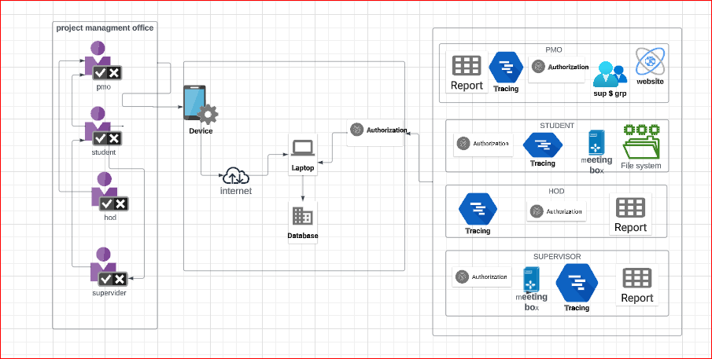

*Figure 1.1: Model-View-Controller*

### Software/Hardware Requirements

* Operating system
* Web browser
* Laptop/system

### Implementation Tools and Technology

* Android Studio
* Java
* Firebase
* XML

### Implementation Plan

### Deliverable Items

* **E-commerce Android Application**: A fully functional Android app built in Android Studio using Java, integrated with Firebase, supporting user features (registration, product browsing, cart management, order placement) and admin capabilities (product and order management)
* Firebase Backend Configuration: A configured Firebase project with Authentication for user/admin login

### Milestone Chart

|  |  |  |  |  |  |  |  |  |  |  |  |  |  |  |  |  |  |  |  |  |  |  |  |  |  |  |  |  |  |  |  |  |  |  |  |  |  |  |  |  |  |  |  |  |  |  |  |  |  |  |  |  |  |  |  |  |  |  |  |  |  |  |  |  |  |  |  |  |  |  |  |  |  |  |  |  |  |  |  |  |  |  |  |  |  |  |  |  |  |  |  |  |  |  |  |  |  |  |  |  |  |  |  |  |  |  |  |  |  |  |  |  |  |  |  |  |  |  |  |  |  |  |  |  |  |  |  |  |  |  |  |  |  |  |  |  |  |  |  |  |  |  |  |  |  |  |  |  |  |  |  |  |  |  |  |  |  |  |  |  |  |  |  |  |  |  |  |  |  |  |  |  |  |  |  |  |  |  |  |  |  |  |  |  |  |
| --- | --- | --- | --- | --- | --- | --- | --- | --- | --- | --- | --- | --- | --- | --- | --- | --- | --- | --- | --- | --- | --- | --- | --- | --- | --- | --- | --- | --- | --- | --- | --- | --- | --- | --- | --- | --- | --- | --- | --- | --- | --- | --- | --- | --- | --- | --- | --- | --- | --- | --- | --- | --- | --- | --- | --- | --- | --- | --- | --- | --- | --- | --- | --- | --- | --- | --- | --- | --- | --- | --- | --- | --- | --- | --- | --- | --- | --- | --- | --- | --- | --- | --- | --- | --- | --- | --- | --- | --- | --- | --- | --- | --- | --- | --- | --- | --- | --- | --- | --- | --- | --- | --- | --- | --- | --- | --- | --- | --- | --- | --- | --- | --- | --- | --- | --- | --- | --- | --- | --- | --- | --- | --- | --- | --- | --- | --- | --- | --- | --- | --- | --- | --- | --- | --- | --- | --- | --- | --- | --- | --- | --- | --- | --- | --- | --- | --- | --- | --- | --- | --- | --- | --- | --- | --- | --- | --- | --- | --- | --- | --- | --- | --- | --- | --- | --- | --- | --- | --- | --- | --- | --- | --- | --- | --- | --- | --- | --- | --- | --- | --- | --- | --- | --- | --- | --- |
| |  |  |  |  |  |  |  |  |  |  |  |  |  |  |  |  |  |  |  |  |  |  |  |  |  |  |  |  |  |  |  |  |  |  |  |  |  |  |  |  |  |  |  |  |  |  |  |  |  |  |  |  |  |  |  |  |  |  |  |  |  |  |  |  |  |  |  |  |  |  |  |  |  |  |  |  |  |  |  |  |  |  |  |  |  |  |  |  |  |  |  |  |  |  |  |  |  |  |  |  |  |  |  |  |  |  |  |  |  |  |  |  |  |  |  |  |  |  |  |  |  |  |  |  |  |  |  |  |  |  |  |  |  |  |  |  |  |  |  |  |  |  |  |  |  |  |  |  |  |  |  |  |  |  |  |  |  |  |  |  |  |  |  |  |  |  |  |  |  |  |  |  |  |  |  |  |  |  |  |  |  |  |  |  |  | | --- | --- | --- | --- | --- | --- | --- | --- | --- | --- | --- | --- | --- | --- | --- | --- | --- | --- | --- | --- | --- | --- | --- | --- | --- | --- | --- | --- | --- | --- | --- | --- | --- | --- | --- | --- | --- | --- | --- | --- | --- | --- | --- | --- | --- | --- | --- | --- | --- | --- | --- | --- | --- | --- | --- | --- | --- | --- | --- | --- | --- | --- | --- | --- | --- | --- | --- | --- | --- | --- | --- | --- | --- | --- | --- | --- | --- | --- | --- | --- | --- | --- | --- | --- | --- | --- | --- | --- | --- | --- | --- | --- | --- | --- | --- | --- | --- | --- | --- | --- | --- | --- | --- | --- | --- | --- | --- | --- | --- | --- | --- | --- | --- | --- | --- | --- | --- | --- | --- | --- | --- | --- | --- | --- | --- | --- | --- | --- | --- | --- | --- | --- | --- | --- | --- | --- | --- | --- | --- | --- | --- | --- | --- | --- | --- | --- | --- | --- | --- | --- | --- | --- | --- | --- | --- | --- | --- | --- | --- | --- | --- | --- | --- | --- | --- | --- | --- | --- | --- | --- | --- | --- | --- | --- | --- | --- | --- | --- | --- | --- | --- | --- | --- | --- | --- | | |  |  |  |  |  |  |  |  |  |  |  |  |  |  |  |  |  |  |  |  |  |  |  | | --- | --- | --- | --- | --- | --- | --- | --- | --- | --- | --- | --- | --- | --- | --- | --- | --- | --- | --- | --- | --- | --- | --- | | 1. **Task Name** | **Start** | **End** | **Duration(weeks)** | **May** | | **May** | | | **May** | | **June** | | | **June** | | **June** | | | **June** | | | **June** | | Project Initiatin | 05/10/2025 | 05/11/2025 | 0.5 |  |  |  | | |  | |  | | |  | |  | | |  | | |  | | Data Set Collection | 05/12/2025 | 05/18/2025 | 1 |  |  |  |  | |  | |  | | |  | |  | | |  | | |  | | SRS | 05/19/2025 | 05/25/2025 | 1 |  | |  | |  |  |  |  | | | |  |  | | |  | | |  | | Design | 05/09/2025 | 10/06/2025 | 1 |  | |  | | |  |  |  |  | |  | |  | | |  | | |  | | Implementation | 05/26/2025 | 06/01/2025 | 1 |  | |  | | |  | |  | |  |  | |  |  | |  | | |  | | Product browsing | 06/02/2025 | 06/08/2025 | 1 |  | |  | | |  | |  | | |  | |  | |  |  |  | |  | | Shopping Cart & checkout | 06/16/2025 | 06/22/2025 | 1 |  | |  | | |  | |  | | |  | |  | | |  | |  |  | |   Figure 2: Gantt chart of E-Commerce Project |

*Figure 1.2: Gantt chart for milestones*

# Chapter 2 Requirement Analysis

## Chapter 2 Requirement Analysis

### Functional Requirements

### For User

##### User Registration & Authentication

Sign-up (Create account)

Login (Email, Password)

##### Product Browsing

User can Browse products by recommended products.

##### Product Details

Access product details by including images, descriptions, prices, and add to cart.

##### Add to Cart

Users can add products to their cart.

* Order Placement and Checkout

User can place order from cart.

##### Discover by Categories

Users can discover products based on different categories like for men, women, kids and sneakers.

##### Profile Management

Users must manage their profile information (e.g., name, email, shipping address) and update their password.

##### Trending Products Based on Area

Users can discover products based on different location, temperatures, and season and weather conditions.

##### Quote of the Day

Users can view quotes of the day.

### Non-Functional Requirement

All non-functional requirements of the proposed system are as followed:

### Security

Only authorized users can assess the system with username and password.

### Performance

Easy tracking of records and updating can have been done.

### User friendly

The system is very interactive.

### Maintainability

Addressing the ease of performing maintenance on product.

### Reliability

Reliability is the ability of a product or service to perform as excepted normal conditions.

### Effective

Our system works effectively

### Use Cases

### Login Use Case

*Table 2.1 login use case*

|  |  |
| --- | --- |
| **Use Case Number** | UC-1 |
| **Use Case Name** | UC-Login |
| **Goal** | User log into the system |
| **Primary actor** | Customer |
| **Level** | User, System |
| **Precondition** | User must have valid login credential and exist in the  system. |
| **Success end** | User successfully login into the system. |
| **Failure and condition** | User does not Login in the system |
| **Main success scenario** | 1. Primary actor clicks on desired Login buttonin android app. 2. The primary actor enters his credentials and presses the Login button. 3. The system verifies the credentials from the   database and move primary actor to the dashboard. |
| **Extensions (error scenarios)** | * 1. If password or email incorrect.   2. System shows an error message   3. User tries again. |

s

### Signup Use Case

*Table 2.2 User signup Use Case*

|  |  |
| --- | --- |
| **Use Case Number** | UC-2 |
| **Use Case Name** | UC-Sign-up |
| **Goal** | User creates a new account in the system. |
| **Primary actor** | Customer |
| **Level** | User, System |
| **Precondition** | User does not have an existing account in the system. |
| **Success end** | User successfully creates an account and is registered in the system. |
| **Failure and condition** | User does not successfully create an account. |
| **Main success scenario** | 1. The customer clicks on the Signup button in the android app. 2. The customer enters their details (e.g., name, email, password) and submits the signup form. 3. The system validates the details provided and stores them in the database. 4. The system confirms successful registration and redirects the customer to the login screen or dashboard. |
| **Extensions (error scenarios)** | 2.a If the email is already registered or the password does not meet requirements (e.g., minimum length):  2.b The system shows an error message.  2.c The customer corrects the details and tries again. |

### Product Browsing Use Case

*Table 2.3 Add supervisor again for PMO Use Case*

|  |  |
| --- | --- |
| **Use Case Number** | UC-3 |
| **Use Case Name** | UC- Product Browsing |
| **Goal** | Users browsing available products in the system. |
| **Primary actor** | Customer |
| **Level** | User, System |
| **Precondition** | User has access to the android app (logged in or as a guest). |
| **Success end** | Users successfully view a list of available products. |
| **Failure and condition** | Users are unable to view products. |
| **Main success scenario** | 1. The customer navigates to the product browsing section (e.g., home screen or product catalog) in the Dressily app. 2. The system displays a list or grid of available clothing items with details such as images, names, and prices. 3. The customer scrolls through the products and optionally applies filters (e.g., category, size, price) or sorting options (e.g., price low to high). 4. The system updates the displayed products based on the applied filters or sorting preferences. |
| **Extensions (error scenarios)** | 2.a If no products are available or the system fails to load products:  2.b The system shows an error message or a "No products found" message.  2.c The customer refreshes the page or tries different filters. |

### Product Details Use Case

*Table 2.4 Product Details Use Case*

|  |  |
| --- | --- |
| **Use Case Number** | UC-4 |
| **Use Case Name** | UC- Product Details |
| **Goal** | User views detailed information about a specific product. |
| **Primary actor** | Customer |
| **Level** | User, System |
| **Precondition** | User has access to the Android app (logged in or as a guest) and is browsing products. |
| **Success end** | Users are unable to view the product details. |
| **Failure and condition** | Technical Issues/Server Error |
| **Main success scenario** | 1. The customer selects a product from the product browsing section in the Android app. 2. The system displays the product details screen, showing information such as product images, name, price, description, available sizes, colors, and reviews. 3. The customer interacts with the product details (e.g., zooms in on images, selects size or color options). 4. The system updates the display based on the customer’s selections (e.g., shows availability for selected size or color). |
| **Extensions (error scenarios)** | * 2.a If the product details fail to load or the product is unavailable: * 2.b The system shows an error message or a "Product not available" message. * 2.c The customer returns to the product browsing section or refreshes the page. |

### Add to Cart Use Case

*Table 2.5 Add to Cart Use Case*

|  |  |
| --- | --- |
| **Use Case Number** | UC-5 |
| **Use Case Name** | UC- Add to cart |
| **Goal** | User adds a product to their shopping cart. |
| **Primary actor** | Customer |
| **Level** | User, System |
| **Precondition** | User has access to the Android app (logged in or as a guest) and is viewing a product’s details. |
| **Success end** | Users successfully add the selected product to their shopping cart. |
| **Failure and condition** | User is unable to add the product to the cart. |
| **Main success scenario** | 1. The customer selects a product from the product Android app. 2. The customer chooses product options (e.g., size, color, quantity) and clicks the "Add to Cart" button. 3. The system validates the selected options (e.g., checks availability of size/color). 4. The system adds the product to the customer’s shopping cart and displays a confirmation message. |
| **Extensions (error scenarios)** | 3.a If the selected product options (e.g., size, color) are out of stock or invalid:  3.b The system shows an error message (e.g., "Selected size is out of stock").  3.c The customer selects different options or returns to the product browsing section. |

### Order Placement and Checkout Use Case

*Table 2.6 Order placement and Checkout Use Case*

|  |  |
| --- | --- |
| **Use Case Number** | UC-6 |
| **Use Case Name** | UC- Order Placement and Checkout |
| **Goal** | User places an order and completes the checkout process. |
| **Primary actor** | Customer |
| **Level** | User, System |
| **Precondition** | User has added at least one product to the shopping cart and is logged into the Android app. |
| **Success end** | User successfully places an order and completes the checkout process. |
| **Failure and condition** | The PMO not view the forms. |
| **Main success scenario** | 1. The customer navigates to the shopping cart in the android app and clicks the "Proceed to Checkout" button. 2. The system displays the checkout screen, showing the cart items, total cost, and fields for shipping and payment information. 3. The customer enters their shipping address, contact details, and selects a payment method (e.g., credit card, PayPal). 4. The customer reviews the order details and clicks the "Place Order" button. 5. The system validates the shipping and payment information, processes the payment, and records the order in the database. 6. The system displays an order confirmation message and sends a confirmation email to the customer. |
| **Extensions (error scenarios)** | 3.a If the shipping or payment information is invalid (e.g., incorrect address, declined payment):  3.b The customer corrects the information and tries again.  5.a If the payment process fails or the system encounters an error. |

### Profile Management Use Case

*Table 2.7 Profile Management Use Case*

|  |  |
| --- | --- |
| **Use Case Number** | UC-7 |
| **Use Case Name** | UC- Profile Management |
| **Goal** | Users manage their profile information in the system. |
| **Primary actor** | Supervisor, Student |
| **Level** | User, System |
| **Precondition** | User is logged into the Android app with a registered account. |
| **Success end** | User successfully views or updates their profile information. |
| **Main success scenario** | 1. The customer navigates to the profile section in the android app. 2. The system displays the customer’s current profile information (e.g., name, email, phone number, shipping address). 3. The customer selects the option to edit their profile details. 4. The customer updates their information (e.g., name, phone number, address, or password) and submits the changes. 5. The system validates the updated information and saves it to the database. 6. The system displays a confirmation message indicating successful profile update. |
| **Extensions (error scenarios)** | * 4.a If the updated information is invalid (e.g., invalid email format, weak password): * 4.b The system shows an error message (e.g., "Invalid email format" or "Password does not meet requirements"). * 4.c The customer corrects the information and tries again. * 5.a If the system fails to save the updated information due to a technical issue: * 5.b The system shows an error message (e.g., "Failed to update profile"). * 5.c The customer retries the update or contacts customer support. |

### Trending Products based on Area Use Case

*Table 2.8 Trending Products Based on Area Use Case*

|  |  |
| --- | --- |
| **Use Case Number** | UC-8 |
| **Use Case Name** | UC- Trending Products based on Area Use Case |
| **Goal** | User views trending products specific to their geographical area. |
| **Primary actor** | Customer |
| **Level** | User, System |
| **Precondition** | User has access to the android app (logged in or as a guest) and has granted location access or set a preferred area. |
| **Success end** | User successfully views a list of trending products based on their area. |
| **Failure and condition** | Users are unable to view trending products based on their area. |
| **Main success scenario** | 1. The customer navigates to the trending products section in the Dressify app. 2. The system retrieves the customer’s location (via device GPS or user-selected area). 3. The system fetches trending products for the customer’s area from the database, based on factors like sales, views, or regional popularity. 4. The system displays a list or grid of trending products with details such as images, names, and prices. 5. The customer scrolls through the trending products and optionally interacts with them (e.g., views details or adds to the cart). |
| **Extensions (error**  **scenarios)** | 2.a If the system cannot access the customer’s location or no area is set:  2.b The system prompts the customer to enable location services or manually select an area.  2.c The customer provides the required location information and tries again.  3.a If no trending products are available for the customer’s area or the system fails to load data:  3.b The system shows an error message (e.g., "No trending products available" or "Failed to load trending products").  3.c The customer refreshes the page or selects a different area. |

### Quote of the Day Use Case

*Table 2.9 Quote of the Day Use Case*

|  |  |
| --- | --- |
| **Use Case Number** | UC-9 |
| **Use Case Name** | UC- Quote of the day |
| **Goal** | The goal is to create and provide the login to the Groups. |
| **Primary actor** | Customer |
| **Level** | User, System |
| **Precondition** | User has access to the Android app (logged in or as a guest). |
| **Success end** | User successfully views the quote of the day. |
| **Failure and condition** | User is unable to view the quote of the day. |
| **Main success scenario** | 1. The customer opens the Android app or navigates to a designated section (e.g., home screen or inspiration tab). 2. The system retrieves the quote of the day from the database or an external API. 3. The system displays the quote of the day, including the quote text and any associated visuals (e.g., background image or styling). 4. The customer views the quote and optionally interacts with it (e.g., shares it on social media). |
| **Extensions (error scenarios)** | 2.a If the system fails to retrieve the quote of the day due to a database or network issue:  2.b The system shows an error message (e.g., "Unable to load quote of the day").  2.c The customer refreshes the page or tries again later. |

### Browse By Category Use Case

*Table 2.10 Browse by category Use Case*

|  |  |
| --- | --- |
| **Use Case Number** | UC-10 |
| **Use Case Name** | UC- Browse By Category |
| **Goal** | User views products organized by a selected category. |
| **Primary actor** | Customer |
| **Level** | User, System |
| **Precondition** | User has access to the Android app (logged in or as a guest). |
| **Success end** | User successfully views a list of products in the selected category. |
| **Failure and condition** | User is unable to view products in the selected category. |
| **Main success scenario** | 1. The customer navigates to the category section (e.g., home screen or category menu) in the Dressify app. 2. The system displays a list of available product categories (e.g., men’s clothing, women’s clothing, accessories). 3. The customer selects a specific category (e.g., women’s dresses). 4. The system retrieves products for the selected category from the database. 5. The system displays a list or grid of products in the selected category with details such as images, names, and prices. 6. The customer scrolls through the products and optionally interacts with them (e.g., views details or adds to cart). |
| **Extensions (error scenarios)** | 4.a If no products are available in the selected category or the system fails to load data:  4.b The system shows an error message (e.g., "No products available in this category" or "Failed to load products").  4.c The customer selects a different category or refreshes the page. |

# Chapter 3 Design

## Chapter 3 DESIGN

### 3 UML Diagrams

### 3.1 Class Diagram

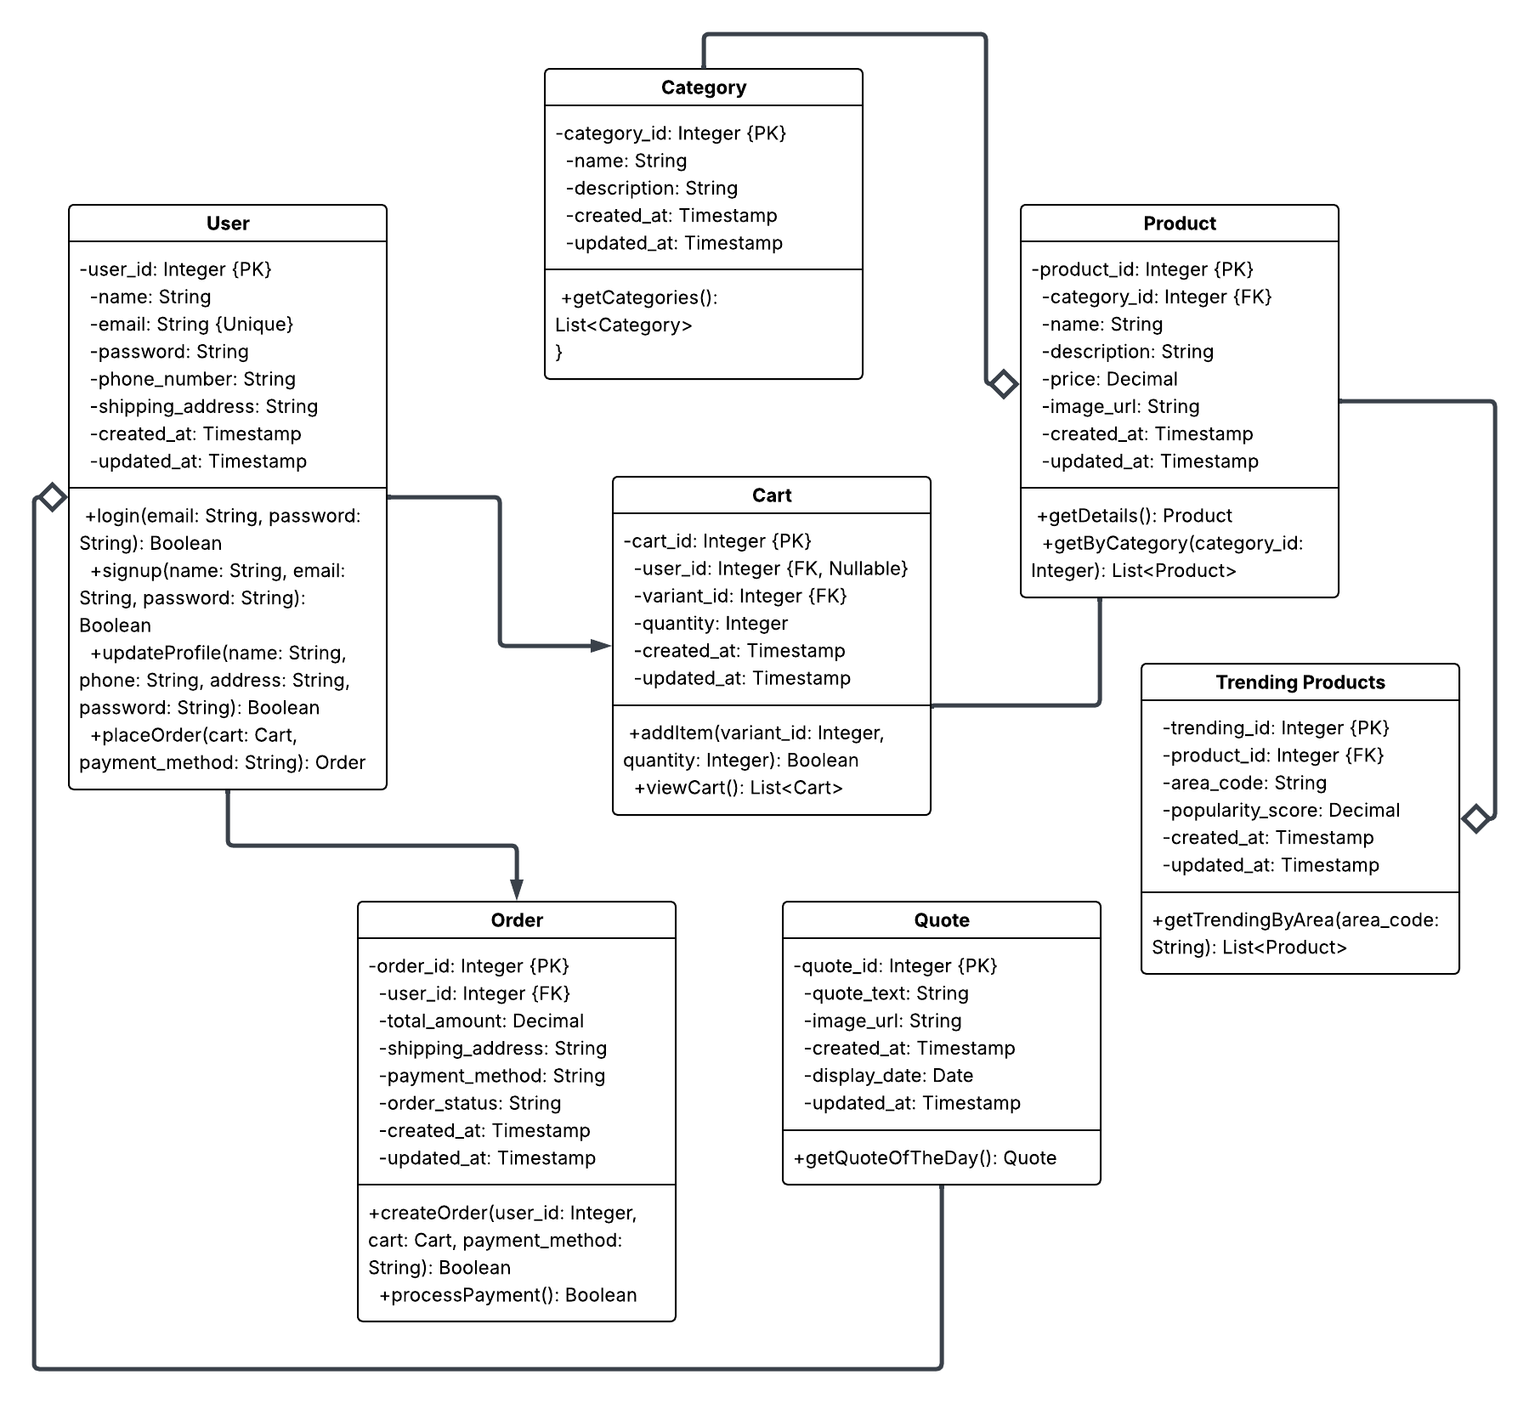

*Figure 3.5 Class Diagram*

### 3.2 Use Case Diagram

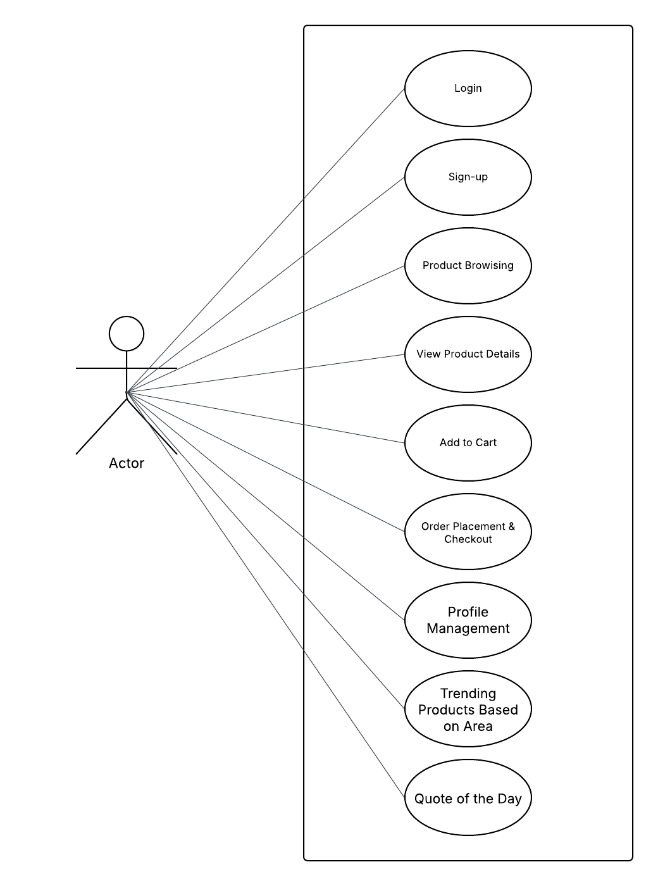

*Figure 3.1 Use-Case Diagram for Dressify*

### Sequence Diagram

### 3.3.1 Login for Customer

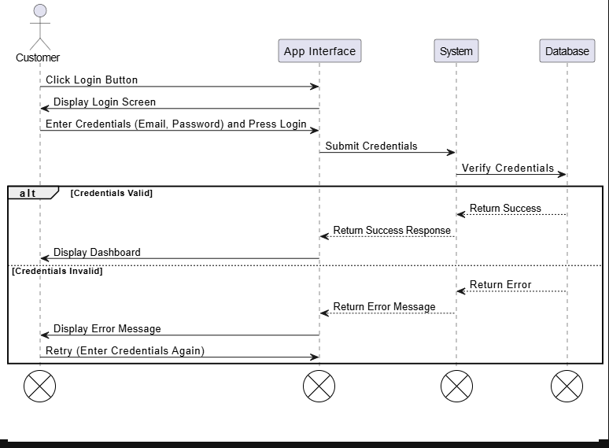

*Figure 3.1 Login for Customer*

### 3.3.2 Sign-Up for Customer

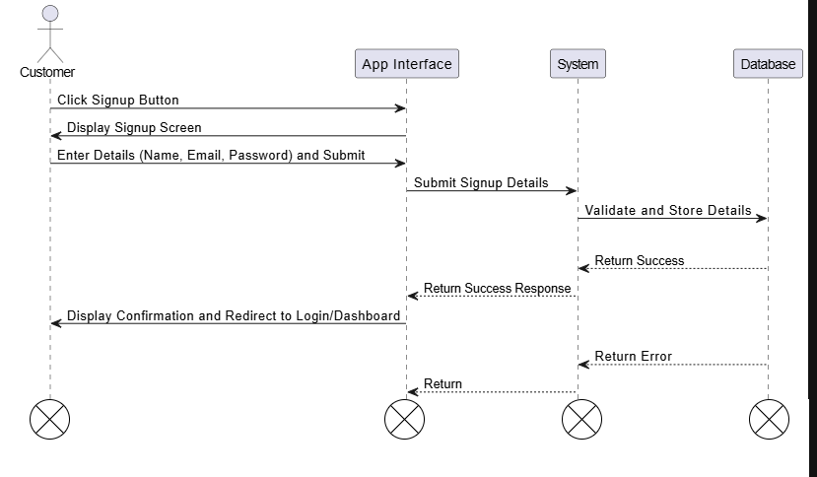

*Figure 3.2 Sign-up for Customer*

### 3.3.3 Product Browsing

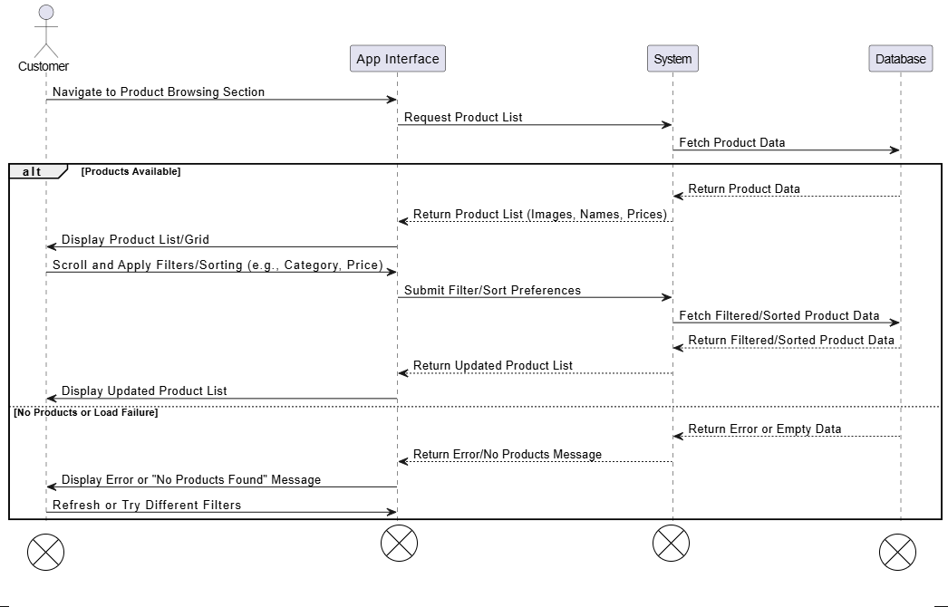

*Figure 3.3 Product Browsing for Customer*

### 3.3.4 Product Details

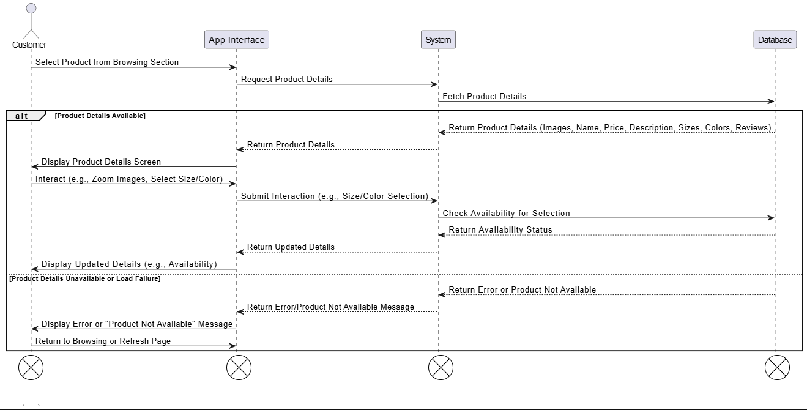

*Figure 3.4 Product Details for Customer*

### 3.3.5 Add to Cart

*Figure 3.5 Add to Cart for Customer*

### 3.3.6 Order Placement and Checkout

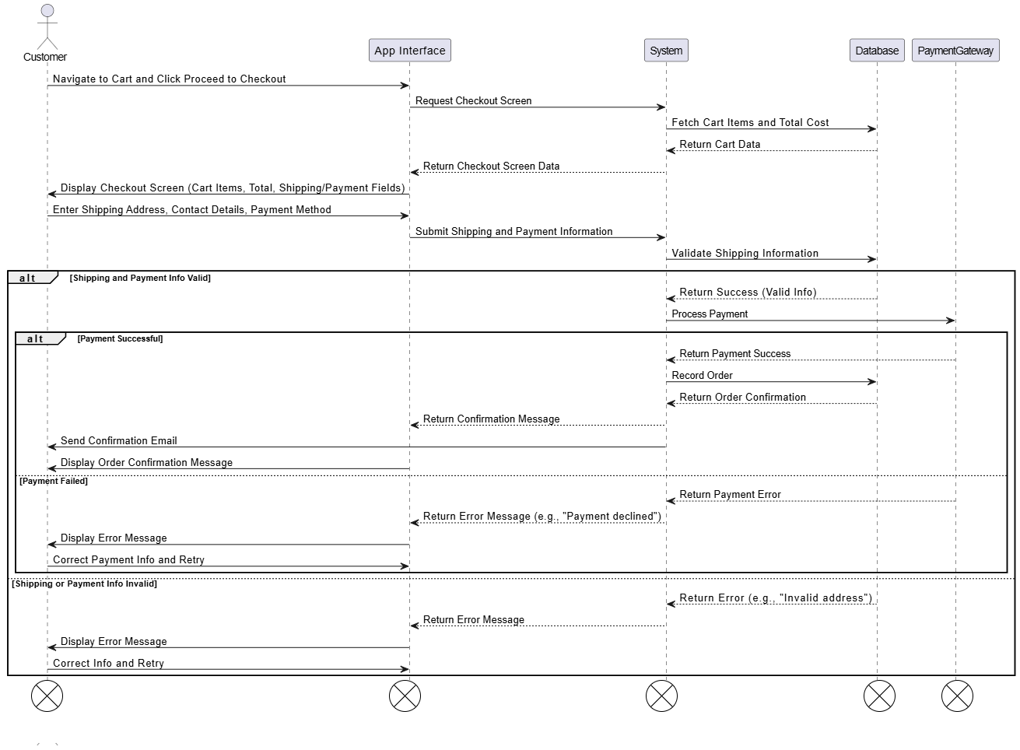

*Figure 3.6 Order Placement and Checkout for Customer*

### 3.3.7 Discover By categories

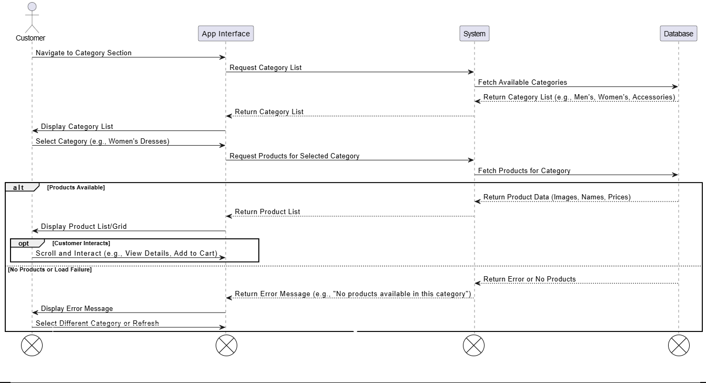

*Figure 3.7 Discover By categories for Customer*

### 3.3.8 Profile Management

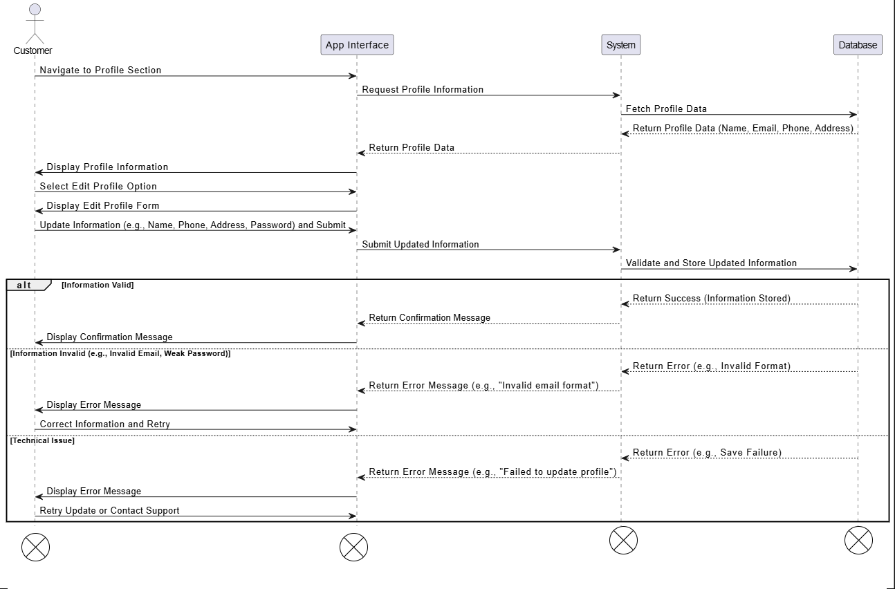

*Figure 3.8 Product Browsing for Customer*

### 3.3.9 Trending Products Based on Area

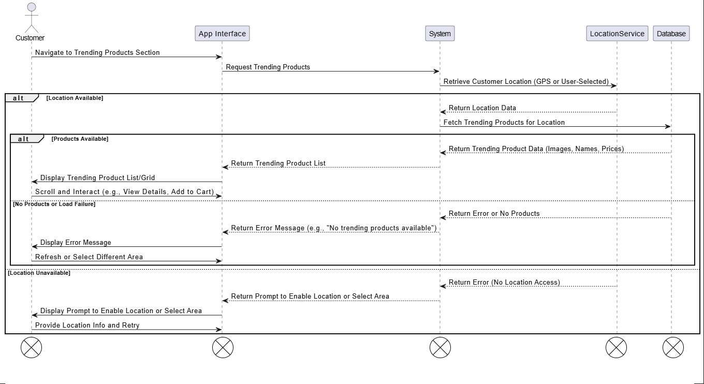

*Figure 3.9 Trending Products Based on Area for Customer*

### 3.3.10 Quote of the Day

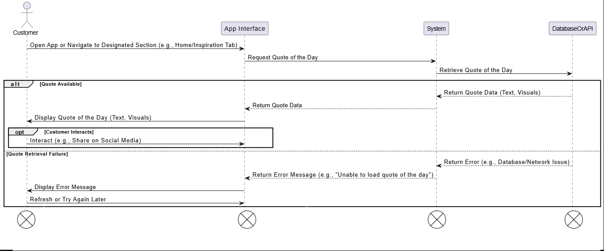

*Figure 3.10* Quote of the Day *for Customer*

### 3.4 ERD

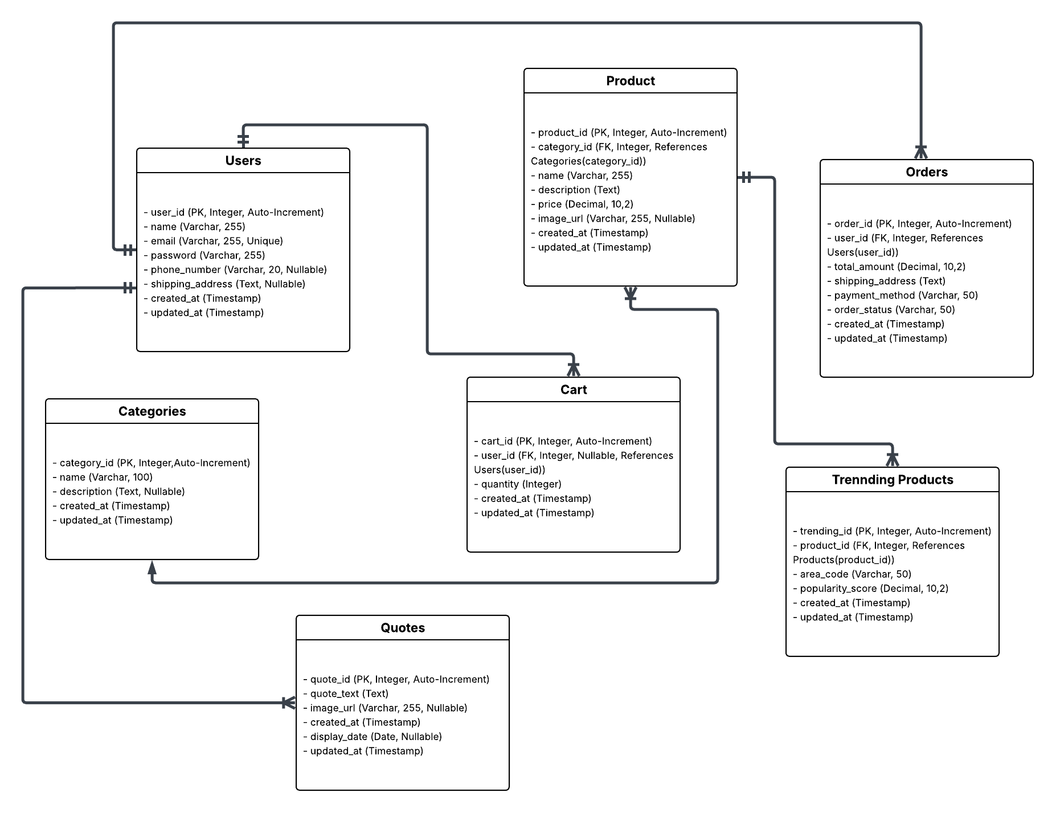

*Figure 3.4.1 ERD of Customer*

# Chapter 5 User Manual

## Chapter 5 User Manual

### Login

User enter email and password and then clicks on “*login button”*.

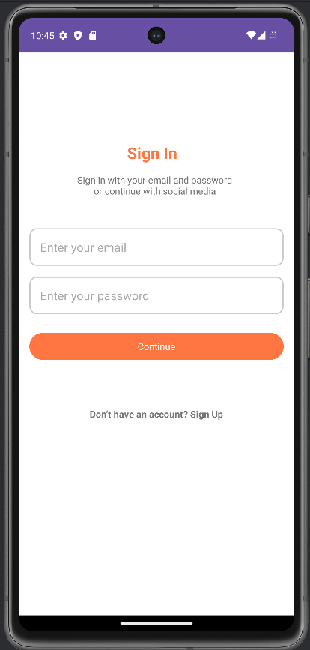

*Figure 5.1 Customer Login*

### Signup

User enters name, email, and password for registering an account.

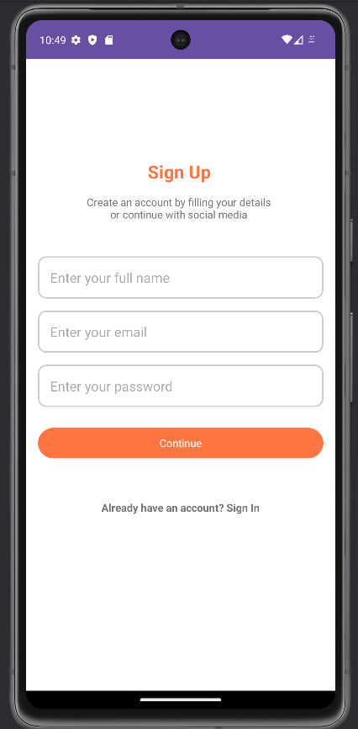

*Figure 5.2 Sign-Up Page*

### Home Page

When user clicks on sign in it will direct to the homepage.

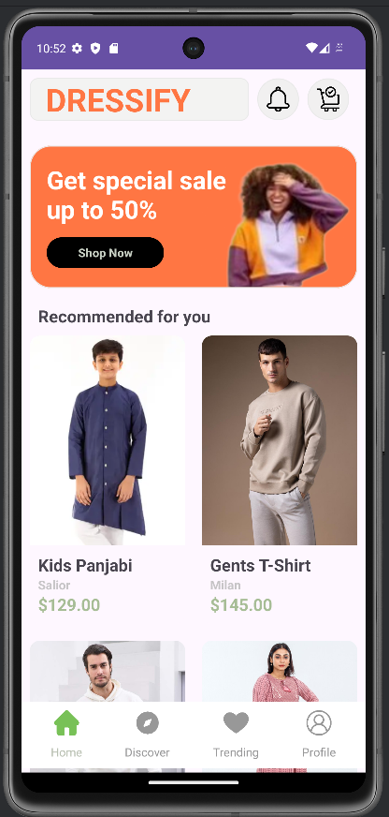

*Figure 5.3 Home Page*

### Add to Cart

User click on “A*dd to cart and it will direct to checkout and place order.*

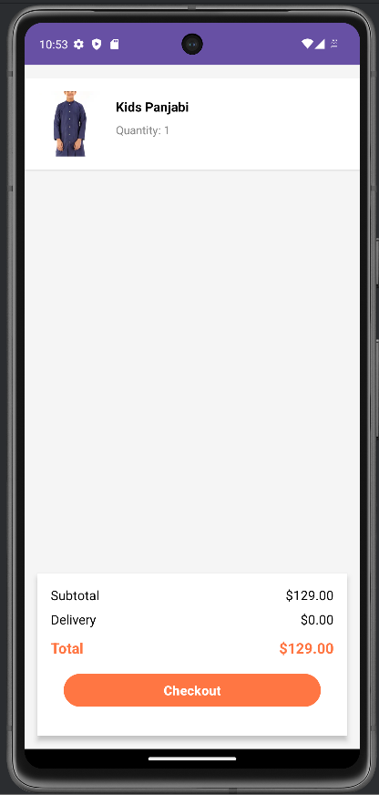

*Figure 5.4 Add to Cart*

### Discover by Categories

User click on “A*dd student”* and fill required fields to add new student.

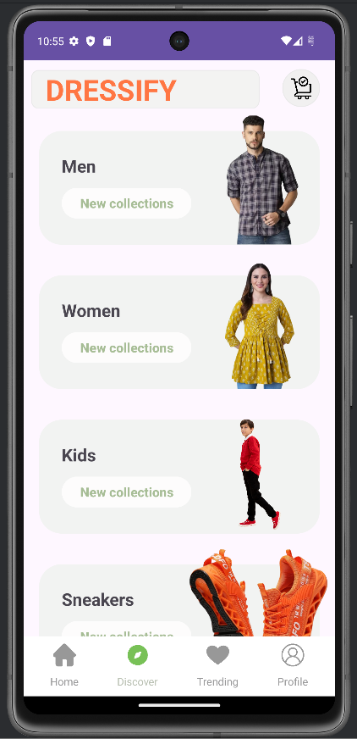

*Figure 5.5 Discover by categories*

### Product Suggestion by Loaction

PMO clicks on “*All Students”* to view no of students.

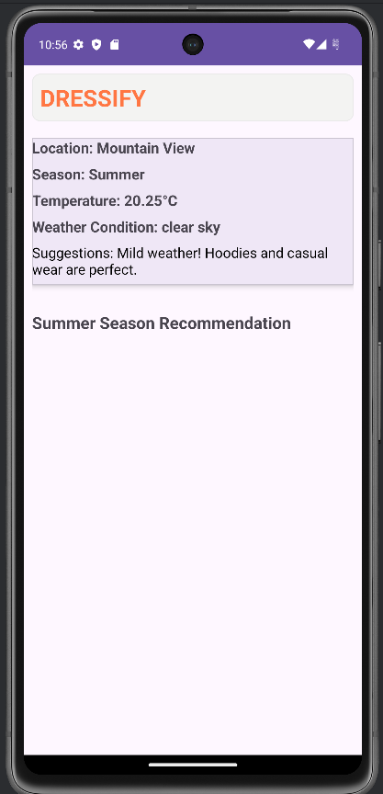

*Figure 5.6 View All Students*

### Profile Update

User clicks on “*Update button”* of specific *Student* to update or edit its data, makes changings and then click on “*Update”* button.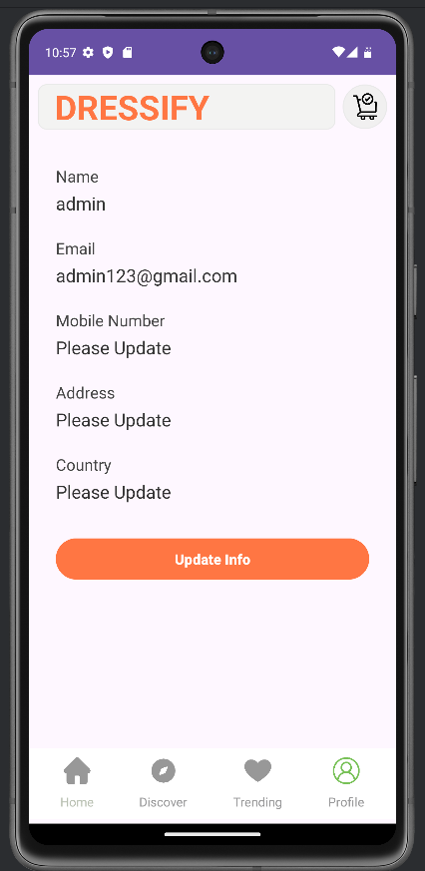

*Figure 5.7 Update Student*