**FINAL PROJECT DOCUMENTATION**

**Dressify**



**Submitted By**

|  |  |
| --- | --- |
| Abeera Noor | 22-Arid-4405 |
| Bismah Arshad | 22-Arid-4410 |
| Eman Mustafa | 22-Arid-4413 |

**Supervisor**

Mr. Bilal Arshad

Lecturer GIMS

**2025**

**Gujrat Institute of Management Sciences**  
**PMAS-Arid Agriculture University, Rawalpindi**

**Dressify**

Project submitted to

Department of Software Engineering

Gujrat Institute of Management Sciences

**By**

|  |  |
| --- | --- |
| Abeera Noor | 22-Arid-4405 |
| Bismah Arshad | 22-Arid-4410 |
| Eman Mustafa | 22-Arid-4413 |

In partial fulfillment of the requirements for the degree of

(BSSE (Hons.))

**Gujrat Institute of Management Sciences**  
**PMAS-Arid Agriculture University, Rawalpindi**

**Members’ Detail**

|  |  |
| --- | --- |
| **Project ID** | GIMS-BSSE-F202019 |

|  |  |  |  |
| --- | --- | --- | --- |
| Dressify | | | |
| **Group Leader:**  Abeera Noor  **Group Members:**3 | | | |
| Name | Registration # | Email Address | Class |
| Abeera Noor | 22-Arid-4405 | abeeranoor2202@gmail.com | BSSE |
| Bismah Arshad | 22-Arid-4410 | ahbismah@gmail.com | BSSE |
| Eman Mustafa | 22-Arid-4413 | manomugal2807@gmail.com | BSSE |

|  |  |
| --- | --- |
| **_____________________**  **Mr. Awais Ilyas Baig**  PMO, GIMS |  |

|  |
| --- |
| **Dated: _____________________** |

# Dedication

To our fathers,

“To My Guiding Light, My Source of Strength -My Beloved Father”

To our mothers,

“To the One Whose Unwavering Support and Kindness guided Me Through Life’s Melodies. Thank You Being My Rock, Mom”

To our Loved Ones,

“For Their Understanding, Tenderness for Keeping Us Motivated to Our Dreams”

To our teacher,

“To Sir Bilal Arshad, Who Kindled Wisdom's Flame Within Us, Guiding My Path with Unwavering Grace and Insight, I Dedicate My Deepest Gratitude and Eternal Appreciation”

~Abeera Noor, Eman Mustafa, Bismah Arshad ~

# Project Summary

|  |  |
| --- | --- |
| **Project Title** | Dressify |
| **Project ID** | GIMS-BSSE-F202019 |
| **Organization** | Gujrat Institute of Management Sciences |
| **Objective** | * To create a robust ecommerce system for online sell and purchase * To enable users to buy items from their home. * To enable users to come across an online ecommerce system. * To provide users with access to a seamless online shopping platform. * To enhance user experience through interactive and smart app features. |
| **Undertaken By** | Abeera Noor 22-Arid-4405, Bismah Arshad 22-Arid-4410 and Eman Mustafa 22-Arid-4413 |
| **Supervised By** | Mr. Bilal Arshad |
| **Date started** | April 25th, 2025 |
| **Date Completed** | May 25th, 2025 |
| **Technologies Used** | Java, XML and Android SDK |
| **System Used** | Window 10,11 |

**Proofreading Certificate**

**This is to acknowledge that the project entitled**

**Dressify [**GIMS-BSSE-F202019**]**

**has been proofread**

**By**

**_____________________**

**Ms. Bilal Arshad**

Lecturer CS, GIMS

|  |
| --- |
| **Dated: _____________________** |

# Declaration

We hereby declare that we developed this project and this report entirely on the basis of our personal efforts made under the sincere guidance of our project supervisor. We further declare that the titled project and all associated documents, reports are submitted as partial requirements for the degree of “**BS (Hons.) in Software Engineering”.**

|  |  |  |
| --- | --- | --- |
| **Members’ Name** | **Registration #** | **Signature** |
| Abeera Noor | 22-Arid-4405 | _______________ |
| Bismah Arshad | 22-Arid-4410 | _______________ |
| Eman Mustafa | 22-Arid-4413 | _______________ |

**Dated:** __________________

# Acknowledgement

Our deepest gratitude goes to Allah Almighty who has provided all the resources required for our education. This project was very difficult for us, and we don’t know how easily this project is completed. It’s all because of Allah Almighty help.

We would also like to express our deepest appreciation to our **parents** and our supervisor **Mr. Bilal Arshad.** His support and provide us true guidance.

**Certificate**

This is to certify that **Abeera Noor,** **22-Arid-4405**, **Bismah Arshad,** **22-Arid-4410**, and **Eman Mustafa**, **22-Arid-4413** have successfully completed the final project titled:“ Dressify”, accepted by the Department of Software Engineering/SE and find satisfactory for the requirement of:

**Gujrat Institute of Management Sciences**

**PMAS-Arid Agriculture University Rawalpindi**

**For Award of the Degree**

**BSSE(Hon’s)**

|  |  |  |
| --- | --- | --- |
|  | ________________  Supervisor  Mr. / MS. XYZ  Designation, GIMS |  |
|  | ________________  Examiner 1  Mr. / MS. XYZ  Designation, GIMS |  |
|  | ________________  Examiner 2  Mr. / MS. XYZ  Designation, GIMS |  |
|  | ________________  Examiner 3  Mr. / MS. XYZ  Designation, GIMS |  |
| ________________  HOD/CS-IT  GIMS |  | ________________  Director General  GIMS |

**Dated:**___________________

# Abstract

Smartphones have revolutionized the e-commerce industry, enabling consumers to shop conveniently through intuitive mobile applications. This project details the design and development of an Android-based e-commerce platform, crafted to deliver a comprehensive and user-centric online shopping experience. Developed using Java in Android Studio and integrated with Firebase for robust backend functionality, the application supports key features such as user authentication, product browsing, shopping cart management, secure checkout, and order tracking. Firebase’s real-time database, authentication services, and cloud storage ensure seamless data synchronization and scalability, while Android’s versatile ecosystem guarantees compatibility across a wide range of devices. The development process adheres to a systematic software engineering methodology, encompassing requirements specification, system architecture design, implementation, and rigorous testing to ensure functionality, performance, and usability. This project not only demonstrates technical proficiency in mobile application development and backend integration but also lays the groundwork for future enhancements, such as advanced product search algorithms, personalized recommendations, and integration of secure payment gateways. By addressing the growing demand for efficient and accessible e-commerce solutions, this application contributes to the evolving digital marketplace, offering a scalable and user-friendly platform for modern retail needs.

# Table of Contents

Dedication ii

Project Summary iv

Declaration vi

Acknowledgement vii

Abstract ix

Table of Contents x

List of Tables xiii

List of Figures xviii

List of Abbreviations xxiii

Chapter 1 2

Introduction 2

1.1 Problem Statement 3

1.2 Significance 3

1.3 Objectives 3

1.4 Limitations and Restrictions: 4

1.5 Overview 5

1.6 System Architecture 6

1.7 Software/Hardware Requirements 6

1.8 Implementation Tools and Technology 7

1.9 Implementation Plan 7

1.9.1 Deliverable Items 7

1.9.2 Milestone Chart 8

Chapter 2 Requirement Analysis 10

2.1 Functional Requirements 10

2.2 Non Functional Requirement 10

2.3 Use Cases 11

2.3.1 Login Use Case 11

2.3.2 Signup Use Case 12

2.3.3 Product Browsing Use Case 14

2.3.4 Product Details Use Case 15

2.3.5 Add to Cart Use Case 16

2.3.6 Order Placement and Checkout Use Case 17

2.3.7 Profile Management Use Case 18

2.3.8 Trending Products based on Area Use Case 20

2.3.9 Quote of the day Use Case 21

2.3.10 Browse by Category Use Case 22

Chapter 3 DESIGN 24

3.1 UML Diagrams 24

3.2 Use-Case Diagram 24

3.2.1 Use-Case Diagram for Dressify 24

3.3 Class Diagram 25

3.4 Sequence Diagrams 26

3.4.1 Login for Customer sequence diagram 26

3.4.2 Sign-up for Customer Sequence Diagram 27

3.4.3 Product Browsing sequence diagram. 28

3.4.4 Product Details sequence diagram 29

3.4.5 Add to Cart Sequence Diagram 30

3.4.6 Order Placement and Checkout Sequence Diagram 31

3.4.7 Discover by Categories Sequence Diagram 32

3.4.8 Profile Management Sequence Diagram 33

3.4.9 Trending Products based on Area Sequence Diagram 34

3.4.10 Quote of the Day Sequence Diagram 35

3.5 ERD 36

Chapter 5 User Manual 37

5.1 Login 38

5.2 Signup 39

5.3 Home Page 41

5.4 Add to Cart 42

5.5 Discover by Categories 44

5.6 Product Suggestion by Loaction 46

5.7 Profile Update 48

References: 49

# List of Tables

Table 2.1: Login for Admin Chat Box Use 20

Table 2.2: Forget Password Use Case 21

Table 2.3: Edit Profile Use Case 22

Table 2.4: Add/Remove Moderator Use Case 23

Table 2.5: Search User in a Chatroom Use Case 24

Table 2.6: Create ChatRoom Use Case 25

Table 2.7: Join Room Slug/pin Use Case 26

Table 2.8: Massage Notification Use Case 27

Table 2.9: Set Background Image Use Case 28

Table 2.10:Disable Room/Chat Massage Use Case 29

Table 2.11: Gust User interaction Use Case 30

Table 2.12: View member Use Case 31

Table 2.13: Manage general site settings Use Case 32

Table 2.14: Manage Chat Page Settings Use Case 33

Table 2.15: User Registration Settings Use Case 34

Table 2.16: Home Page Settings Use Case 35

Table 2.17: Header/Footer Settings Use Case 36

Table 2.18: GIF Settings Use Case 37

Table 2.19: Progressive Web App (PWA) Settings Use Case 38

Table 2.20: Cloud Storage Management Use Case 39

Table 2.21: Spam/Profinity Control Management Use Case 40

Table 2.22: User/Gust Settings Configuration Use Case 41

Table 2.23: Report Management Use Case 42

Table 2.24: Social Login Integration Use Case 43

Table 2.25: Admin Logout Use Case 44

Table 2.26: User login Use Case 45

Table 2.27: Send Massage Box Use Case 46

Table 2.28: Send Audio Massage Use Case 47

Table 2.29: Send Media Use Case 48

Table 2.30: Join Chatroom Use Case 49

Table 2.31: Leave Chatroom Use Case 50

Table 2.32: Replay to direct chat Use Case 51

Table 2.33: Search user in row Use Case 52

Table 2.34: Add user to Favorites Use Case 53

Table 2.35: Toggle Notifications Use Case 54

Table 2.36: Share Room Use Case 55

Table 2.37: Report Room Use Case 56

Table 2.38: Clear Chat Use Case 57

Table 2.39: Forward Massages Use Case 58

Table 2.40: Delete Massages Use Case 59

Table 2.41: Block Members Use Case 60

Table 2.42: Report user Use Case 61

Table 2.43: Search in Room Use Case 62

Table 2.44: Switch between Multiple Rooms Use Case 63

Table 2.45: Set User Status Use Case 64

Table 2.46: View Media Use Case 65

Table 2.47: User logout Use Case 66

Table 2.48: IP logging Use Case 67

Table 2.49: Monotor Forum Traffic Use Case 68

Table 2.50: Popular Searches Use Case 69

Table 2.51: View Higu Presence topics Use Case 70

Table 2.52: View user presence Use Case 71

Table 2.53: View login Use Case 72

Table 2.54: View Statistics Use Case 73

Table 2.55: Manage roles and permissions Use Case 74

Table 2.56: Manage group Use Case 75

Table 2.57: Set Reputations Use Case 76

Table 2.58: Ban User Use Case 77

Table 2.59: Unban User Box Use Case 78

Table 2.60: Delete User and his Content Use Case 79

Table 2.61: Manage Adnims and Moderators Case 80

Table 2.62: Manage Tags/Categories Use Case 81

Table 2.63: Manage User Group Use Case 82

Table 2.64: Manage Rewards Use Case 83

Table 2.65: Manage Markdown Settings Use Case 84

Table 2.66: Manage 2factor authentication settings Use Case 85

Table 2.67: Forget Password Use Case 86

Table 2.68: Manage Profile Use Case 87

Table 2.69: Manage Topics Use Case 88

Table 2.70: Search By Category and Tags Use Case 89

Table 2.71: Check Followers and Followings Use Case 90

Table 2.72: Search User By Post or Status Use Case 91

Table 2.73: Unfollow User Use Case 92

Table 2.74: See Post and Topic for Specific User Use Case 93

Table 2.75: Knowledge Base Updates Use Case 94

Table 2.76: Delete Questions and Answers Use Case 95

Table 2.77: Create Questions and Answers Use Case 96

Table 2.78: View Questions and Answers Use Case 97

Table 2.79: Post a Questions Use Case 98

Table 2.80: Plate Form Creation Updations Use Case 99

Table 2.81: Save File Use Case 100

Table 2.82: Run a Program Use Case 101

Table 4.1: Login Admin and User Test case 192

Table 4.2: Profile Manafement Test case 193

Table 4.3: Discussion Threads Test case 194

Table 4.4: Post Questions Test case 195

Table 4.5: Post Questions Test case 197

Table 4.6: Real Time Massaging Test case 199

Table 4.7: Content Recommendations Test case 200

Table 4.8: Lanaguage Translation Test case 201

Table 4.9: Reporting and Flagging Test case 202

Table 4.10: User Registration and Profile Test case 203

Table 4.11: Aunthentication Method Test case 204

Table 4.12: QnA Bot Interaction Test case 206

Table 4.13: Notification SystemTest case 207

Table 4.14: User Assistance and Support Test case 209

Table 4.15: Privacy Settings Test case 210

Table 4.16: Content Discovery Test case 211

Table 4.17: Chat box interaction Test case 212

Table 4.18: Group Chat Creation Test case 213

Table 4.19: Pricate Massaging Test case 215

Table 4.20: Massage Search and History Test case 217

Table 4.21: Send Audio Massage Test case 218

Table 4.22: Join Chatroom Test case 220

Table 4.23: Search User in row Test case 221

Table 4.24: Toggle Notifications Test case 222

Table 4.25:Report RoomTest case 224

Table 4.26: Switch between multiple rooms Test case 225

Table 4.27: View Media Test case 226

Table 4.28: Cheak Unread Topic Test case 227

Table 4.29: Filter User by Online Test case 228

Table 4.30: Post a Question Test case 229

Table 4.31: Content Moderations Test case 230

Table 4.32: User Reporting Test case 232

Table 4.33: Community Guidelines Test case 233

Table 4.34: Announcement and Notifications Test case 234

Table 4.35: User Analytics Test case 235

Table 4.36: User Management Test case 237

Table 4.37: Aunthication Configurations Test case 238

Table 4.38: QnA Bot Management Test case 239

Table 4.39: Notification Management Test case 240

Table 4.40: Privacy Compliance Test case 242

Table 4.41: Chat box Management Test case 243

Table 4.42: Add or Remove moderator Test case 245

Table 4.43: Search user in a chat room Test case 246

Table 4.44: Massage Notifications Test case 247

Table 4.45: Set BackGround Image Test case 249

Table 4.46: Disable chat list and Direct massages Test case 250

Table 4.47: Gust User interactions Test case 252

Table 4.48: Manage General site settings Test case 253

Table 4.49: Manage Email Settings Test case 255

Table 4.50: Manage Email Settings Test case 256

Table 4.51: Manage Chat Page Settings Test case 258

Table 4.52:Home Page Settings Test case 260

Table 4.53: Progressive web App (PWA) Settings Test case 262

Table 4.54: Cloud Storage Management Test case 264

Table 4.55: RE Captcha Integration Test case 266

Table 4.56: Social Login IntergrationTest case 268

Table 4.57: Change Email Test case 270

Table 4.58: Manage Registration Queue Test case 272

Table 4.59: Manage Flagged Content Test case 274

Table 4.60: Manage Notifications Test case 275

Table 4.61: Manage Cookies Test case 277

Table 4.62: Manage Markdown Settings Test case 279

Table 4.63: Manage 2Factor cuthentications settings Test case 281

Table 4.64: Manage Black List IPS Test case 283

Table 4.65: Plate Form Creation Updations Test case 285

Table 4.66: Run a Program Test case 287

Table 4.67: Create Workspace for user Test case 289

Table 4.68: Create new Workspace Plateform Test case 290

Table 4.69: Manage Existing Workspace Test case 291

Table 4.70: User Management Test case 293

Table 4.71: Workspcase Management Test case 294

Table 4.72: Workspcase Management for user Test case 296

Table 4.73: AI Chat Box Test case 298

# List of Figures

Figure 1.1: System Architecture 8

Figure 1.2: Gantt chart for milestones 10

Figure 3.1: Use-Case Diagram for Admin operations 103

Figure 3.2: Use-Case Diagram for User Operations 104

Figure 3.3: Use-Case Diagram for AI enagement 105

Figure 3.4: Use-Case Diagram for Chat System 106

Figure 3.5: Class Diagram Use Case 107

Figure 3.6: Forget Password Use Case 108

Figure 3.7: Edit Profile Use Case 109

Figure 3.8: Add/Remove Moderator Use Case 110

Figure 3.9: Search User in a Chatroom Use Case 111

Figure 3.10: Create ChatRoom Use Case 112

Figure 3.11: Join Room Slug/pin Use Case 113

Figure 3.12: Massage Notification Use Case 114

Figure 3.13: Set Background Image Use Case 115

Figure 3.14:Disable Room/Chat Massage Use Case 116

Figure 3.15: Gust User interaction Use Case 117

Figure 3.16: View member Use Case 118

Figure 3.17: Manage general site settings Use Case 119

Figure 3.18: Manage Chat Page Settings Use Case 120

Figure 3.19: User Registration Settings Use Case 121

Figure 3.20: Home Page Settings Use Case 122

Figure 3.21: Header/Footer Settings Use Case 123

Figure 3.22: GIF Settings Use Case 124

Figure 3.23: Progressive Web App (PWA) Settings Use Case 125

Figure 3.24: Cloud Storage Management Use Case 126

Figure 3.25: Spam/Profinity Control Management Use Case 127

Figure 3.26: User/Gust Settings Configuration Use Case 128

Figure 3.27: Report Management Use Case 129

Figure 3.28: Social Login Integration Use Case 130

Figure 3.29: Admin Logout Use Case 131

Figure 3.30: User login Use Case 132

Figure 3.31: Send Massage Box Use Case 133

Figure 3.32: Send Audio Massage Use Case 134

Figure 3.33: Send Media Use Case 135

Figure 3.34: Join Chatroom Use Case 136

Figure 3.35: Leave Chatroom Use Case 137

Figure 3.36: Replay to direct chat Use Case 138

Figure 3.37: Search user in row Use Case 139

Figure 3.38: Add user to Favorites Use Case 140

Figure 3.39: Toggle Notifications Use Case 141

Figure 3.40: Share Room Use Case 142

Figure 3.41: Report Room Use Case 143

Figure 3.42: Clear Chat Use Case 144

Figure 3.43: Forward Massages Use Case 145

Figure 3.44: Delete Massages Use Case 146

Figure 3.45: Block Members Use Case 147

Figure 3.46: Report user Use Case 148

Figure 3.47: Search in Room Use Case 149

Figure 3.48: Switch between Multiple Rooms Use Case 150

Figure 3.49: Set User Status Use Case 151

Figure 3.50: View Media Use Case 152

Figure 3.51: User logout Use Case 153

Figure 3.52: IP logging Use Case 154

Figure 3.53: Monotor Forum Traffic Use Case 155

Figure 3.54: Popular Searches Use Case 156

Figure 3.55: View Higu Presence topics Use Case 157

Figure 3.56: View user presence Use Case 158

Figure 3.57: View login Use Case 159

Figure 3.58: View Statistics Use Case 160

Figure 3.59: Manage roles and permissions Use Case 161

Figure 3.60: Manage group Use Case 162

Figure 3.61: Set Reputations Use Case 163

Figure 3.62: Ban User Use Case 164

Figure 3.63: Unban User Box Use Case 165

Figure 3.64: Delete User and his Content Use Case 166

Figure 3.65: Manage Adnims and Moderators Case 167

Figure 3.66: Manage Tags/Categories Use Case 168

Figure 3.67: Manage User Group Use Case 169

Figure 3.68: Manage Rewards Use Case 170

Figure 3.69: Manage Markdown Settings Use Case 171

Figure 3.70: Manage 2factor authentication settings Use Case 172

Figure 3.71: Forget Password Use Case 173

Figure 3.72: Manage Profile Use Case 174

Figure 3.73: Manage Topics Use Case 175

Figure 3.74: Search By Category and Tags Use Case 176

Figure 3.75: Check Followers and Followings Use Case 177

Figure 3.76: Search User By Post or Status Use Case 178

Figure 3.77: Unfollow User Use Case 179

Figure 3.78: See Post and Topic for Specific User Use Case 180

Figure 3.79: Knowledge Base Updates Use Case 181

Figure 3.80: Delete Questions and Answers Use Case 182

Figure 3.81: Create Questions and Answers Use Case 183

Figure 3.82: View Questions and Answers Use Case 184

Figure 3.83: Post a Questions Use Case 185

Figure 3.84: Plate Form Creation Updations Use Case 186

Figure 3.85: Save File Use Case 187

Figure 3.86: Run a Program Use Case 188

Figure 3.86:Admin Login Use Case 189

Figure 3.87: ERD of Dressify 190

Figure 5.1: Home Page 300

Figure 5.2: Sign Up Page 301

Figure 5.3: Login Page 302

Figure 5.4: Post Page 302

Figure 5.5: Reviews Page 303

Figure 5.6: Group Page 304

Figure 5.7: About Page 304

Figure 5.8: Admin Dash Board Page 305

Figure 5.9: Admin Page 305

Figure 5.10: User Page 306

Figure 5.11: Badges Page 307

Figure 5.12: Customize the Section Page 307

Figure 5.13: Category Page 308

Figure 5.14: Staff Page 308

Figure 5.15: All Category Page 309

Figure 5.16: Add Customer Section Page 309

Figure 5.17: Profile Page 310

Figure 5.18: Push Notifications Page 310

Figure 5.19: Home Page 311

Figure 5.20: Sign Up Page 312

Figure 5.21: Templates Page 312

Figure 5.22: Users Page 312

Figure 5.23: Deployment Page 313

Figure 5.24: Account/ Profile Page 313

Figure 5.25: Home Page 314

Figure 5.26: Login Page 314

Figure 5.27: Create An Account Page 315

Figure 5.28: Forget Password Page 315

Figure 5.29: My Room Page 316

Figure 5.30: Home Page 316

Figure 5.31: Settings General Page 317

Figure 5.32: Email Setting Page 317

Figure 5.33: Chat Setting Page 318

Figure 5.34: Registration Page 318

Figure 5.35: Home Page 319

Figure 5.36: Header Page 320

Figure 5.37: Footer Page 320

Figure 5.38: GIF Page 321

Figure 5.39: PWA Page 321

Figure 5.40: Notification Page 321

Figure 5.41: IP Page 322

Figure 5.42: Cloud Page 322

Figure 5.43: Reaction Page 322

Figure 5.44: Image Page 323

Figure 5.45: Theme Page 323

Figure 5.46: Fount Page 324

Figure 5.47: reCAPTCHA Setting 324

Figure 5.48: Chat Room Setting 324

Figure 5.49: Vedio Calling Setting 325

Figure 5.50: Member Setting 325

Figure 5.51: Gust Setting 325

Figure 5.52: Social Login Setting 326

Figure 5.53:Reports Setting 326

Figure 5.54: Add Chat Room Setting 326

Figure 5.55: Login Page 327

Figure 5.56: Home Page 327

# List of Abbreviations

|  |  |  |
| --- | --- | --- |
| HCI |  | Human Computer Interaction |
| UI |  | User Interface |
| UX |  | User Experience |
|  |  |  |
|  |  |  |
|  |  |  |
|  |  |  |
|  |  |  |
|  |  |  |
|  |  |  |
|  |  |  |
|  |  |  |
|  |  |  |
|  |  |  |

Chapter 1

Introduction

# 

# Introduction

The advent of mobile technology has fundamentally reshaped the retail landscape, with e-commerce applications becoming essential tools for consumers seeking convenience, accessibility, and efficiency in their shopping experiences. As smartphones continue to dominate daily life, the demand for robust, user-friendly mobile applications has surged, prompting developers to create innovative solutions that cater to modern consumer needs. This project focuses on the development of an Android-based e-commerce application, designed to provide a seamless and intuitive platform for online shopping. Built using Java in Android Studio and integrated with Firebase for backend services, the application aims to deliver core functionalities such as user authentication, product browsing, shopping cart management, and secure order processing, aligning with industry standards set by leading platforms like Amazon and eBay.

The motivation for Dressify stems from the growing significance of mobile e-commerce in the global market, where businesses increasingly rely on mobile apps to connect with customers and drive sales. By leveraging Android’s widespread adoption and Firebase’s scalable infrastructure, this application seeks to address the needs of both consumers and developers, offering a practical solution that balances functionality with ease of use. The project draws inspiration from educational resources, such as online tutorials, which provide structured guidance on building e-commerce applications. These resources emphasize the importance of combining front-end design with robust backend integration to create a cohesive user experience, a principle that guides the development process of this application.

This project serves as a capstone for applying software engineering principles, including requirements analysis, system design, implementation, and testing, to create a fully functional mobile application. It demonstrates proficiency in Android development using Java, a versatile and widely adopted programming language, and Firebase, a powerful backend-as-a-service platform that simplifies data management and authentication.

## Problem Statement

Before The surge in Dressify has increased demand for user-friendly, scalable shopping applications, yet small to medium-sized businesses often lack affordable, customizable solutions. Many existing Android e-commerce apps suffer from poor device compatibility, inadequate backend integration, and unintuitive interfaces, limiting their usability and commercial viability. Additionally, available open-source or tutorial-based solutions often lack robust security, scalability, or comprehensive documentation, making them unsuitable for business deployment.

This project aims to address these challenges by developing an Android e-commerce application using Java and Firebase. The application provides essential features like user authentication, product browsing, shopping cart management, and secure checkout, ensuring seamless user experience across devices. By leveraging Firebase’s real-time database and authentication services, it offers a scalable, secure solution tailored for small businesses, with potential for future enhancements like advanced search and personalization.

## Significance

O This project, developing an Android e-commerce application using Java and Firebase, is significant for providing small to medium-sized businesses with an affordable, scalable platform to establish a digital presence, enhancing customer engagement through features like product browsing, secure authentication, and order processing. It demonstrates proficiency in Android development and Firebase integration, fostering valuable technical skills while adhering to industry standards for usability and security. By enabling businesses to compete in the digital marketplace and offering potential for future enhancements like personalized recommendations, the project contributes to both economic growth and academic research in mobile app development.

## Objectives

The objectives are:

* **Develop a Functional E-commerce Platform**: Create a user-friendly Android application that enables seamless online shopping, incorporating essential features such as user registration, product browsing, shopping cart management, and secure order processing.
* **Integrate Robust Backend Services**: Leverage Firebase for real-time data management, user authentication, and cloud storage to ensure scalability, security, and efficient handling of user and product data.
* **Ensure Cross-Device Compatibility**: Design the application to be responsive and compatible across a wide range of Android devices, providing consistent and intuitive user experience.
* **Apply Software Engineering Principles**: Implement a structured development process, including requirements analysis, system design, implementation, and testing, to produce a reliable and maintainable application.
* **Enhance Developer Skills**: Gain proficiency in Android development using Java, Android Studio, and Firebase integration, fostering technical expertise applicable to real-world mobile app development.
* **Enable Future Scalability**: Build a modular application architecture that supports future enhancements, such as advanced search functionality, personalized recommendations, and payment gateway integration, to meet evolving business needs.
* **Support Small Businesses**: Provide an affordable, customizable e-commerce solution tailored for small to medium-sized businesses, enabling them to establish a competitive digital presence and improve customer engagement.

## Limitations and Restrictions:

There can be various limitations and restrictions that we need to consider. These limitations and restrictions can arise from different sources, including budget constraints, regulatory requirements, resource availability, and more.

Limited payment gateway integration

Dependence on Firebase infrastructure

Basic feature set

Device and platform constraints

Offline functionality limitations

## Overview

This letter should be issued by the concerned organization with the subject; that student will deploy the project in their organization.

|  |
| --- |
| **Project Goal:**  Giving tech community a powerful, robust and enhanced discussion platform where they can easily communicate with each other, share ideas, promote innovations and communicate with like-minded persons. |
| **Type of project:** ¾ R&D **☑** Development |
| **Project Success criteria:**  All core features (user registration, product browsing, cart management, checkout, admin panel) are fully implemented and operational.Firebase services (authentication, database, storage) are seamlessly integrated, ensuring secure and real-time data handling. |
| Risks of the Project:  |  |  |  |  | | --- | --- | --- | --- | | **(Please mark þ where applicable)** | **Low** | **Medium** | **High** | | Technical risk | **☑** | ❑ | ❑ | | Timing risk | ❑ | **☑** | ❑ | | Budget risk | ❑ | **☑** | ❑ | |
| Organization Details (if any): |
| **Target End users:**  This Project is mainly for business admins and general users who want to sell their products and the users who want to buy all those products from online store. |
| **Development Technology/ Languages:**   * Java * XML * Android SDK |
| **Platform:**  ¾ Web based ¾ Distributed ¾Setup Configurations  ¾Desktop based **☑** Android ¾iOS  ¾Other_____________________ |
| **Project Supervisor: Mr. Bilal Arshad** |

## System Architecture

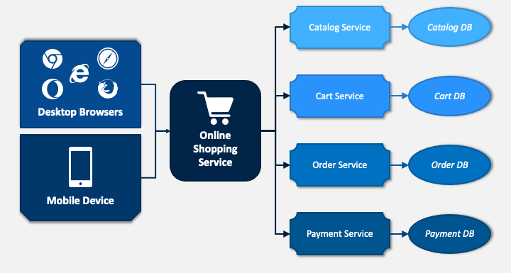

Figure 1.1: System Architecture

## Software/Hardware Requirements

Following are the software and hardware requirements that are necessary to develop and deploy this Platform.

* **Hardware Requirements**
* Hard Drive: 30 GB.
* Dual-core processor or better recommended.
* At least 4 GB RAM, 8 GB RAM recommended.
* **Software Requirements**
  + Windows 10 version 1709 or higher.
  + Windows 11 version 21H2 or higher.
  + Linux

## Implementation Tools and Technology

The application tools, which are to be used on front and back end of the system to be developed, are listed below.

* **Technology:**
* XMLfor frontend.
* JAVA for backend.
* **Application Tools:**
* Android Studio
* **Database:**
* Firebase
* SQLite
* **Documentation:**
* MS Visio
* MS Word
* MS Power Point
* MS Project

## Implementation Plan

### Deliverable Items

1. Project Documentation
2. Frontend Development
3. Backend Development
4. CD
5. User Manual

### Milestone Chart

|  |  |  |  |  |  |  |  |  |  |  |  |  |  |  |  |  |  |  |  |  |  |  |
| --- | --- | --- | --- | --- | --- | --- | --- | --- | --- | --- | --- | --- | --- | --- | --- | --- | --- | --- | --- | --- | --- | --- |
| **Task Name** | **Start** | **End** | **Duration(weeks)** | **May** | | **May** | | | **May** | | **June** | | | **June** | | **June** | | | **June** | | | **June** |
| Project Initiatin | 05/10/2025 | 05/11/2025 | 0.5 |  |  |  | | |  | |  | | |  | |  | | |  | | |  |
| Data Set Collection | 05/12/2025 | 05/18/2025 | 1 |  |  |  |  | |  | |  | | |  | |  | | |  | | |  |
| SRS | 05/19/2025 | 05/25/2025 | 1 |  | |  | |  |  |  |  | | | |  |  | | |  | | |  |
| Design | 05/09/2025 | 10/06/2025 | 1 |  | |  | | |  |  |  |  | |  | |  | | |  | | |  |
| Implementation | 05/26/2025 | 06/01/2025 | 1 |  | |  | | |  | |  | |  |  | |  |  | |  | | |  |
| Product browsing | 06/02/2025 | 06/08/2025 | 1 |  | |  | | |  | |  | | |  | |  | |  |  |  | |  |
| Shopping Cart & checkout | 06/16/2025 | 06/22/2025 | 1 |  | |  | | |  | |  | | |  | |  | | |  | |  |  |

|  |
| --- |
|  |

Figure 1.2: Gantt chart for milestones

Chapter 2

Requirement Analysis

# Requirement Analysis

The purpose of this chapter is to provide detail description of requirements and overview of system requirements before the developing process carried out for system “Dressify”. The requirements of the system were divided into two parts functional and non-functional requirements. The second part of the chapter will describe detail system functionality using “use-cases”.

## Functional Requirements

**For User**

* **User Registration and Authentication:**
* Users create and manage profiles with personal information.
* **Product Browsing:**
* User can Browse products by recommended products.
* **Product Browsing:**
* User can Browse products by recommended products.
* **Add to Cart:**

Users can add products to their cart.

* **Order Placement and Checkout:**
* User can place order from cart.
* **Discover by Categories**
* Users can discover products based on different categories like for men, women, kids and sneakers.
* **Profile Management:**
* Users can manage their profiles information (e.g., name, email, shipping address) and update their password.
* **Trending Products based on area:**
* Users can discover products based on different location, temperatures, and season and weather conditions.

## Non Functional Requirement

* **Performance**: The platform should be responsive and load quickly.
* **Scalability**: The system should handle growth in users and data.
* **Reliability**: Minimal downtime and rapid recovery from failures.
* **Security**: User data must be securely stored and protected.
* **User Experience (UX):** An intuitive and responsive user interface.
* **Internationalization and Localization:** Support for multiple languages and regions.
* **Interoperability:** Integration with third-party services.
* **Maintainability:** Well-documented and easy-to-maintain code.
* **Cross-Browser Compatibility:** Compatibility with major web browsers.
* **Version Control:** Use of a version control system.
* **Documentation:** Comprehensive documentation for all users.
* **Search and Retrieval Performance:** Fast and accurate search results.

## Use Cases

### Login Use Case

*Table 2.1: Login Use Case*

|  |  |
| --- | --- |
| **Use Case Number** | UC-1 |
| **Use Case Name** | UC-Login |
| **Goal** | User log into the system |
| **Primary actor** | Customer |
| **Level** | User, System |
| **Precondition** | 1. The user has a registered account in the system 2. The user has a valid username and password. |
| **Success end** | User successfully login into the system. |
| **Failure and condition** | User does not login in the system. |
| **Main success scenario** | 1. Primary actor clicks on desired Login button in android app. 2. The primary actor enters his credentials and presses the Login button. 3. The system verifies the credentials from the database and move primary actor to the dashboard. |
| **Extensions (error scenarios)** | * If password or email incorrect. * System shows an error message * User tries again. |

### Signup Use Case

*Table 2.2: SignUp Use Case*

|  |  |
| --- | --- |
| **Use Case Number** | UC-2 |
| **Use Case Name** | UC-SignUp |
| **Goal** | User creates a new account in the system. |
| **Primary actor** | Customer |
| **Level** | User, System |
| **Precondition** | User does not have an existing account in system. |
| **Success end** | User successfully creates an account is logged into the system |
| **Failure and condition** | User does not successfully create an account. |
| **Main success scenario** | 1. The customer clicks on the Signup button in the android app. 2. The customer enters their details (e.g., name, email, password) and submits the signup form. 3. The system validates the details provided and stores them in the database. 4. The system confirms successful registration and redirects the customer to the login screen or dashboard. |
| **Extensions (error scenarios)** | 2.a If the email is already registered or the password does not meet requirements (e.g., minimum length):  2.b The system shows an error message.  2.c The customer corrects the details and tries again. |

### Product Browsing Use Case

*Table 2.3: Product Browsing Use Case*

|  |  |
| --- | --- |
| **Use Case Number** | UC-3 |
| **Use Case Name** | UC- Product Browsing |
| **Goal** | Users browsing available products in the system. |
| **Primary actor** | Customer |
| **Level** | User & System |
| **Precondition** | The admin has a registered account in the system.  The admin is logged into the system. |
| **Success end** | Users successfully view a list of available products. |
| **Failure and condition** | Users are unable to view products. |
| **Main success scenario** | 1. The customer navigates to the product browsing section (e.g., home screen or product catalog) in the Dressily app. 2. The system displays a list or grid of available clothing items with details such as images, names, and prices. 3. The customer scrolls through the products and optionally applies filters (e.g., category, size, price) or sorting options (e.g., price low to high). 4. The system updates the displayed products based on the applied filters or sorting preferences. |
| **Extensions (error scenarios)** | 2.a If no products are available or the system fails to load products:  2.b The system shows an error message or a "No products found" message.  2.c The customer refreshes the page or tries different filters. |

### Product Details Use Case

*Table 2.4: Product Details Use Case*

|  |  |
| --- | --- |
| **Use Case Number** | UC-4 |
| **Use Case Name** | UC- Product Details |
| **Goal** | User views detailed information about a specific product. |
| **Primary actor** | Customer |
| **Level** | User, System |
| **Precondition** | User has access to the Android app (logged in or as a guest) and is browsing products. |
| **Success end** | Users can view the product details. |
| **Failure and condition** | Technical Issues/Server Error |
| **Main success scenario** | 1. The customer selects a product from the product browsing section in the Android app. 2. The system displays the product details screen, showing information such as product images, name, price, description, available sizes, colors, and reviews. 3. The customer interacts with the product details (e.g., zooms in on images, selects size or color options). 4. The system updates the display based on the customer’s selections (e.g., shows availability for selected size or color). |
| **Extensions (error scenarios)** | 2.a If the product details fail to load or the product is unavailable:  2.b The system shows an error message or a "Product not available" message.  2.c The customer returns to the product browsing section or refreshes the page. |

### Add to Cart Use Case

*Table 2.5: Add to Cart Use Case*

|  |  |
| --- | --- |
| **Use Case Number** | UC-5 |
| **Use Case Name** | UC- Add to Cart |
| **Goal** | User adds a product to their shopping cart. |
| **Primary actor** | Customer |
| **Level** | User, System |
| **Precondition** | User has access to the Android app (logged in or as a guest) and is viewing a product’s details. |
| **Success end** | Users successfully add the selected product to their shopping cart. |
| **Failure and condition** | User is unable to add the product to the cart. |
| **Main success scenario** | 1. The customer selects a product from the product Android app. 2. The customer chooses product options (e.g., size, color, quantity) and clicks the "Add to Cart" button. 3. The system validates the selected options (e.g., checks availability of size/color). 4. The system adds the product to the customer’s shopping cart and displays a confirmation message. |
| **Extensions (error scenarios)** | 3.a If the selected product options (e.g., size, color) are out of stock or invalid:  3.b The system shows an error message (e.g., "Selected size is out of stock").  3.c The customer selects different options or returns to the product browsing section. |

### Order Placement and Checkout Use Case

*Table 2.6: Order placement and Checkout Use Case*

|  |  |
| --- | --- |
| **Use Case Number** | UC-6 |
| **Use Case Name** | UC- Order Placement and Checkout |
| **Goal** | User places an order and completes the checkout process. |
| **Primary actor** | Customer |
| **Level** | User and system |
| **Precondition** | User has added at least one product to the shopping cart and is logged into the Android app. |
| **Success end** | User successfully places an order and completes the checkout process. |
| **Failure and condition** | The order is not placed successfully. |
| **Main success scenario** | The customer navigates to the shopping cart in the android app and clicks the "Proceed to Checkout" button.  The system displays the checkout screen, showing the cart items, total cost, and fields for shipping and payment information.  The customer enters their shipping address, contact details, and selects a payment method (e.g., credit card, PayPal).  The customer reviews the order details and clicks the "Place Order" button.  The system validates the shipping and payment information, processes the payment, and records the order in the database.  The system displays an order confirmation message and sends a confirmation email to the customer. |
| **Extensions (error scenarios)** | 3.a If the shipping or payment information is invalid (e.g., incorrect address, declined payment):  3.b The customer corrects the information and tries again.  5.a If the payment process fails or the system encounters an error. |

### Profile Management Use Case

*Table 2.7: Profile Management Use Case*

|  |  |
| --- | --- |
| **Use Case Number** | UC-7 |
| **Use Case Name** | UC- Profile Management |
| **Goal** | Users manage their profile information in the system. |
| **Primary actor** | Customer |
| **Level** | User, system |
| **Precondition** | User is logged into the Android app with a registered account. |
| **Success end** | User successfully views or updates their profile information. |
| **Failure and condition** | Some data is invalid leading to failed profile updating. |
| **Main success scenario** | 1. The customer navigates to the profile section in the android app. 2. The system displays the customer’s current profile information (e.g., name, email, phone number, shipping address). 3. The customer selects the option to edit their profile details. 4. The customer updates their information (e.g., name, phone number, address, or password) and submits the changes. 5. The system validates the updated information and saves it to the database. 6. The system displays a confirmation message indicating successful profile update. |
| **Extensions (error scenarios)** | * 4.a If the updated information is invalid (e.g., invalid email format, weak password): * 4.b The system shows an error message (e.g., "Invalid email format" or "Password does not meet requirements"). * 4.c The customer corrects the information and tries again. * 5.a If the system fails to save the updated information due to a technical issue: * 5.b The system shows an error message (e.g., "Failed to update profile"). |

### Trending Products based on Area Use Case

*Table 2.8: Trending Products Based on Area Use Case*

|  |  |
| --- | --- |
| **Use Case Number** | UC-8 |
| **Use Case Name** | UC- Trending Products based on Area Use Case |
| **Goal** | User views trending products specific to their geographical area. |
| **Primary actor** | Customer |
| **Level** | User, System |
| **Precondition** | User has access to the android app (logged in or as a guest) and has granted location access or set a preferred area. |
| **Success end** | User successfully views a list of trending products based on their area. |
| **Failure and condition** | Users are unable to view trending products based on their area. |
| **Main success scenario** | The customer navigates to the trending products section in the Dressify app.  The system retrieves the customer’s location (via device GPS or user-selected area).  The system fetches trending products for the customer’s area from the database, based on factors like sales, views, or regional popularity.  The system displays a list or grid of trending products with details such as images, names, and prices.  The customer scrolls through the trending products and optionally interacts with them (e.g., views details or adds to the cart). |
| **Extensions (error scenarios)** | 2.a If the system cannot access the customer’s location or no area is set:  2.b The system prompts the customer to enable location services or manually select an area.  2.c The customer provides the required location information and tries again. |

### Quote of the day Use Case

*Table 2.9: Quote of the day Use Case*

|  |  |
| --- | --- |
| **Use Case Number** | UC-9 |
| **Use Case Name** | UC- Quote of the day |
| **Goal** | The goal is to create and provide the login to the Groups. |
| **Primary actor** | Customer |
| **Level** | User, System |
| **Precondition** | User has access to the Android app (logged in or as a guest). |
| **Success end** | User successfully views the quote of the day. |
| **Failure and condition** | User is unable to view the quote of the day. |
| **Main success scenario** | 1. The customer opens the Android app or navigates to a designated section (e.g., home screen or inspiration tab). 2. The system retrieves the quote of the day from an external API. 3. The system displays the quote of the day, including the quote text and any associated visuals (e.g., background image or styling). 4. The customer views the quote and optionally interacts with it (e.g., shares it on social media). |
| **Extensions (error scenarios)** | 2.a If the system fails to retrieve the quote of the day due to a database or network issue:  2.b The system shows an error message (e.g., "Unable to load quote of the day").  2.c The customer refreshes the page or tries again later. |

### 2.3.10 Browse by Category Use Case

*2.10 Browse by Category Use Case*

|  |  |
| --- | --- |
| **Use Case Number** | UC-10 |
| **Use Case Name** | UC- Browse by Category |
| **Goal** | User views products organized by a selected category. |
| **Primary actor** | Customer |
| **Level** | User, system |
| **Precondition** | User has access to the Android app (logged in or as a guest). |
| **Success end** | User successfully views a list of products in the selected category. |
| **Failure and condition** | User is unable to view products in the selected category. |
| **Main success scenario** | The customer navigates to the category section (e.g., home screen or category menu) in the Dressify app.  The system displays a list of available product categories (e.g., men’s clothing, women’s clothing, accessories).  The customer selects a specific category (e.g., women’s dresses).  The system retrieves products for the selected category from the database.  The system displays a list or grid of products in the selected category with details such as images, names, and prices.  The customer scrolls through the products and optionally interacts with them (e.g., views details or adds to cart). |
| **Extensions (error scenarios)** | 4.a If no products are available in the selected category or the system fails to load data:  4.b The system shows an error message (e.g., "No products available in this category" or "Failed to load products").  4.c The customer selects a different category or refreshes the page. |

Chapter 3

Design

# DESIGN

## UML Diagrams

## Use-Case Diagram

### Use-Case Diagram for Dressify

|  |
| --- |
| Picture 23, Picture |

Figure 3.1:Use-Case Diagram for Dressify

## Class Diagram

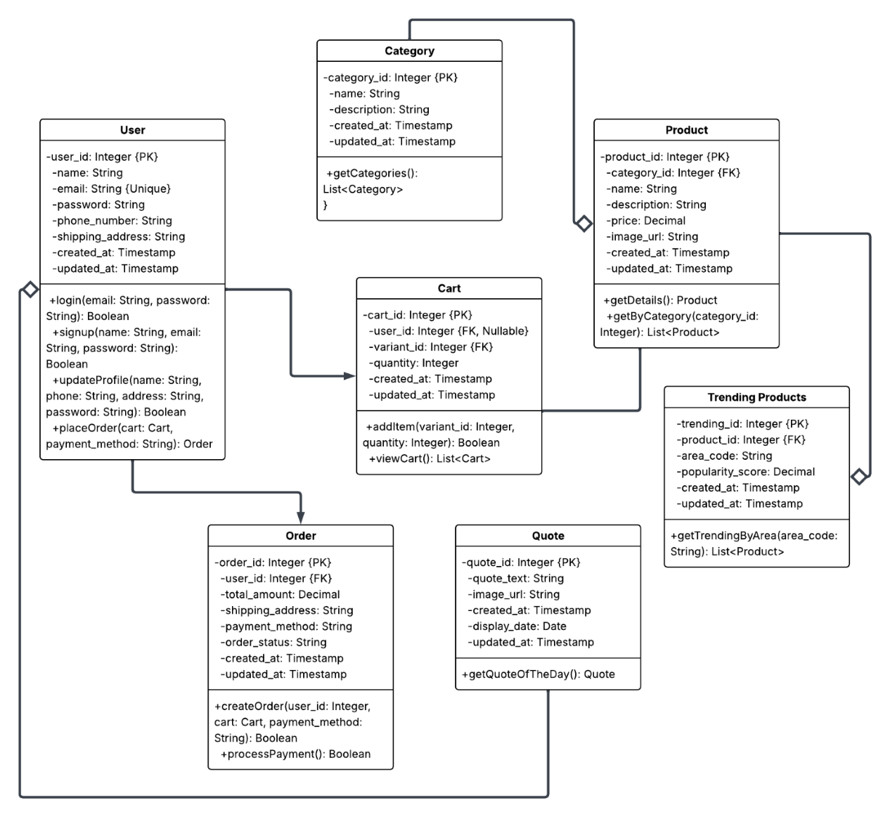

*Figure:3.5 Class Diagram*

## Sequence Diagrams

### Login for Customer sequence diagram

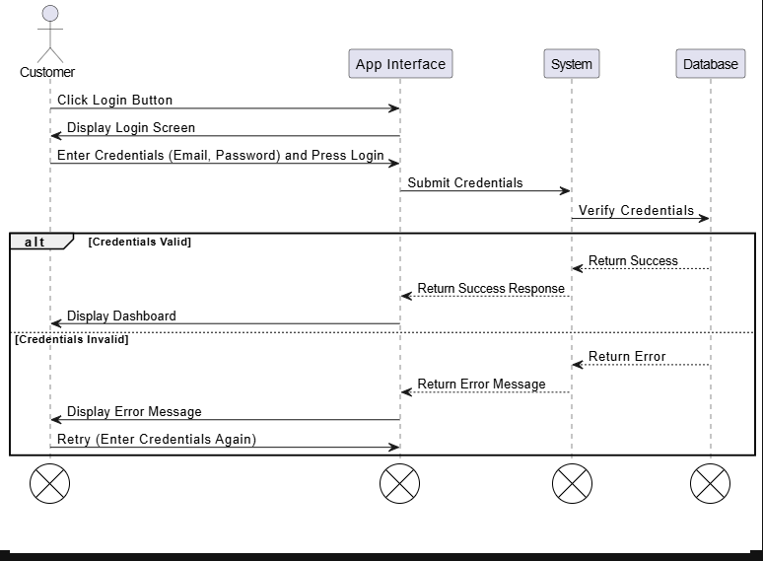

*Figure 4.1: Sequence Diagram for f* *Login for Customer*

### Sign-up for Customer Sequence Diagram

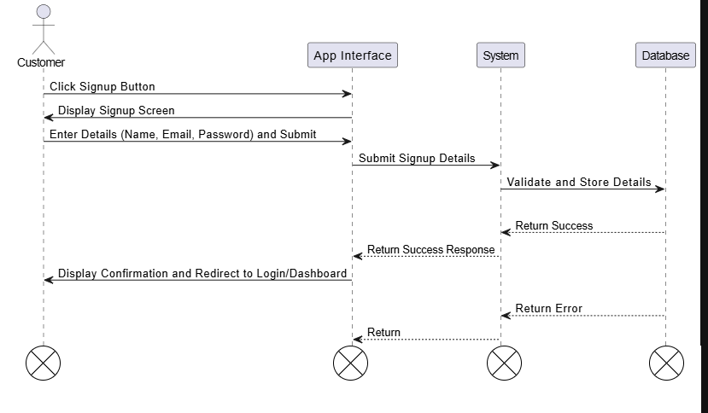

*Figure4.2: Sequence Diagram for Sign-up for Customer*

### Product Browsing sequence diagram.

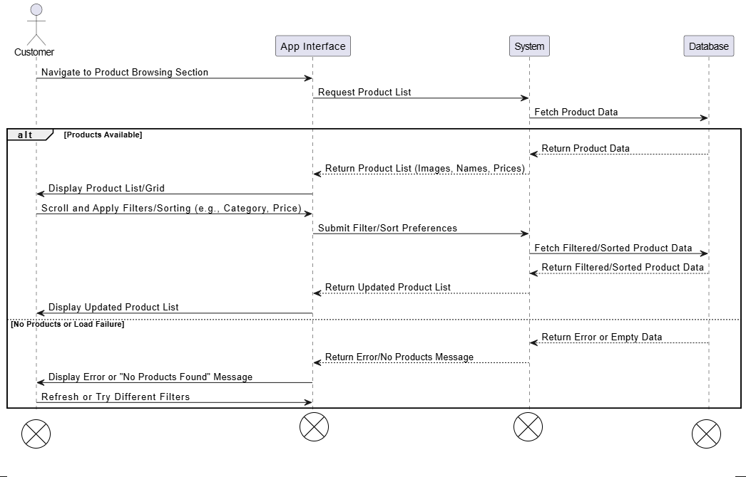

*Figure4.3: Sequence Diagram for Product Browsing*

### Product Details sequence diagram

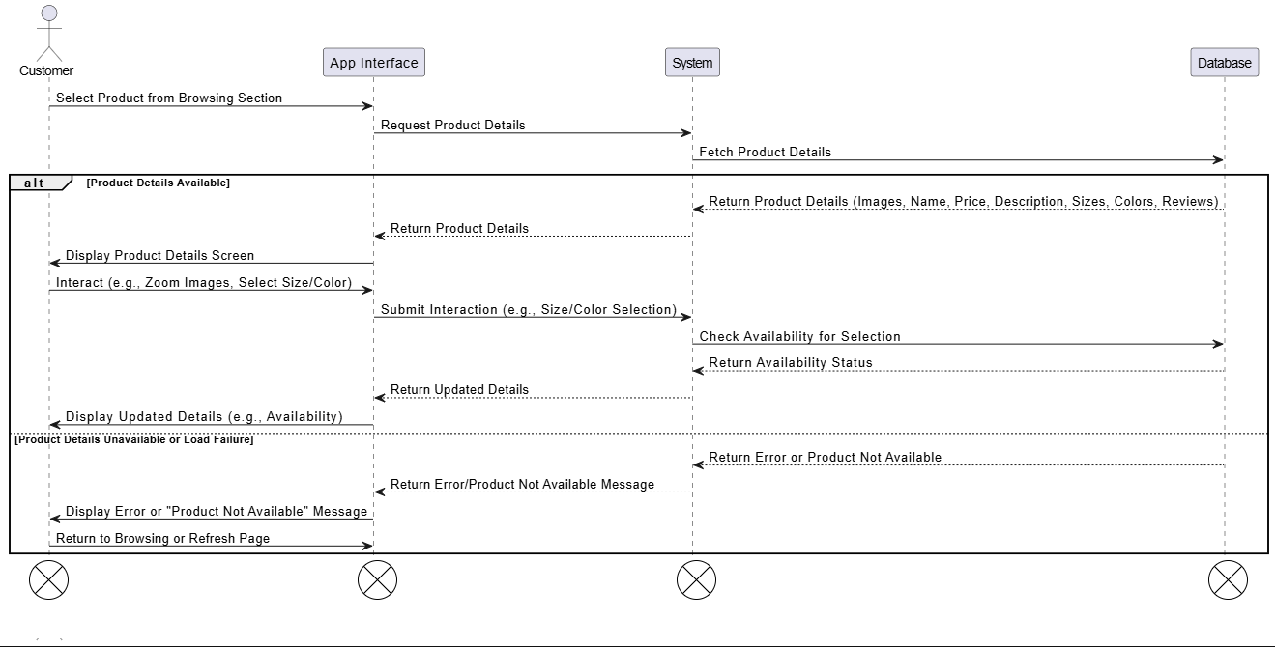

*Figure4.4: Sequence Diagram for Product Details*

### Add to Cart Sequence Diagram

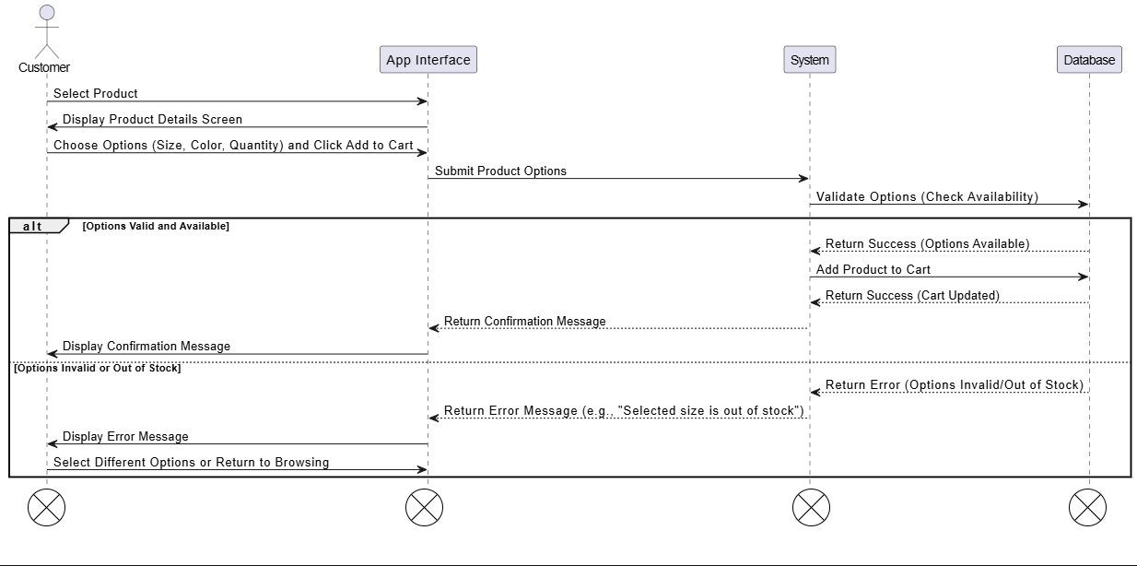

*Figure4.5: Sequence Diagram for Add to Cart*

### Order Placement and Checkout Sequence Diagram

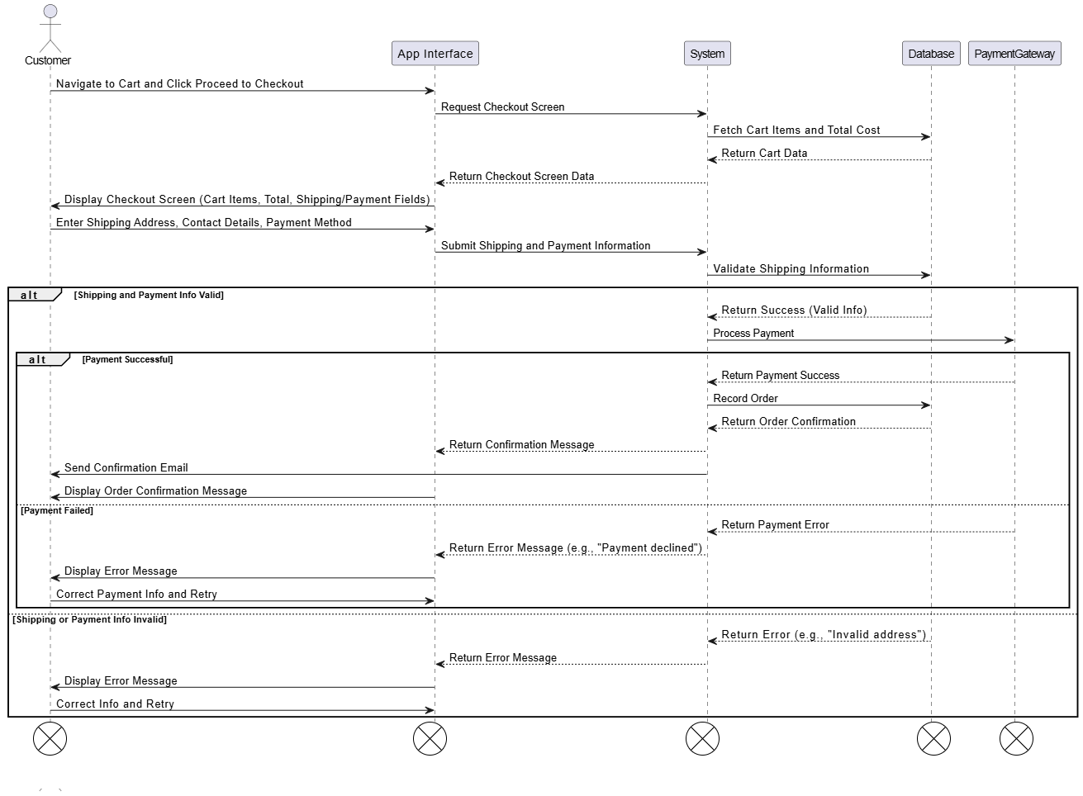

*Figure4.6: Sequence Diagram for Order Placement and Checkout*

### Discover by Categories Sequence Diagram

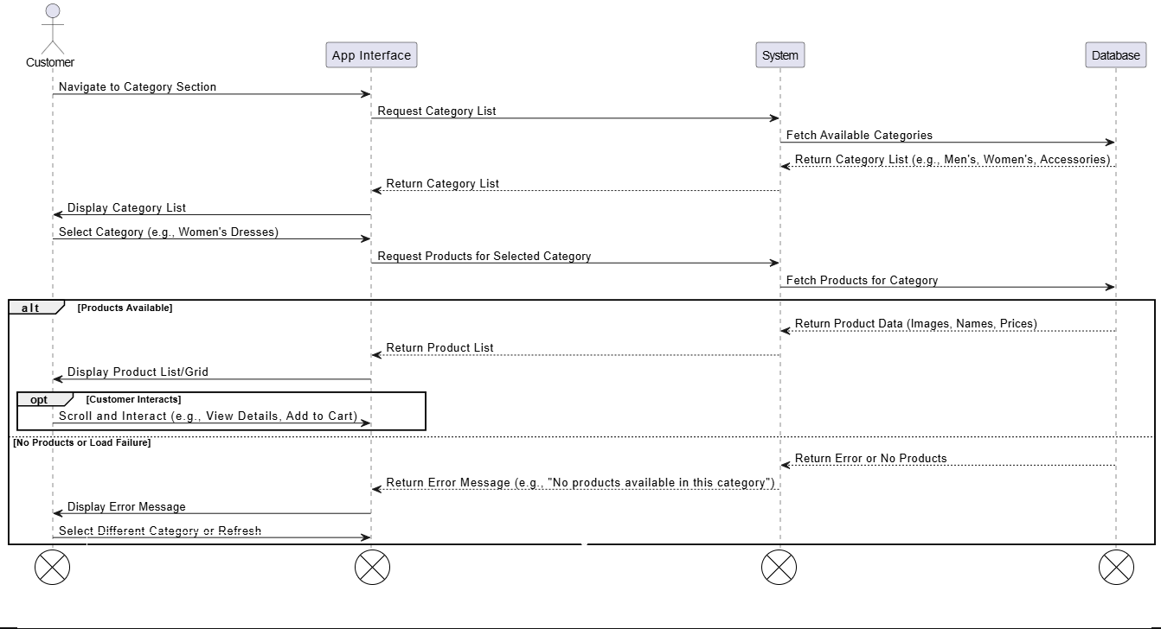

*Figure4.7: Sequence Diagram for Discover by Categories*

### Profile Management Sequence Diagram

**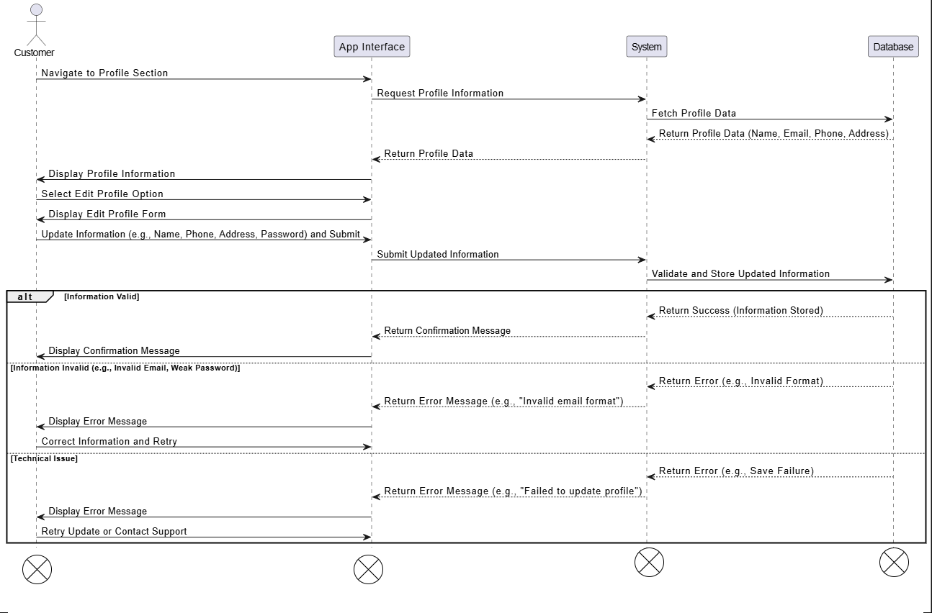***Figure4.8: Sequence Diagram for Profile Management*

### Trending Products based on Area Sequence Diagram

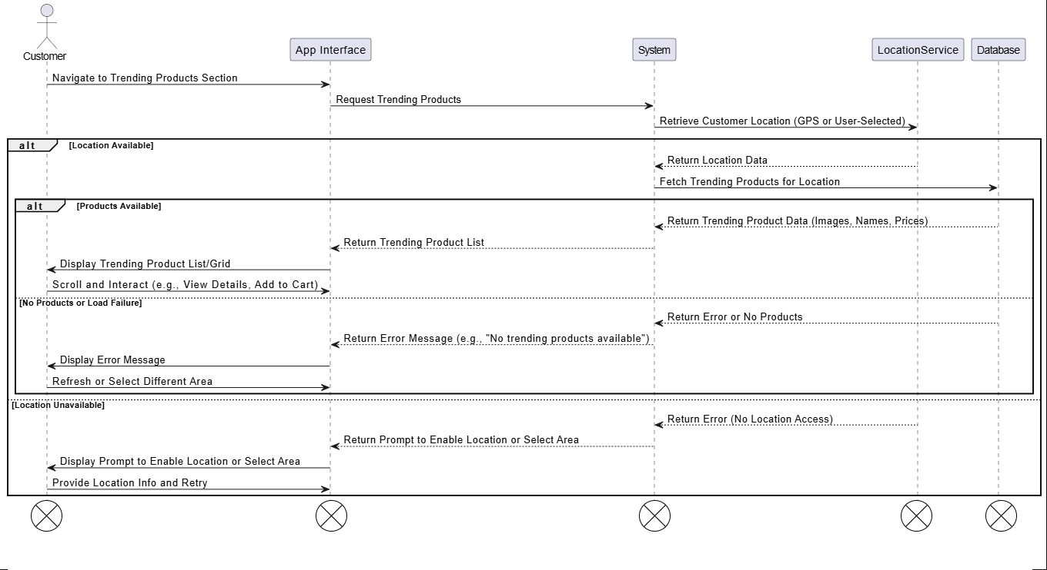

*Figure4.9: Sequence Diagram for Trending Products based on Area*

### Quote of the Day Sequence Diagram

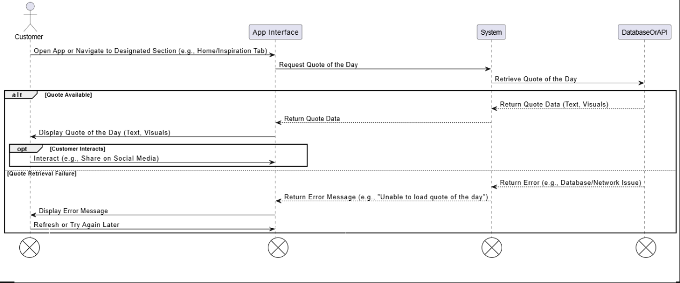

*Figure4.10: Sequence Diagram for Quote of the Day*

## ERD

|  |
| --- |
| Picture 44, Picture |

Figure 3.89: ERD of Dressi

# Chapter 5 User Manual

### Login

User enter email and password and then clicks on “*login button”*.

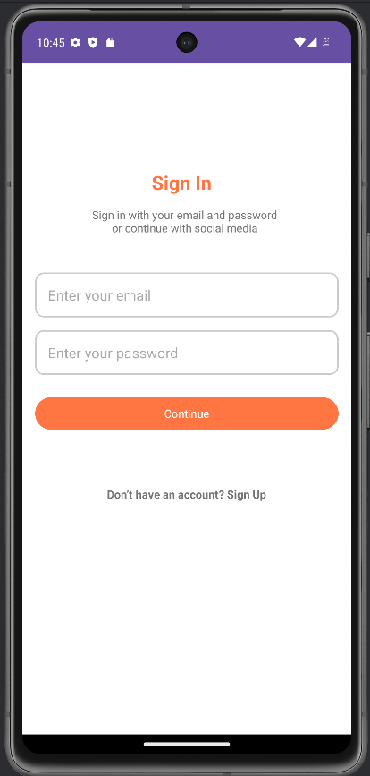

*Figure 5.1 Customer Login*

Signup

User enters name, email, and password for registering an account.

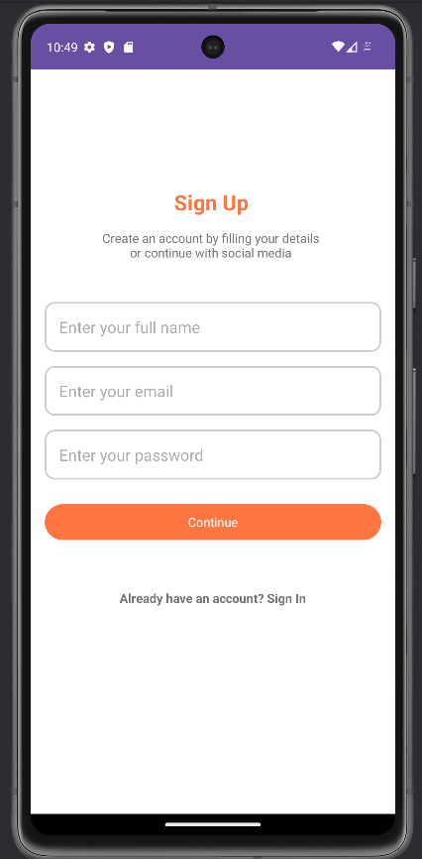

*Figure 5.2 Sign-Up Page*

### Home Page

When user clicks on sign in it will direct to the homepage.

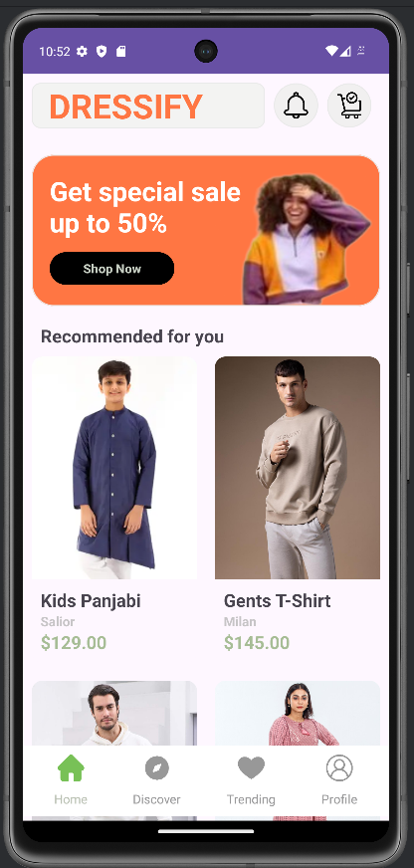

*Figure 5.3 Home Page*

### Add to Cart

User click on “A*dd to cart and it will direct to checkout and place order.*

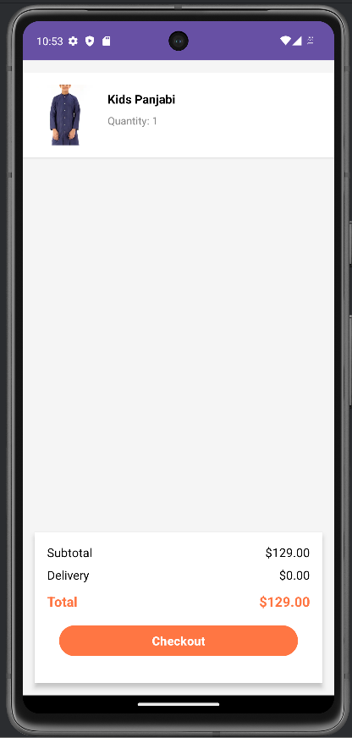

*Figure 5.4 Add to Cart*

### Discover by Categories

User click on “A*dd student”* and fill required fields to add new student.

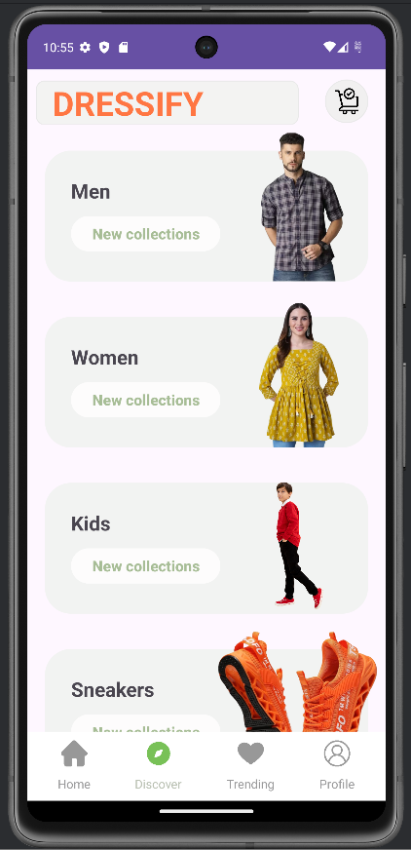

*Figure 5.5 Discover by categories*

### Product Suggestion by Loaction

PMO clicks on “*All Students”* to view no of students.

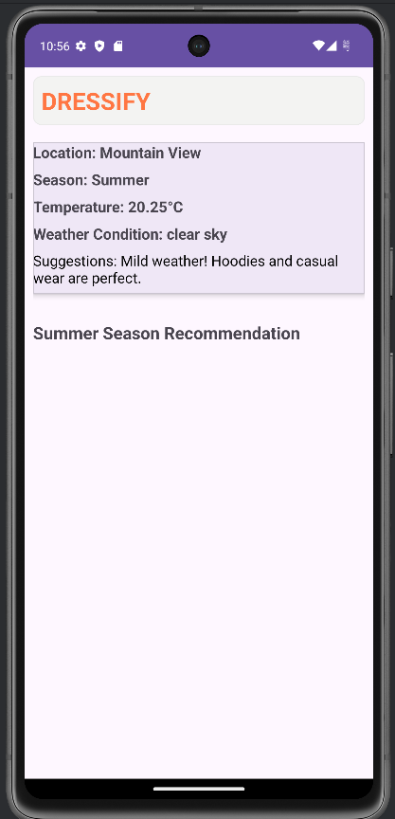

*Figure 5.6 View All Students*

### Profile Update

User clicks on “*Update button”* of specific *Student* to update or edit its data, makes changings and then click on “*Update”* button.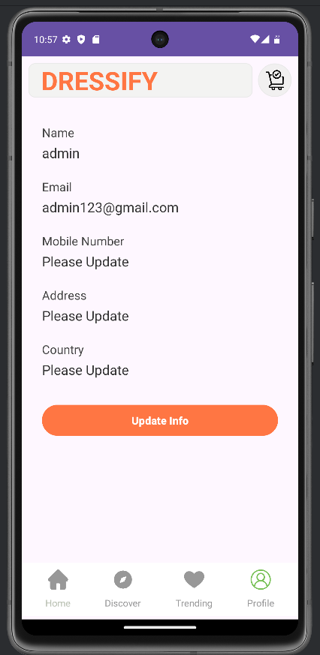

*Figure 5.7 Update Student*

### Splash Screen

User clicks on “*Dressify” and the splash screen will appear for some seconds. Where user will clickon button getting started.*

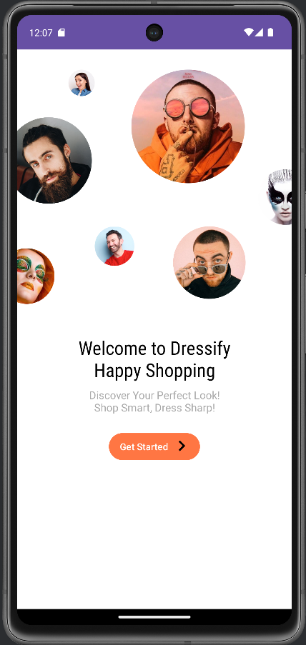

*Figure 5.8 Splash Screen*

### Quote of the Day

User clicks on “*Quote of the day ”* and thescreen will show the specific quote to the user.

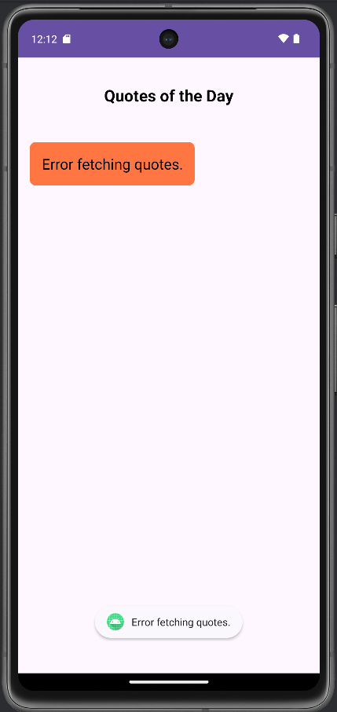

*Figure 5.9 Quote of the day*

# References:

**For URL:**