Database Project GUI
Name: Abeer Ashraf | Wania Khurram
Roll no: 24F-0762 | 24F-0751
BCS-4A
Forms
DB HELPER:
using Oracle.ManagedDataAccess.Client;
using System.Data;

namespace BankManagementSystem
{
public class DBHelper
{
private static string connStr =
"User Id=system;Password=123456789;Data Source=127.0.0.1:1521/XE;";

public static OracleConnection GetConnection()
{
OracleConnection conn = new OracleConnection(connStr);
conn.Open();
return conn;
}
}
}
LOGIN FORM:
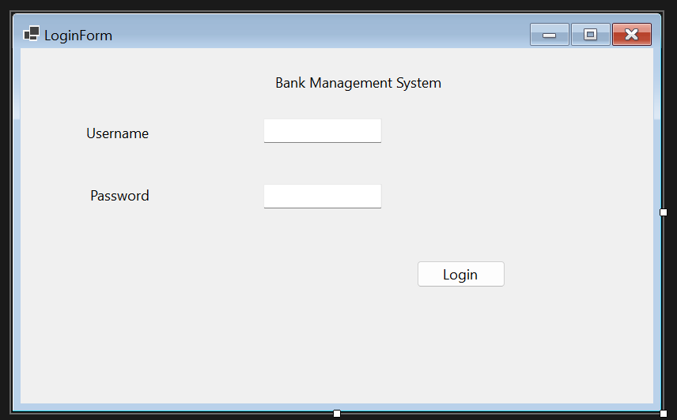
CODE:
using System;
using System.Collections.Generic;
using System.ComponentModel;
using System.Data;
using System.Drawing;
using System.Linq;
using System.Text;
using System.Threading.Tasks;
using System.Windows.Forms;
using Oracle.ManagedDataAccess.Client;

namespace BankManagementSystem
{
public partial class LoginForm : Form
{
public LoginForm()
{
InitializeComponent();
}

private void btnLogin_Click(object sender, EventArgs e)
{
string username = txtUsername.Text.Trim();
string password = txtPassword.Text.Trim();

if (username == "" || password == "")
{
MessageBox.Show("Please enter username and password!", "Warning");
return;
}

try
{
using (OracleConnection conn = DBHelper.GetConnection())
{
string query = "SELECT Position FROM WANIA.Employee WHERE Email = :username AND SSN = :password";
OracleCommand cmd = new OracleCommand(query, conn);
cmd.Parameters.Add("username", OracleDbType.Varchar2).Value = username;
cmd.Parameters.Add("password", OracleDbType.Varchar2).Value = password;

string position = cmd.ExecuteScalar()?.ToString();

if (position == null)
{
MessageBox.Show("❌ Invalid username or password!", "Login Failed");
}
else
{
MessageBox.Show("✅ Welcome! Role: " + position);
this.Hide();
new DashboardForm().Show();
}
}
}
catch (Exception ex)
{
MessageBox.Show("Error: " + ex.Message);
}
}
}
}
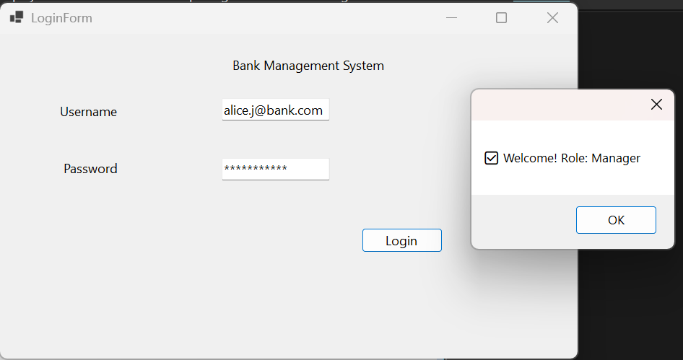
CUSTOMER FORM:
using System;
using System.Collections.Generic;
using System.ComponentModel;
using System.Data;
using System.Drawing;
using System.Linq;
using System.Text;
using System.Threading.Tasks;
using System.Windows.Forms;
using Oracle.ManagedDataAccess.Client;

namespace BankManagementSystem
{
public partial class CustomerForm : Form
{
public CustomerForm()
{
InitializeComponent();
LoadCustomers();
}

private void btnClear_Click(object sender, EventArgs e)
{
txtCusID.Text = "";
txtFName.Text = "";
txtLName.Text = "";
txtEmail.Text = "";
txtPhone.Text = "";
txtAddress.Text = "";
}

private void LoadCustomers()
{
try
{
using (OracleConnection conn = DBHelper.GetConnection())
{
string query = "SELECT CusID, FName, LName, Email, PhoneNo, Address FROM WANIA.Customer";
OracleDataAdapter da = new OracleDataAdapter(query, conn);
DataTable dt = new DataTable();
da.Fill(dt);
dgvCustomers.DataSource = dt;
}
}
catch (Exception ex)
{
MessageBox.Show("Error: " + ex.Message);
}
}
private void btnDelete_Click(object sender, EventArgs e)
{
if (MessageBox.Show("Are you sure?", "Confirm", MessageBoxButtons.YesNo) == DialogResult.Yes)
{
try
{
using (OracleConnection conn = DBHelper.GetConnection())
{
string query = "DELETE FROM WANIA.Customer WHERE CusID = :id";
OracleCommand cmd = new OracleCommand(query, conn);
cmd.Parameters.Add("id", OracleDbType.Int32).Value = int.Parse(txtCusID.Text);
cmd.ExecuteNonQuery();
MessageBox.Show("✅ Customer deleted!");
LoadCustomers();
btnClear_Click(sender, e);
}
}
catch (Exception ex)
{
MessageBox.Show("Error: " + ex.Message);
}
}
}

private void btnUpdate_Click(object sender, EventArgs e)
{
try
{
using (OracleConnection conn = DBHelper.GetConnection())
{
string query = "UPDATE WANIA.Customer SET FName=:fn, LName=:ln, Email=:em, PhoneNo=:ph, Address=:ad WHERE CusID=:id";
OracleCommand cmd = new OracleCommand(query, conn);
cmd.Parameters.Add("fn", OracleDbType.Varchar2).Value = txtFName.Text;
cmd.Parameters.Add("ln", OracleDbType.Varchar2).Value = txtLName.Text;
cmd.Parameters.Add("em", OracleDbType.Varchar2).Value = txtEmail.Text;
cmd.Parameters.Add("ph", OracleDbType.Varchar2).Value = txtPhone.Text;
cmd.Parameters.Add("ad", OracleDbType.Varchar2).Value = txtAddress.Text;
cmd.Parameters.Add("id", OracleDbType.Int32).Value = int.Parse(txtCusID.Text);
cmd.ExecuteNonQuery();
MessageBox.Show("✅ Customer updated successfully!");
LoadCustomers();
}
}
catch (Exception ex)
{
MessageBox.Show("Error: " + ex.Message);
}
}

private void btnAdd_Click(object sender, EventArgs e)
{
try
{
using (OracleConnection conn = DBHelper.GetConnection())
{
OracleCommand cmd = new OracleCommand("WANIA.sp_AddCustomer", conn);
cmd.CommandType = CommandType.StoredProcedure;
cmd.Parameters.Add("p_CusID", OracleDbType.Int32).Value = int.Parse(txtCusID.Text);
cmd.Parameters.Add("p_SSN", OracleDbType.Varchar2).Value = "000-00-0000";
cmd.Parameters.Add("p_FName", OracleDbType.Varchar2).Value = txtFName.Text;
cmd.Parameters.Add("p_LName", OracleDbType.Varchar2).Value = txtLName.Text;
cmd.Parameters.Add("p_DOB", OracleDbType.Date).Value = DateTime.Now;
cmd.Parameters.Add("p_Email", OracleDbType.Varchar2).Value = txtEmail.Text;
cmd.Parameters.Add("p_PhoneNo", OracleDbType.Varchar2).Value = txtPhone.Text;
cmd.Parameters.Add("p_Address", OracleDbType.Varchar2).Value = txtAddress.Text;
cmd.ExecuteNonQuery();
MessageBox.Show("✅ Customer added successfully!");
LoadCustomers();
btnClear_Click(sender, e);
}
}
catch (Exception ex)
{
MessageBox.Show("Error: " + ex.Message);
}
}

private void btnSearch_Click(object sender, EventArgs e)
{
try
{
using (OracleConnection conn = DBHelper.GetConnection())
{
string query = "SELECT CusID, FName, LName, Email, PhoneNo, Address FROM WANIA.Customer WHERE CusID = :id";
OracleCommand cmd = new OracleCommand(query, conn);
cmd.Parameters.Add("id", OracleDbType.Int32).Value = int.Parse(txtCusID.Text);
OracleDataAdapter da = new OracleDataAdapter(cmd);
DataTable dt = new DataTable();
da.Fill(dt);
if (dt.Rows.Count > 0)
{
txtFName.Text = dt.Rows[0]["FName"].ToString();
txtLName.Text = dt.Rows[0]["LName"].ToString();
txtEmail.Text = dt.Rows[0]["Email"].ToString();
txtPhone.Text = dt.Rows[0]["PhoneNo"].ToString();
txtAddress.Text = dt.Rows[0]["Address"].ToString();
}
else
{
MessageBox.Show("Customer not found!");
}
}
}
catch (Exception ex)
{
MessageBox.Show("Error: " + ex.Message);
}
}
}
}
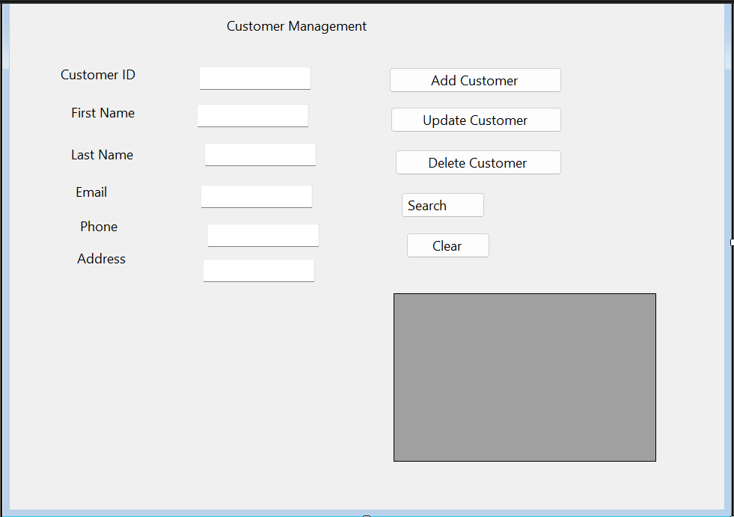
ACCOUNT FORM:
using System;
using System.Collections.Generic;
using System.ComponentModel;
using System.Data;
using System.Drawing;
using System.Linq;
using System.Text;
using System.Threading.Tasks;
using System.Windows.Forms;
using Oracle.ManagedDataAccess.Client;

namespace BankManagementSystem
{
public partial class AccountForm : Form
{
public AccountForm()
{
InitializeComponent();
cmbType.Items.AddRange(new string[] { "Checking", "Saving", "CD" });
cmbType.SelectedIndex = 0;
LoadAccounts();
}

private void LoadAccounts()
{
try
{
using (OracleConnection conn = DBHelper.GetConnection())
{
string query = "SELECT AccNo, TypeCode, Balance, Status, CusID, BranchID FROM WANIA.Account";
OracleDataAdapter da = new OracleDataAdapter(query, conn);
DataTable dt = new DataTable();
da.Fill(dt);
dgvAccounts.DataSource = dt;
}
}
catch (Exception ex)
{
MessageBox.Show("Error: " + ex.Message);
}
}
private void btnAdd_Click(object sender, EventArgs e)
{
try
{
using (OracleConnection conn = DBHelper.GetConnection())
{
OracleCommand cmd = new OracleCommand("WANIA.sp_AddAccount", conn);
cmd.CommandType = CommandType.StoredProcedure;
cmd.Parameters.Add("p_AccNo", OracleDbType.Int32).Value = int.Parse(txtAccNo.Text);
cmd.Parameters.Add("p_Balance", OracleDbType.Decimal).Value = decimal.Parse(txtBalance.Text);
cmd.Parameters.Add("p_Rate", OracleDbType.Decimal).Value = 0.015;
cmd.Parameters.Add("p_TypeCode", OracleDbType.Varchar2).Value = cmbType.SelectedItem.ToString();
cmd.Parameters.Add("p_CusID", OracleDbType.Int32).Value = int.Parse(txtCusID.Text);
cmd.Parameters.Add("p_BranchID", OracleDbType.Int32).Value = int.Parse(txtBranchID.Text);
cmd.ExecuteNonQuery();
MessageBox.Show("✅ Account added successfully!");
LoadAccounts();
btnClear_Click(sender, e);
}
}
catch (Exception ex)
{
MessageBox.Show("Error: " + ex.Message);
}
}

private void btnClear_Click(object sender, EventArgs e)
{
txtAccNo.Text = "";
txtBalance.Text = "";
txtCusID.Text = "";
txtBranchID.Text = "";
cmbType.SelectedIndex = 0;
}

private void btnSearch_Click(object sender, EventArgs e)
{
try
{
using (OracleConnection conn = DBHelper.GetConnection())
{
string query = "SELECT AccNo, TypeCode, Balance, Status, CusID, BranchID FROM WANIA.Account WHERE AccNo = :id";
OracleCommand cmd = new OracleCommand(query, conn);
cmd.Parameters.Add("id", OracleDbType.Int32).Value = int.Parse(txtAccNo.Text);
OracleDataAdapter da = new OracleDataAdapter(cmd);
DataTable dt = new DataTable();
da.Fill(dt);
if (dt.Rows.Count > 0)
{
txtBalance.Text = dt.Rows[0]["Balance"].ToString();
txtCusID.Text = dt.Rows[0]["CusID"].ToString();
txtBranchID.Text = dt.Rows[0]["BranchID"].ToString();
cmbType.SelectedItem = dt.Rows[0]["TypeCode"].ToString();
}
else
{
MessageBox.Show("Account not found!");
}
}
}
catch (Exception ex)
{
MessageBox.Show("Error: " + ex.Message);
}
}

private void btnUpdate_Click(object sender, EventArgs e)
{
try
{
using (OracleConnection conn = DBHelper.GetConnection())
{
OracleCommand cmd = new OracleCommand("WANIA.sp_UpdateAccountStatus", conn);
cmd.CommandType = CommandType.StoredProcedure;
cmd.Parameters.Add("p_AccNo", OracleDbType.Int32).Value = int.Parse(txtAccNo.Text);
cmd.Parameters.Add("p_Status", OracleDbType.Varchar2).Value = "Inactive";
cmd.ExecuteNonQuery();
MessageBox.Show("✅ Account status updated!");
LoadAccounts();
}
}
catch (Exception ex)
{
MessageBox.Show("Error: " + ex.Message);
}
}
}
}
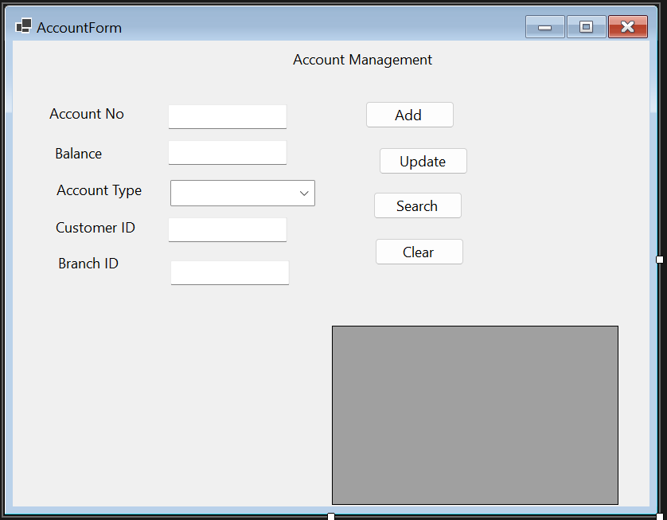
TRANSACTION FORM:
using System;
using System.Collections.Generic;
using System.ComponentModel;
using System.Data;
using System.Drawing;
using System.Linq;
using System.Text;
using System.Threading.Tasks;
using System.Windows.Forms;
using Oracle.ManagedDataAccess.Client;

namespace BankManagementSystem
{
public partial class TransactionForm : Form
{
public TransactionForm()
{
InitializeComponent();
cmbType.Items.AddRange(new string[] { "Deposit", "Withdrawal", "Transfer" });
cmbType.SelectedIndex = 0;
LoadTransactions();
}
private void LoadTransactions()
{
try
{
using (OracleConnection conn = DBHelper.GetConnection())
{
string query = "SELECT TransID, TypeCode, Amount, Trans_DateTime, AccNo FROM WANIA.Bank_Transaction ORDER BY Trans_DateTime DESC";
OracleDataAdapter da = new OracleDataAdapter(query, conn);
DataTable dt = new DataTable();
da.Fill(dt);
dgvTransactions.DataSource = dt;
}
}
catch (Exception ex)
{
MessageBox.Show("Error: " + ex.Message);
}
}
private void btnProcess_Click(object sender, EventArgs e)
{
try
{
using (OracleConnection conn = DBHelper.GetConnection())
{
string type = cmbType.SelectedItem.ToString();
OracleCommand cmd = new OracleCommand();
cmd.Connection = conn;
cmd.CommandType = CommandType.StoredProcedure;

if (type == "Deposit")
{
cmd.CommandText = "WANIA.sp_Deposit";
cmd.Parameters.Add("p_TransID", OracleDbType.Int32).Value = int.Parse(txtTransID.Text);
cmd.Parameters.Add("p_AccNo", OracleDbType.Int32).Value = int.Parse(txtAccNo.Text);
cmd.Parameters.Add("p_Amount", OracleDbType.Decimal).Value = decimal.Parse(txtAmount.Text);
cmd.Parameters.Add("p_EmpID", OracleDbType.Int32).Value = 2;
cmd.Parameters.Add("p_Description", OracleDbType.Varchar2).Value = "Deposit via System";
}
else if (type == "Withdrawal")
{
cmd.CommandText = "WANIA.sp_Withdrawal";
cmd.Parameters.Add("p_TransID", OracleDbType.Int32).Value = int.Parse(txtTransID.Text);
cmd.Parameters.Add("p_AccNo", OracleDbType.Int32).Value = int.Parse(txtAccNo.Text);
cmd.Parameters.Add("p_Amount", OracleDbType.Decimal).Value = decimal.Parse(txtAmount.Text);
cmd.Parameters.Add("p_PIN", OracleDbType.Varchar2).Value = "0000";
}
else if (type == "Transfer")
{
cmd.CommandText = "WANIA.sp_Transfer";
cmd.Parameters.Add("p_TransID", OracleDbType.Int32).Value = int.Parse(txtTransID.Text);
cmd.Parameters.Add("p_FromAccNo", OracleDbType.Int32).Value = int.Parse(txtAccNo.Text);
cmd.Parameters.Add("p_ToAccNo", OracleDbType.Int32).Value = int.Parse(txtToAccNo.Text);
cmd.Parameters.Add("p_Amount", OracleDbType.Decimal).Value = decimal.Parse(txtAmount.Text);
cmd.Parameters.Add("p_EmpID", OracleDbType.Int32).Value = 2;
}

cmd.ExecuteNonQuery();
MessageBox.Show("✅ Transaction processed successfully!");
LoadTransactions();
btnClear_Click(sender, e);
}
}
catch (Exception ex)
{
MessageBox.Show("Error: " + ex.Message);
}
}
private void btnClear_Click(object sender, EventArgs e)
{
txtTransID.Text = "";
txtAmount.Text = "";
txtAccNo.Text = "";
txtToAccNo.Text = "";
cmbType.SelectedIndex = 0;
}

private void cmbType_SelectedIndexChanged(object sender, EventArgs e)
{

}
}
}

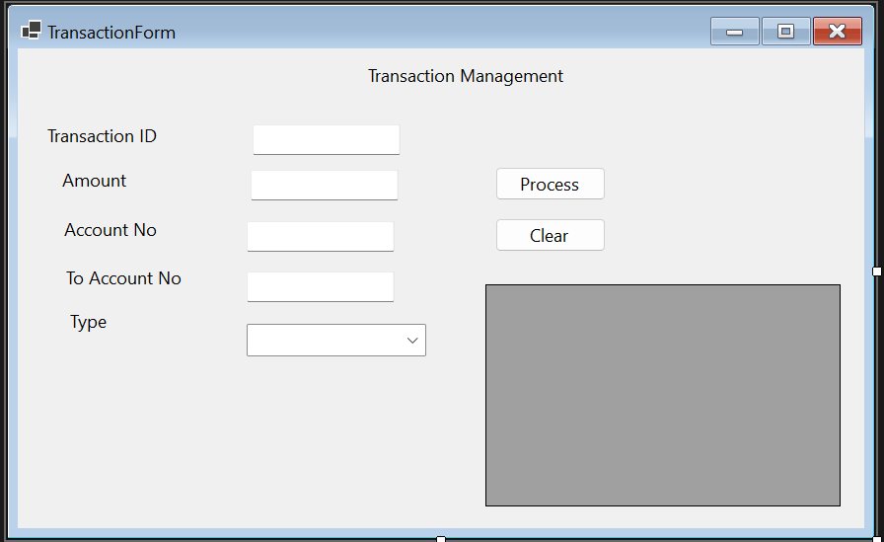
LOAN FORM:
using System;
using System.Collections.Generic;
using System.ComponentModel;
using System.Data;
using System.Drawing;
using System.Linq;
using System.Text;
using System.Threading.Tasks;
using System.Windows.Forms;
using Oracle.ManagedDataAccess.Client;

namespace BankManagementSystem
{
public partial class LoanForm : Form
{
public LoanForm()
{
InitializeComponent();
cmbType.Items.AddRange(new string[] { "Mortgage", "CarLoan", "PersonalLoan" });
cmbType.SelectedIndex = 0;
LoadLoans();
}

private void txtLoanID_TextChanged(object sender, EventArgs e)
{

}

private void txtAmount_TextChanged(object sender, EventArgs e)
{

}

private void btnAdd_Click(object sender, EventArgs e)
{
try
{
using (OracleConnection conn = DBHelper.GetConnection())
{
OracleCommand cmd = new OracleCommand("WANIA.sp_AddLoan", conn);
cmd.CommandType = CommandType.StoredProcedure;
cmd.Parameters.Add("p_LoanID", OracleDbType.Int32).Value = int.Parse(txtLoanID.Text);
cmd.Parameters.Add("p_Amount", OracleDbType.Decimal).Value = decimal.Parse(txtAmount.Text);
cmd.Parameters.Add("p_Rate", OracleDbType.Decimal).Value = decimal.Parse(txtRate.Text);
cmd.Parameters.Add("p_Term", OracleDbType.Int32).Value = int.Parse(txtTerm.Text);
cmd.Parameters.Add("p_LoanType", OracleDbType.Varchar2).Value = cmbType.SelectedItem.ToString();
cmd.Parameters.Add("p_CusID", OracleDbType.Int32).Value = int.Parse(txtCusID.Text);
cmd.Parameters.Add("p_BranchID", OracleDbType.Int32).Value = int.Parse(txtBranchID.Text);
cmd.ExecuteNonQuery();
MessageBox.Show("✅ Loan added successfully!");
LoadLoans();
btnClear_Click(sender, e);
}
}
catch (Exception ex)
{
MessageBox.Show("Error: " + ex.Message);
}
}
private void LoadLoans()
{
try
{
using (OracleConnection conn = DBHelper.GetConnection())
{
string query = "SELECT LoanID, LoanType, Amount, CurrBal, Rate, Status, CusID FROM WANIA.Loan";
OracleDataAdapter da = new OracleDataAdapter(query, conn);
DataTable dt = new DataTable();
da.Fill(dt);
dgvLoans.DataSource = dt;
}
}
catch (Exception ex)
{
MessageBox.Show("Error: " + ex.Message);
}
}
private void btnClear_Click(object sender, EventArgs e)
{
txtLoanID.Text = "";
txtAmount.Text = "";
txtRate.Text = "";
txtTerm.Text = "";
txtCusID.Text = "";
txtBranchID.Text = "";
txtPayment.Text = "";
cmbType.SelectedIndex = 0;
}

private void btnPay_Click(object sender, EventArgs e)
{
try
{
using (OracleConnection conn = DBHelper.GetConnection())
{
OracleCommand cmd = new OracleCommand("WANIA.sp_UpdateLoanBalance", conn);
cmd.CommandType = CommandType.StoredProcedure;
cmd.Parameters.Add("p_LoanID", OracleDbType.Int32).Value = int.Parse(txtLoanID.Text);
cmd.Parameters.Add("p_PaymentAmount", OracleDbType.Decimal).Value = decimal.Parse(txtPayment.Text);
cmd.ExecuteNonQuery();
MessageBox.Show("✅ Payment processed successfully!");
LoadLoans();
}
}
catch (Exception ex)
{
MessageBox.Show("Error: " + ex.Message);
}
}
}
}
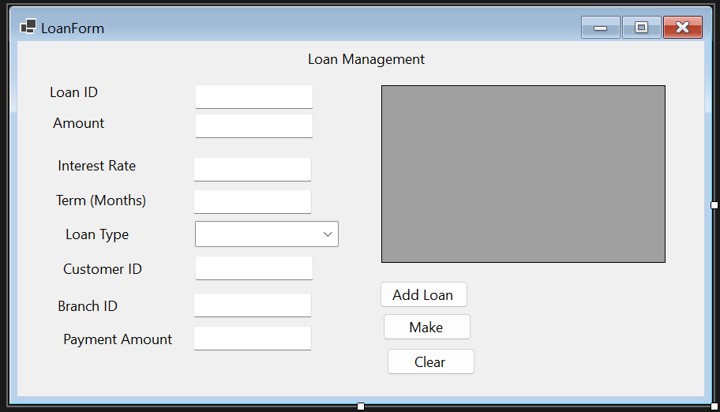
EMPLOYEE FORM:
using System;
using System.Collections.Generic;
using System.ComponentModel;
using System.Data;
using System.Drawing;
using System.Linq;
using System.Text;
using System.Threading.Tasks;
using System.Windows.Forms;
using Oracle.ManagedDataAccess.Client;

namespace BankManagementSystem
{
public partial class EmployeeForm : Form
{
public EmployeeForm()
{
InitializeComponent();
LoadEmployees();
}

private void LoadEmployees()
{
try
{
using (OracleConnection conn = DBHelper.GetConnection())
{
string query = "SELECT EmpID, FName, LName, Position, Salary, Email, BranchID FROM WANIA.Employee";
OracleDataAdapter da = new OracleDataAdapter(query, conn);
DataTable dt = new DataTable();
da.Fill(dt);
dgvEmployees.DataSource = dt;
}
}
catch (Exception ex)
{
MessageBox.Show("Error: " + ex.Message);
}
}
private void btnSearch_Click(object sender, EventArgs e)
{
try
{
using (OracleConnection conn = DBHelper.GetConnection())
{
string query = "SELECT EmpID, FName, LName, Position, Salary, Email, BranchID FROM WANIA.Employee WHERE EmpID = :id";
OracleCommand cmd = new OracleCommand(query, conn);
cmd.Parameters.Add("id", OracleDbType.Int32).Value = int.Parse(txtEmpID.Text);
OracleDataAdapter da = new OracleDataAdapter(cmd);
DataTable dt = new DataTable();
da.Fill(dt);
if (dt.Rows.Count > 0)
{
txtFName.Text = dt.Rows[0]["FName"].ToString();
txtLName.Text = dt.Rows[0]["LName"].ToString();
txtPosition.Text = dt.Rows[0]["Position"].ToString();
txtSalary.Text = dt.Rows[0]["Salary"].ToString();
txtEmail.Text = dt.Rows[0]["Email"].ToString();
txtBranchID.Text = dt.Rows[0]["BranchID"].ToString();
}
else
{
MessageBox.Show("Employee not found!");
}
}
}
catch (Exception ex)
{
MessageBox.Show("Error: " + ex.Message);
}
}

private void btnUpdateSalary_Click(object sender, EventArgs e)
{
try
{
using (OracleConnection conn = DBHelper.GetConnection())
{
OracleCommand cmd = new OracleCommand("WANIA.sp_UpdateSalary", conn);
cmd.CommandType = CommandType.StoredProcedure;
cmd.Parameters.Add("p_EmpID", OracleDbType.Int32).Value = int.Parse(txtEmpID.Text);
cmd.Parameters.Add("p_NewSalary", OracleDbType.Decimal).Value = decimal.Parse(txtSalary.Text);
cmd.ExecuteNonQuery();
MessageBox.Show("✅ Salary updated successfully!");
LoadEmployees();
}
}
catch (Exception ex)
{
MessageBox.Show("Error: " + ex.Message);
}
}

private void btnClear_Click(object sender, EventArgs e)
{
txtEmpID.Text = "";
txtFName.Text = "";
txtLName.Text = "";
txtPosition.Text = "";
txtSalary.Text = "";
txtEmail.Text = "";
txtBranchID.Text = "";
}
}
}

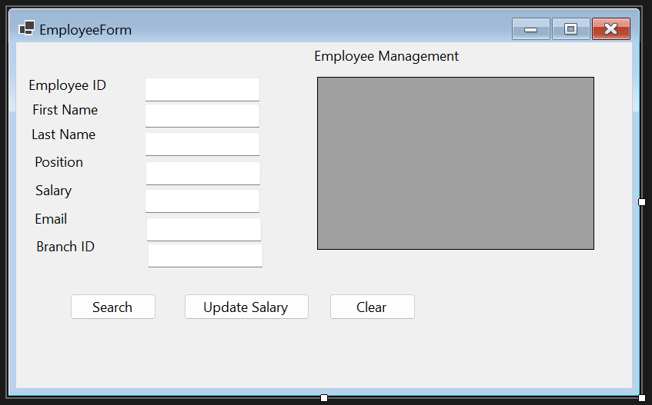
DASHBOARD FORM:
using System;
using System.Collections.Generic;
using System.ComponentModel;
using System.Data;
using System.Drawing;
using System.Linq;
using System.Text;
using System.Threading.Tasks;
using System.Windows.Forms;

namespace BankManagementSystem
{
public partial class DashboardForm : Form
{
public DashboardForm()
{
InitializeComponent();
}

private void btnAccount_Click(object sender, EventArgs e)
{
new AccountForm().Show();
}

private void btnCustomer_Click(object sender, EventArgs e)
{
new CustomerForm().Show();
}

private void btnTransaction_Click(object sender, EventArgs e)
{
new TransactionForm().Show();
}

private void btnLoan_Click(object sender, EventArgs e)
{
new LoanForm().Show();
}

private void btnEmployee_Click(object sender, EventArgs e)
{
new EmployeeForm().Show();
}

private void btnLogout_Click(object sender, EventArgs e)
{
this.Hide();
new LoginForm().Show();
}
}
}
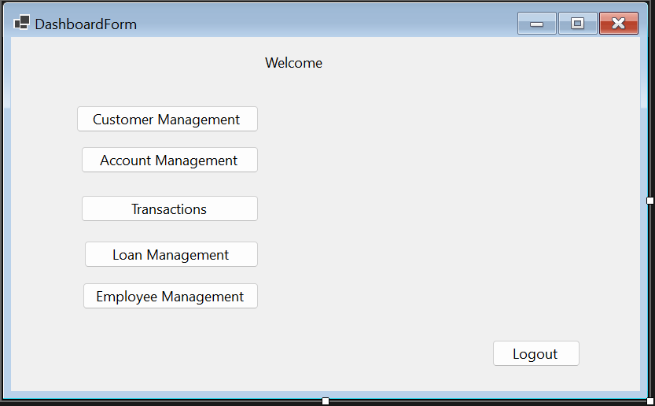

OUTPUT SCREEN SHOT:
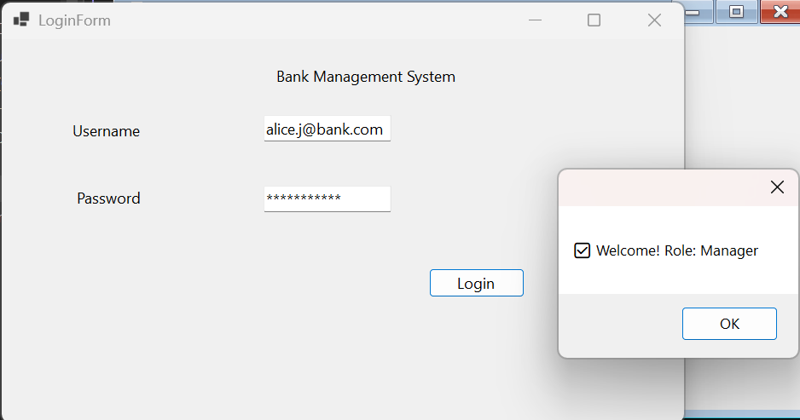
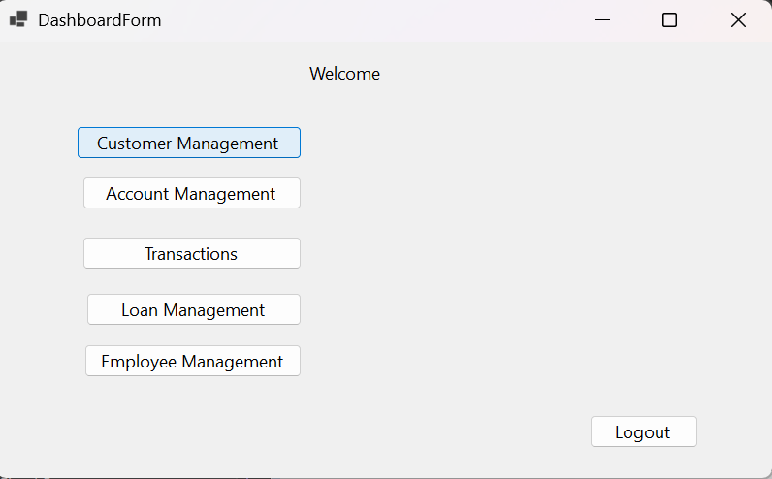
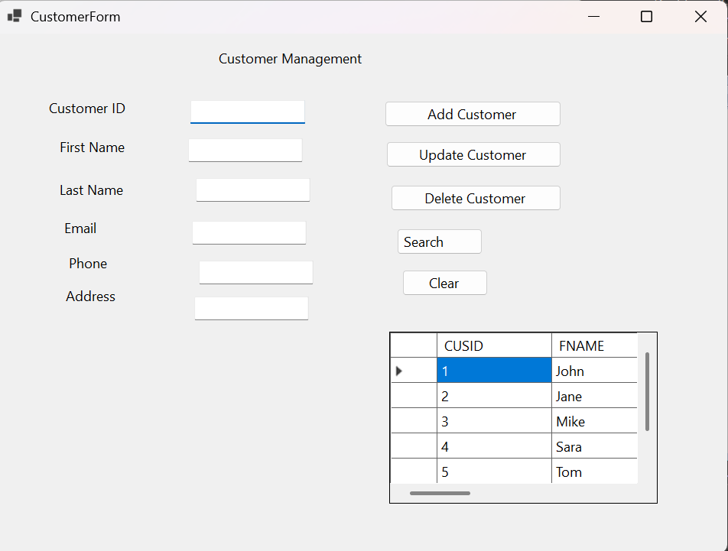
Add customer:
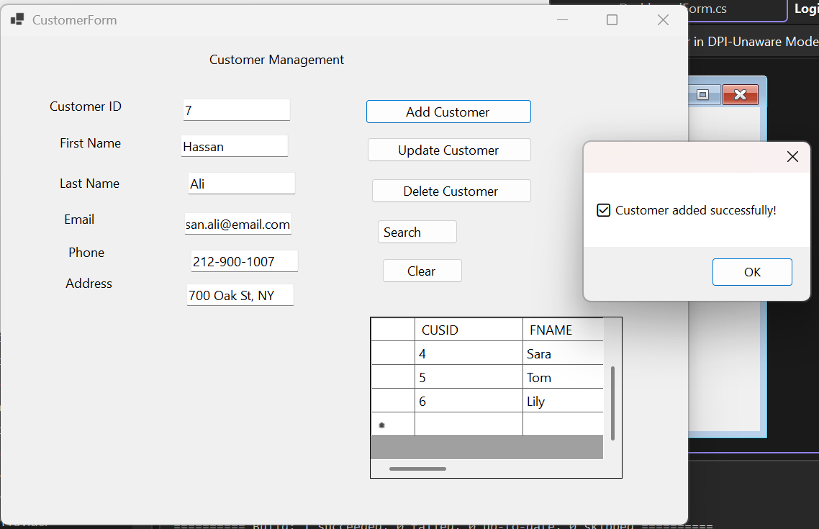
Account:
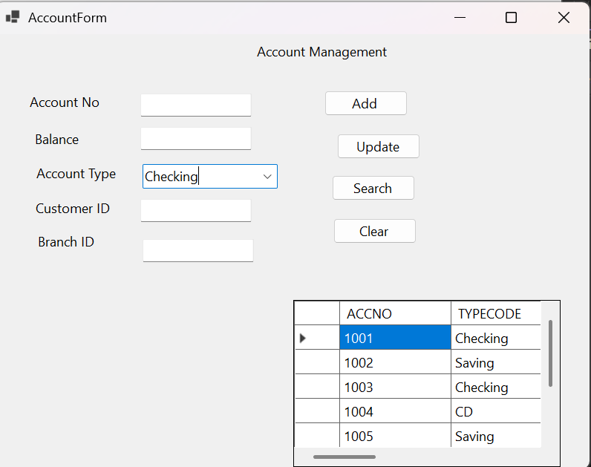
Check:
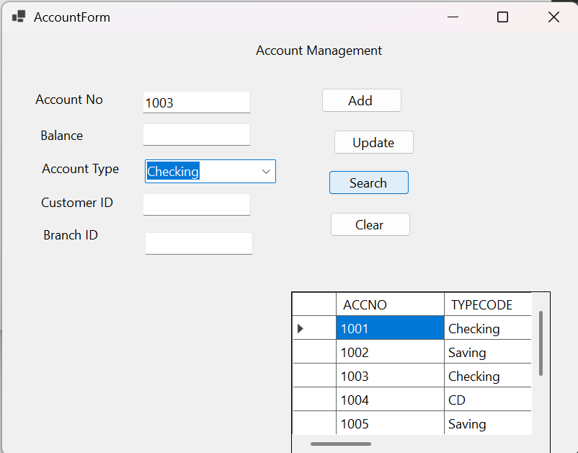
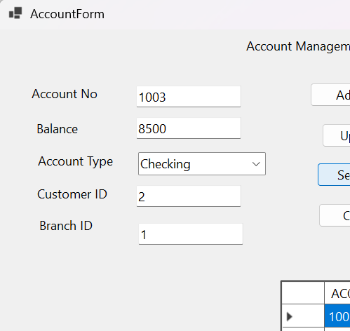
Transaction:
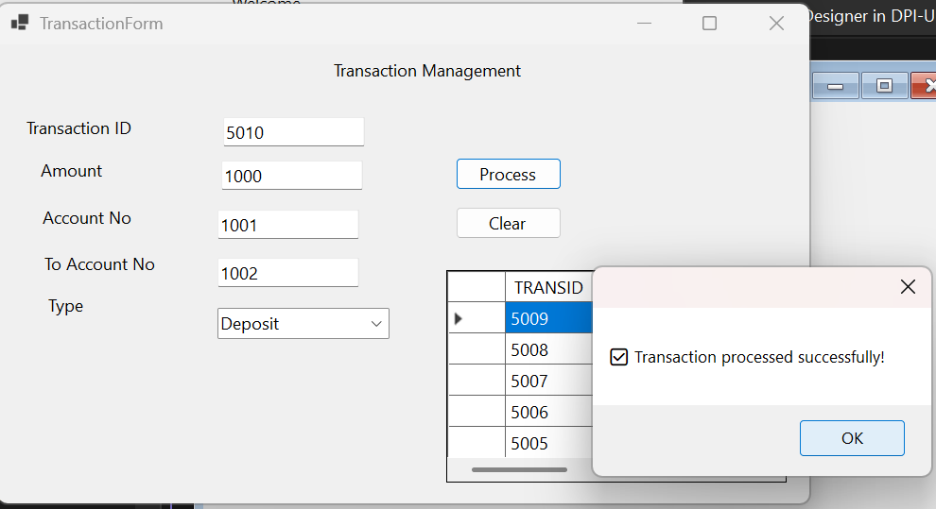
Loan:
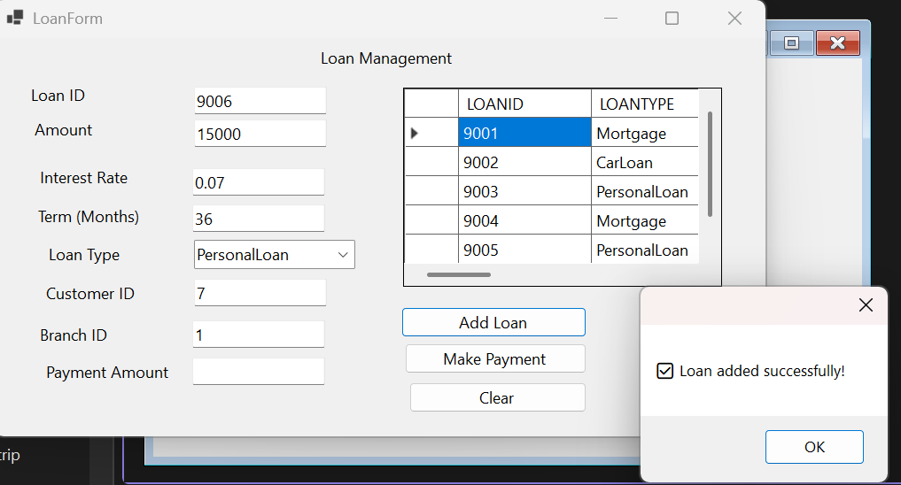
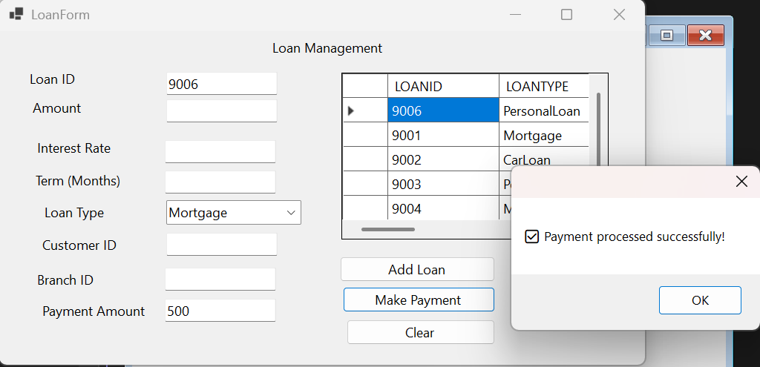
Employee
