To install the ESP32 board in your Arduino IDE, follow these next instructions:

1. In your Arduino IDE, go to **File**> **Preferences**

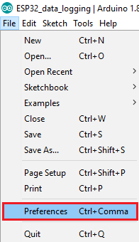

1. Enter the following into the “Additional Board Manager URLs” field:

https://raw.githubusercontent.com/espressif/arduino-esp32/gh-pages/package_esp32_index.json

Then, click the “OK” button:

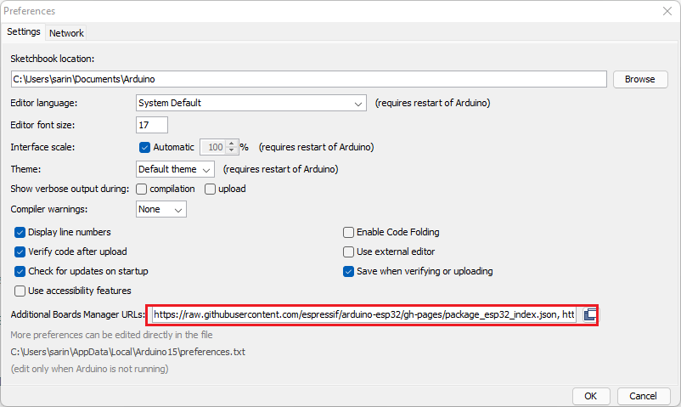

**Note:** if you already have the ESP8266 boards URL, you can separate the URLs with a comma as follows:

https://raw.githubusercontent.com/espressif/arduino-esp32/gh-pages/package_esp32_index.json, http://arduino.esp8266.com/stable/package_esp8266com_index.json

1. Open the Boards Manager. Go to **Tools** > **Board** > **Boards Manager…**

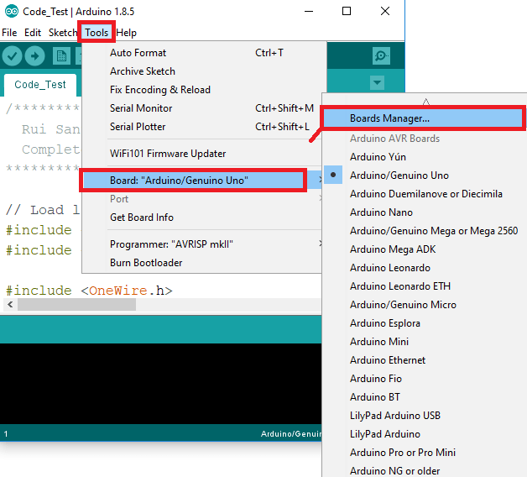

1. Search for **ESP32** and press install button for the “**ESP32 by Espressif Systems**“:

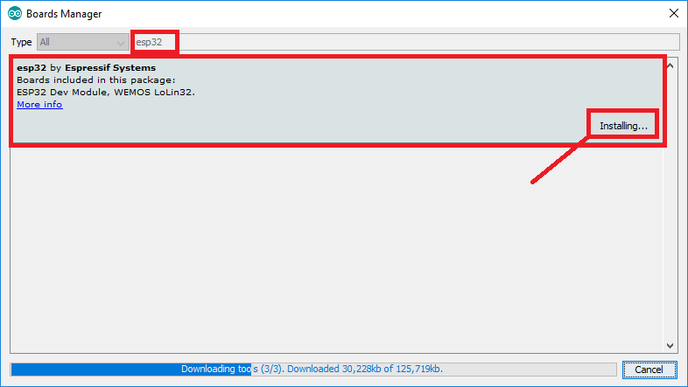

1. That’s it. It should be installed after a few seconds.

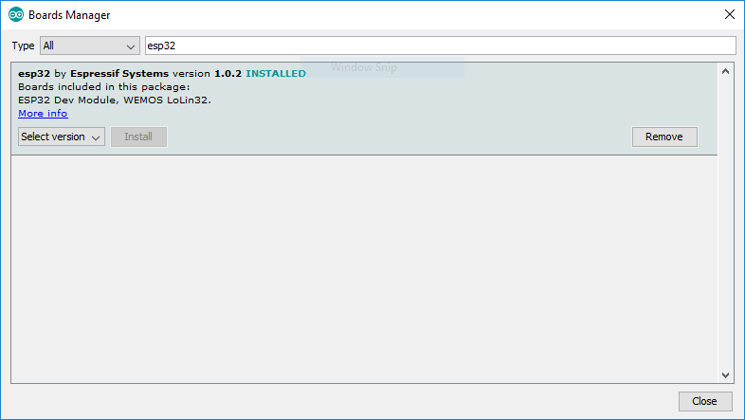

**Testing the Installation**

Plug the ESP32 board to your computer. With your Arduino IDE open, follow these steps:

1. Select your Board in **Tools** > **Board** menu (in my case it’s the **DOIT ESP32 DEVKIT V1**)

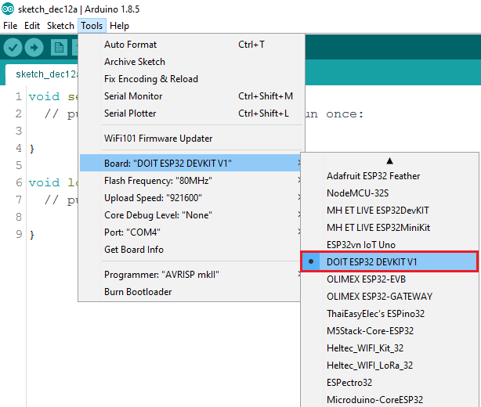

2. Select the Port (if you don’t see the COM Port in your Arduino IDE, you need to install the [CP210x USB to UART Bridge VCP Drivers](https://www.silabs.com/products/development-tools/software/usb-to-uart-bridge-vcp-drivers)):

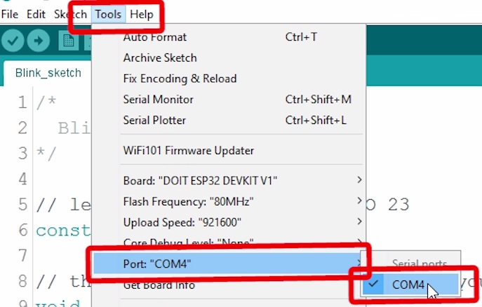

3. Open the following example under **File** > **Examples** > **WiFi (ESP32)** > **WiFiScan**

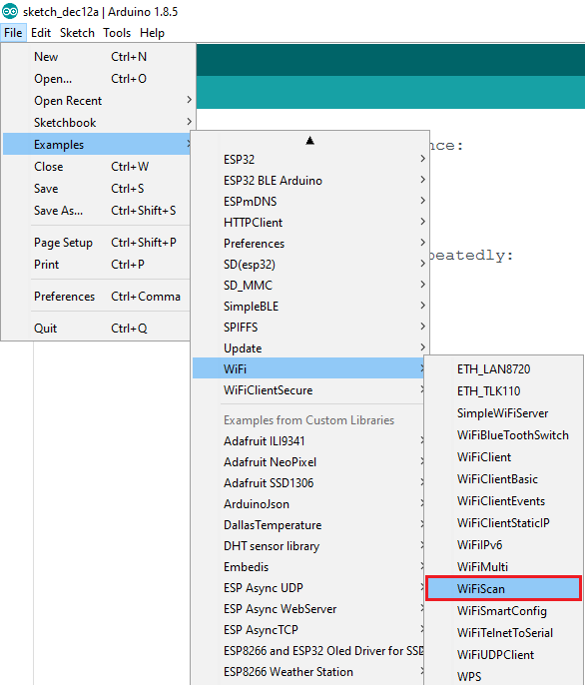

4. A new sketch opens in your Arduino IDE:

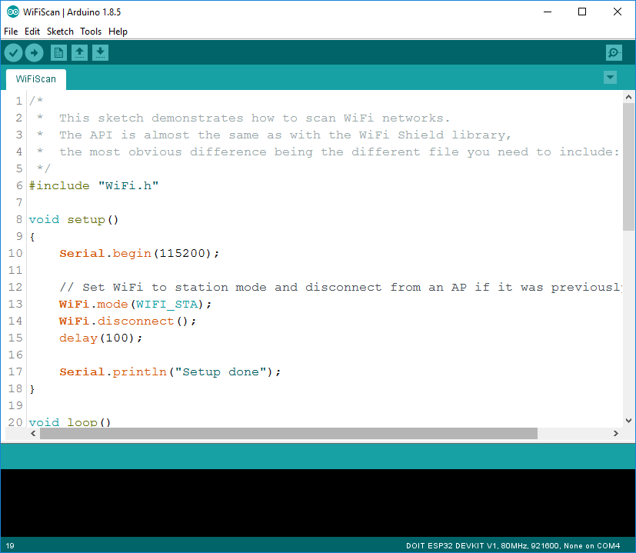

5. Press the **Upload** button in the Arduino IDE. Wait a few seconds while the code compiles and uploads to your board.



6. If everything went as expected, you should see a “**Done uploading.**” message.

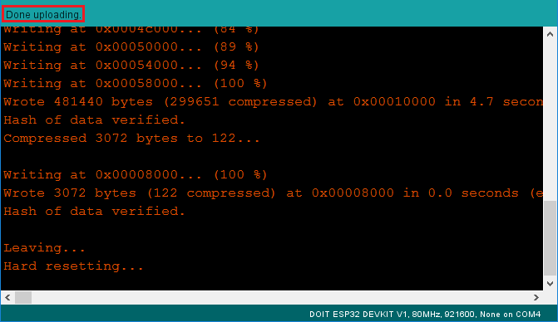

7. Open the Arduino IDE Serial Monitor at a baud rate of 115200:



8. Press the ESP32 on-board **Enable** button and you should see the networks available near your ESP32:

