Statistical Inference Assignment Part 1

Bernard Akyena

August 23, 2017

# Part 1

# Simulations

## Codes compare the distribution of avergaes of 40 exponentials for 1000 simulations

set.seed(145)  
lambda <- 0.2  
ranexp <- 40  
  
average <- NULL  
for(i in 1:1000)  
 average <- c(average, mean(rexp(ranexp, lambda)))

# Theoretical Mean

lambda ^ -1

## [1] 5

# Sample Mean

mean(average)

## [1] 4.959671

There is very samll difference between the both means

# Theoretical Variance

(lambda * sqrt(ranexp)) ^ -2

## [1] 0.625

# Sample Variance

var(average)

## [1] 0.6112324

The variances exhibit very small differences

# Distribution

library(ggplot2)  
m <- ggplot(data.frame(column = average), aes(x = column))  
m <- m + geom_histogram(aes(y = ..density..), binwidth = 0.2, fill = 'blue', color = 'black')  
m <- m + stat_function(fun = dnorm, args = list(mean = lambda^-1, sd=(lambda*sqrt(ranexp))^-1), size=2)  
m <- m + labs(title = "Distribution of Exponentials", x = "Simulation Means", y = "Density")  
m

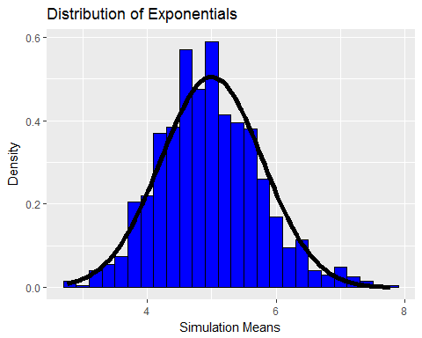 Per the perfect overlay of the normal distribution on the histogram, we can conclude that the distribution of averages of a large samples of exponentials is really normal