**ARCHITECTURAL DESIGN OF AN INSULIN PUMP**

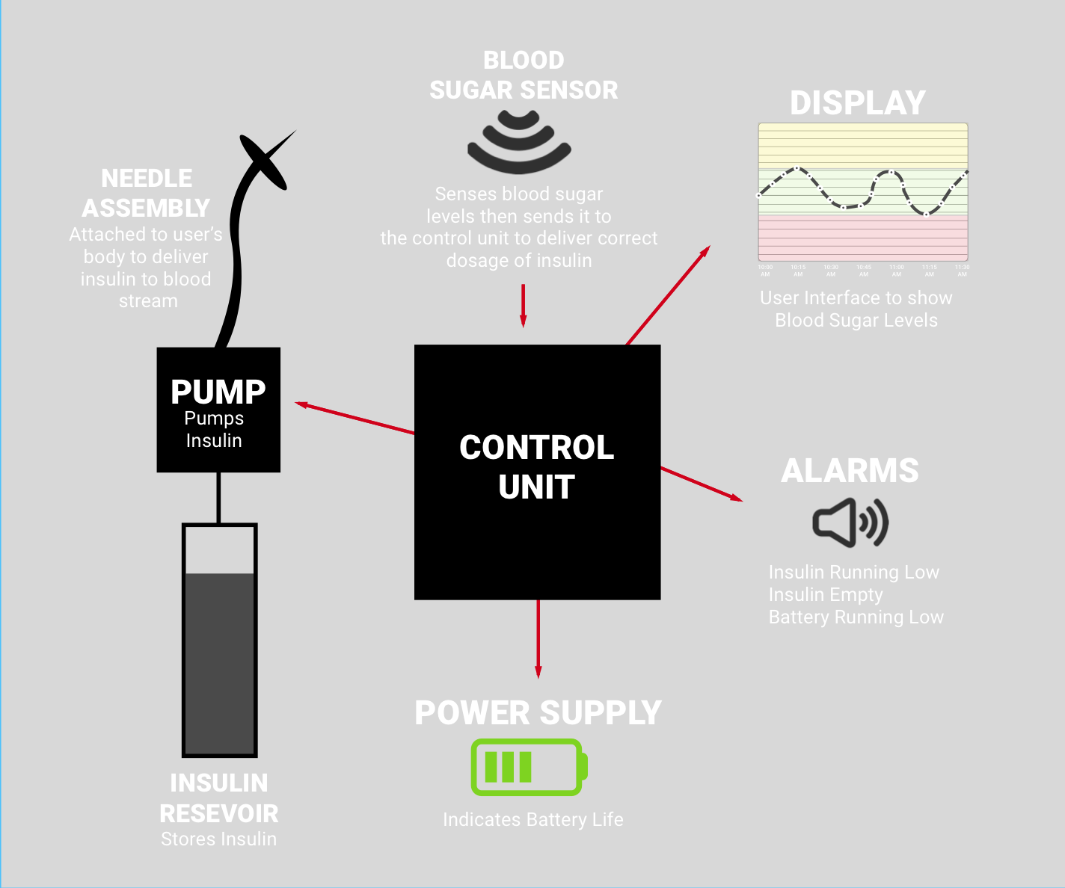

**Activity Flow (Pipe and Filter Architectural Design)**

