

SiSy Short-Exam-1:

Duration: 45 Minutes Open book exam, without calculator. Your calculations and solution approach need to be readable and comprehensible in order to get the full points. Please write your final results in the reserved gray fields and use the provided spaces for the sketches. Do not forget to label your axes.

|  |  |  |  |  |  |  |
| --- | --- | --- | --- | --- | --- | --- |
| Name: | | | | | Class: | |
| 1: | 2: | 3: |  |  | Points: | Grade: |

**Exercise 1** *Signals: Dirac Impulse and Unit-Step [8+6 = 14 Points].*

The block diagram below describes the generation of the signal y(t).



AB = 0

τ = +2

δ(t-τ)

u1(t)

u0(t)

*Integrator block*

*signal source*

**+**

y(t)



AB = 0

τ = +1

δ(t-τ)

K= -1

**K**

x1(t)

x2(t)

x0(t)

*signal source*

*gain block*

1. Draw sketchs of the signals u0(t), u1(t), x2(t) and y(t) in the time domain.

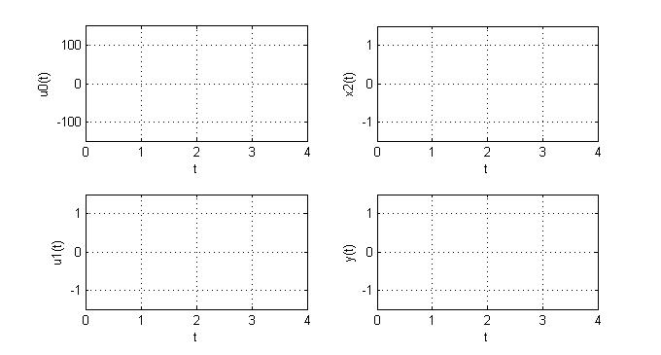

**Blank page !**

1. Complete the Matlab code below, which simulates the generation of the signal y(t) .

clear all, close all, clc;

% PARAMETERS

tstep = 1e-2;

t = 0:tstep:4;

% FUNCTION DEFINITION

x0_t = (1/tstep)*double(t==1);

x1_t = -1*x0_t;

x2_t = cumsum(x1_t)*tstep;

u0_t = (1/tstep)*double(t==2);

u1_t = cumsum(u0_t)*tstep;

y_t = u1_t + x2_t ;

% GENERATE PLOTS

subplot(231),plot(t,u0_t),grid on,xlabel('t'),ylabel('u0(t)')

…

**Exercise 2** *Fourier Series with complex Coefficients [5+5+2=12 points].*

The equation of a periodic time signal x(t) is given below:



1. Determine the basic frequency f0 in (Hz) , and ω0 in (rad/s) and find out which ck coefficients are **not** equal to zero (fill out these values in the table below).

*Hint:* the complex value in polar notation showing amplitude and phase of ck are expected.

f0 = ? ω0 = ?

|  |  |  |  |  |  |  |
| --- | --- | --- | --- | --- | --- | --- |
| **k** |  |  | -1 | +1 |  |  |
| **abs(ck)** |  |  |  |  |  |  |
| **phase(ck)** |  |  |  |  |  |  |
| **ck** |  |  |  |  |  |  |

1. Prepare a sketch of the corresponding double sided spectrum. Do not forget to label the axes.

0 f [Hz]

abs(ck)

phase(ck)

0 f [Hz]

1. What does it change in the spectrum of item (b) if we change the second term from cosine to sine?



**Exercise 3** *IMU Mobile Sensors [2x3=6 Points].*

A person moves his/her telephone in such a way that the following sensor signals are registered: [1]

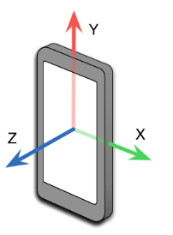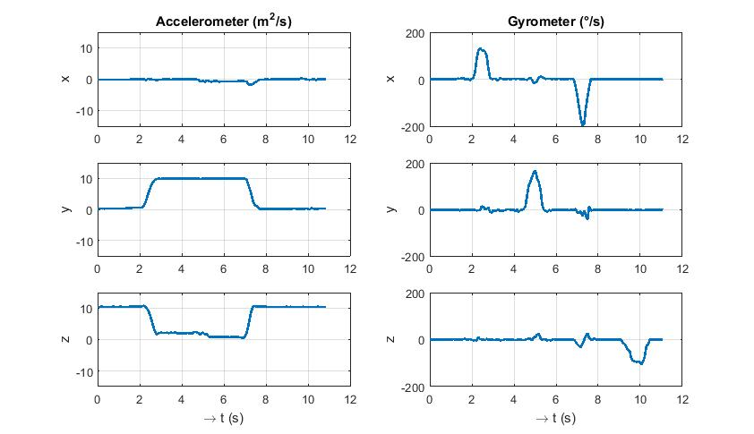

The sequence of movements starts from position A, and ends up again with position A. Determine which other positions had the mobile at the following points in time, and justify your answer with a short comment.

|  |  |  |
| --- | --- | --- |
| **Time** | **Position** | **Justification** |
| **t = 1s** | A | Initial position given in exercise description, and no movement sensed between 0s and 1s |
| **t = 3s** |  |  |
| **t = 6s** |  |  |
| **t = 8s** |  |  |
| **t = 11s** | A | Final position given in exercise position.  Plus gravity is again sensed fully in z-axis (only for A and B possible) |

Possible positions

|  |  |
| --- | --- |
| **A**  flat laying  over table | **B**  flat laying sideways  over table |
| **C**  up right  facing  display | **D**  up right  sideways  display to the right |

1. Source figure axes: http://blog.contus.com/how-to-measure-acceleration-in-smartphones-using-accelerometer/