SiSy Short-Exam-2:

Duration: 45 Minutes Open book exam, without calculator. Your calculations and solution approach need to be readable and comprehensible in order to get the full points. Please write your final results in the reserved gray fields and use the provided spaces for the sketches. Do not forget to label your axes.

|  |  |  |  |  |  |  |
| --- | --- | --- | --- | --- | --- | --- |
| Name: | | | | | Class: | |
| 1: | 2: | 3: | 4: |  | Points: | Grade: |

**Exercise 1** Convolution (Faltung)  *[6 Points].*

An audio recording (signal u[n] on 1st graphic below), and a discrete signal (y[n] on the 2nd graphic below), are convolved with each other. Which audio effect is created by this operation?

Justify your answer with a short comment, a sketch of the resulting signal, and an equation.

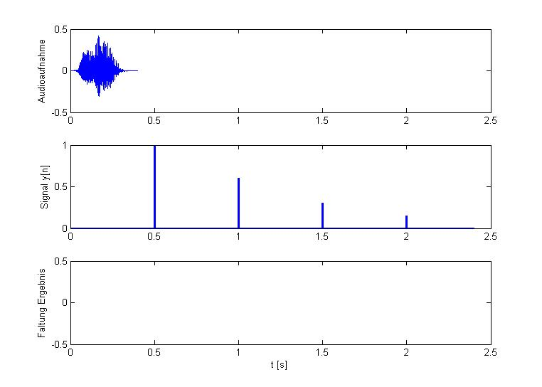

**Exercise 2** DFT and Aliasing  *[3+2+3 +3=11 Points].*

The Matlab code below calculates the DFT of the signal y(t) .

clear all, close all, clc;

N = 50;

Fs = 50e3; % sampling frequency

aux = 0:1:N-1;

t = (1/Fs)*aux;

f = (Fs/N)*aux;

fsig = [ 10e3 , 20e3 ];

y_t = 2*sin(2*pi*fsig(1)*t) + cos(2*pi*fsig(2)*t);

Y_f = (1/N)*fft(y_t);

stem(f,abs(Y_f)), …

**?**

**?**

**?**

**?**

The following plots are generated using different values of N . The sampling frequency Fs is kept constant for both variations.

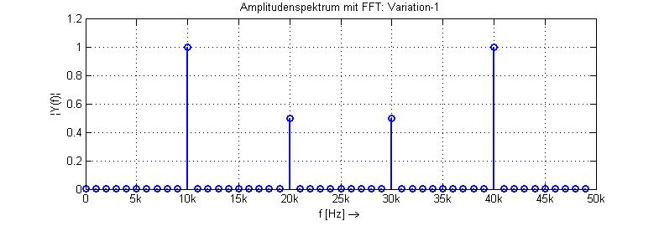

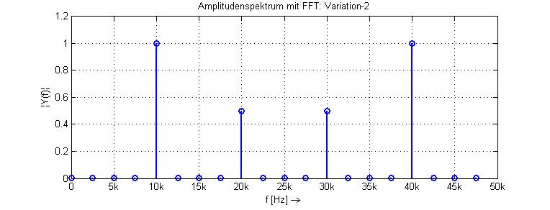

1. Determine the value of Fs and N used for Variation-1 and Variation-2 in the plots above. Justify your answer by comparing to the corresponding frequency resolution in each graphic.

Var-2:

Var-1:

1. Suppose that the signal y(t) was not distorted by aliasing in both graphics above. Determine the frequency fsig(1) and fsig(2) of the 2 harmonic components in signal y(t).   
   Justify your answer with a short comment.
2. Now, determine 3 other combinations of harmonic components, which due to aliasing would result in the same amplitude spectrum.

|  |  |
| --- | --- |
| fsig(1) | fsig(2) |
|  |  |
|  |  |
|  |  |

1. How are the time and frequency vectors declared in the Matlab code above? What is the purpose to declare these vectors like this?

**Exercise 3** *Fourier Transformation Characteristics [3+3+4=10 Points].*

The following Fourier-Transformation pair of functions is given :

|  |  |
| --- | --- |
| x(t) | X(f) |
| δ(t) | 1 |

1. Use the Fourier-Transformation pair above and properties of the Fourier-Transformation to calculate the Fourier transform of the function y(t) :

; with A = 3



OBS: Justify your answer with a short comment about your calculation.

1. Draw a sketch of (Amplitude-Spectrum of y(t) ).



0 f [Hz]

|Y(f)|

1. The time function z(t) is defined with help of y(t) as:

; with A = 3



Draw a sketch of , and justify your answer with a short comment about the differences between und .



0 f [Hz]

|Z(f)|

**Exercise 4**  System Views *[4+2+4=10 Points].*

The blockdiagram of an LTI system is given below.

y(t)





u(t)



A1

A0

B0

-

-

+



+





1. Calculate the differential equation, which describes the complete LTI system. In this equation there should only appear terms with u(t), y(t) and corresponding derivatives.

*Hint:* Determine first the 2 differential equations, which describe  and  . Then find out how you can combine these 2 equations to get the complete equation for the whole LTI system.

Diff.Equ.:

1. Use a Fourier transformation property to show that the following frequency response G(jω) also describes the LTI system above.



*Obs:* In this way, you can check your answer for item (a).

1. Challenge: calculate the characteristic equation of the LTI system above, and determine for which conditions is the system able to oscillate.