SiSy Short-Exam-2:

Duration: 45 Minutes Open book exam, without calculator. Your calculations and solution approach need to be readable and comprehensible in order to get the full points. Please write your final results in the reserved gray fields and use the provided spaces for the sketches. Do not forget to label your axes.

|  |  |  |  |  |  |  |
| --- | --- | --- | --- | --- | --- | --- |
| Name: | | | | | Class: | |
| 1: | 2: | 3: | 4: |  | Points: | Grade: |

**Exercise 1** Convolution (Faltung)  *[6 Points].*

*Asked:* a short comment, a sketch of the resulting signal, and an equation.

Ein Echo-Effekt wird erzeugt: Wiederholung der Audio-Sequenz mit zeitlichen Verschiebungen und mit kleineren Amplituden (wegen Faltung mit verschobene Dirac-Stösse mit abklingenden Amplituden).

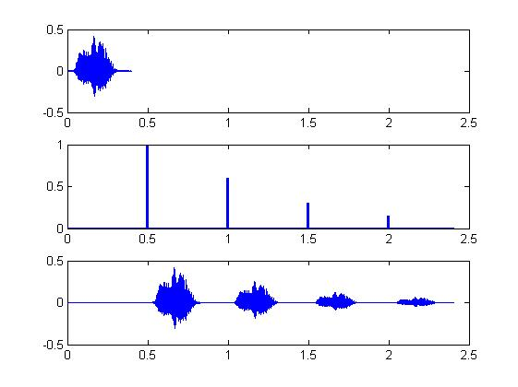

The convolution of 2 analog (continuous) signals is described by the following equation

Convolution Integral  (chap-1)

Since the 2 signals we have here are discrete, the convolution can be calculated with a sum:

Convolution Sum  (chap-1)

If we want to achieve a comparable result (in the same output range) with the convolution sum as with the convolution integral, we should scale it with Ts (sampling step):

Scaled convolution Sum 

**Exercise 2** DFT and Aliasing  *[3+2+3 +3=11 Points].*

1. For both variations Fs=50kHz (can be observed in max range of DFT-output plots)

**Var-1 :** N=50 ; fstep = Fs/N = 50kHz/50 = 1kHz

(wie Frequenzauflösung in Plot Var-1 fstep = 5kHz/5)

**Var-2 :** N=20 ; fstep = Fs/N = 50kHz/20 = 2,5kHz

(wie Frequenzauflösung in Plot Var-2 fstep = 5kHz/2 )

1. If both harmonic components where not distorted, it means that:

Max{fsig} < Fs/2 => Max{fsig} < 25kHz

Here we have:

fsig(1) = 10kHz (higher amplitude then fsig(2))

fsig(2) = 20kHz

1. Bmk: Mehrere Lösungen möglich, z.Bsp:

|  |  |
| --- | --- |
| fsig(1) | fsig(2) |
| 10kHz | 30kHz |
| 30kHz | 40kHz |
| 20kHz | 60kHz |

Allgemeiner:

Anteil 10kHz kann auch sein: n.Fs ± 10kHz , z.Bsp.: 40kHz; 60kHz ; 90kHz ; 110kHz; …

Anteil 20kHz kann auch sein: n.Fs ± 20kHz , z.Bsp.: 30kHz; 70kHz ; 80kHz ; 120kHz; …

1. The time and frequency vectors were declared using an auxiliary index vector aux, which guarantees that both vectors start at zero and have exactly N points.

Furthermore the resolution of the vectors is made explicit:

* 1/Fs for time vector;
* FS/N for frequency vector

Which guarantees that a time signal declared with this time vector, can have its frequency spectrum calculated with FFT and correctly plotted in dependency to this frequency vector.

In other words:

One over the resolution in the time domain represents the maximum frequency in the frequency domain, and one over the resolution of the frequency domain represents the length of the observation window in the time domain.

DFT

(FFT)

N-Points

time

domain

N-Points

 frequency

domain

Ts

N.Ts

t (s)

fstep

N.fstep

f (Hz)

Fs

Fs/2

Fs (N-1)/N

t (s)

fmin= fstep=1/(N.Ts) = Fs /N

fstep

**Exercise 3** *Fourier Transformation Characteristics [3+3+4=10 Points].*

The following Fourier-Transformation pair of functions is given :

|  |  |
| --- | --- |
| x(t) | X(f) |
| δ(t) | 1 |

1. Use the Fourier-Transformation pair above and properties of the Fourier-Transformation to calculate the Fourier transform of the function y(t) :

; with A = 3



OBS: Justify your answer with a short comment about your calculation.

Lösung: using the following properties:

|  |  |  |
| --- | --- | --- |
| Property | x(t) | X(f) |
| Duality | 1 | δ(f) |
| Frequency Shift | 1.exp(2π f0 t) | δ( f- f0 ) |

One can find the pair of functions associated via FT:

$$y\left(t\right)=\frac{A}{2}∙\left[\left(e^{+j2πf_{0}t}\right)+\left(e^{-j2πf_{0}t}\right)\right] \underset{↔}{FT} Y\left(f\right)=\frac{A}{2}∙\left[δ\left(f-f_{0}\right)+δ\left(f+f_{0}\right)\right]$$

1. Draw a sketch of (Amplitude-Spectrum of y(t) ).



-f0 0 +f0 f [Hz]

|Y(f)|

**A/2**

1. The time function z(t) is defined with help of y(t) as:

; with A=3



Draw a sketch of , and justify your answer with a short comment about the differences between und .



0 f [Hz]

|Z(f)|

A/2

A

Lösung:

There is only a new DC component with amplitude A. This DC-offset appears at f=0Hz. The change of sign (-1 . y(t) ) is not visible in the amplitude spectrum.

**Exercise 4**  System Views *[4+2+4=10 Points].*

1. Von BSB herauslesen: 

Dann die 2te DGl einmal ableiten, und ersetzen



DGl: 

1. Mit FT und die Ableitung-Eigenschaft:



Oder alternative: mit Testsignal exp(jωt), und Ausgangssignal G(jω). exp(jωt) .

1. The characteristic equation can be calculated by applying the hypotheses of an exponential solution for the homogene response (with input equal zero) of the system:

 Hypothesis: 

Which implies: 



Then applying to the homogene differential equation, we get the characteristic equation, and corresponding solution (2 roots for s):





The system will be able to oscillate when these roots have an imaginary part, so when s1,2 have complex conjugated values. And this will happen for:

