

List 1

Signals and Systems

**Exercise 1** *Sinusoidal Signal.*

Describe the signal x(t) shown below with three different mathematical expressions using:

1. A single cosine function.
2. A sum of sine and cosine functions.
3. The real part of a complex exponential function.

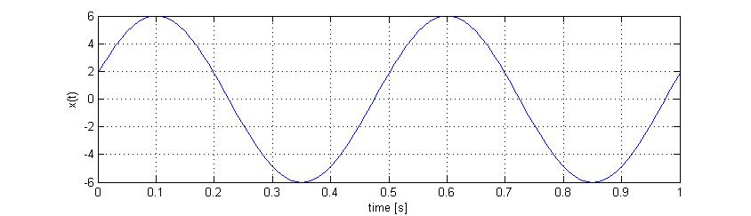

**Exercise 2** *Phasors (vector rotating about the origin in a complex plane).*

Use the phasor notation to solve the following equations:

1. 
2. 

**Exercise 3** *Signalbeschreibung.*

Describe the following signals with a mathematical equation:

1. A time limited sine signal from *t*1 = 1 s until *t*2 = 5 s , with a period length of *T* = 0.5 s.   
   Hint: Use the Heaviside or unit step function.
2. An infinite sequence of unit impulses (Dirac deltas) with a spacing of *Ts* and a weight (or amplitude) *A.*
3. Determine for the signals above (items a and b) the following characteristics: power/energy signals, symmetric (even/odd) or not, periodic or not.
4. Which kind of signal do you get in Matlab with the command:

* sig_d = randn(1 , 100)

Calculate the average value and the standard deviation of sig_d .

**Exercise 4** *Signal Conversions.*

Given the continuous time signal x(t) shown below, prepare a sketch for each of the following signals (conversions of x(t) ):

1. x(t-2)
2. x(2.t)
3. x(t/2)
4. x(-t)

3

2

1

x(t)

-1 0 1 2 3 4 5 t [s]

**Exercise 5** *Signal Conversions.*

Given the discrete time signal x[n] shown below, prepare a sketch for each of the following signals (conversions of x[n] ):

1. x[n-2]
2. x[2.n]
3. x[-n]
4. x[-n+2]

3

2

1

x[n]

-1 0 1 2 3 4 5 n [ ]

1. Describe the signal x[n] as a sum of weighted and shifted unit impulses δ[n] .

**Exercise 6** *Sampling and Discrete Signals.*

The time continuous signal x(t) is described as:



1. Draw a sketch representing x(t) .

The signal x(t) is then sampled with different sampling intervals (also called sampling period Ts ). Prepare sketches of the resulting discrete signals x[n] for the following values of Ts :

x[n]

x(t)

Sampling

Ts

1. Ts = 0.25 s
2. Ts = 0.5 s
3. Ts = 1 s

**Exercise 7** *System Classification.*

Consider a system with a single input signal x(t) and a single output signal y(t) as shown below:

y(t)

x(t)

System

Which of the following functions describe then a linear system? Justify your answer with an equation or a short sentence.

1. 
2. 
3. 
4. 

**Exercise 8** *Linear time invariant System (LTI).*

The following LTI system is a low pass filter, it let through low frequencies unchanged and attenuates high frequencies. Check its effect on test signals u1(t) und u2(t) and determine then the output signals y3(t) und y4(t) for the input signals u3(t) und u4(t) .

Hint: consider the properties of a LTI system.

1khz

System LTI

u(t)

f{u(t)}=y(t)

f{ }

1. **Simplified LTI (only amplitude effect)**

 

 

1. **LTI with Amplitude and Phase Effect**

 

 