**List 2:**

**Spectrum Introduction and Fourier Series**

**Exercise 1** *Fourier Series: Identifying Coefficients*

Two periodic functions (A) and (B) are given below. Determine the following parameters:

* 1. The fundamental angular frequency (ω0) und the fundamental frequency (f0)
  2. The period (T0)
  3. The DC-component or mean value
  4. The symmetry characteristics

Shortly justify your answers. Hint: there is no need for integral calculations.

**(A)** The function is defined by the following equation:



**(B)** The function is described by the graphics below, where one can read out the ak und bk Fourier series coefficients for the corresponding angular frequencies.

…

0 3π 6π 9π 12π ω (rad/s)

ak

…

0 3π 6π 9π 12π ω (rad/s)

bk

**Exercise 2** *Fourier Series: Identifying Coefficients*

The time function x(t) is given below. Determine the following parameters:



* fundamental angular frequency (ω0), fundamental frequency (f0) and period (T0);
* Prepare a sketch of the Amplitude- and Phase-Spectrum (single and double sided).
* Fourier series coefficients with notation-I (ak, bk) , notation-II (Ak, ϕk), and notation-III ( ck );

**Exercise 3** *Signal Description in Time and Frequency Domains*

The double sided spectrum of the signal y(t) is plotted below. This spectrum has the complex exponential  as basis function. Determine the equation describing y(t) as a sum of cosine waves.

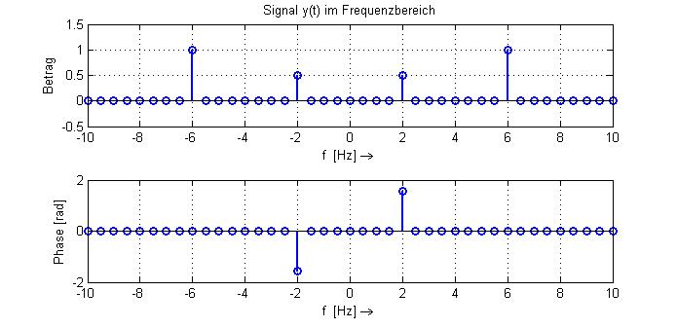

**Exercise 4** *Signal Description in the Frequency Domain*

The single sided spectrum of the signal y(t) is plotted below. This spectrum has the cosine wave  as basis function.

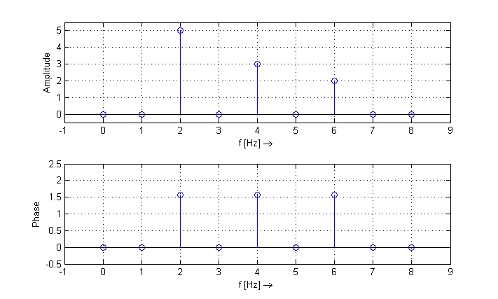

(rad)

pi/2

1. Determine the equation describing x(t).
2. Is the signal x(t) periodic? Why?
3. Does x(t) present a certain symmetry characteristic? Which one and why?
4. Prepare a sketch of the double sided spectrum of x(t). Use the axes provided below.

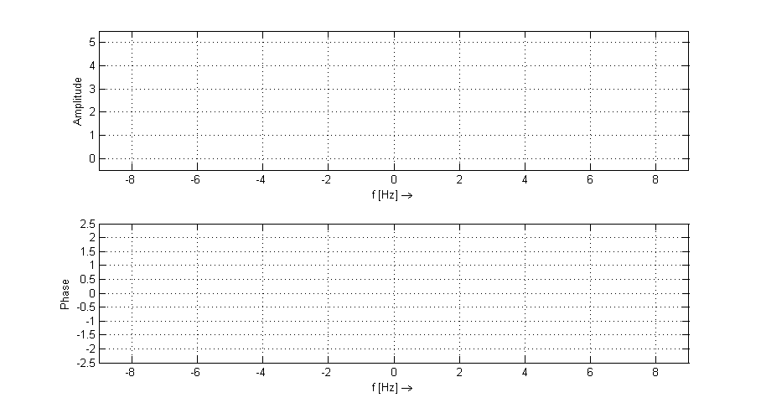

[rad]

**Exercise 5** *Fourier Series with Complex Coefficients*

The complex Fourier series coefficients of a periodic time function are plotted below.

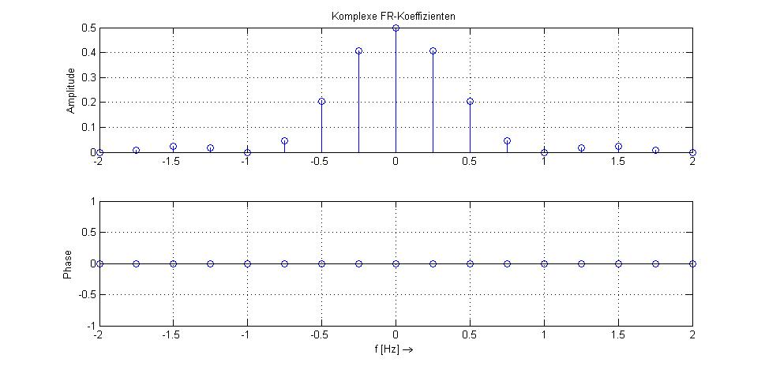

Based on this graphic determine:

1. The period T0, the fundamental frequency f0 and the fundamental angular frequency ω0 .
2. The mean value or DC-component .
3. The observed symmetry property, and a short justification.
4. How does the spectrum change if the time function is shifted by T0/4 to the right? Justify your answer with a short calculation using the relevant property of the Fourier series.

**Exercise 6** *Signal Description in Time and Frequency Domains*

The graphic and equations below describe the two time signals x(t) and y(t):

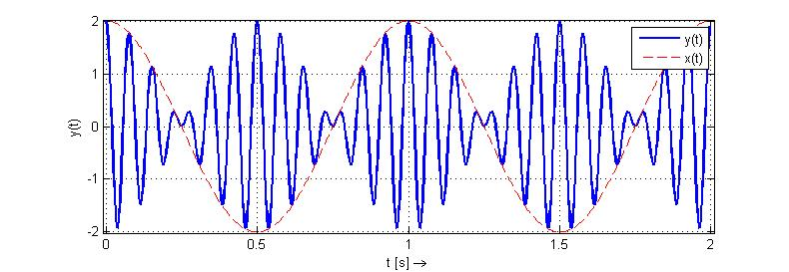



1. Determine the value of the amplitudes A1 and A2, and the value of the frequencies f1 and f2 (in Hz).
2. Use the trigonometric formulas below to express y(t) as a sum of sine or cosine waves.



1. Sketch the single sided spectrum of y(t) (with basis function cos(ωt) ) in the axes below.   
   Do not forget in your sketch to mark the relevant values and to label the axes.

Amplitude

f [Hz]

Phase

f [Hz]

**Exercise 7** *Fourier Series with Complex Coefficients*

The time domain plot of the periodic signal x(t) is given below.

-T0 0 T0 2.T0 t[s]

x(t)

A

Let us call ckx the complex Fourier series coefficients of x(t).

1. Calculate the DC-component (coefficient c0x) of x(t) .
2. Let the time function p(t) be defined as: 

So that p(t) equals the original function x(t) without the DC-content.

Prepare a sketch of p(t) in the time domain.

-T0 0 T0 2.T0 t[s]

p(t)

1. Does the function p(t) show any symmetry property? Which influence does this property have on the complex coefficients ckx ?
2. Calculate the remaining ckx coefficients of x(t) (for k ≠0) , and show that: 

Hint: follow the steps below, which indicate the split for the partial integration and give intermediate results to guide your calculation.

….



Then apply partial integration with:  mit 

….



Next simplify the term:  für 

….

Which leads to the final result

 für  und 

1. Prepare a sketch of the double sided spectrum of x(t).
2. Verify the expression for the ckx coefficients by synthesizing your signal as a sum of complex exponentials. Complete and try out the Matlab code below, which implements this synthesis.

% Konstanten und Zeitvektor definieren

T0 = ………………; w0 = ………………;

t = -2*T0:T0/100:2*T0;

% Anzahl Harmonische und Mittelwert eingeben

Kmax = 5;

c0x = ………………;

x_t =………………; % Zeitfunktion initialisieren

for k = -Kmax:1:Kmax

if k ~= ………………

………………………………………………

………………………………………………

end

end

plot(………………,………………),grid on

xlabel('t [s] \rightarrow'),ylabel('x(t)')

title('Periodic Synthesised Time Function')

**Exercise 8**  *Symmetry und Orthogonality*

1. The time function y(t) is described in the following graphics. Find the even (gerade) and odd (ungerade) components of y(t) and prepare a sketch in the axes provided.

*Hint:*



1. When you calculate the ck coefficients of the Fourier series representing y(t), how can you distinguish which part represents yg(t) and which part represents yu(t) ? Justify your answer by comparing the complex coefficients ck and the real coefficients ak and bk of the Fourier series.
2. Calculate the complex ck coefficients of the Fourier series representing y(t) . Use as much as possible previous available results (e.g. Fourier series for the periodical square function, and for the periodical sawtooth function).

