**List 2:**

**Spectrum Introduction and Fourier Series**

**Sample solution**

**Exercise 1**

Function A

1. 
2. s
3. DC-component : 
4. Symmetry: even

because for 

all  , so there are only cosine components, and the sum of even functions results in another even function.

Function B

From the graphic: 

1. 
2. 
3. DC-component: 
4. Symmetry: odd because all 

**Exercise 2**

*kgV = LCM*

*(kleinstes gemeinsames Vielfaches)*

*(least common multiple)*

ω0 zuerst:

*ggT = GCD*

*(grösster gemeinsamer Teiler)*

*(greatest common divisor)*

1. 

Ak

0.75

0.5

1. Einseitiges Spectrum

0 1/4 2/4 3/4 4/4 5/4 6/4 f [Hz]

ϕk

π/4

-5π/6

0 1/4 2/4 3/4 4/4 5/4 6/4 f [Hz]





1. 

a3 b3 a5 b5





**Exercise 3**

Supposing the phase value for f=±2Hz equals ±pi/2 rad.





**Exercise 4**

(a)





(b) Yes, the time function is periodic because the spectrum is discrete. Or, yes, because the signal consists of a sum of sine waves, whose frequencies are multiples of a common fundamental frequency.

(c) Yes, the function is odd (shows point-symmetry with respect to the origin point (0,0)), because it consists of a sum of sine components (sines with phase=0 for t=0), which are also odd functions.

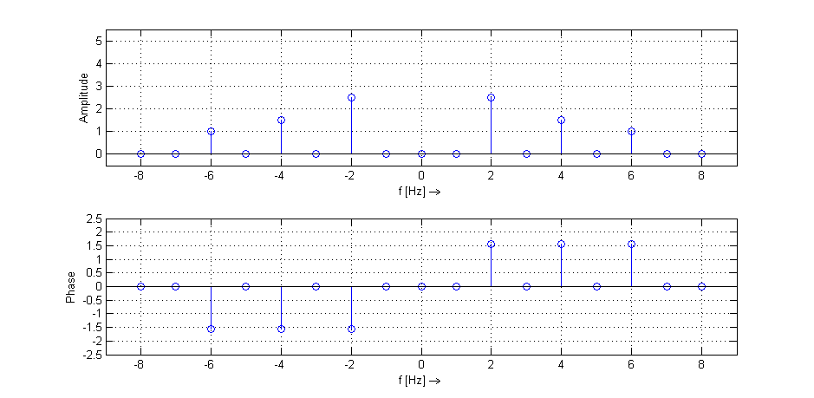

**Exercise 5**







(b)

(c) ck Fourier series-coeffs are pure real numbers => ak ≠ 0 and bk=0

=> because the function is even (gerade)

(d) Only phase spectrum changes, because if ck are the coeffs from x(t), the coeffs from  are  and  .

**Exercise 6**

(a)

A1 = 2; A2 = 1

f1 = 1 Hz; f2 = 13 Hz

(b)



(c)

Amplitude

1

12 14 f [Hz]

Phase [°]

0

12 14 f [Hz]

**Exercise 7**

1. 

-T0 0 T0 2.T0 t[s]

p(t)

A/2

-A/2

1. The function p(t) is odd, so that one can expect that the ckx coefficients (except c0x) are pure imaginary (because ak = 0 und bk≠0 ).



Then apply partial integration with:  mit 







Next simplify the term:  für 

Which leads to the final result



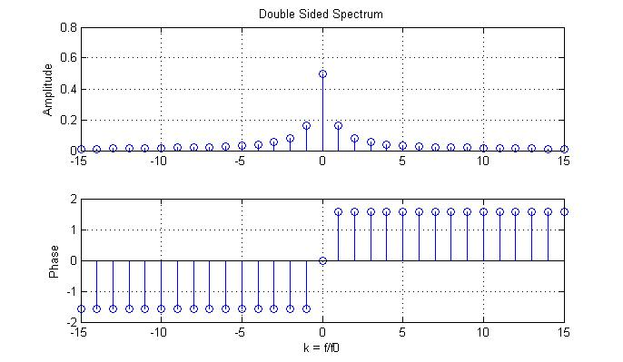

You can generate the double sided spectrum plot with the following Matlab Code:

% Ueb 6 Auf7-e

% =======================

clear all, close all, clc;

A = 1;

Kmax = 15;

k = -Kmax:1:Kmax;

ckx = j*A./(k*2*pi);

ckx(Kmax+1) = A/2;

figure(1)

subplot(211),stem(k,abs(ckx)),grid on

ylabel('Amplitude')

title('Double Sided Spectrum')

subplot(212),stem(k,angle(ckx)),grid on

ylabel('Phase')

xlabel('k = f/f0')

% Konstanten und Zeitvektor definieren

T0 = 2; w0 = 2*pi/T0; A = 1;

t = -2*T0:T0/100:2*T0;

% Anzahl Harmonische und Mittelwert eingeben

Kmax = 5;

c0x = A/2;

x_t = c0x*ones(1,length(t)); % Zeitfunktion initialisieren mit DC-Wert

for k = -Kmax:1:Kmax

if k ~= 0

ck = j*A/(k*2*pi);

x_t = x_t + ck*exp(j*k*w0*t);

end

end

figure(2)

plot(t,x_t),grid on

xlabel('t [s] \rightarrow'),ylabel('x(t)')

title('Periodic Synthesised Time Function')

disp('Because of warning, check how big mag(imag(x_t))')

max(imag(x_t))

**Exercise 8**

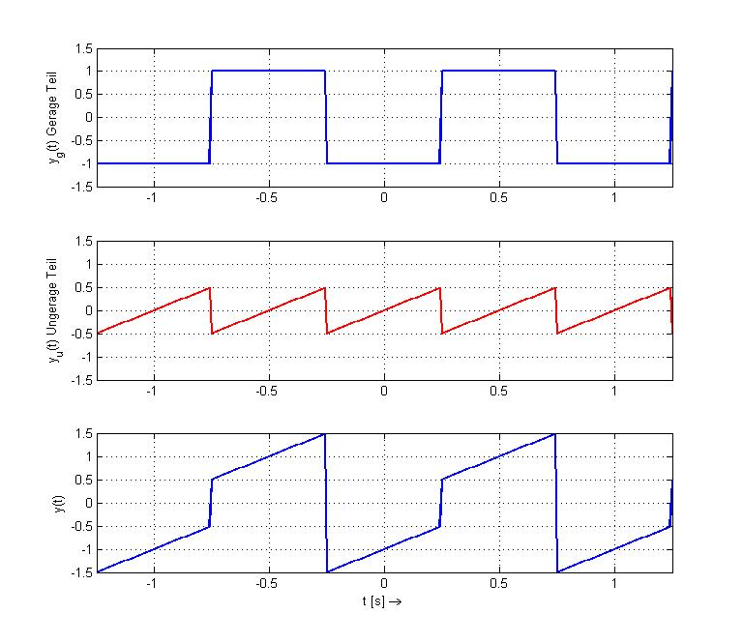

1. Real part of ck (=ak/2) represents the even part of the time-function, and

imaginary part of ck (=-bk/2) represents the odd part of the time-function.

1. Overall function has a T0=1, f0=1Hz

* Even part yg(t) has Period=T0=1 and coefficients (from periodic square example)



* Odd part yu(t) has Period=T0/2=1/2 , so that only every 2nd coefficient is not 0. The coefficents value can be taken from ramp function (Ueb6-Auf7) plus consider a time shift of λ=0,25 .



Obs. : to consider the Period=T0/2=1/2 , we can say in terms of the k index, that the index for the odd part ku=k/2, and every 2nd coefficient only is not zero (done with the term abs(cos(kpi/2)).

The following Matlab code can be used to check these results :

% Ueb 6 Auf7-e

% =======================

clear all, close all, clc;

% Parameter Overall function: y(t)

T0 = 1; w0 = 2*pi/T0; % overall period

Kmax = 50;

k = -Kmax:1:Kmax; % k-vector = f/f0

t = -2*T0:T0/100:2*T0; % time-vector

% Parameter Gerade-Anteil: yg(t)

Ag = 2;

tau = T0/2;

ckg = Ag./(k*pi).*sin(k*pi/2);

ckg(Kmax+1) = 0; % DC-Anteil = 0

% Parameter Ungerade-Anteil: yu(t)

Au = 1;

% Period is half so large, or will only have cku!=0 for every 2nd-k

cku = j*Au./(k*pi) .* abs(cos(k*pi/2)) .* exp(-j*k*w0/4);

cku(Kmax+1) = 0; % DC-Anteil = 0

ck = ckg + cku; % Gerade und Ungerade Anteile kombiniert

figure(1)

subplot(211),stem(k,abs(ck)),grid on

ylabel('Amplitude')

title('Double Sided Spectrum')

subplot(212),stem(k,angle(ck)),grid on

ylabel('Phase')

xlabel('k = f/f0')

% Check mit Synthesis im Zeitbereich

x_t = zeros(1,length(t)); % Zeitfunktion initialisieren

for kid = -Kmax:1:Kmax

id = kid+Kmax+1; % Index für ck Vektor

x_t = x_t + ck(id)*exp(j*k(id)*w0*t);

end

figure(2)

plot(t,x_t),grid on

xlabel('t [s] \rightarrow'),ylabel('x(t)')

title('Periodic Synthesised Time Function')

disp('Because of warning, check how big mag(imag(x_t))')

max(imag(x_t))