**List 3:**

**Discrete Fourier Transformation (DFT) and**

**Fast Fourier Transformation (FFT)**

**Exercise 1** *Discrete Fourier Transformation (DFT) .*

The spectra Xa[k] till Xe[k] were calculated with DFT. Match each spectrum with the corresponding discrete time functions from x1(t) till x6(t) and fill out the table below.

|  |  |  |  |  |  |  |  |
| --- | --- | --- | --- | --- | --- | --- | --- |
| **Spek-trum** | **time function** | **Why do these functions match each other?** | **N** | **Ts**  **[s]**  **Sampling time or**  **tstep** | **Fs**  **[Hz]**  **Sampling frequency** | **fstep [Hz]**  **frequency step** | **(N.Ts)**  **time window[[1]](#footnote-1)**  **[s]** |
|  |  |  |  |  |  |  |  |
|  |  |  |  |  |  |  |  |
|  |  |  |  |  |  |  |  |
|  |  |  |  |  |  |  |  |
|  |  |  |  |  |  |  |  |

|  |
| --- |
| Spektra |
| Xa[k]  v12_u6_Xaw |
| Xb[k]  v12_u6_Xbw |
| Xc[k]  v12_u6_Xcw |
| Xd[k]  v12_u6_Xdw |
| Xe[k]  v12_u6_Xew |

|  |
| --- |
| Time functions |
| x1(t)  v12_u6_xdt |
| x2(t)  v12_u6_xbt |
| x3(t)  v12_u6_xat |
| x4(t)  v12_u6_xet |
| x5(t)]  v12_u6_xct |
| x6(t)  v12_u6_xht |

**Exercise 2** *FFT and Sampling*

The plot of a time continuous function x(t) is given below. The function x(t) should be sampled and its spectrum calculated with the FFT (algorithm for the implementation of the DFT).

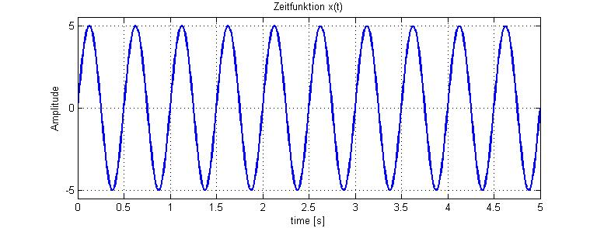

(a) How long must be the time window in order to get a spectrum with a frequency resolution (or frequency step) of fstep= 0.25Hz ?

(b) What is the minimum value for the sampling frequency Fs according to the sampling theorem, which avoids aliasing effects?

**Exercise 3** *Discrete Fourier Transformation*

The spectrum of a periodic square pulse was calculated with FFT and the amplitude values are plotted below. Determine the following parameters and justify your answer with a short statement.

1. The sampling frequency (Fs) :
2. The length of the time window (N.Ts) :
3. The period of the periodic square pulse (T0) :
4. The width of the pulses in the time domain ( tau) :

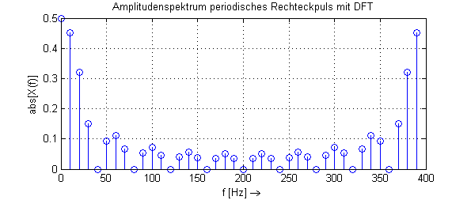

1. The time window (N.Ts) is also called the observation window, which means how long values of the time function x(t) are sampled and stored, before being used to calculate the corresponding X[k] coefficients with the DFT. [↑](#footnote-ref-1)