List 4:

Fourier Transform and Properties

**Exercise 1** *Decaying or Fading Exponential Function*

Let x(t) be a fading exponential function defined by the equation below. Calculate the Fourier transform of the signal x(t), and prepare a sketch of both X(f) and x(t) .



**Exercise 2** *Fourier Transform (FT) Properties: Linearity*

The Fourier transforms X1(f) and X2(f) of the aperiodic signals x1(t) and x2(t) are given below:

¦X1(f)¦

0.5



-10 10 f [Hz]

¦X2(f)¦

1



-30 -20 20 30 f [Hz]

1. Let x3(t) be defined as the sum showed below. Prepare a sketch of X3(f) (Fourier transform of x3(t) ), and justify your answer with a short statement.

¦X3(f)¦



f [Hz]

1. Now you want to sample the time function x3(t), and calculate its spectrum numerically. Determine the minimum sampling frequency in order to avoid aliasing effects.

**Exercise 3** *FT Properties : Time-Bandwidth Product*

The step response of two low pass filters of same order are given below:

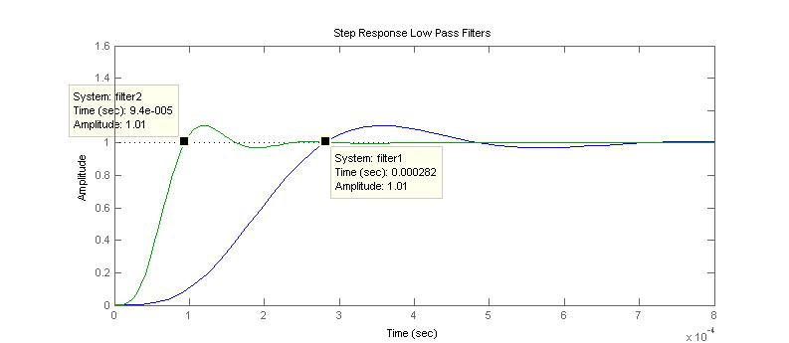

The filter with the narrower bandwidth has a bandwidth (BW) of 2.5 kHz.

Determine the bandwidth of both filter1 and filter2. Don’t forget to justify your answer.

**Exercise 4** *Fourier Transform and Properties*

Two church bells sound one after another with an interval of 4 seconds. Let us simplify each tone and represent it as a single fading cosine (cosine curve with a fading exponential envelope).

bell 1: - envelope: 

- tone: 

bell 2: - envelope: 

- tone: 

(a) Let x(t) be the sum of the envelope curves: 

Prepare a sketch in the time domain of x(t)

(b) Calculate the Fourier transform of x(t): 

(c) Find where are the zero crossings of the amplitude spectrum  .

(d) Prepare a sketch in the frequency domain of  (amplitude spectrum of the bell 1 tone) . Verify the shape of your sketch with a plot in Matlab.

**Exercise 5** *FT Properties: Multiplication vs Convolution*

Let x1(t) be a time function and X1(f) the associated Fourier transform specified by:



Find the Fourier transform X2(f) of the time function x2(t) . Use the FT duality property multiplication versus convolution for your calculation.



**Exercise 6** *FT Properties : Modulation*

The signals x1(t) , x2(t) and x3(t) are modulated and summed up before being transmitted in a radio broadcast station.

¦X1(f)¦

-fmax fmax f [Hz]

¦X3(f)¦

-fmax fmax f [Hz]

¦X2(f)¦

-fmax fmax f [Hz]

cos(2πfc1.t)

x1(t)

y1(t)

z(t)

cos(2πfc2.t)

x2(t)

cos(2πfc3.t)

x3(t)

y2(t)

y3(t)

1. What is the minimal distance among fc1, fc2 and fc3 , such that the receiver can later distinguish and retrieve the three original signals x1(t) , x2(t) and x3(t) ?
2. Prepare a sketch of the amplitude spectrum ¦Z(f)¦ of the antenna signal z(t) . Remember to label the axes and write the relevant values.

¦Z(f)¦

A block diagram of the demodulator in a receiver station is shown below.

cos(2πfc1.t)

x1(t)

y1(t)

z(t)

H1(f)

H2(f)

1. This station should be tuned to receive the signal x1(t) . How should the amplitude spectrum of the filters H1(f) and H2(f) look like? Sketch your answer in the axes below and justify it with a short statement. Remember to label the axes and write the relevant values.

¦H1(f)¦

¦H2(f)¦

**Exercise 7** *Fourier Transform and Properties*

Fill out the table below with the corresponding equations, properties and sketches. The missing elements are marked with grey frames.

|  |  |  |
| --- | --- | --- |
| Property | Time Signal | Spectrum |
| ---  (reference) | Ueb2b_x1_t | Ueb2b_x1_f  +π  - π |
| ……………… | Ueb2b_x2_t_empty | Ueb2b_x2_f  +π  - π |
| ……………… | Ueb2b_x3_t | Ueb2b_x3_f_empty |
| time-bandwidth product | Ueb2b_x4_t_empty | Ueb2b_x4_f |

**Exercise 8** *Transition between Fourier Series and Fourier Transform*

1. Find the Fourier transform Q(ω) of the aperiodic signal q(t) shown below.

-T0 0 T0 2.T0 t[s]

q(t)

A

Hint: Instead of calculating Q(ω) with the Fourier transform definition (integral formula), use rather the relationship between the Fourier transform for an aperiodic function and the Fourier series for a periodic function with the same shape within a period. The Fourier series coefficients for the periodic sawtooth wave (vide List-6 Fourier Series exercise 7) are repeated below for your convenience:

 for  und  .

….

….



….

1. How does the spectrum Q(ω) look like? Is it a discrete line spectrum or a continuous spectrum (also called a spectrum density function) ? Comment your answer by comparing the control variable of a complex Fourier series with the control variable of a Fourier transform.
2. Prepare a sketch of the spectrum Q(ω). Use the axes below and remember to add labels and relevant values.

│Q(ω)│

ω [rad/s]

arg{Q(ω)}

Zweiseitiges Spektrum

ω [rad/s]