List 4:

Fourier Transform and Properties

**Sample solution**

**Exercise 1** *Decaying or Fading Exponential Function*

Find the Fourier transform using the definition (integral formula).



The plots below show the Fourier transform X(ω) with a linear scale for the control variable ω in (rad/s).

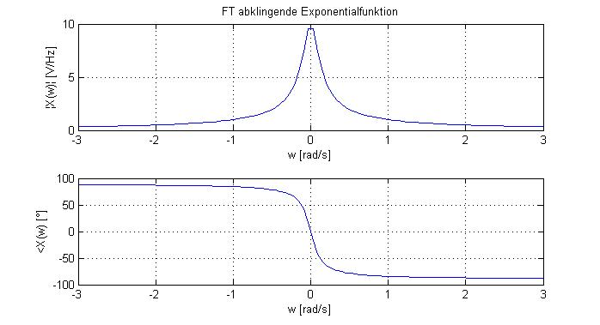

But you can also express the Fourier transform as X(f) using as control variable f in (Hz). Please remember that ω = 2πf (so this only changes the scaling of the horizontal axis).

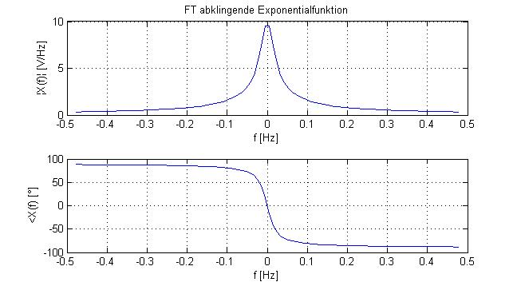

Furthermore it is interesting to **compare** these plots using the **linear scale**, with plots using a **logarithmic scale** for both frequencies and amplitude. Please do that in Matlab. Does the shape of the curve with the logarithmic axes look familiar? Which limitations do you have to consider for the range of the control variable when using a logarithmic scale?

Plot of x(t) in time domain:

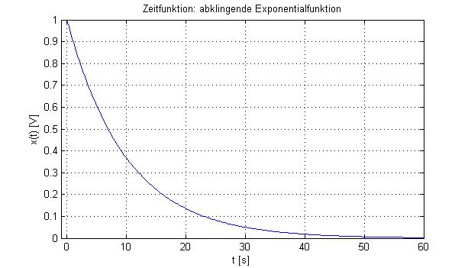

63%

**Exercise 2** *Fourier Transform (FT) Properties: Linearity*

(a)

¦X3(f)¦

1

-30 -20 20 30 f [Hz]

Because of the linear property of the Fourier transform, can weight and sum the spectra.

(b)

Fs > 60Hz = 2.30 Hz

**Exercise 3** *FT Properties : Time-Bandwidth Product*

The filter with the narrower bandwidth has a slower reaction => filter-1 has BW = 2.5 kHz

Now using the property that the time-bandwidth product stays constant, gives us

Filter-2 reacts 3 times faster as filter-1, therefore => filter-2 has BW = 7.5 kHz

**Exercise 4** *Fourier Transform and Properties*

a)

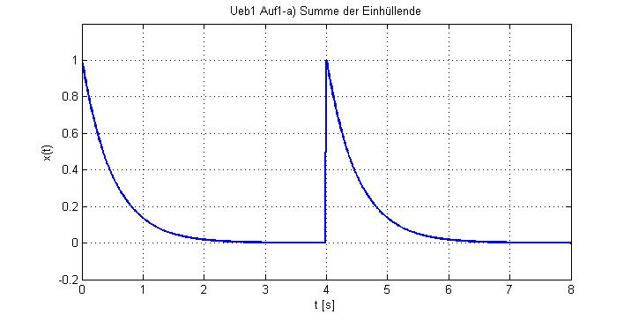

b)

Use the properties of the Fourier transform:

linearity 

time-shift 

and calculate then:

 ; 

c)

Find the zero crossings by setting the numerator equals 0 and solving for ω:





d) Use the property of the Fourier transform:

frequency-shift 

or multiplication with complex exponential ( exp(jωt) )



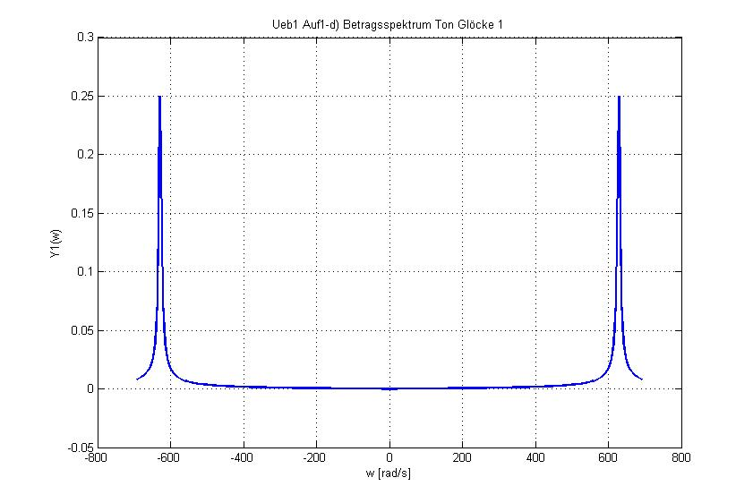

**Exercise 5** *FT Properties: Multiplication vs Convolution*

Since the signal was multiplied in the time domain, it is convoluted in the frequency domain:



Obs.: this result can be confirmed by comparison with the trigonometric formula



**Exercise 6** *FT Properties : Modulation*

**(a)**

The minimum distance needs to be: (fc2 - fc1) ≥ 2.fmax ; and also (fc3 - fc2) ≥ 2.fmax

These both distances can be the same: (fc2 - fc1) = (fc3 - fc2)

Obs.: in the context of telecommunications systems this is called the ***channel spacing*** for a multiple access or multiplexing in the frequency domain.

**(b)**

¦Z(f)¦

Amp/2

- fc3 -fc2 -fc1  fc1 fc2 fc3 f [Hz]

**(c)**

The filter H1(f) is a band pass filter, which lets the modulated signal y1(t) through and attenuates the other two modulated signals y2(t) und y3(t) .

¦H1(f)¦

1

- fc3 -fc2 -fc1  fc1 fc2 fc3 f [Hz]

The filter H2(f) is a low pass filter, which lets through the low frequency component of the product x1(t). cos(4πfc1.t) , and attenuates the high frequency component of the same product.

¦H2(f)¦

2

- fmax fmax f [Hz]

Obs.: in the telecommunications field this multiplication with a cosine function is referred as the mixing-up (in the modulator) and the mixing-down (in the demodulator). The cosine function which determines the center frequency of the modulated signal is called the carrier signal.

**Exercise 7** *Fourier Transform and Properties*

|  |  |  |
| --- | --- | --- |
| Property | Time Signal | Spectrum |
| ---  (reference) | Ueb2b_x1_t | Ueb2b_x1_f |
| time-shift | Ueb2b_x2_t | Ueb2b_x2_f |
| frequency-shift  or  modulation | Ueb2b_x3_t | Ueb2b_x3_f |
| time-bandwidth product  or  time scaling | Ueb2b_x4_t | Ueb2b_x4_f |

**Exercise 8** *Transition between Fourier Series and Fourier Transform*

(a)

 valid for 

For , use the Fourier transform definition and calculate:



(b) Q(ω) is a continuous spectrum (or more exactly a spectrum density), with a continuous control variable ω in (rad/s) , and  .

In contrast to the Fourier series, which delivers a line spectrum with a discrete control variable k, with  .

(c)

