List 5:

Analog-Digital / Digital-Analog Conversion

Sampling, Aliasing, Quantisation and Reconstruction

**Exercise 1** *Sampling and Aliasing*

A train drives by with a speed of 100km/h, which gives for a wheel with radius of 0.4m a rotation speed of 11.0 revolutions/second. Someone records the train ride in a video with an image resolution of 15 frames/second (fps). Assume that you can uniquely distinguish the position of the wheel, by a single hatched radial marking bar.

100km/h

fR = 11.0 revolutions

per second

Which rotation speed will one observe at the video? Justify your answer with a sketch of the spectrum (of the signal representing the rotation speed of the wheel), where one can see:

* The original rotation speed fR of the marking bar;
* The sampling frequency Fs and the Nyquist frequency Fs/2;
* The video rotation speed fV . What is the relationship between fR and fV ?

Drehungsgeschwindigkeit

f [Hz]

**Exercise 2**  *Sampling and Aliasing*

The sum of two continuous sinusoidal time functions is sampled and its spectrum is calculated with FFT. The amplitude spectrum is shown in the plot below. Determine the parameters of the FFT and the frequency of the two sine waves (fsig1 and fsig2), in case that aliasing effect has occurred or not. *Hint:* there are different possible solutions for fsig1 and fsig2 .

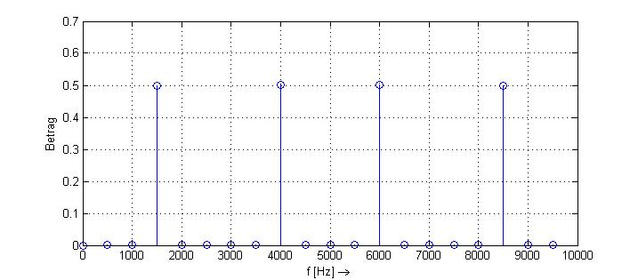

|  |  |  |  |  |  |  |  |
| --- | --- | --- | --- | --- | --- | --- | --- |
|  | **Sampling Frequency**  Fs [Hz] | **Sampling Period**  Ts [s] | **Number of points**  N | **Frequency step or resolution**  Δf [Hz] | **Time window**  ΔT [s] | **Sine wave 1**  fsig1 [Hz] | **Sine wave2**  fsig2 [Hz] |
| without aliasing |  |  |  |  |  |  |  |
| with aliasing |  |  |  |  |  |  |  |

**Exercise 3** *FFT and Sampling*

Obs.: parts (a) and (b) are the same as List-7 Exercise 2.

The plot of a time continuous function x(t) is given below. The function x(t) should be sampled and its spectrum calculated with the FFT (algorithm for the implementation of the DFT).

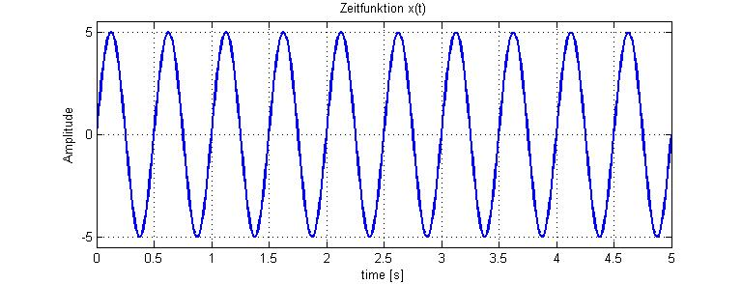

(a) How long must be the time window in order to get a spectrum with a frequency resolution (or frequency step) of Δf= 0.25Hz ?

(b) What is the minimum value for the sampling frequency Fs according to the sampling theorem, which avoids aliasing effects?

(c) Assume now that the signal x(t) has been sampled with an Fs = 8Hz. Which other sine waves would give the same discrete sequence after the sampling? Verify your answer with a plot in Matlab.

(d) Calculate now the DFT of x(t) in Matlab (using the fft() function), once with N=16, then N=8 and N=4. What is the difference in the spectrum when using these different N values ?

(e) Calculate the DFT with N=4 on paper and compare to the Matlab results. The required formula can be found in chapter 3, page 15, equation (8), “DFT Definition”.

(e) You want to insert an anti-aliasing filter (AAF) before the ADC. Determine the characteristics of this filter (type and cut-off frequency).

(f) Consider now you want to reconstruct your discrete signal (e.g. from part c), with a zero order holder digital-analog converter (ZOH DAC):

- How is the signal at the output of the DAC? Prepare a sketch of it.

- How can one smooth out the DAC output signal? Determine the characteristics of the reconstruction filter (also called anti-imaging Filter).

(g) Add question like: how large is the SNR of the sampled signal, when using 4, 5 or 6 bits for the quantisation?