List 5:

Analog-Digital / Digital-Analog Conversion

Sampling, Aliasing, Quantisation and Reconstruction

**Sample solution**

**Exercise 1** *Sampling and Aliasing*

rotation speed

fV Fs/2 fR Fs f [Hz]

4.0 7.5 11.0 15

In the video one see the speed fV= 4.0 Hz . The spectrum is symmetric with respect to Fs/2, such that: 

**Exercise 2**  *Sampling and Aliasing*

|  |  |  |  |  |  |  |  |
| --- | --- | --- | --- | --- | --- | --- | --- |
|  | Fs [Hz] | Ts [s] | N | Δf [Hz] | ΔT [s] | fsig1 [Hz] | fsig2 [Hz] |
| without aliasing | 10k | 0.1m | 20 | 0.5k | 2m | 1.5k | 4k |
| with aliasing | 10k | 0.1m | 20 | 0.5k | 2m | 6k | 8.5k |

**Exercise 3** *FFT and Sampling*

(a) Time window : 

(b) The sampling frequency must be larger than 4Hz, because the signal x(t) has a fmax = 2 Hz.



(c) The sinusoidal signals with the following frequencies can give the same discrete sequence:



For example: 

The graphic below shows that the sampling of sin(2pi2t) and –sin(2pi6t) with an Fs=8Hz, gives the same result.

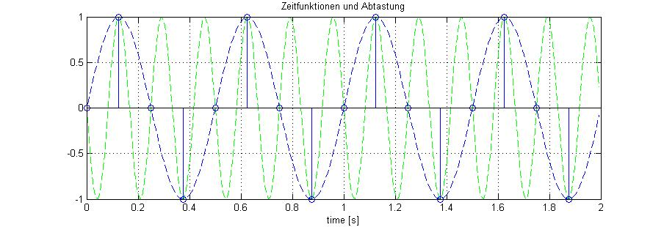

(d)

The plots below show the amplitude spectrum for N=16 and N=4. In fact as far as you normalise the output of the FFT, the only difference will be in the frequency resolution, which gets finer for a higher number of points. For example:

N=16 => fstep = Δf = 8/16 = 0.5Hz

N=8 => fstep = Δf = 8/8 = 1Hz

N=4 => fstep = Δf = 8/4 = 2Hz

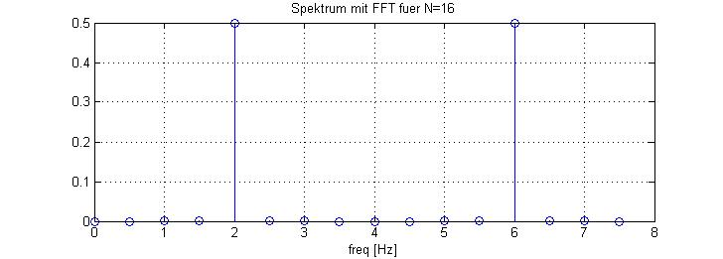

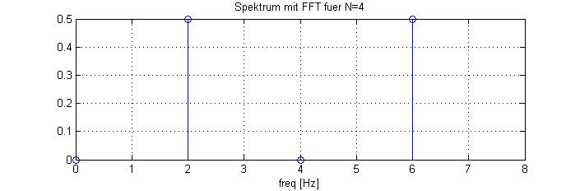

(e)

In order to simplify the DFT calculation (on paper!), let us take the minimum N value, where we can still observe a complete period of x(t): N=4 (with Fs = 8Hz und fsig = 2Hz):

Then applying the DFT definition formula we get:



====================================================================



====================================================================

====================================================================

====================================================================

====================================================================

OBS.: which delivers the same coefficients as the fft() in Matlab with N=4.

(e) AAF: low pass filter with fcut < Fs/2 .

For an ideal low pass filter you could select fcut = Fs/2 , but since real low filters have a limited steepness it is usual to have fcut ≤ (0.4)(Fs)

(f) The output of the ZOH DAC looks like a staircase signal (you can generate in Matlab a sketch of this signal by convoluting the discrete signal with the impulse response of the ZOH).

The reconstruction filter, used to smooth out the output of the ZOH, is also a low pass filter with the same characteristics of the AAF. In the time domain you can see it as an additional inertia slowing down the reactiveness of the signal and therefore attenuating the edges of the staircase. In the frequency domain you can see that this filter let the original spectrum as much as possible through and attenuates the image spectra.

(g) needs to add answer for quantisation noise