List 6:

Modelling mechanical and electrical Systems

**Exercise 1** *Mechanical System*

The mathematical model of a mechanical system is given below. Draw the free body diagram and determine the differential equation, which describes the movement of the mass m.

Hint: Assume that x=0 corresponds to the static position for Fin=0.

m

Fin

k1

k2

c2

x

**Exercise 2** *System Modelling*

Given the following electrical system with input and output voltage signals u(t) and y(t).

R

10kΩ

C

u(t)

y(t)

Physical Rules



-

+

+

-

(a) Determine the differential equation which describes this system.

(b) Determine the transfer function which describes this system.

(c) Which type of filter is implemented with this system? Determine the value of C, such that the break-point (or kink or corner frequency) of the magnitude in the bode diagram is by ωb= 100 rad/s.

(d) Estimate the step response of this system (equation plus graphics). Confirm your estimation considering the physical nature of the elements of the system (e.g. can the voltage across a condensator change suddenly?)

**Exercise 3** *System Representation with Differential Equations*

1. Analyse the electrical system below and determine the differential equation which describes it.

*u(t)*

L

C

*y(t)*

R1

-

+

1. Normalise your differential equation from part (a), such that the coefficient of the highest derivate of y(t) equals 1 .
2. Show that this differential equation (from part (b) ) corresponds to the following transfer function G(s) :

Obs: so you can verify your results from parts (a) and (b).

 mit 

**Exercise 4** *System Representation*

Consider a 3rd order system which is described by the differential equations below. The signal u(t) is the input, and the signal y(t) the output of the system. The signals x1(t) , x2(t) und x3(t) are internal signals or states of the system, and S, R and T are constant coefficients.



1. Complete the block diagram below, which describes this system. Identify in the block diagram the three internal state variables x1(t) , x2(t) und x3(t) .

y(t)







u(t)

1. Is the system output able to follow an abrupt change in the input, like a step[1]? Justify your answer with a short statement.

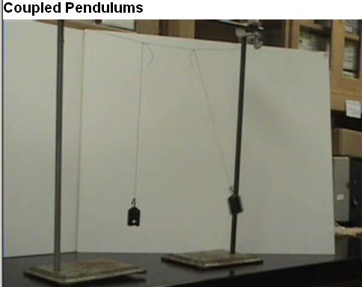**Exercise 5** *Coupled Pendulums.*

1. Watch the video „Coupled Pendulums“

under the URL:

<http://www.youtube.com/watch?v=RoSYKPTdlxs>

Let us call θA and θB the angles and

IA und IB the inertia of the two pendulums.

1. Draw a structural diagram of the coupled pendulums (with rotation springs, and rotating bodies with known inertia values), and identify all the torques (torsional or turning moments) that have an influence on each rotating body.
2. Determine the two differential equations which describe this system (derived from the balance of torques for pendulum A and B). For the moment let us neglect the energy loss or attenuation due to friction on the rotating axes (damping factor = 0). What are the consequences of this approximation? And next, linearise the two differential equations by using the small-angle approximation.
3. Complete the sketch below representing the block diagram of this coupled system. Suppose there are no external inputs, but the output of each subsystem acts as a stimuli to the other subsystem (e.g. θA is the output of the subsystem representing pendulum A and input for subsystem B, and vice versa).   
   Do not forget to identify the initial conditions. The system outputs are the angles θA and θB .



…



θA



…



θB

1. Enter the block diagram in a Simulink model file (*.mdl). Leave the parameters m (mass) and l (length) of the pendulum, and the kt (torsional constant) of the spring as symbolic variables, so that you can change their values easily in a Matlab file (*.m) . Estimate feasible numerical values for m and l, and leave kt value initially equals 1 N.m/rad. Do not forget to given an initial condition, for example an start angle at θA , such that θA(0) ≠ 0 rad .
2. Simulate now your Simulink model and adapt the numerical value of kt in order to match the frequency of the movement you can observe in the video.
3. Make a second version of your Simulink model file (*.mdl) without using the small-angle approximation. Repeat the simulation and compare the difference with the previous model. Does this approximation have a significant influence on the simulation results? Under which conditions does this approximation deliver satisfactory results?

1. In german this is called a *“sprungfähiges System”*.