List 6:

Modelling mechanical and electrical Systems

**Sample Solution**

**Exercise 1** *Mechanical System*

m

Fin

k1.x

x

k2.x

c2.x’



**Exercise 2** *System Modelling*

1. 

 

1. 
2. High pass filter



1. Step response has no DC-content (in stationary part), because the capacitor blocks it. The transient part shows an abrupt change (jump following the step input, because the capacitor can not load instantaneously) and then a decay in exponential form (corresponds to the substraction of the capacitor loading curve).

0 5.τ t

**Exercise 3**

1. 



1. 
2. Self-checking

**Exercise 4** *System Representation*

(a)

y(t)







u(t)

x1(t)

T

S

R

+

+

+

+

x2(t)

x3(t)

(b) No, this system cannot follow an abrupt change on the system input, because its output comes from an integrator (and integrator outputs cannot “jump” for real physical input signals), there is no feedthrough between the system input and output.

**Exercise 5** *Coupled Pendulums*

kt1

kt2

kt1

IA

IB

θA

θB



Torque on each disc (rotating body): from gravitation force, and from rotational springs 1 and 2.

Obs.: the attenuation due to friction on the rotation point, and other attenuation effects were neglected.

1. The effect of neglecting the attenuation is that the oscillation would never stop.





% Spring constants

k1 = 0.025; k2 = 0.75*k1;

% start winkel (AB)

phiA_0 = pi/6;

% Mass & length

m = 0.2; l = 0.4;

(d-e-f-g)

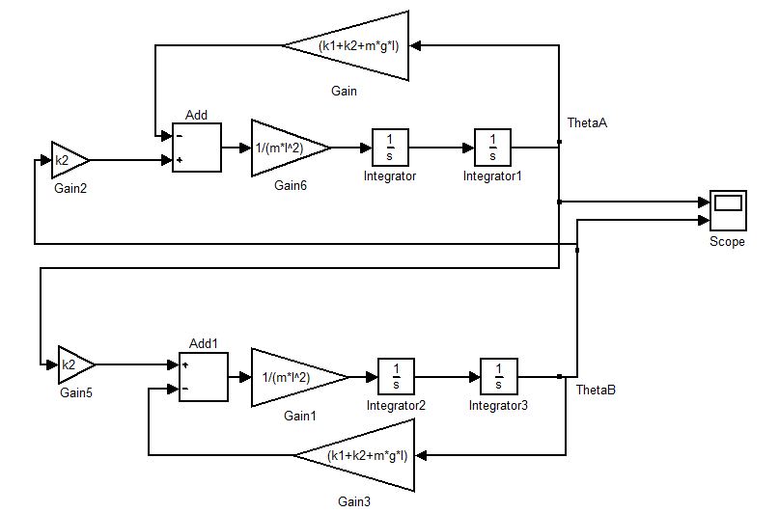

Simulation without small-angle approximation has almost the same result for phi<pi/4.

Obs:Try out in Simulink. Simulink!