List 7:

Step Response, Impulse Response and Convolution

**Exercise 1** *Signal Description in Time Domain*

(a) Complete the Matlab code below, which generates the following figure:

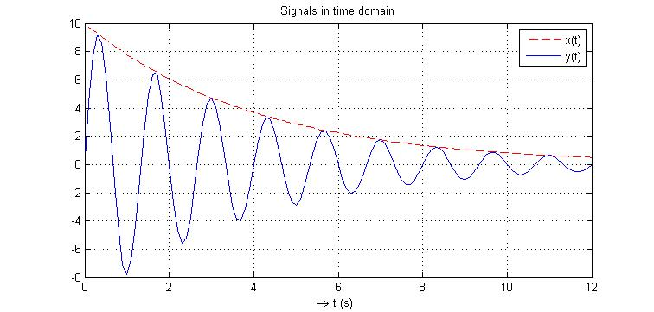

3.6

t = ………………………………………………………………………

x_t = …………………………………………………………………

y_t = …………………………………………………………………

plot(t,x_t,'r--',t,y_t,'b-'), grid on

xlabel('\rightarrow t (s) ')

title('Signals in time domain')

legend('x(t)','y(t)')

(b) Consider an LTI system which has an impulse response like y(t) (a sinusoidal with an envelope of a decaying real exponential function). Determine the following system properties: stability and capacity to oscillate.

(c) Estimate the step response of the system (equation plus sketch).

(d) Calculate and plot in Matlab a numerical approximation for the step response, and verify your answer for the part (c).

**Exercise 2** *Convolution Operation*

The two time functions p1(t) and p2(t) are given below. Answer the questions below in order to determine graphically the convolution product: 

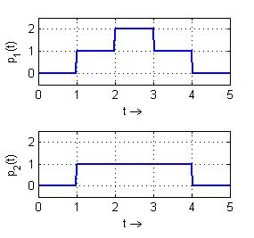

1. Write the convolution integral describing p3(t) (use λ Lambda as auxiliary time variable).
2. Complete the graphics below showing the function p2(t-λ) for selected time points.

**t = 2 t = 3 t = 4**

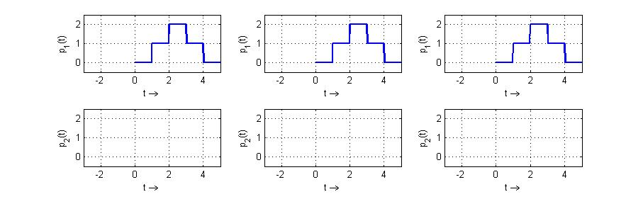

λ →

λ →

λ →

λ →

λ →

λ →

**p2(t-λ)**

**p1(λ)**

1. Sketch now p3(t) in the graphics below.

Hint: check how much the areas of p1 and p2 overlap for each time point.

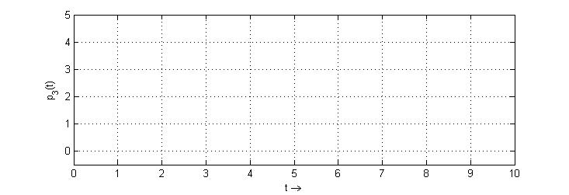

**Exercise 3** *Sampled Impulse Response*

The impulse response of a 1st order system is sampled and weighted, and the resulting curve gs[n] is shown below:

δ(t)

LTI

System

g(t)

Ts

Ts

=1ms

gs[n]

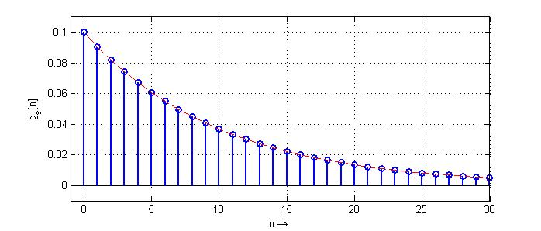

(a) Determine the constants k (gain) and τ (tau, time constant) of the system, and the equation describing the continuous impulse response g(t) in the time range t ≥ 0 .

(b) Determine the equation of the step response h(t) in the time range t ≥ 0 .

(c) How can you calculate in Matlab the response of the system to an arbitrary input signal u(t) ? Complete the code skelet below showing an example for a given u(t) (square pulse).

Obs-1: in Matlab we approximate the continuous time variable by a sampled vector t ≈ Ts.n   
 where n is an index vector, e.g. n=[0:1:30];

Obs-2: the vector tlong is used to plot the result of the convolution. Check the requested length.

% Define the constants and time vector

Ts = ………………; tau = ………………; k = ………………;

t = ……………………………… ; tlong = ………………………………;

u(t)

1

0

τ 2.τ t

% System impulse response and stimuli

gs_t = ………………………………………………………;

u_t = ………………………………………………………;

% Calculate output and plot

y_t = ………………………………………………………;

plot(………………………………………………………………………………………………………………) ;

**Exercise 4** *Convolution*

The result of the convolution of two time fucntions u1(t) and g(t) is shown below:

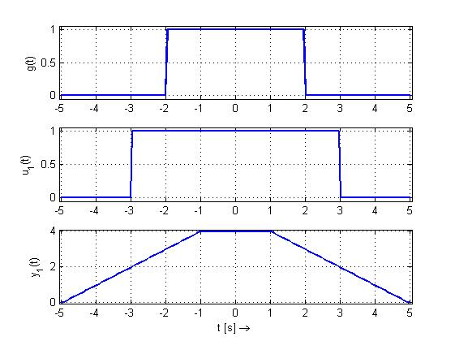



Complete the missing curves in the graphics below. Justify your answer by calculating the convolution integral in the requested time points.

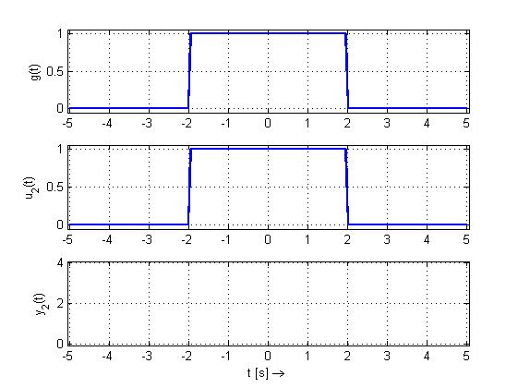



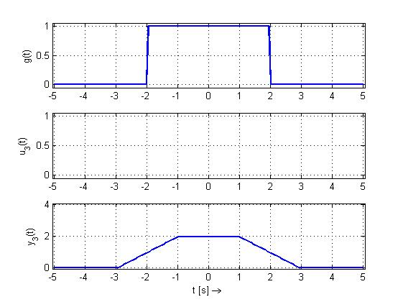



**Exercise 5** *System Representations in Time Domain*

1. The stimuli signal u(t) and the corresponding response y(t) of an LTI system, Sys1, are given below:

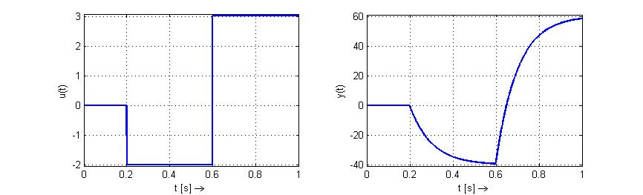



Response

Stimuli

0.3

Use this information to determine:

* + 1. The equation of the step response h(t)

Hint: h(t) is the response to an unit step input signal with initial conditions equal 0.

* + 1. The equation of the impulse response g(t)

What is the relationship between h(t) and g(t) ?

* + 1. Is Sys1 causal?

Justify your answer with an equation or a short statement.

1. The block diagram of the system Sys2 is given below:

y(t)

+

c1

u(t)



c2

-

* 1. Determine the equation, implemented with this block diagram, which describes y(t) .
  2. Derive both sides of the equation from part (a), in order to get the differential equation of system Sys2.
  3. Is the output of Sys2 able to follow abrupt changes in the input of the system? And why?

**Exercise 6** *Convolution*

Four time functions p1(t), p2(t), p3(t) and p4(t) are given below.

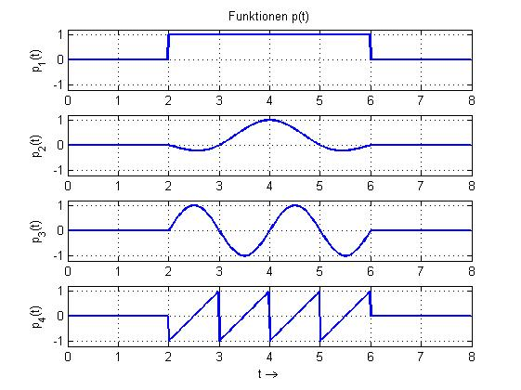

(a) Draw in the graphics below the mirrored and shifted function **p1(λ-t)** for the requested time points:

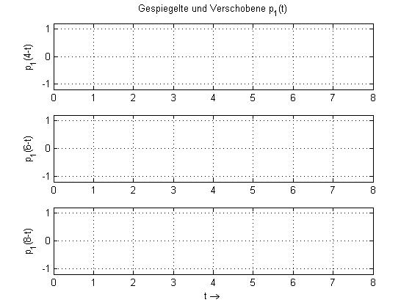

λ=4

λ=6

λ=8

The functions ya(t), yb(t) and yc(t) were calculated via convolution among the pi(t) functions.

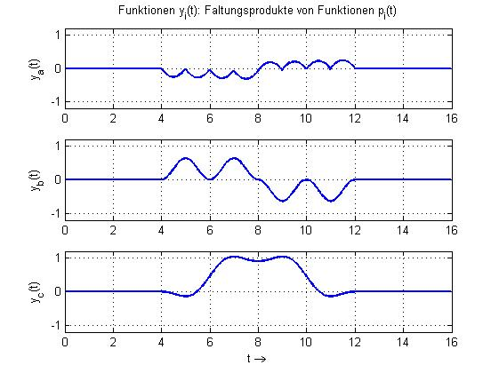

(b) Fill out the table below, by completing the equations on the left side and justifying your answer with an observation about the shape of resulting curve yi(t) .

|  |  |
| --- | --- |
| Convolution Product | Observation |
|  | Because of the odd symmetry of p4(t) about t=4 , one expects that ya(t)=0 at t=8, and in the intervals 4 < t < 8 and 8 < t < 12 that ya(t) has the same period as p4(t) |
|  |  |
|  |  |

**Exercise 7**  *Discrete System*

1. The impulse response of an LTI discrete system (LTD) is given below. Calculate the response of this system to the following input signal u[n] .

Hint: use the table below for your calculation.

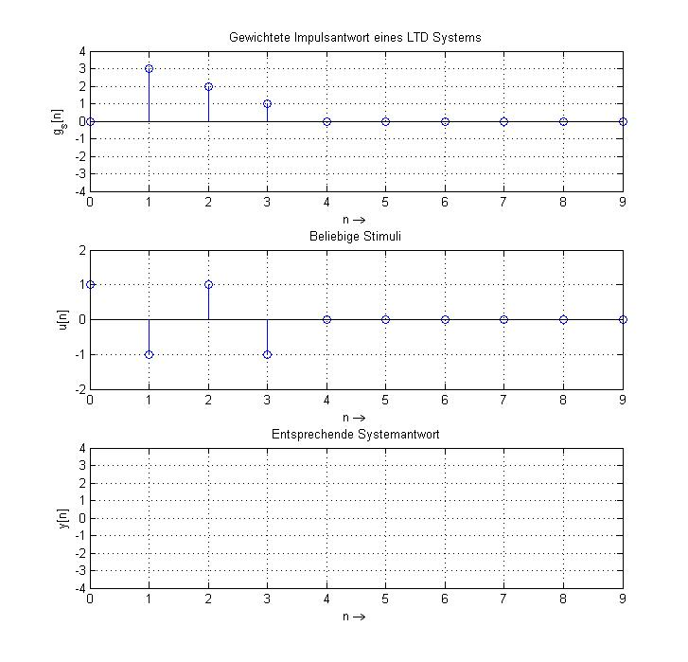

|  |  |  |  |  |  |  |  |  |  |  |
| --- | --- | --- | --- | --- | --- | --- | --- | --- | --- | --- |
| n  Response  part accounting for | 0 | 1 | 2 | 3 | 4 | 5 | 6 | 7 | 8 | 9 |
| u[0] |  |  |  |  |  |  |  |  |  |  |
| u[1] |  |  |  |  |  |  |  |  |  |  |
| u[2] |  |  |  |  |  |  |  |  |  |  |
| u[3] |  |  |  |  |  |  |  |  |  |  |
| Total |  |  |  |  |  |  |  |  |  |  |

(b) Write a three line Matlab code which allows you to verify your answer from part (a).

(c) Complete the difference equation below which describes this LTD system.

LTD

System

u[n]

y[n]

