List 7:

Step Response, Impulse Response and Convolution

**Sample solution**

**Exercise 1** *Signal Description in Time Domain*

(a)

t = 0:0.1:12; % other solutions are also possible

x_t = 10*exp(-t/4); % like the discharge curve of a 1st order system

y_t = x_t.*sin(2*pi*3/4*t); % element wise multiplication of sine and envelope curve

(b) Stable (because the impulse response tends to 0 for t-> ∞) and oscillating (because the impulse response oscillates and consequently the step response will also do ).

(c-d)

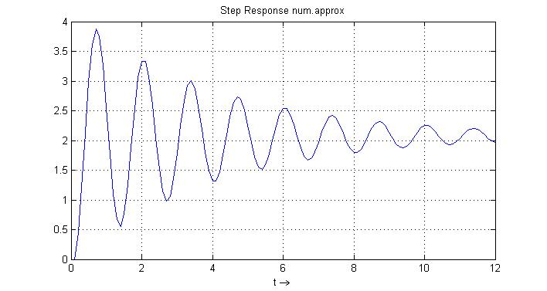

h_t = 0.1*(cumsum([0 y_t(1:end-1)]));

figure(2)

plot(t,h_t), grid on

xlabel('t \rightarrow')

title('Step Response num.approx')

% check declaring system with corresponding poles and gain

% this part of the theory comes later...

sigma_e = 1/4;

omega_e = 2*pi*3/4;

sys = zpk([],[-sigma_e+j*omega_e,-sigma_e-j*omega_e],[2.077*omega_e^2])

figure(3)

subplot(121),impulse(sys)

subplot(122),step(sys)

**Exercise 2** *Convolution Operation*

(a) 

(b)

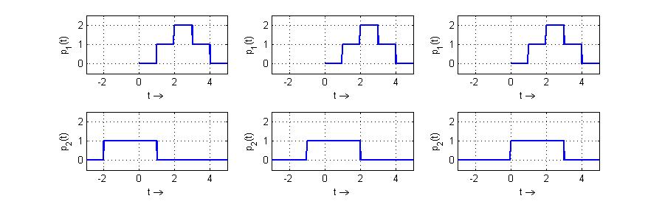

λ →

λ →

λ →

λ →

λ →

λ →

**t = 2 t = 3 t = 4**

**p2(t-λ)**

**p1(λ)**

(c)

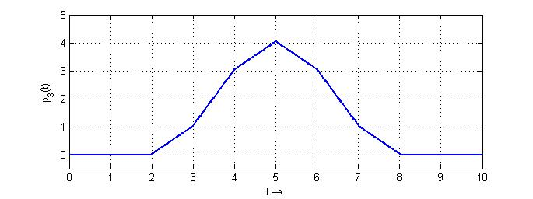

**Exercise 3** *Sampled Impulse Response*

(a) Read out of the graphic: 

System 1st order: impulse response: 



(b) System 1st order: step response : 

(c)

% Declare constants and time vector

Ts = 1e-3; tau = 10e-3; k = 1;

t = 0:Ts:3*tau; tlong = 0:Ts:6*tau;

% System impulse response and stimuli

gs_t = Ts*(k/tau)*exp(-t/tau);

u_t = double( (t>=tau) & (t<=2*tau) );

% Calculate output and plot

y_t = conv(u_t,gs_n);

plot(tlong,y_t)

**Exercise 4** *Convolution*

(a) (b)

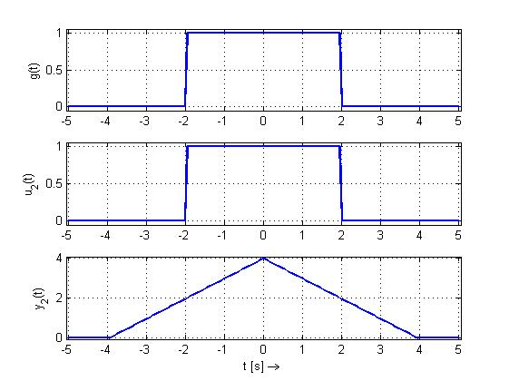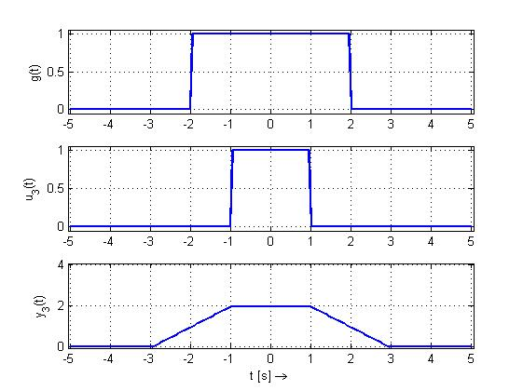

For (a)



**Exercise 5** *System Representations in Time Domain*

(a) From the graphic one can read out the constants k (gain) and tau (time constant):

SYS1: 

(a.i) 

(a.ii) 

(a.iii) Yes, causal. The system reacts only after being stimulated, which means for the impulse and step response that



(b) SYS2:

(b.i) 

(b.ii) 

**Exercise 6** *Convolution*

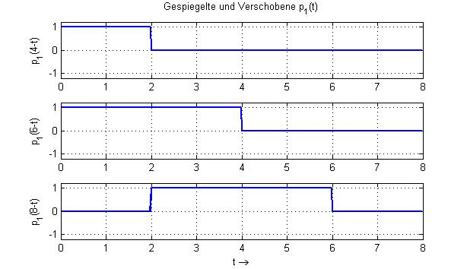(a)

(b)

|  |  |
| --- | --- |
| Convolution Product | Observation |
|  | Because of the odd symmetry of p4(t) about t=4 , one expects that ya(t)=0 at t=8, and in the intervals 4 < t < 8 and 8 < t < 12 that ya(t) has the same period as p4(t) |
|  | Because of the odd symmetry of p3(t) about t=4 , one expects that yb(t)=0 at t=8, and in the intervals 4 < t < 8 and 8 < t < 12 that yb(t) has the same period as p3(t) |
|  | Because of the even symmetry of p2(t) about t=4 , one expects that yc(t) show even symmetry about t=8, and because of the shape of p2(t) (mostly positive values) expect a function with mostly positive values and a maximum point close to t=8 (maximum overlap with positive values from p2(t) ). |

**Exercise 7**  *Discrete System*

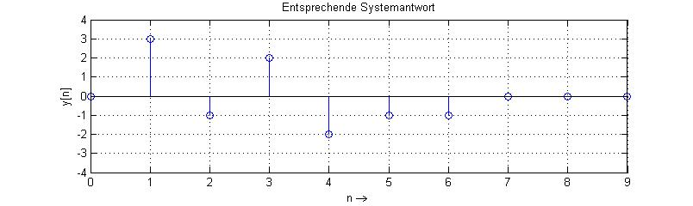(a)

|  |  |  |  |  |  |  |  |  |  |  |
| --- | --- | --- | --- | --- | --- | --- | --- | --- | --- | --- |
| n  Antwort-  Anteil bezüglich | 0 | 1 | 2 | 3 | 4 | 5 | 6 | 7 | 8 | 9 |
| u[0] | 0 | 3 | 2 | 1 | 0 | 0 | 0 | 0 | 0 | 0 |
| u[1] | 0 | 0 | -3 | -2 | -1 | 0 | 0 | 0 | 0 | 0 |
| u[2] | 0 | 0 | 0 | 3 | 2 | 1 | 0 | 0 | 0 | 0 |
| u[3] | 0 | 0 | 0 | 0 | -3 | -2 | -1 | 0 | 0 | 0 |
| Total | 0 | 3 | -1 | 2 | -2 | -1 | -1 | 0 | 0 | 0 |

(b) gs_n = [0 3 2 1 0 0 0 0 0 0]; % impulse response

u_n = [1 -1 1 -1 0 0 0 0 0 0];% stimuli

y_n = conv(u_n,gs_n); % corresponding output

(c) 