List 8:

Frequency Response and Bode Diagram

**Exercise 1** *Stationary System-Response*

The bode diagram of an LTI system is given below. Fill out the table by determining the corresponding input signals and stationary output signals. Do also indicate in the graphics of the Bode diagram, the amplitude and phase values that you assumed for your calculation.

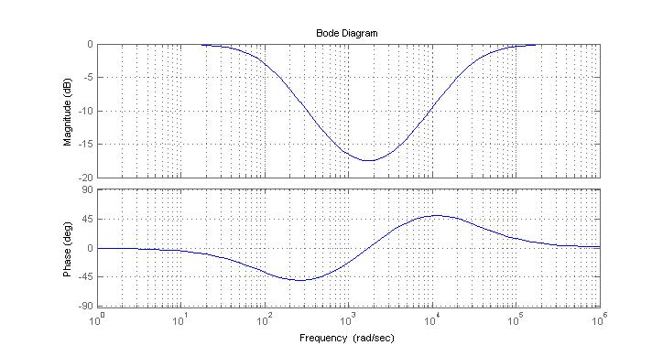

System-1

LTI





|  |  |
| --- | --- |
| Input signal | Output signal |
|  | ……………………………………… |
| ……………………………………… |  |
| ……………………………………… |  |

**Exercise 2** *Bode Diagram*

The transfer function G(jω) of the system Sys3 is given below. Complete the following table and prepare a sketch of the corresponding Bode diagram in the graphic provided below.



|  |  |  |  |
| --- | --- | --- | --- |
| ω | G(jω) | Magnitude of G(jω)  [dB] | Phase of G(jω)  [degrees] |
|  |  |  |  |
|  |  |  |  |
|  |  |  |  |

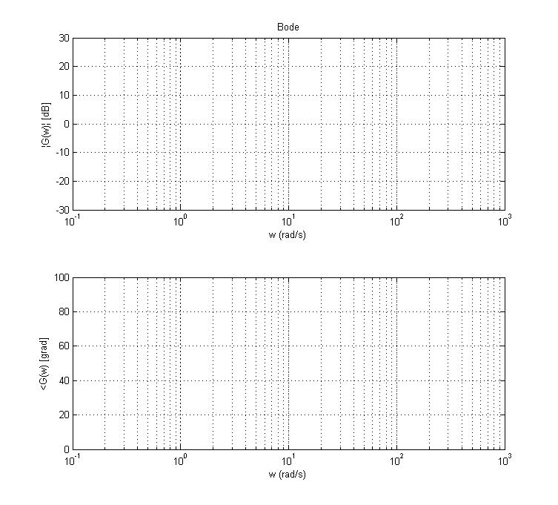

**Exercise 3** *System Representations*

(a) The block diagram of a coupled system is given below. Determine the two differential equations which describe this system.

y(t)

-





+

c1

x(t)



c2

-

+

(b) The frequency response of an LTI system was measured and it is plotted below in the form of a Bode diagram. Determine the corresponding transfer function G(ω) or G(jω) of the System.

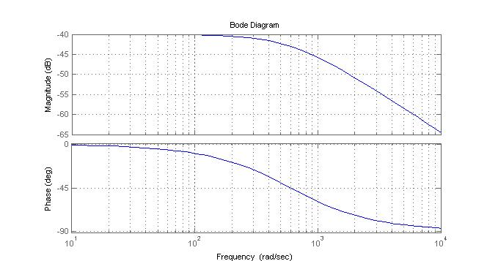

**Exercise 4** *Bode Diagram*

An LTI system is described by the following frequency response G(ω) . Determine the asymptotes of the amplitude and phase graphics (fill out the auxiliary table) and prepare a sketch of the Bode diagram.



|  |  |  |
| --- | --- | --- |
| Part of the transfer function | Amplitude Freq Response | Phase Freq Response |
| Numerator : |  |  |
| Denominator : |  |  |

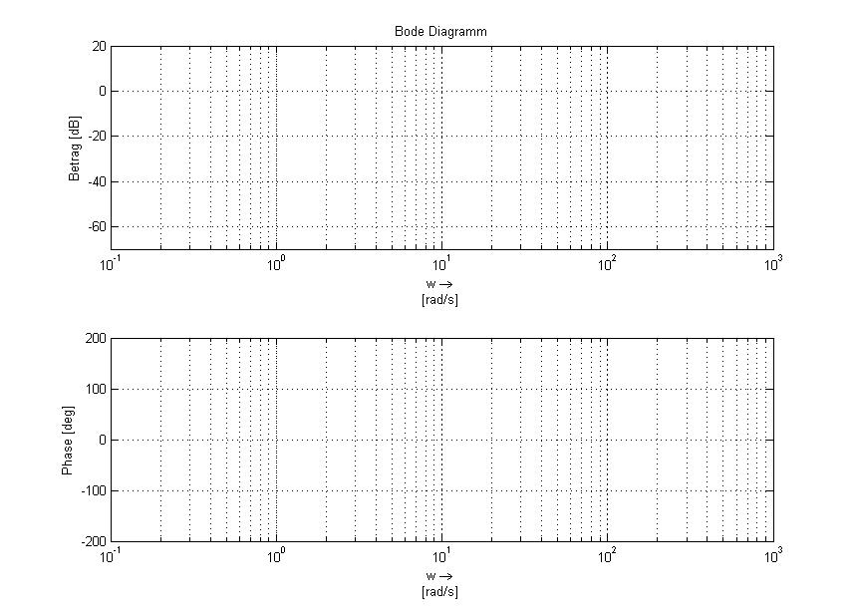

**Exercise 5** *System Representations*

An LTI system is described by the following differential equation:

LTI

System







(a) Determine the transfer function G(ω) which also describes the system.

(b) Assume that the coefficients A, B, C; D are real and constant values.

Which types of filter (LPF, HPF, BPF, BSF) can one implement with this transfer function? Justify your answer by calculating the corresponding constraints for the values of A, B, C, D.

1. Consider that you have the step response h(t) of this system available (via measurement). How can you use it to calculate the response to the following input signal u(t) ? Determine the equation of the output signal y(t) and the system properties which allow you to do so.

Stimuli signal u(t)

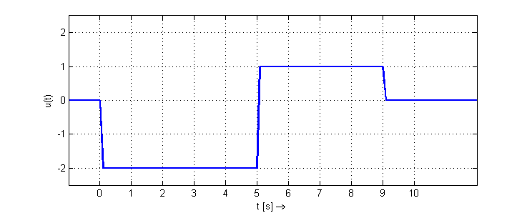

y(t) = ?