List 8:

Frequency Response and Bode Diagram

**Sample solution**

**Exercise 1** *Stationary System-Response*

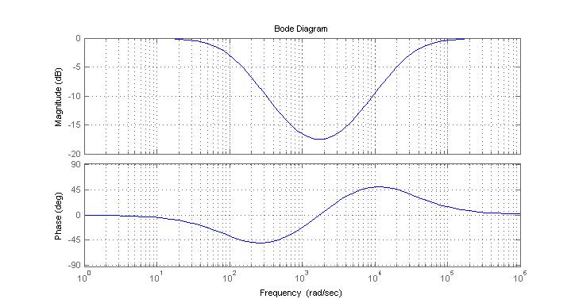

≈0°

≈-18dB

≈0dB

≈+22.5° = +π/8

≈-45° = -π/4

≈-3dB

|  |  |
| --- | --- |
| Input signal | Output signal |
|  |  |
| ¨ |  |
|  |  |

**Exercise 2** *Bode Diagram*



|  |  |  |  |
| --- | --- | --- | --- |
| ω | G(jω) | Magnitude of G(jω)  [dB] | Phase of G(jω)  [degrees] |
|  |  |  | imaginary positive: + |
|  |  |  |  |
|  |  |  | real positive: |

(exercise 2 continued)

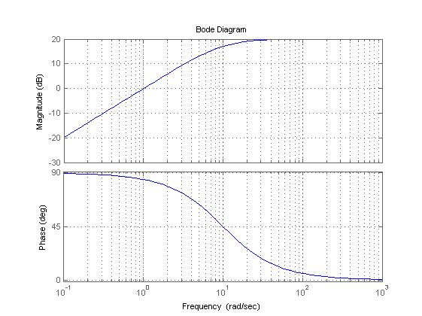

**Exercise 3** *System Representations*

(a)



(b)



**Exercise 4** *Bode Diagram*

|  |  |  |
| --- | --- | --- |
| Part of the transfer function | Amplitude Freq Response | Phase Freq Response |
| Numerator : | 0dB  +20dB/dek  100 rad/s | 100 rad/s  90°  45°  0° |
| Denominator : | 0dB  -20dB/dek  2k rad/s | 2k rad/s  0°  -45°  -90° |

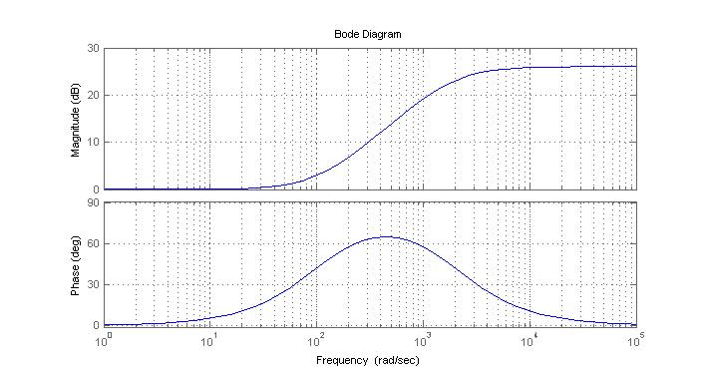

=26dB

**Exercise 5** *System Representations*

(a)



(b)

Low pass filter in case D/C < B/A Amplitude freq. response like:

High pass filter in case B/A < D/C Amplitude freq. response like:

(c) Because the input signal equals :

 one can determine the output signal by the following sum of weighted and shifted step responses



Related system properties: linearity (for superposition) and time invariance (for shifts).