List 9:

First and Second Order Reference Systems

Behaviour in Time and Frequency Domains

**Exercise 1** *LTI System Response*

The step response of an LTI system is given below :

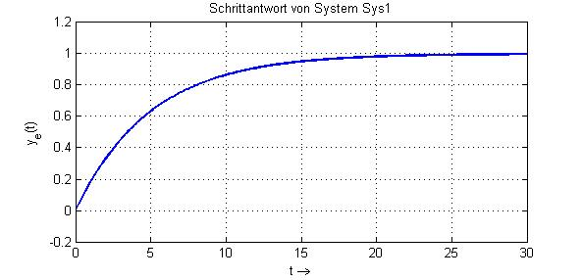

(a) Determine the equation of the step response ye(t) and the corresponding transfer function G(ω) . Explain how you read out from the graphics the numerical values for the required parameters.

(b) An unknown input signal u(t) causes the following system response y(t) plotted below. Determine the equation of u(t) and justify your response with a short statement.

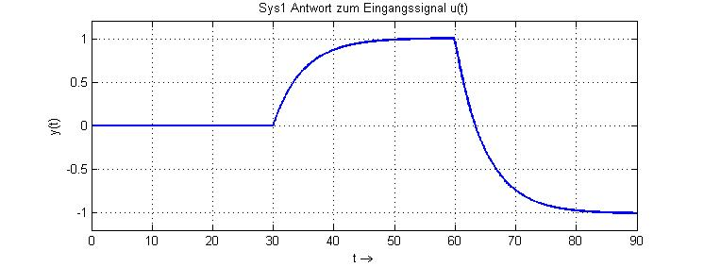

**Exercise 2** *Block Diagram*

Consider the block diagram of a system given below, and determine:

p(t)

+

-

u(t)

k1



k3

k2

q(t)

(a) The differential equation between the input u(t) and the output p(t);

(b) The differential equation between the input u(t) and the output q(t);

(c) The order of the system, and its time constant parameter τ (Tau).   
Is one of these system outputs able to follow an abrupt change of the input signal? In case yes, which one?

**Exercise 3** *First Order Systems in Time and Frequency Domains*

The Bode diagram of two 1st order LTI systems (SysA und SysB) are given below:

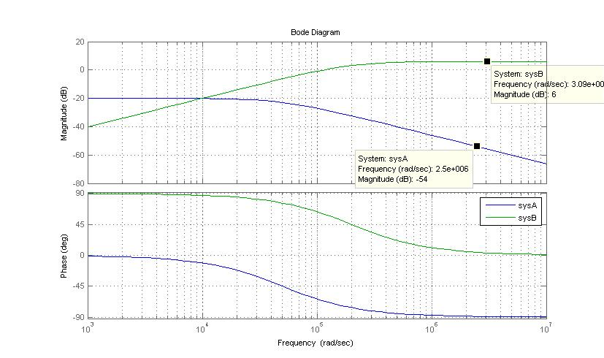

ω [rad/s]

1. Determine the transfer functions (equations) of SysA and SysB. Which type of filter is implemented with each of them?
2. Calculate the stationary responses yA(t) and yB(t) for the following input signal:

 mit 

Obs: the equation of the response signals yA(t) and yB(t) are expected.

SysA

u(t)

yA(t)

SysB

yB(t)

1. Observe the plots below and identify which ones are the: step response, impulse response or response to the stimuli signal p(t) from the systems SysA and SysB.

Obs-1: The stimuli signal p(t) equals:  (step times sine wave)

Obs-2: Justify your choices with a statement about the decisive characteristic that you have observed.

|  |  |
| --- | --- |
| This function is the … of system … because .... | This function is the … of system … because .... |
| This function is the … of system … because .... | This function is the … of system … because .... |
| This function is the … of system … because .... | This function is the … of system … because .... |

**Exercise 4**  *Identifying System Parameters*

The impulse and step responses of a second order low pass filter are given below.

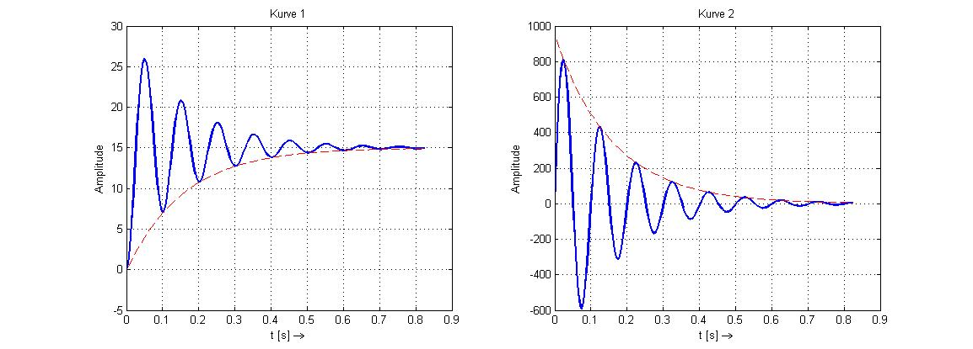





(a) Which curve is the impulse and which one the step response? Justify your answer with a short statement.

(b) Compare these responses with the normalised representation of a 2nd order low pass filter, and estimate the numerical values of the parameters: k (gain), σ (sigma – decay constant of the envelope curve), ω0 (natural angular frequency – undamped-) and d (damping factor of the oscillation) of the system.

Hint: Assume that ω0 ≈ ωe (Eigenfrequency or natural damped frequency) , since d<<1 .

**Exercise 5** *System Representations*

The impulse response, step response and Bode diagram of three systems are given below. Analyse the graphics and fill out the table below.

|  |  |  |  |
| --- | --- | --- | --- |
| Impulse Response | Step Response | Frequency Response | Parameter  (1st order: k, τ ;  2nd order: k, d, ω0 ) |
| A |  |  |  |
| B |  |  |  |
| C |  |  |  |

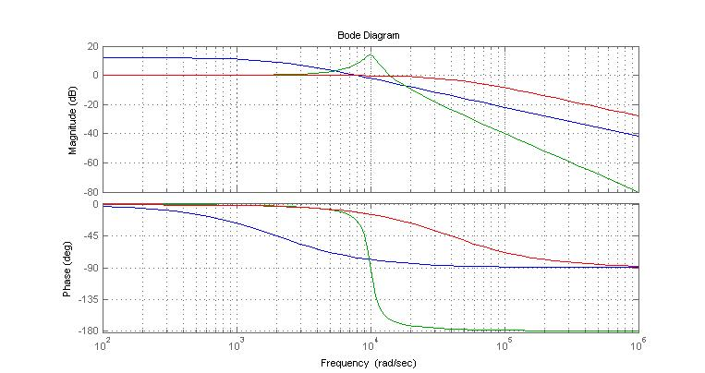

14dB

E

G

F

E

G

F

12dB

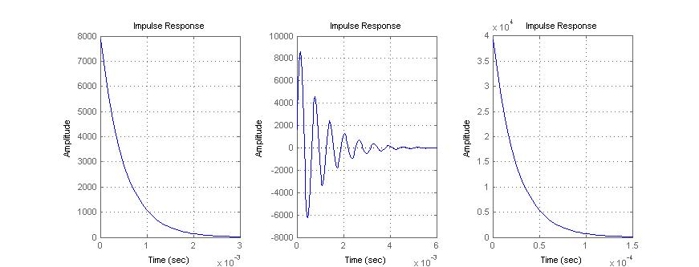

C

B

A

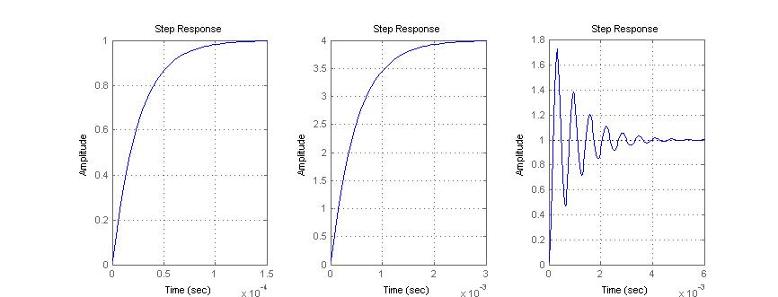

R

P

Q