**Laboratory 1A:**

**Pre-SiSy Math Exercises**

**&**

**Matlab as a Calculator**

**Thema-1 : Functions with fractions**

1. Simplify the compound fraction (“Doppelbruch”) in the expression below:



1. Calculate the following limit cases for the function f(x) from exercise (1):



Write a Matlab script generating a plot of f(x) for

Use the function *logspace* to define a vector x.

Check the syntax of this function with the help in Matlab.

**Thema-2 : Complex Numbers** (specially polar notation with Euler’s identity)

1. Determine the Cartesian notation of the following complex numbers:



1. Determine the polar notation of the following complex numbers:

*Hint: draw them as a vector in a complex plane*



Find out the Matlab conversion functions that allow you to verify your results from exercises 3 & 4.

1. Open, execute and understand the code of the Matlab script *presisy_auf5.m*

Make the necessary changes, such that you generate a plot showing a spiral with four windings (Spiralwicklung).

1. Determine the polar notation of the following complex numbers:

*Hint: Please do not use the method of multiplication with the conjugated complex,  
 but rather calculate the polar notation for both numerator and denominator*



1. Given the complex function  , determine the value of x for which:
   1. 
   2. 
2. What is the value of the magnitude and phase of the complex function  , when x=1:
   1. 
   2. 

First calculate the exercises 6, 7 and 8 on paper, and then verify your results using Matlab as a calculator.

**Thema-3: Trigonometric Functions**

1. Draw a sketch of the function x(t) defined as:

 with 

1. What changes in the sketch from x(t) of exercise (9) if you have now:
   1. 
   2. 

Verify your sketch by generating the same plot in Matlab. Define your time vector so that you have 20 points per period of the sinus function x(t).

**Thema-4 : Function description using the sum-sign**

1. Expand the expression described with the sum-sign below and give explicitly the first four terms of the function x(t) :



with

|  |  |  |
| --- | --- | --- |
| n | An | φn |
| 0 | 2 | 0 |
| 1 | 0,5 | 0 |
| 2 | 0 | --- |
| 3 | 1,5 | 180° = π rad |

1. Draw a sketch of the function y(t) defined as:



1. Draw a sketch of the function yP(t) defined as:

 with  and y(t) as defined in exercise (12).

**Thema-5 : Integration and Differentiation of exponential-function**

1. Calculate the following integrals and differentiation below:
   1. 
   2. 
   3. 

**Thema-6 : Graphical solution for Integrals** (as area under the curve)

1. The sketches of the functions x1(t), x2(t) and x3(t) are given below. Determine graphically the related integral-functions y1(t), y2(t) and y3(t) and draw sketches describing these functions.



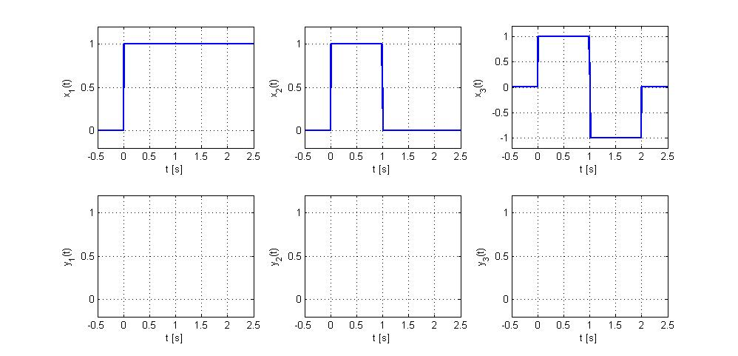

Open the Matlab file *presisy_exer15.m* , execute and understand the code.

For example, what does the function *cumsum* ?

Extend the code to verify the results of your sketches above (functions y2 and y3).

**Thema-7 : Plots in log-log scale**

1. The plot of a function f(x) is given below. Please notice that this plot is in a log-log scale. Determine the equation of the lines (asymptotes) approximating the behaviour of f(x) in the two regions below:



Check the value of the function f(x) for x=1, and determine the equation describing f(x).

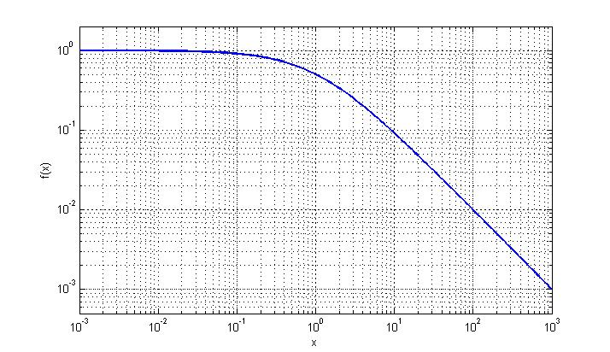

**Thema-8 : Logarithm of basis 10**

1. Determine the value of the following logarithmic expressions:
   1. 
   2. 
   3.  given 
   4. 
   5. 

Check your results in Matlab, using the function *log10* which calculates the logarithm with basis 10.