Laboratory 3B:

**Fourier Tranformation**

**Properties and Applications**

In this laboratory you experiment with different properties of the Fourier Transformation as: time-bandwidth property, duality and frequency shift or modulation.

**Exercise 1** *The Uncertainty Principle (or Time-Bandwidth Produkt)*

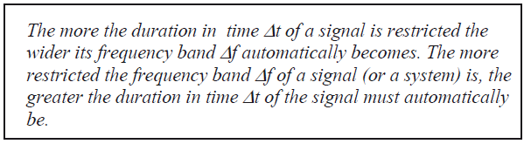

*Source : Ulrich Karrenberg „Signals, Processes and Systems“*

*Uncertainty Principle in german „Unschärferelation“*

1. Let us experiment with the Uncertainty Principle as expressed above. Define in Matlab three rectangle functions x1(t), x2(t) and x3(t), corresponding to the red dotted functions in figure 1 below (these are the envelope functions in figure 1).

*Hint: Define a time vector with exactly 1’000 points, and a sampling frequency of 5kHz. In the function x1(t) all the points are equal to ‘1’, in x2(t) half of the points, and in x3(t) one fourth of the points are equal to ‘1’.*

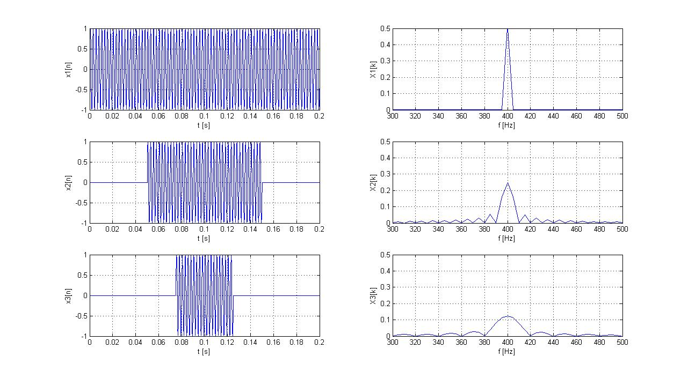

Figur 1 Three rectangular envelope curves in red, defining the width of the sinus impulses

1. Use the FFT to calculate the corresponding spectra X1(f), X2(f) and X3(f), and generate a plot of the amplitude spectra. Explain the differences among these spectra based on the property time-bandwidth product.

*Hint: Use the command xlim(), to zoom around and fix the frequency range [0; 100]Hz .*

**Exercise 2 : *Frequency Shift or Amplitude Modulation (AM)***

1. Define now the signals y1(t), y2(t) and y3(t), which correspond to the multiplication of the envelope curves x1(t), x2(t) and x3(t) with a sinus wave of frequency 400Hz.
2. Calculate and plot the spectra Y1(f), Y2(f) and Y3(f), and use *xlim()* to zoom around the interesting part of the spectrum. Where is it now (which frequency range) ?

Check the frequency shift property and explain the differences among the Xn(f) and Yn(f) spectra.

1. How do these spectra change, if you take instead of the rectangular envelope curves, three new envelope curves with the form of slow sinuses with frequency 5Hz, 10Hz and 20Hz ? You can consider these envelope curves last over the entire time window [0 0.2]s Justify your answer with a plot in Matlab.
2. The frequency shift property is often used to modulate a source signal on a carrier signal. Generate now with the function generatror TTI TG5011 an amplitude modulated signal, and use the oscilloscope to observe the output signal in the time and frequency domain.

*Hint-1 : Set first the carrier signal, as a sinus with frequency 10kHz and amplitude A=2Vpp. Add then the modulation with:*

*>Mod >Type AM >Done ; >Source >Internal ; >Depth > 100%;*

*>Freq > 1kHz; Shape >Sine*

*Hint-2 : in order to get a more stable display, connect the output signal on channel-1 and the SyncOut signal on channel-2, and use channel-2 as source for the trigger.*

1. Can you confirm that this AM signal from the signal generator is generated according to the block diagram below? Try out and explain the influence of the parameter “m” Modulation Depth (or in german „der Modulationsgrad“).

