

**Chapter 1:**

**Signals and Systems: Introduction**

Contents

1. Signals and Systems: Examples 1

2. Signal Properties 5

3. System Properties 7

4. Test Signals 9

5. Discrete Signals 12

6. Operations with the time-variable 13

7. Two new operations 14

8. Vocabulary 14

**References**

[1] L.F.Chaparro , „Signals and Systems using Matlab“, Academic Press, 2015

[2] I.Rennert, Signale und Systeme, Fachbuchverlag Leipzig, 2013

# Signals and Systems: Examples

The terms signal and system are used in many fields and can have slightly different meanings. So what are signals and systems in this course?

We deal here with technical applications (mostly in electrical and mechanical fields) and in this context we understand signals as measurements of physical quantities as a function of time, and systems as processes that can generate or modify signals. Let us look at some examples:

1. Global Positioning System (GPS)

GPS is a geolocation system, which allows calculating the position of a receiver device in any point on the earth, as far as this user device is able to receive the signals of at least four GPS satellites.

There are 32 satellites in operation, distributed in 6 orbital planes, in such a way to optimise the coverage of the earth surface. Each satellite has on board an extremely precise clock (atomic clocks with deviations below 10ns/day), and send telegrams with time-stamps and detailed orbit information.

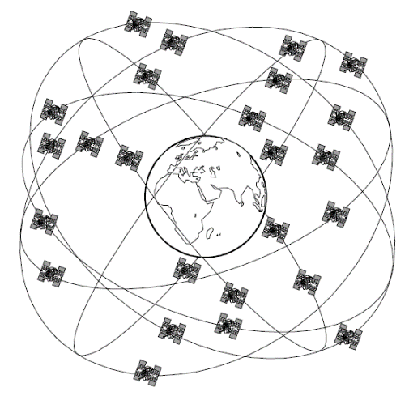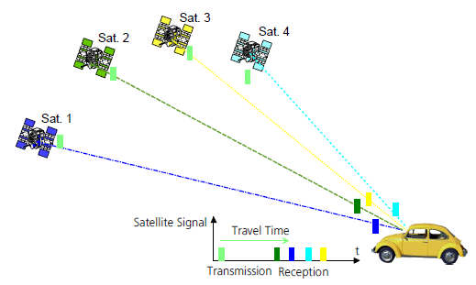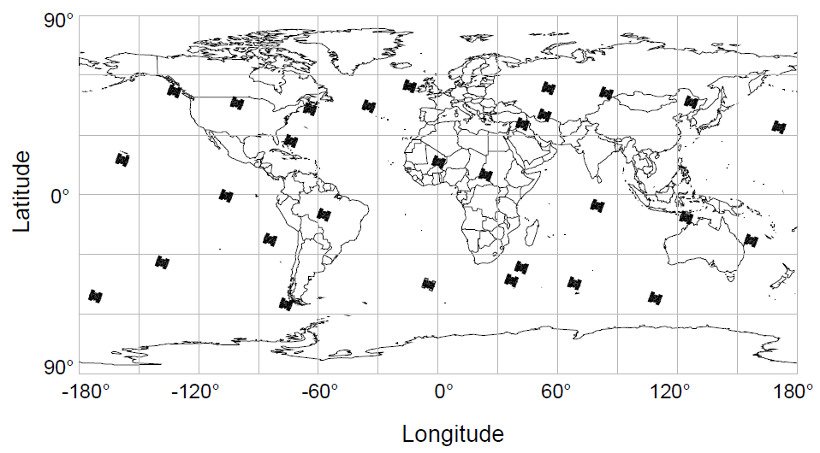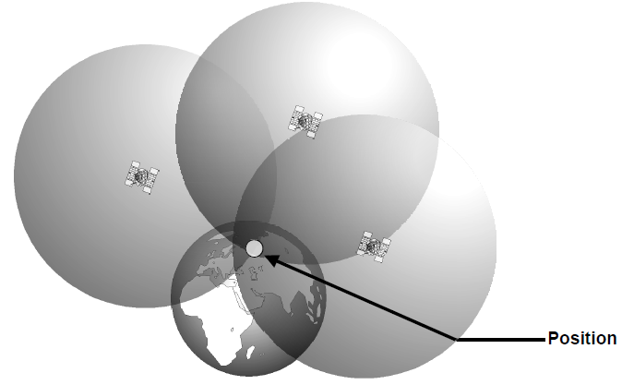

*Figure 1-1 GPS System Overview (extracts from GPS-Compendium of www.u-blox.com)  
 GPS satellites orbit the Earth on 6 orbital planes*

*Position of the GPS satellites at 12:00 hrs UTC on 14th April 2001*

*Four satellites are needed to determine longitude, latitude, altitude and time*

*The position is determined at the point where all three spheres intersect*

The receiver device compares the time-stamps received from the satellite with its local clock, and determines the time of flight (how long took the signal between transmitter –TX- and the receiver –RX-). Assuming a known speed of light, the receiver can calculate the distance to the satellite.

Combining the information of 3 satellites allow to calculate the x,y,z coordinates of the receiver. Nevertheless the local clock of the receiver has an unknown time-shift Δt in comparison to the satellite clocks, therefore the information of a 4th satellite is required to estimate Δt as well.

In this example the input signals are the telegrams from the satellites, and the output signals are the calculated coordinates plus time-shift over time.

GPS is a very complex system, and in order to understand further details, we would need to break it into sub-systems. For example, how are the telegrams sent from the satellite in such a way that we can still retrieve them on receivers which are about 20’000km away? [1]

1. Robot Arm

Robots are extensively used in the automation of production lines. For instance a robot arm can be controlled to move along a desired trajectory and execute tasks along its way.

Here the input signal can be marks or shapes describing the pattern to follow and the output can be the current position of the robot arm in each degree of freedom. Usually each degree of freedom has a driving motor, such that we can split this system into sub-systems each containing a motor and a sensor.

 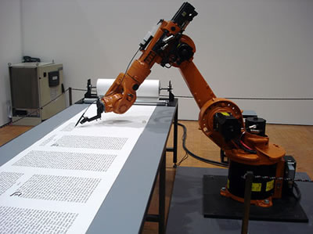

Source: <http://vimeo.com/12626341> ; <http://www.technovelgy.com/graphics/content07/kuka-bible-2.jpg>

*Figure 1-2 Robot arms examples in packaging line and doing precision tasks (“hand writing”)*

1. Electronic Stability Control (ESC)

After ABS (anti-locking braking system), ESC is one of the driving security systems that is becoming standard in new manufactured vehicles. This system compares the steering direction (given by the driver) to the vehicle’s direction (measuring the wheel rotation and lateral acceleration) and intervenes if it detects a probable loss of steering control. The mismatch between steered and current position signalises a loss of traction, which the system helps to recuperate by reducing speed, and correcting wheels direction step-by-step. The reaction time of such electronic systems (much shorter than human reaction) has been proven to prevent a significant number of accidents.

1. Ultrasound medical instrument

Also known as ultrasonography, it is a diagnosis method enabling the visualisation of subcutaneous body structures, including soft structures like muscles, tendons or neonatals. The principle is based on sending sounds waves (typical range 2 -18 MHz) and measuring the echoes produced by reflection in body structures (any layer or tissue where density changes reflects part of the wavesound). Through analysis of the echo signals one can determine the depth of the tissue (delay of propagation) and the nature of it (amplitude of echo). [2]

The sonography machine can be split into two main systems: the sender producing the sound waves by exciting a piezoelectric element in the desired frequency, and the receiver where a transducer (piezoelectric sensor) converts the pressure waves into a voltage signal that can be stored and processed to produce the image output.

Question 1-1

Identify the input and output signals, plus the system and some sub-systems for the following applications:

* Cellular Phones
* Internet Music/Video Streaming
* Radars

A large number of technical systems nowadays process signals in digital form using DSP (digital signal processors) and FPGAs (field.programmable gate arrays). The advances of digital technologies (hardware and software) in the last 60 years have enabled a spectacular development of applications in numerous fields like: communication, control and biomedical engineering.

Nevertheless analog signals have not lost their importance, since many sensor & actuators signals and several transmitted signals are originally analog signals, and the theory of analog signals & systems forms a base to understand digital signal processing.

The theory of this semester will cover primarily analog signals & systems, conversion methods A/D & D/A, and some basics on digital signals & systems. For purpose of simulations the analog signals will often be approximated by discrete representations.

# Signal Properties

In the next chapters we discuss alternative ways to describe and analyse signals. The methods we choose are dependent on the signal properties. Let us identify some of the properties relevant for our study:

* Analog vs Digital

Analog signals have a continuous domain of definition (continuous time) and a continuous domain of possible values (continuous amplitude). Digital signals are defined only for certain points in time (discrete time) and have a limited number of possible amplitude values (quantised).

We can also differentiate among signals that have continuous amplitude and either continuous definition range (continuous signals) or sampled definition range (discrete signals).

* Periodic vs Aperiodic

Periodic signals repeat their pattern over time with a regular interval, in contrast to aperiodic signals where no regular repetition takes place.

A periodic signal x(t) can be described mathematically as:

Periodic signal: . (1)

Question 1-2

How can you mathematically describe a periodic sine signal y(t) with period of 0.5 seconds, an amplitude within the range [-2 ; 2], and by t=0 (initial condition) of y(0)=2 ?

* Power vs Energy

The energy of a signal is defined as the integral over time of the squared signal amplitude.

Signal Energy: . (2)

Since this integral is calculated over an infinitely long interval and the squared amplitude is always positive or zero, the value of this integral can only converge if the signal equals zero for most of the time. This is the case for signals that pulse for a short interval and disappear for the rest of the time.

For power signals instead, which have non-zero values for most of the time, we can calculate the energy over intervals of time, which corresponds to the power of the signal.

Signal Power: . (3)

If you compare this signal power definition with the power of a voltage or current signal, it corresponds to the power of such electrical signals for a normalised resistance of R=1Ω.

The SI unit for energy is joule (J=N.m=W.s), and the SI unit for power is watt (W).

Question 1-3

If you are calculating the power of a periodic signal, it is interesting to make the integral interval equals to the signal period. Can you explain why?

* Even vs Odd

These properties concern the symmetry of the signals. If we split the graphics plane where we represent a signal into 4 quadrants: even signals show symmetry along the vertical axis (mirror quadrant I and IV into quadrants II and III). And odd signals show symmetry with respect to the origin point (0, 0) (mirror quadrant I into III and quadrant IV into II).

x(t)

t

*Quadrant-I*

*Quadrant-II*

*Quadrant-III*

*Quadrant-IV*

x(t)

t

*Quadrant-I*

*Quadrant-II*

*Quadrant-III*

*Quadrant-IV*

*Figure 1-3 The symmetry of even and odd signals*

Mathematically these symmetries can be described as:

Even signal: . (4a)  
  
 Odd signal: . (4b)

Question 1-4

The signal you described in Question 1-2, is it an odd or an even signal? Can you change its symmetry property by varying the phase of the sinusoidal function?

* Deterministic vs Random

The signals called deterministic are known over time and their value at each point in time can be described, for example with a mathematical function. Random signals in contrast, have an unknown waveform that cannot be precisely described for every point in time. Nevertheless most random signals can be described by statistical characteristics like average value and standard deviation for example.

Question 1-5

The input signal coming into a TV set via cable, is it a deterministic or a random signal? Can a deterministic signal carry information?

Obs.: information in the sense of a previously unknown message for its receiver.

# System Properties

In this SiSy1 semester we concentrate on a type of system called LTI, as the abbreviation for linear, time-invariant systems. Let us discuss therefore the most important characteristics of such LTI systems:

* Linearity

This property is more restrictive than the description of a geometrical line as we are used to from mathematics. In fact a linear system has to satisfy the principle of superposition, which means:

Superposition Principle:

.

 (5)

If an input signal x1(t) causes an output signal y1(t) and x2(t) causes y2(t), then a sum of these inputs weighted by constant factors (A and B) will produce a sum of the corresponding outputs weighted by the same constant factors.

The consequence is that the only operations possible within such a linear system are operations which produce terms via multiplication with constant factors and time derivation or integration. The sum of such terms is also possible, but the sum of an offset (a constant term) is already non-linear.

* Time-invariance

This property implies that given an input signal x1(t) and the associated output signal y1(t); a delayed or earlier version of the same input signal, causes an output signal with the same time shift.

.

 (6)

* Causality

A causal system produces a non-zero output, only from the moment onwards where it receives a non-zero input. In other words: the system waits for a cause before it reacts. This is the case for all physically implementable systems (which can be built or observed in nature), but not the case for all mathematical systems that we can define. Therefore this may become an issue when implementing systems first defined mathematically.

Example 1-1

Let us check if a simple passive R-C circuit is a LTI system. One way to describe this system is to apply Kirchhoff mesh and node rules and get the corresponding differential equation.

*x(t)*

R

C

*y(t)*

*i(t)*

*x(t)* : input voltage (V)

*y(t)* : output voltage (V)

*i(t)* : internal current (A)

[ R ] = Ω = Ohm

[ C ] = F = Faraday

We consider an ideal measurement of the output y(t), such that the whole current flowing through the resistor R is going to the capacitor C . Plus recalling the relationship between current and voltage in a capacitor  , we can then deduce[3]:



 (7)

Question 1-6

Check by applying the superposition principle (as defined by equation (5) ) if the R-C circuit from Example 1-1 is a linear system.

Question 1-7

The response of the R-C circuit for a staircase input signals u(t) is given below. Use this result to discuss and explain why the system is or is not time invariant.

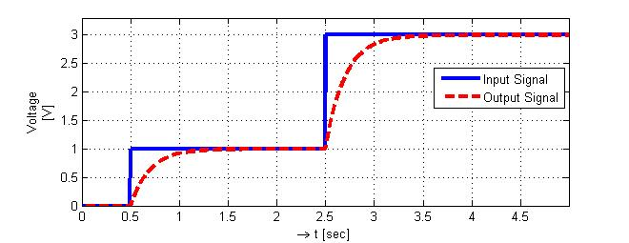

*Figure 1-4 Response of passive RC circuit to staircase input*

# Test Signals

Test signals are often used to describe more complex signals or to analyse and compare the behaviour of unknown systems.

For instance analog systems are commonly characterised by setting at the input a step signal and recording the output, which is called step response.

* Step or Heaviside Step Function

The unitary step signal, commonly named sigma or epsilon, is defined as:

 (8)

Question 1-8

Use the definition of the step signal σ(t) to describe mathematically the staircase input signal from Question 1-7.

Question 1-9

Use the information of Figure 1-4 to define the step response of the passive RC circuit. Can you imagine a mathematical function that describes this step response?

* Impulse or Dirac Delta Function

The impulse function is more exactly a distribution, which we can imagine as taking the whole energy of a signal and concentrating it on a single point (by t = 0).

Since the signal energy corresponds to the area under the curve, we can picture this as a limit case of a narrow square signal whose width tends to zero, but area remains equals to 1 (which implies that the amplitude tends to infinite).

The mathematical and graphical representations are given below.

Taking a narrow square with unitary area:

  
then the delta impulse equals:

 (9)  
  
such that:  
  (10)

The uselfulness of this delta signal will become clear in the next chapter.

- τ/2 0 +τ/2 t[s]

s(t)

1/τ

lim

τ → 0

δ(t)

t[s]

Figure 1-5 From a narrow unitary square to the impulse or Dirac delta function

Question 1-10

Calculate the following integral and compare the result to the step function.



What is the relationship between the step and the impulse functions?

* Sinus and complex-exponential

The sine and cosine functions can be defined by selecting the value of 3 parameters:

* + Frequency ( [ f ] = Hz or angular frequency [ ω ] = rad/s = s-1 ); [4]
  + Phase initial value ( [φ0 ] = rad );
  + Amplitude (A with unit matching the unit of the signal, e.g. [ A ] = V ).

 (11)

Furthermore by remembering Euler’s identity:

 (12)

We can also describe the sine and cosine as a sum of two complex exponentials.

 (13)

 (14)

The complex exponential signal can be represented graphically as an arrow with unitary radius, rotating around zero in a complex plane. This representation is called a rotating phasor, and its projection in the horizontal (real) axis is the cosine value, and the projection in the vertical (imaginary) axis is the sine value.

Imag

+1.j

-1.j

ω

**exp(+jωt)**

-1 +1 Real

**sin(ωt)**

**cos(ωt)**

Im

+1.j

-1.j

ω

**exp(+jωt)**

-1 +1 Re

ω

**exp(-jωt)**

Figure 1-6 Complex exponential exp(+jωt) and exp(-jωt) as rotating phasors

Question 1-11

Draw a graphic representing the function x(t) with respect to time, and a second graphic representing x(t) as a sum of phasors in a complex plane.



Question 1-12

Define the equation that describes the function y(t) represented in the graphics below:

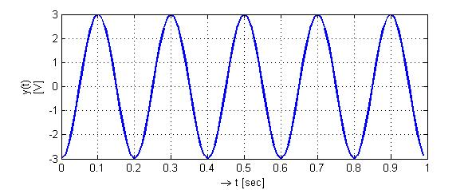

Question 1-13

Given  , rewrite the equation (for an equivalent function) :

* 1. using a cosine function
  2. using complex exponentials

# Discrete Signals

Discrete signals can be generated by sampling continuous signals. In this course we deal with discrete signals that are sampled with a known and constant time interval, named sampling period TS .

The figure below shows the sampling of a continuous signal x(t), resulting in a discrete signal known only in the time points  with  . This discrete signal is often represented as a sequence x[n], where the square brackets help to identify it as discrete, and the constant factor TS is implicit.

Ts

x(n.Ts) = x [n]

x(t)

t (s)

x(t)

0 1 2

n ( )

x[n]

Ts

Figure 1-7 Sampling of continuous signal x(t) producing a discrete signal x[n]

Let us look at some special discrete signals:

* Unit Impulse:

Also called Kronecker delta, which equals one when n = 0 and equals zero elsewhere.

-2 -1 0 1 2 3 4 n

δ[n]

1

|  |
| --- |
| (15) |

In fact every discrete signal can be described as a sum of weighted and shifted unit impulses. As for example the sequence y[n] below. The coefficients bk are real constants taking the value of the sequence amplitude at the point n=k.

 (16)

* Unit Step:

It corresponds to a sampled continuous step function, and equals zero for negative n values and one elsewhere.

|  |
| --- |
| (17) |

-2 -1 0 1 2 3 4 n

ε[n]

1

It is interesting to compare the relationship of the discrete impulse and the discrete step, with the continuous impulse and the continuous step (discussed in Question 1-10). They are in fact very similar, and the integral of the continuous time domain can be approximated in the discrete time domain by a cumulative sum.

discrete continuous

  (18)

# Operations with the time-variable

In the next chapters we often face situations, where functions are modified by taking an operation in the independent variable of the function, which is the time in our case. Let us have a look at some of these operations and their effect in the original function.

* Time Shift

The time variable is added to a constant value causing a horizontal shift in the original function. In order to find out how to shift the function, you can check by one or two points.

 Shifted Function (19)

For example, given the shifted function y(t) defined as:



Check how to shift x(t) in order to obtain y(t), by testing for one or two points:



so x(t) needs to be shifted right by 2 in order to get y(t).

* Time Scaling

The time variable can be multiplied with a constant factor, causing it to be compressed or stretched.

 Modified Function (20)  
 if a > +1 horizontal axis compressed  
 if 0<a < +1 horizontal axis stretched

* Mirroring

The mirroring is a special case of the time scaling discussed above, when the constant factor a = -1 . In this case the function is mirrored along the vertical axis.

 Mirrored Function (21)

Exercises for this topic can be found in list number 1.

# Two new operations

In this section we introduce two new operations required for the following chapters. We will discuss examples of these operations during the laboratory exercises.

**Continuous/Discrete-Time Correlation**

The cross-correlation between two signals measures how similar the two signals are over time-shifts. The similarity (function output) is given as a function of the time-shift.

Correlation is widely used for various purposes including signal detection in communication systems. It can be defined for both continuous-time and discrete-time signals.

Cross-Correlation for continuous signals  (22)

Cross-Correlation for discrete signals  (23)

**Convolution**

The convolution allows to calculate the sum of shifted and weighted copies of a signal. In the definitions below, one signal should be seen as a sequence of weights, which is used to scale the amplitude of the shifted copies of the second signal. This operation is widely used to calculate the response of linear time invariant systems based on their impulse response (this topic will be discussed in chapter 4).

The convolution can be defined for continuous-time signals (convolution integral), or for discrete-time signals (convolution sum).

Convolution Integral  (24)

Convolution Sum  (25)

The convolution is in fact commutative, and can also be written as (star operator):

 (26)

# Vocabulary

convolution Faltung

correlation Korrelation

Dirac delta: Diracstoss

DC: Gleichanteil

even: gerade

initial condition: Anfangsbedingung

odd: ungerade

random: zufall

rotating phasor: Drehzeiger

sampling: Abtastung

sampling period: Abstatsperiode

width: Breite

1. For instance, which modulation scheme allows compensating for the large losses during such a long transmission path? Which problems are commonly encountered on the receiver side?
2. For more details check: <http://en.wikipedia.org/wiki/Medical_ultrasonography#From_sound_to_image>
3. If you are not familiar with electrical components like R and C, we can consider the analogy of a room with a radiator used for heating. The thermal resistance of the radiator is then R and the air within the room (which will cumulate the heat) is the C. The input signal x(t) is the temperature of the water flowing inside the radiator and the output signal y(t) is the temperature of the air in the room.
4. The square brackets are used to indicate the units of the variable within it.