

**Chapter 2:**

**Fourier Series and DFT**

**Periodic Signals in the Frequency Domain**

Contents

1. Spectrum Introduction 1

2. Fourier Series with Real Coefficients 4

3. Fourier Series with Complex Coefficients 6

4. Reference Signal: Periodic Square 7

5. Properties of Fourier Series 12

6. Numerical Approximation with DFT 16

7. Vocabulary 19

8. Annexes 19

2-A Orthogonality 19

2-B The sinc function 21

2-C Fourier-Series Notations and Correspondances 22

**References**

[1] I.Rennert, Signale und Systeme, Fachbuchverlag Leipzig, 2013

[2] L.F.Chaparro , „Signals and Systems using Matlab“, Academic Press, 2015, 2nd ed

[3] J.Hoffmann, Einführung in Signale und Systeme, Oldengourg Verlag München, 2013

# Spectrum Introduction

In this chapter we learn how to represent periodic time signals in the frequency domain. The basic idea of this representation is to break down any periodic signal in a series of sine and cosine waves, or a series of cosine waves with distinctive amplitude and phase values.

But before we dive into the mathematical treatment, let us check how a cosine wave in the time domain can be represented in the frequency domain. Figure 2-1 below shows two equivalent representations of periodic time function x(t).

The time domain representation shows that x(t) is a cosine wave with amplitude A, frequency f0 (or angular frequency ω0 or period T0), and initial phase φ. If we assume that the representation in frequency domain takes a cosine wave as the basis function, we can represent x(t) by simply giving the corresponding amplitude A and initial phase φ values at the corresponding ω0 position. It is also possible to have the frequency axis in Hz and indicate the corresponding f0 value. This representation is called the single sided spectrum, split into an amplitude spectrum and a phase spectrum.

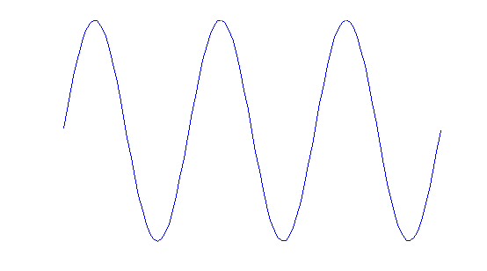

x(t)

A

T0

t (s)

φ/ω0

Amp(ω) = Amp(f)

(lin or dB)

A

ω0 ω (rad/s)

f0 f (Hz)

Phase(ω) = Phase(f)

(rad or ° )

φ

ω0 ω (rad/s)

f0 f (Hz)



Time Domain Representation

Frequency Domain Representation with cosine wave as basis function



Figure 2‑1 Single Sided Spectrum of a cosine function

Question 2-1

Draw the single sided amplitude- and phase-spectrum of the following functions:

*Hint:* please pay attention that the basis function here is always a cosine wave.

|  |  |  |  |  |  |
| --- | --- | --- | --- | --- | --- |
| (a) |  | (b) |  | (c) |  |

As already discussed in chapter (1), the Euler identity allows to represent every cosine wave as the sum of two complex exponential functions.

When we use the complex exponential as a basis function, the corresponding spectrum has positive and negative frequencies and is therefore called a double sided spectrum.

Amp(ω) = Amp(f)

(lin or dB)

A/2

-ω0 +ω0 ω (rad/s)

-f0 +f0 f (Hz)

Phase(ω) = Phase(f)

(rad or ° )

+φ

-φ



Frequency Domain Representation with complex exponential as basis function

-ω0

+ω0 ω (rad/s)

+f0 f (Hz)

Figure 2‑2 Double Sided Spectrum of a cosine function

Compare and notice the differences and similarities between the single and double sided spectrum representation, for the amplitude and phase values!.

# Fourier Series with Real Coefficients

In the parallel mathematics course this semester you learn about the Fourier series with the real coefficients ak and bk defined as:

|  |
| --- |
| Given a periodic function x(t) with period T0 , you can calculate the corresponding Fourier series  (1) |

|  |
| --- |
| with  (2) |

The principle of the Fourier series is based on the idea that any periodic signal x(t) with period T0 can be decomposed in or approximated by a sum of cosine and sine waves with frequencies that are multiples of the basic frequency f0 of x(t).

How accurate is this approximation? If the function has no discontinuities, the approximation can be 100% accurate by taking the necessary number of cosine and sine waves[1]. The cosine and sine terms are also called harmonics, for k=1 1st harmonic, k=2 2nd harmonic and so on. The term a0 is called the constant term or DC-offset.

How are the coefficients calculated? The formula (2) above shows that you can calculate them by taking an integral of the function times a cosine or sine with the frequency corresponding to that harmonic. The integral limits can vary, but you need to integrate over a period. The effect of this integral is to check if the signal x(t) has power in each k-th harmonic, and if so**,** the corresponding amplitude is associated with the coefficients ak and bk. Otherwise ak and bk equals zero. It is as if you distribute the power of the signal in buckets for each harmonic.

Furthermore if the signal is even you have only ak coefficients that are different from zero, and for odd signals only the bk coefficients are different from zero. This is a direct consequence of the fact that cos(kω0t) are always even functions, and sin(kω0t) always odd.

The Fourier series can be used for either decomposing a given signal (Fourier analysis) or to generate a desired signal (Fourier synthesis). In both cases you have coefficients associated with a set of functions, forming the base of your series.

Which sets of functions are adequate for such series? The sine and cosine with frequencies multiple of the basic frequency are an example, but not the only one. In fact, any set of functions that are orthogonal to each other can be used. The orthogonality means that if you multiply any of these functions (two by two) and integrate over a period, the result equals zero. This property brings an important advantage in that if you start your series with Kmax harmonics and later decide to add an extra harmonic, the coefficients previously calculated do not need to be modified. An example is shown in annex 2-A.

Now, if we compare the idea of the Fourier analysis with the spectrum concept from the previous section, we see that it is possible to represent any periodic signal in the frequency domain, by showing in a spectrum the associated amplitude and phase for each harmonic.

For example, let us check how can we get the amplitude and phase values for the 1st harmonic (k=1), given that we have the corresponding a1 and b1 coefficients:

Because



If we take this approach for each harmonic we can rewrite the Fourier series as:

|  |
| --- |
| (3) |

The Ak and φk coefficients can be then used to draw the single sided spectrum of the periodic function. This notation is called the *trigonometric Fourier series*.

# Fourier Series with Complex Coefficients

There is a third notation of the Fourier series that uses complex coefficients ck, which are used for a double sided spectrum representation. This representation is also called the *complex exponential Fourier series*.

Let us check this idea for a simple function with only one harmonic plus DC content:



Where c1 and c-1 are complex conjugated numbers with:





and 

This idea can be expanded for a periodic function with k-th harmonics, and grouped in a single sum with k varying from -∞ to +∞ .

|  |
| --- |
| (4a)  with  (4b) |

The amplitude and phase of the ck coefficients can be then used to draw the double sided spectrum of the periodic function.

In appendix 2-C you find a summary with the three notations for the Fourier series and the correspondences among them.

# Reference Signal: Periodic Square

Example 2-1

The periodic square wave is a helpful reference signal. Let us consider a periodic square pulse with width τ and period T0 as shown in figure 2-3 below, and calculate the corresponding real and complex Fourier coefficients.

x(t)

A

-T0 0 +T0 +2.T0 t

τ

**…**

**…**

Figure 2‑3 Periodic square pulse function with duty cycle ( τ / T0 ).100%

**Real Coefficients ak and bk**

Let us recall the definition of the real coefficients and determine the values that we can by inspection (without integral calculation):



Since the function is even:



and the DC-offset corresponds to the average value which is equal to:



Finally we use equation (2) to calculate the ak coefficients:



Then simplify remembering that 



This means that x(t) can be approximated by the sum of cosine waves with amplitudes thatequal ak:



For example with a 50% duty cycle (τ/T0 = ½) you can synthesise a periodic square wave with the following Fourier series:





Question 2-2

Calculate the corresponding coefficients Ak and φk for the periodic square signal, and then generate a plot in Matlab of the single sided spectrum for a square wave with 50% duty cycle ( τ / T0 = 0,5 ). Use k (or f/f0) as the variable for the horizontal axis.

Question 2-3

Check in Matlab how good the approximation of the square wave is, when you have only the sum of the first 5 harmonics and when you have the first 50 harmonics.

Tip: Generate a time function which is the sum of k cosinus (or 2.k complex exponentials) corresponding to the harmonics.

Question 2-4

How would the Ak and φk coefficients from the question above change if you took an odd-square function, instead of an even square wave?

**Complex Coefficients ck**

Let us now calculate the complex Fourier Coefficients for the same periodic square wave reference signal x(t) . According to the definition (equation 4a):



Since the function is even, the ck coefficients have real values (remember ak ≠ 0, and bk = 0 ), and c0 equals the average value: 

We can now calculate the value of the ck coefficients using two methods: deriving from the already calculated ak and bk, or using directly the definition with the integral calculation. Let us do both and compare the results.

**Calculation of Coefficients ck based on ak and bk**

Using the relationship between the real and complex coefficients,

 

We get the following expression for the complex coefficients of the periodic square wave:



**Calculation of Coefficients ck based on definition with Integral**

Using the definition of the complex coefficients:





We get the same result as withthe previous method:



Furthermore it is common to use the sinus cardinalis function ( sinc [2]) to get an expression for the ck coefficients, which one can use to easily estimate the spectrum plot:

|  |
| --- |
| (5) |

So that the coefficients ck can be rewritten as:

|  |
| --- |
| (6) |

Example 2-2

Figure 2-4 shows a numeric example of a periodic square wave with:



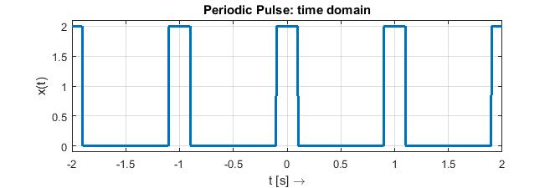

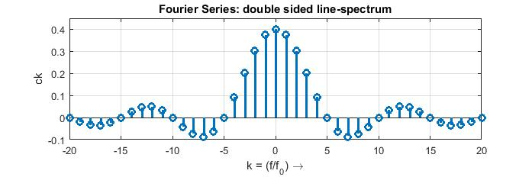

Figure 2‑4 Example Plots of a periodic square wave in time and frequency domain

One can calculate the complex Fourier coefficients using equation (6):



which means that the spectrum will have zero-points (nulls) at:

(where the sinc argument equals an integer value)

The unit of the horizontal axis in the spectrum plot is k (the index of the harmonics). So we have here a discrete spectrum with complex amplitude values ck for integer values of k. [3]

For an even function which implies real valued ck coefficients, we can make the spectrum plot in a single graphic. But most usually the spectrum is represented in two graphics (magnitude and phase), which is necessary when working with complex ck coefficients. Figure 2-5 shows this split and the corresponding double sided amplitude- and phase-spectrum.

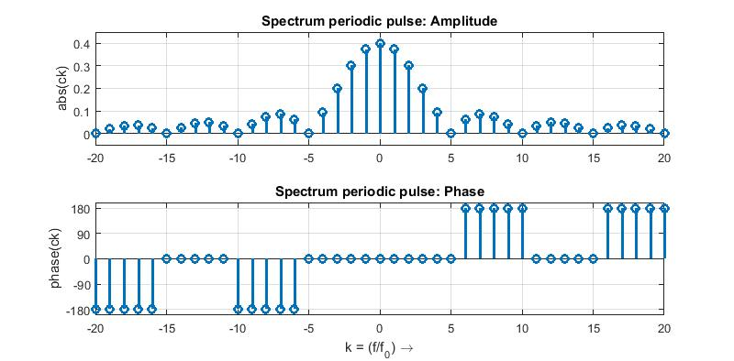

Figure 2‑5 Spectrum Plot divided into Amplitude- and Phase-Spectrum

Question 2-5

What would the spectrum of the periodic square wave in figure 2-4 look like, if the duty cycle changed to : (a) (τ / T0 ) = ½ ; (b) (τ / T0 ) = ¼ ;

Tip: verify first for which k value you expect the zero-points (nulls).

# Properties of Fourier Series

Table 2-1 summarises the properties of the Fourier series, which are relevant for us in this course. Further we experiment withthese properties by varying parameters of the periodic square wave signal from example 2-2.

|  |  |
| --- | --- |
| Property | Observation |
| Symmetry | Because  the amplitude spectrum is always an even function, and the phase spectrum an odd function[4] |
| Discrete Spectrum | Functions which are periodic in the time domain are discrete in the frequency domain (because they can be represented with Fourier series). |
| DC-Offset | Adding a constant value (DC-offset) to a time function only affects its c0 coefficient. |
| Time-Shift | Shifting a time function only affects the phase spectrum (phase of ck).  (7)  Which means:  Only the phase of the Fourier complex coefficients change! |
| Parseval Theorem | The power of a periodic function can be calculated as the sum of the power of its harmonics.  (8)  The power of a periodic function can be calculated as the sum of the power of its harmonics. |

Table 2‑1 Selected Properties of the Fourier Series

The following examples and questions will work with the properties listed above.

Example 2-3

Figure 2-6 below shows the changes in time and frequency domain when a constant value (offset) is summed up to the square wave from example 2-2. Check the value of the DC-Offset and verify it in the spectrum plot.

Hint: calculate the mean-value (area under the curve over period).

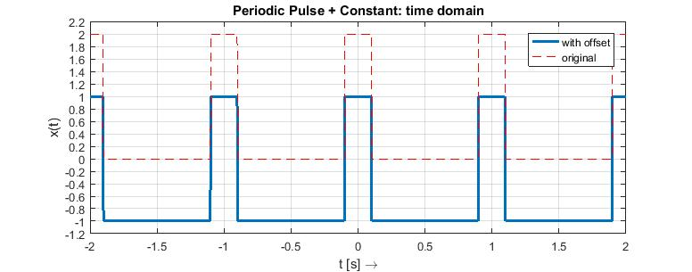

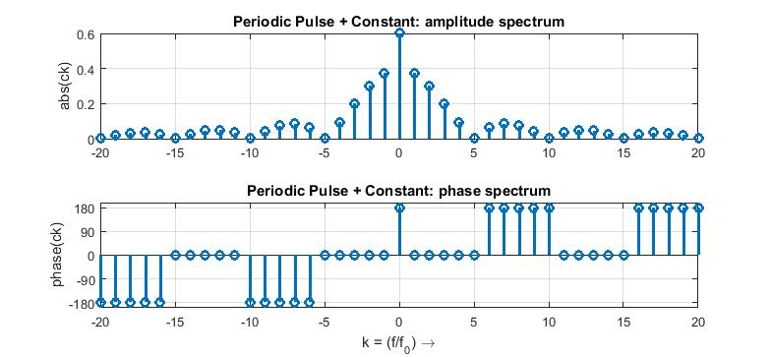

Figure 2‑6 Changes in spectrum when adding a constant value

Example 2-4

Figure 2-7 shows the changes in time and frequency domain when the time function is shifted. Check the value of the time-shift and use equation (7) to verify it in the spectrum plot.

Observation: the time-shifted function has complex ck coefficients, and it is no longer possible to represent the spectrum in a single graphic.

 ; 

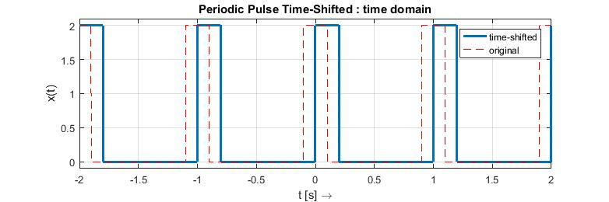

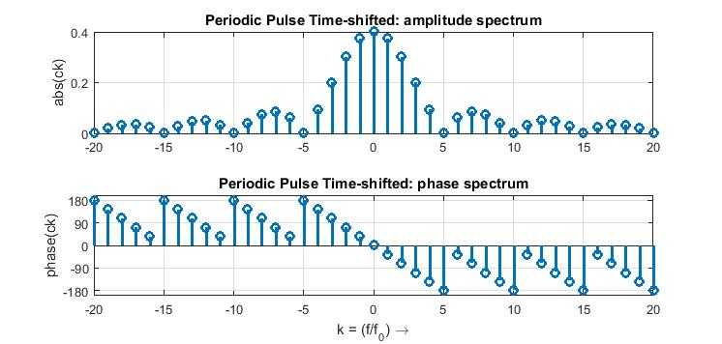

Figure 2‑7 Changes in spectrum when function shifted in the time domain

Question 2-6

Check the slope of the phase spectrum (for instance in the range -5≤ k ≤ +5) and compare to the time-shift equation (7).

Question 2-7

Calculate the power of the square wave function from example 2-2 in the time domain. Calculate the sum of the power of the lower harmonics until the first null in the spectrum. What percentage of the signal power is concentrated in the bandwidth 1/tau Hz ?

*Solution*

Power in the time domain: 

 for 

Power in frequency domain: 

 with 

Bandwidth  with 



Comparing with total power



Check these calculations with a Matlab script.

# Numerical Approximation with DFT

The ck coefficients are most usually calculated numerically with the Discrete Fourier Transformation (DFT).

The DFT calculates in fact the spectrum of a function which is discrete and periodic in the time domain; and the period is given by the time window where the function is defined. On the other hand with the ck coefficients we represent a function which is periodic (with period T0) and continuous in the time domain. Therefore the coefficients we calculate with the DFT are an approximation of the ck coefficients, and we have to examine the limitations and characteristics of this approximation.

Table 2-2 below shows a comparison between the calculation of the ck coefficients and the numerical approximation with the DFT, which calculates the X[k] coefficients.

|  |  |  |
| --- | --- | --- |
| Fourier Series for a periodic and continuous time function | | Discrete Fourier Transformation for a periodic and discrete time function |
|  | |  |
| Let us take a time window with the same length as the period T0 | | |
|  | |  |
|  | |  |
|  | |  |
|  | | or    ([5]) |
|  | | |
| Now using these equivalences above we get the following expressions for x[n] and X[k]: | | |
|  | | |
| Summarizing: | | |
| Fourier analysis | **Normalized Discrete Fourier Transformation (DFT)** | |
|  | (9) | |
| Fourier synthesis | **Inverse Discrete Fourier Transformation (IDFT)** | |
|  | (10) | |

The basic ideas of the DFT are shown in figure 2.8 :

* Starting with a time function, which is sampled during a time window of length N.Ts , with Ts being the sampling period;
* The FFT takes these N points in thetime domain and calculate N points of the corresponding spectrum in the frequency domain;
* The duality between time and frequency means that:
  + theinverse of the time window length 1/(N.Ts) corresponds to the minimum step or resolution of the frequency spectrum fmin;
  + And the inverse of the time step or time resolution 1/Ts relates to the maximum frequency in the calculated spectrum Fs. In fact the calculated spectrum goes from 0Hz up to almost Fs;it stops at Fs.(N-1)/N ;
* The calculated spectrum is symmetric with respect to Fs/2, and the lower half from 0 to Fs/2 represents the ck coefficients and the upper half represents the c-k coefficients. The reasons for this symmetry will be discussed in detail in chapter 5 (the sampling of the time function causes the spectrum to be periodic).

DFT

N-Points

time

domain

N-Points

frequency

domain

Ts

N.Ts

t (s)

fstep

N.fstep

f (Hz)

Fs

Fs/2

Fs (N-1)/N

t (s)

fmin= fstep=1/(N.Ts) = Fs /N

fstep

Figure 2‑8 FFT basic idea: converting N points in time to N points in frequency domain

The DFT is often implemented with an optimised algorithm, which reduces the calculation effort, called Fast Fourier Transformation (FFT). This algorithm is mostly efficient when the number of points N is a power of 2.

The FFT algorithm is a standard function in most microprocessor libraries and in mathematical simulation tools. The implementation of the algorithm is thesubject of a later course (DSV). In this semester we concentrate on using the fft function in Matlab and interpreting its results (as discussed in questions below).

Question 2-8

Declare in Matlab a discrete time function x[n]=x(n.Ts) representing a periodic square pulse and calculate the spectrum X[k] using the DFT. Use the following parameters for x[n]:

Period T0 = 1 s

Duty cycle = 50%

Amplitude = 1

Number of points for DFT N = 32

Time window representing 1 period T0 = N.Ts

Plot the resulting spectrum, splitting the magnitude and phase of X[k] in two graphics. Vary the parameters (duty-cycle, amplitude and N) and check their influence. Most often only the amplitude spectrum is used, can you imagine why?

Question 2-9

Verify the changes in the numerically calculated spectrum when you use a time window with length:

1. N.Ts = (2).T0
2. N.Ts = (1,5). T0

What are the consequences when using the DFT to analyse an unknown signal in the time domain?

# Vocabulary

discontinuity: Unstetigkeit

DFT: diskrete Fourier-Transformation

Fourier series: Fourierreihe (FR)

Fourier series analysis: FR-Analyse oder Zerlegung

Fourier series synthesis: FR-Synthese

FFT: Fast Fourier Transformation

line spectrum: Linienspektrum

normalized: normiert

resolution: Auflösung

zero point or null: Nullstelle

# Annexes

### 2-A Orthogonality

Orthogonality in base functions for series decomposition





### 2-B The sinc function

Definition: 

Value for x= 0 (using rule of l’Hopital): 

Zero-points (nulls): 

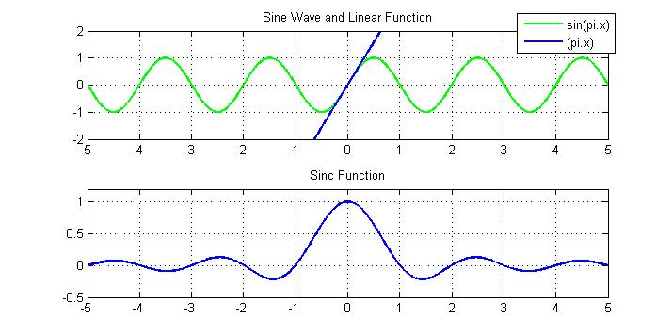

Polar Notation: 

Amplitude: 

Phase: ∠



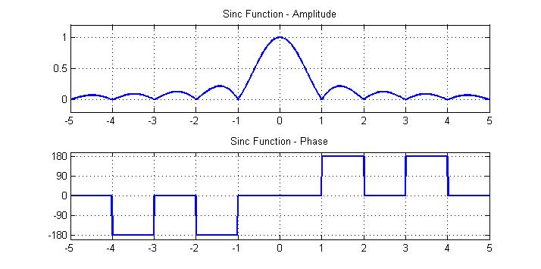

### 2-C Fourier-Series Notations and Correspondances

**Notation I : real coefficients ak and bk**



**Notation II: real coefficients Ak and φk : The Trigonometric Fourier Series**



**Notation III: complex coefficient ck : The Complex Exponential Fourier Series**

 with 

**Correspondances**

DC-value: 

Harmonics:





 





1. In case of discontinuity, the Fourier series converges to the middle value before and after the jump of the time function.
2. The sinus cardinalis function is discussed in more detail in appendix 2-B.
3. It is also common to see spectrum plots using as independent variable f in (Hz). But the plot remains a discrete plot, with equidistant spaced lines (in this case spaced by f0), representing the amplitude of the different harmonic components.
4. This symmetry property applies for all functions which have real values in the time domain. In telecommunications one can find complex signals in the time domain, which will then not present this symmetry property.
5. () The k index in the DFT is limited to N points. In fact the spectrum of a sampled or discrete time function is periodic and repeats with an interval Fs. Therefore a sum of the X[k] coefficients over a frequency range of Fs fully describes the discrete time function x[n] .