

**Chapter 5:**

**System Modelling in Time Domain**

Contents

1. Introduction 1

2. System Description with Differential Equations 2

3. System Modelling with Test Signals 10

4. Convolution with Impulse Response 13

5. Vocabulary 15

**References**

[1] P.D. Cha, J.I. Molinder, „Fundamentals of Signals and Systems – A Building Block Approach“, Cambridge University Press, 2006.

[2] G.Lekkas, J.Wild, „Signale und System“, ZHW-Vorlesung, 2007.

# Introduction

Whether we are analysing an existing system or developing a new one, we often need a description of the system. This description should reflect the characteristics which are relevant for the context of the application.

For example: if we are interested in controlling a DC-motor driving the movement of a robot arm. In order to have a desired trajectory for the movement, we need to know how the motor responds to a voltage input signal. Does it have a latency? How large is it? Is there an output (acceleration, speed, position) which is proportional to the input voltage signal?

In order to respond to these questions we need to deduce a model for this motor. And here we can proceed in two different ways, one **analytical** (let us call it the *transparent box* approach) and another **empirical** (*black box* approach).

In the analytical method we proceed by investigating the way the motor works, looking for the physical rules describing the interaction between its parts and writing the corresponding equations (many times a differential equation). Along the way we will need to decide which effects we consider relevant and which ones we ignore or simplify. As a rule of thumb always start with the simplest model possible, and check if it is accurate enough for your application. If not, you can always go back and refine your model.

We call this approach *transparent box*, because here you can check the parts and construction of your system and write equations for it.

By contrast, in the empirical method, you apply different test signals to your system, register its responses and extract information from these responses (output to the test signals). For example we will see in this chapter that the impulse response can be used to calculate the system output for any arbitrary input signal via an operation called convolution. Or that the frequency response can be used to calculate the stationary output for any combination of sine input signals.

Furthermore in the empirical method you can also compare the system responses to reference systems (most often 1st and 2nd order systems), and check if the system can be approximated by one of these. We call this empirical approach *black box*, because here you proceed like you were dealing with a closed box that you cannot open or see through, but whose reaction to known input signals can be measured.

# System Description with Differential Equations

The tables below bring a summary of the elements and physical rules for mechanical and electrical systems.

Mechanical Systems

|  |  |  |
| --- | --- | --- |
| Element | Translation  Movement | Rotation  Movement |
| Spring | k [N/m] | kt [N.m/rad] |
| Damper | c [N.s/m] | ct [N.m.s/rad] |
| Mass or  Inertia | m [kg] | I [N.m.s2/rad] |

We will deal with simplified models of mechanical systems, which use lumped elements (concentrated element with ideal characteristics) and can be solved by applying Newton’s 2nd Law: balance of forces for translation and balance of torque for rotation movements.

Newton 2nd Law - Translation: . (1a)  
  
 Newton 2nd Law - Rotation:  (1b)

Where x(t) stands for the position of the translation movement (so 1st derivative is speed or velocity and 2nd acceleration). And θ(t) stands for the angular position of the rotation movement (with 1st derivative rotation speed and 2nd rotational acceleration or spin).

Electrical Systems

|  |  |  |
| --- | --- | --- |
| Element | Basic Equation | Nature / Behaviour |
| Inductor | L [H =V.s/A] | stores energy from magnetic field |
| Resistor | R [Ω= V/A] | consumes energy |
| Capacitor | C [F = A.s/V] | Store energy from electrical field (in the form of electrical charges) |

Here the basic physical rules we need are Kirchhoff laws for current and voltage (also known as node and mesh rules):

at each node in the circuit: . (5a)  
  
 for each mesh of the circuit:  (5b)

These rules are in fact completely analogous to Newton’s law above, where we could have written mass times acceleration as the inertial force on the left hand-side of the equation, and have then, the sum of all forces equals zero.

In fact the analogy between mechanical and electrical systems can be pushed further by comparing the single elements. Electrical analogies can be used for many other types of systems (e.g. hydraulic and thermal). These types of analogies were especially useful before the availability of simulation software, which nowadays are spread in every field of application.

Let us now calculate some examples to apply the formulas and ideas above.

*Example 5-1:*  Spring-Mass (Horizontal)

m

x(t)

k

f(t)

Free body diagram:

Physical Law:

Set up equation:

Resulting differential equation: 

Block diagram:

Example 5-2: Spring-Mass Suspended

m

z(t)

f(t)

ys

y(t)

Free body diagram:

Physical Law:

Set up equation:

Resulting differential equation: 

Block diagram:

Example 5-3: Base Excitation System

m

f(t)

yin(t)

yout(t)

**Example 5-4: Propeller of a Ship**

Free body diagram:

Physical Law:

Set up equation:

Differential equation: 

Block diagram:

φin(t)

kt

θ(t)

I



Free body diagram:

Physical Law:

Set up equation:

Differential equation: 

Block diagram:

Example 5-5: Suspended Pendulum

θ(t)

l

m

Free body diagram:

Physical Law:

Set up equation:

Linearisation:

Differential equation: 

Block diagram:

The block diagrams of LTI systems can be drawn using three basic elements: integrator box, sum point and branching points. We prefer to work with integrator boxes instead of derivative blocks because:

1st , the output of an integrator box often represents a physical quantity that can be measured;

2nd , the integration operation can be more accurately approximated in a numerical simulation;

3rd it is possible to set initial conditions with an integrator block, but not with a derivative block;

4th noise is often amplified by a derivative block.

The number of integrator boxes in the block diagram corresponds to the number of elements capable of storing energy in the system, and it also corresponds to the order of the system and the order of the differential equation describing it.

Examples of electrical systems are discussed in exercise list number 6.

The analytical approach to model and describe systems as presented in this chapter, is often combined with a state space representation of a system (specially for complex systems of higher order). This topic will be subject of following courses in the area of control and automation. An example of state space representation will be discussed in Laboratory 5.

# System Modelling with Test Signals

We discuss now the empirical method to investigate a *black-box* system using selected test signals. The most common test signals are: step, impulse and sine waves. Let us see when and which information these test signals can bring.

### Continuous Systems

continuous

system

σ(t)

δ(t)

cos(ωt)=cos(2π f t)

yσ(t) = h(t)

yδ(t) = g(t)

A(f).cos(2π f t + φ(f) )

*Test Signals*

*step*

*impulse*

*cosine wave*

*(varying freq)*

*Outputs*

*step response*

*impulse response*

*amplitude and phase changes*

*(varying with freq)*

*Notation vary*

*(GRT,RT,DSV,NTM)!!*

Figure 5‑1 Empirical approach to model a black-box continuous system

For continuous LTI systems the easiest test signal one can apply is a step, or a constant input value that is switched at a given point in time (if the amplitude of the input is not one, you can use the linearity property to find out the corresponding step response).

The dirac delta impulse instead, is rather a mathematical abstraction, that we cannot ideally generate in practice for a measurement. We have, nevertheless, the possibility to get the impulse response with two alternatives: by approximating the dirac impulse (e.g. stimulate the system with a short pulse of strong amplitude), or by differentiating the step response. Furthermore we will see that the impulse response has the same shape as the homogene response for low pass filters (when input signal equals zero, but initial conditions are not zero).

The third usual test signal is a sine wave. The steady response we obtain is then called the frequency response, because we apply sine waves with different frequency values and check for each frequency how the amplitude and phase of the input sine wave has been affected by the system. An example of such frequency response is shown in figure 2-3 (only the amplitude or magnitude part here). The theory about the frequency response is discussed later in this chapter in section 6.

The step, impulse and frequency responses of three LTI systems are shown next. Study the curves and answer the following questions.

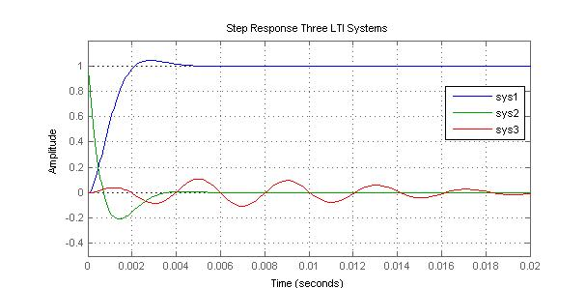

Figure 5-2 Step Response of three continuous systems (LPF, HPF, BPF)

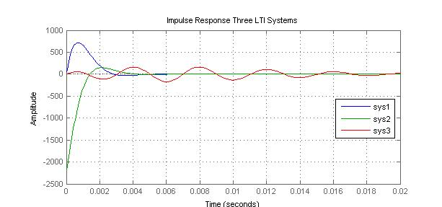

Figure 5-3 Impulse Response of three continuous systems (LPF, HPF, BPF)

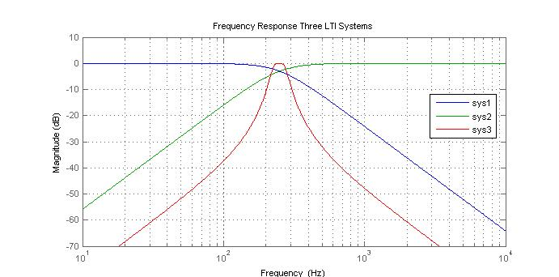

Figure 5-4 Frequency Response of three continuous systems (LPF, HPF, BPF)

Question 5-1

Figure 5-2 shows the step response of three continuous LTI systems. Which of these systems is a low-pass filter (LPF), which is a high-pass filter (HPF) and which is a band-pass filter (BPF)? Justify your answer by observing characteristics of the output signals.

Question 5-2

Figure 5-3 shows the impulse response of the three LTI systems: sys1, sys2, sys3 (same as in Question 5-1). Verify in the plot if you can agree that the impulse response is the derivative of the step response, and look for a mathematical justification.

Question 5-3

Which test signal could you apply to a black-box continuous system in order to verify if this system is linear and time invariant (LTI)? What about the causality property, do you need a special signal to test it?

Question 5-4

The frequency response G(f) of a system is the Fourier transform of the impulse response g(t). Confirm this relationship by taking the frequency response of a first order LPF (e.g. passive RC circuit), then take the inverse Fourier transform and compare to the impulse response (see table of reference systems in chapter 6).

# Convolution with Impulse Response

The impulse response of the system can be used to calculate the answer of the system to any arbitrary input signal. How is this possible?

By using the linearity, and causality properties of the systems, plus remembering that the dirac delta is the neutral element of the convolution operation. Let us check this step by step:

Given:

Impulse response of the system:



Dirac Impulse Impulse Response

The dirac impulse is the neutral element of the convolution operation



And our systems are LTI (linear, causal and time invariant). Therefore we can use the superposition principle to say:

If a weighted and shifted series of dirac impulses comes in a system, the response of the system corresponds to a weighted and shifted series of impulse responses:



Impulse impulse response of the system

= dirac-delta



In conclusion, the convolution with the impulse response is a method to calculate the output signal for an arbitrary input signal.

**Example 5-6**

Execute and analyse the graphical ouput of the following Matlab script *DemoFaltung.m* showing the convolution operation of two time functions.

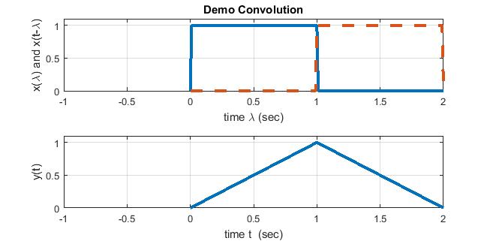

We have exercises on this topic in list number 7.

***Observation:***

The convolution operation is commutative:

Convolution – definition and commutative property



# Vocabulary

acceleration: Beschleunigung

block diagram: Blockschaltbild (BSB)

branching point: Verzweigung

capacitor / condensator: Kondensator

convolution: Faltung

damper: Dämpfer

differential equation: Differentialgleichung (DGl)

difference equation: Differenzgleichung (DzGl)

electrical charges: elektrische Ladung

field: Feld

force: Kraft

inductor: Spule, Induktor

inertia: Massenträgheit

resistor: Widerstand

rotation: Drehbewegung

signal flow diagram: Signalflussdiagramm

speed: Geschwindigkeit

spring: Feder

transfer function: Übertragungsfunktion

torque: Moment / Drehmoment

to store (energy): speichern

to consume (energy): verbrauchen

ABBREVIATIONS:

LTD = LT(I)D : linear time-invariant and discrete system

LTI : linear time-invariant continuous system