Business Requirements Document

*CyberSphere Website Rewrite*

Author: Sreekanth Reddy, Santosh Kumar, Abhishek Behera

Version: 1.0.1

Date: October 2nd, 2017

Table of Contents

1 Executive Summary 3

2 Project Description 3

3 Project Scope 3

3.1 In Scope 3

3.2 Out of Scope 3

4 Business Drivers 5

4.1 Business Driver 1 5

4.2 Business Driver 2 5

4.3 Business Driver 3 5

5 Current Process 6

6 Proposed Process 7

7 Functional Requirements 7

7.1 Priority 7

7.2 Requirements Category 1 (RQC) 7

7.3 Requirements Category 1 (RQC) 9

8 Non-Functional Requirements 10

9 Glossary 11

10 References 12

11 Appendix 13

12 Document History 14

# Executive Summary

This Business Requirements Document (BRD) outlines the requirements for the Cybersphere Website Re-write solution project. It contains both functional and non-functional requirements, an overview of the current design and process, as well as the proposed design enhancements once the solution is implemented.

# Project Description

The purpose of the project is to move the current static web pages for <http://cysphere.net/> to more modern looking website with latest technology stack for a faster and secure form of platform for engaging with clients and employees. The existing form of information in the current website is to be updated and carried forward into the new platform.

The project also outlines a modern approach to build and deploy platform enhancements in short sprints (2-weeks) to design, develop and release features for the new website. The project takes an AGILE approach to document and collaborate with project stakeholders to build and comply with features that meets the client requirements 100%.

The implementation focuses on using modern frameworks for building the platform using HTML5, CSS3, Bootstrap, JavaScript, jQuery, VSTS, MS Azure, Git & GitHub, Angular, HTTPS secure etc. to enhance platform’s features and provide a better usability to the end-users.

# Project Scope

This section describes the scope of the project at a high level. It is kind of a summary of the business requirements, so people can read this section to understand what is being done, and what isn’t being done.

The project outlines a transition towards a more modern looking and secure platform for engaging and sharing company’s profile and goals with the end users which ranges from corporate organizations to job seekers. The platform chose to carry the existing web contents and update a few sections which showcase company’s

## In Scope

The following areas are in scope for this project:

* Point 1
* Point 2
* Point 3
* Point 4
* Point 5

## Out of Scope

The following areas are out of scope for this project:

* Point 1
* Point 2
* Point 3
* Point 4
* Point 5

# Business Drivers

This section details the “business drivers”, which are the reasons why the business is initiating this project. Why is it being done? Some common answers are:

* Improve sales revenue
* Improve efficiency in an existing system or process
* Upgrade of an older system
* Reduce time or costs in a current process
* Regulatory or legal requirement

Subheadings may be created to expand further on this. It’s a good idea to include numbers and targets in these subheadings, such as “aim to reduce cost of manual effort by $500k per year” with breakdown of how this is achieved.

## Business Driver 1

Explanation and information about business driver.

## Business Driver 2

Explanation and information about business driver.

## Business Driver 3

Explanation and information about business driver.

# Current Process

This section contains the current process that is related to this system. It’s usually a process that the business follows, that the solution aims to improve or resolve.

This can be included as either a diagram, or a list of steps. Diagrams are preferred, as they can visually communicate processes easier.

Diagrams can be done in Microsoft Visio, otherwise, you can do them in Microsoft Word.

# Proposed Process

This section details the proposed process, which is the process that will occur after the solution is implemented. Perhaps more volume will be handled, or some steps are removed, or several systems are integrated. This will depend on your project.

It should be in a consistent format to the Current Process above, so readers can switch between the two and see the differences.

# Functional Requirements

This is the main section and will detail the functional requirements of the project. The Priority table describes what each of the priorities stand for, and each section below includes the requirements

## Priority

The requirements in this document are divided into the following categories:

|  |  |  |
| --- | --- | --- |
| **Value** | **Rating** | **Description** |
| 1 | Critical | This requirement is critical to the success of the project. The project will not be possible without this requirement. |
| 2 | High | This requirement is high priority, but the project can be implemented at a bare minimum without this requirement. |
| 3 | Medium | This requirement is somewhat important, as it provides some value but the project can proceed without it. |
| 4 | Low | This is a low priority requirement, or a “nice to have” feature, if time and cost allow it. |
| 5 | Future | This requirement is out of scope for this project, and has been included here for a possible future release. |

## Requirements Category 1 (RQC)

The requirements in this document should be broken down by categories, to make them easier to read. This section can be duplicated for each category of your project (such as customer journey, security, data, authentication, and other main functions).

The brackets at the end of each heading indicate the acronym given to each section’s requirements, and is used to identify the section. You should change this for each heading.

For example, a section on “Authentication” may be labelled AUT, and all requirements will be labelled “AUT 1”, “AUT 2”, and so on.

Add a new number for each section by going to Insert > Quick Parts > Field. Select the “Seq” type, and give it a unique value that matches this abbreviation, such as “SEQ RQA”.

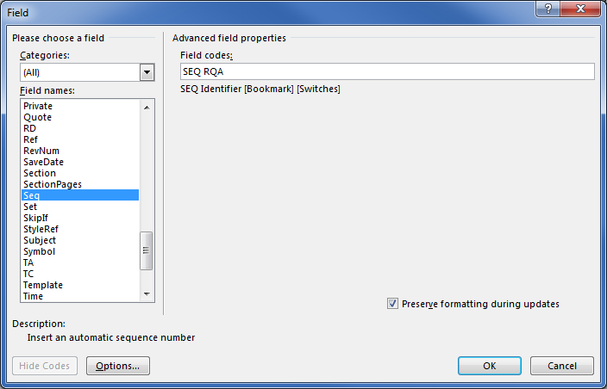

This table includes:

* ID: The unique ID number of this requirement. Has a number which changes automatically
* Requirement: The description of the requirement.
* Priority: The number value for the priority of this requirement
* Raised By: The name of the person who raised this requirement.

|  |  |  |  |
| --- | --- | --- | --- |
| **ID** | **Requirement** | **Priority** | **Raised By** |
| RQC 1 |  |  |  |
| RQC 2 |  |  |  |
| RQC 3 |  |  |  |
| RQC 4 |  |  |  |
| RQC 5 |  |  |  |

## Requirements Category 1 (RQC)

|  |  |  |  |
| --- | --- | --- | --- |
| **ID** | **Requirement** | **Priority** | **Raised By** |
| RQA 1 |  |  |  |
| RQA 2 |  |  |  |
| RQA 3 |  |  |  |
| RQA 4 |  |  |  |
| RQA 5 |  |  |  |

# Non-Functional Requirements

This section includes all of the non-functional requirements for the solution, such as processing time, concurrent users, availability, etc.

This can be filled out in a similar way to the Functional Requirements section.

|  |  |
| --- | --- |
| **ID** | **Requirement** |
| NFR 1 |  |
| NFR 2 |  |
| NFR 3 |  |
| NFR 4 |  |
| NFR 5 |  |
| NFR 6 |  |
| NFR 7 |  |
| NFR 8 |  |
| NFR 9 |  |

# Glossary

This section explains all of the terms and abbreviations that were used in this document, for those who are unfamiliar with them. Not everybody who reads this document will understand all of the terms, so this section is helpful.

|  |  |
| --- | --- |
| **Term** | **Explanation** |
|  |  |
|  |  |
|  |  |
|  |  |
|  |  |
|  |  |
|  |  |
|  |  |
|  |  |

# References

This section contains links to all other places that were referred to in this document. These may include:

* Documents on shared document control systems (such as SharePoint)
* Web sites
* URLs or network locations

|  |  |
| --- | --- |
| **Name** | **Link** |
|  |  |
|  |  |
|  |  |
|  |  |
|  |  |

# Appendix

This section may include any other information that does not fit in the document above. This may include:

* Details of the processes
* Analysis of existing process and benefits for the Business Drivers section.
* Any other information you might need

Beware of overloading this document with information. Preferably, any extra documents should be created separately and linked to, rather than embedding, as it is better for file sizes and version control.

# Document History

This section details the history of the document at each version. It’s good to know what has changed in each version, by who, and when it happened.

|  |  |  |  |
| --- | --- | --- | --- |
| **Version** | **Date** | **Changes** | **Author** |
| 0.1 |  |  |  |
| 0.2 |  |  |  |
| 0.3 |  |  |  |
| 0.4 |  |  |  |
| 0.5 |  |  |  |