BDA400 – Data Science Tools and Techniques
Assignment 2
Technical Analysis using R – Preliminary Stage

Student: Ali Beheshtinejad
Course: BDA400
Assignment: A02
Repository: TechnicalAnalysis
GitHub repository link: https://github.com/abeheshtinejad57/TechnicalAnalysis

1. Assignment Overview
This report documents the preliminary stage of the Technical Analysis project. The work includes installing R and RStudio, installing the required technical-analysis packages, creating the TechnicalAnalysis project structure, defining a stock portfolio, importing historical stock data, computing basic statistics, and displaying the results and visualizations.

2. R Installation
R 4.6.1 was installed locally on the Windows computer used for the assignment.
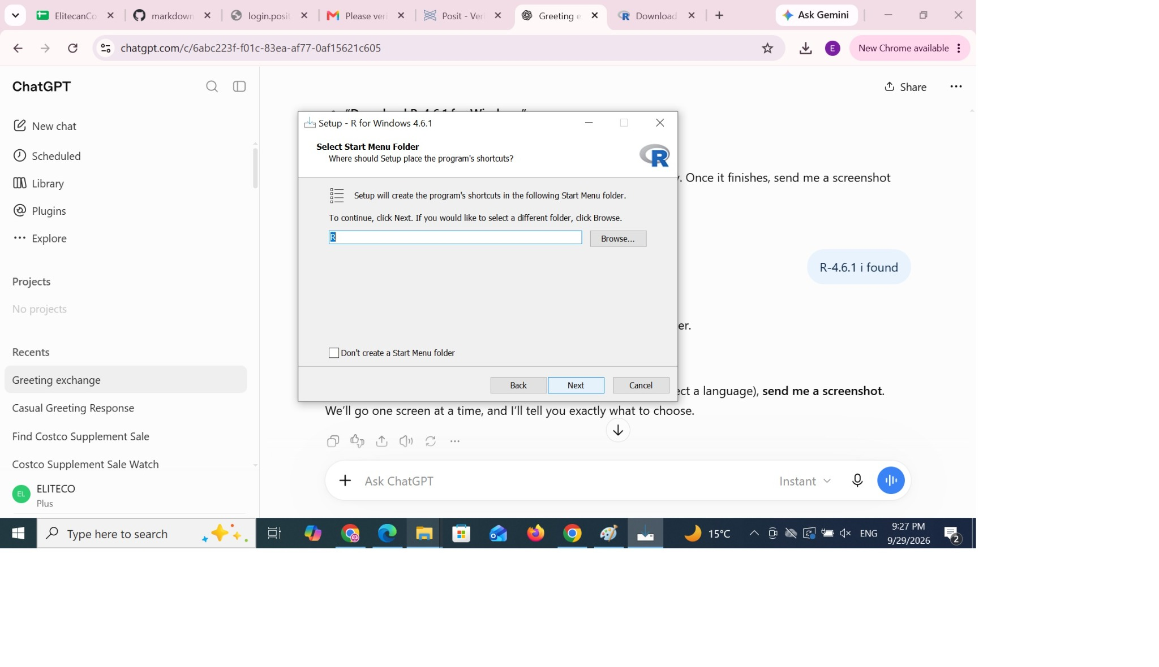
Figure 1. R installation setup on Windows.

3. RStudio Installation and First Launch
RStudio Desktop was installed after R and then launched successfully.
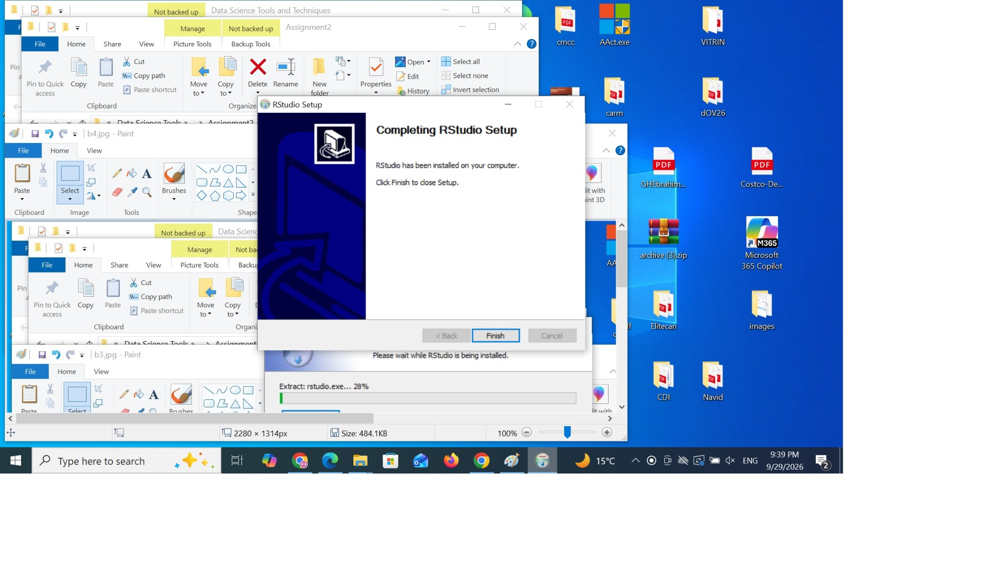
Figure 2. RStudio installation completed.
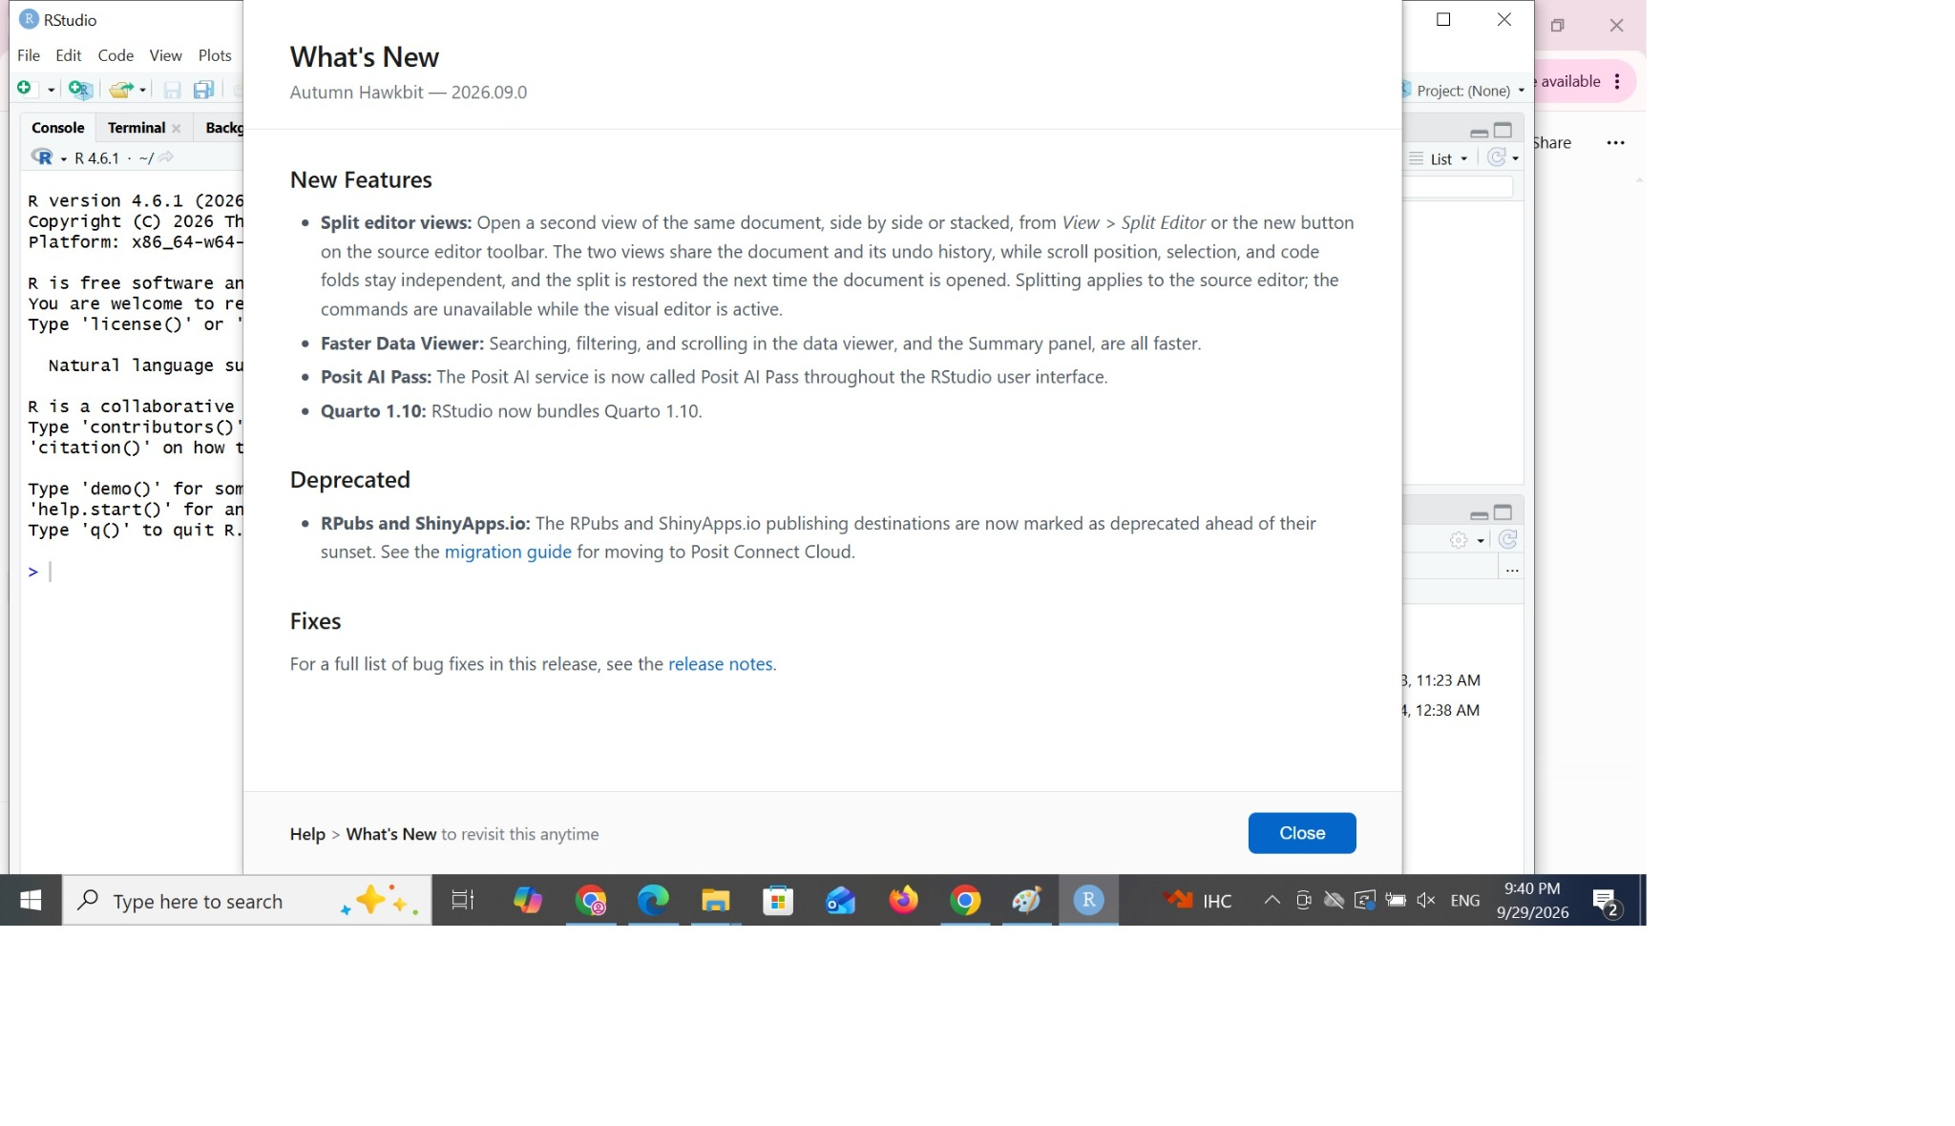
Figure 3. RStudio first launch / What's New screen.

4. Required R Packages
The quantmod package was installed for importing and working with stock-market data. Its dependencies, including TTR, were installed successfully. The libraries were then loaded in RStudio.
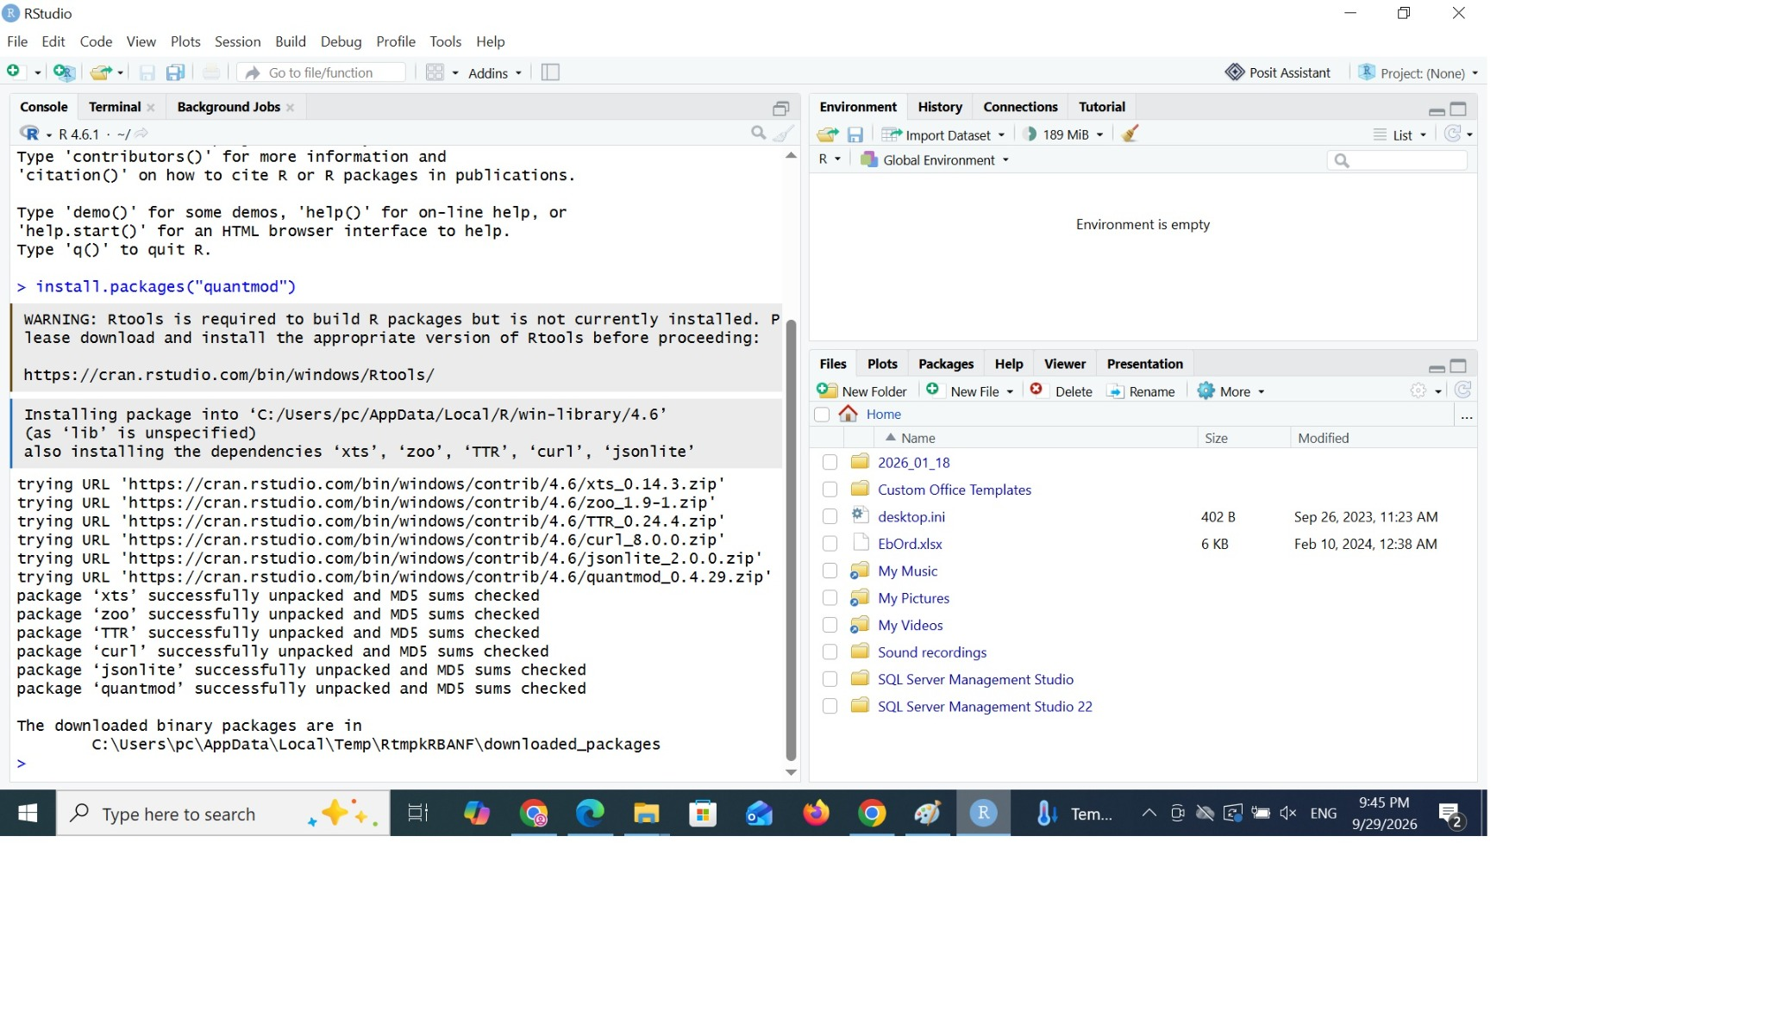
Figure 4. Package installation process in RStudio.
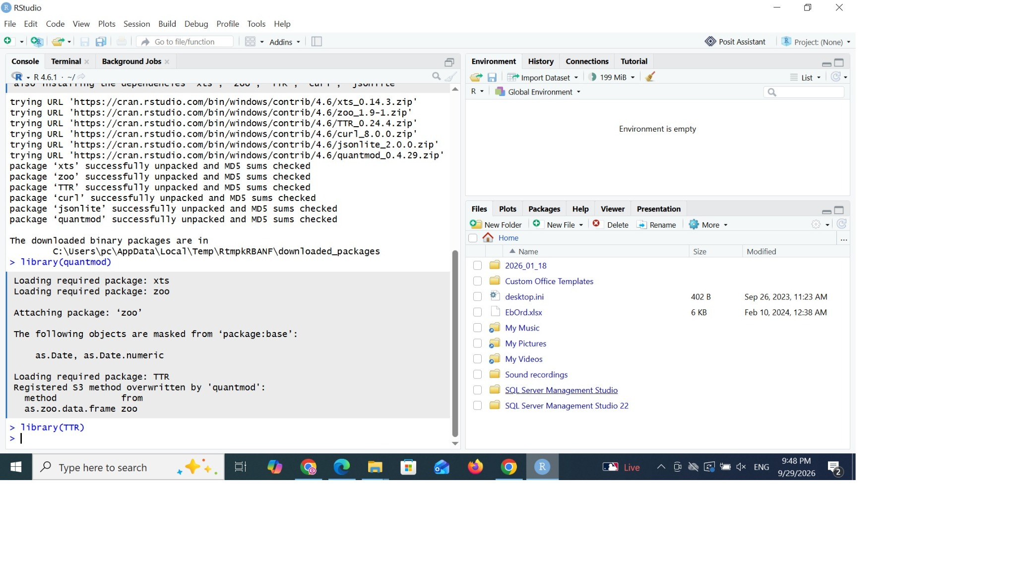
Figure 5. Required packages installed and available.

5. Project Configuration
An RStudio project named TechnicalAnalysis was created. Inside the project, an Assignment_2 subdirectory was created to keep the files for this assignment organized.
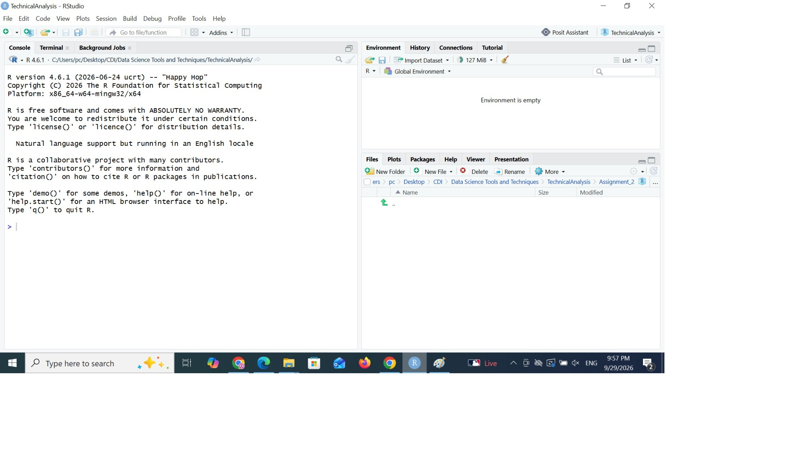
Figure 6. TechnicalAnalysis RStudio project.
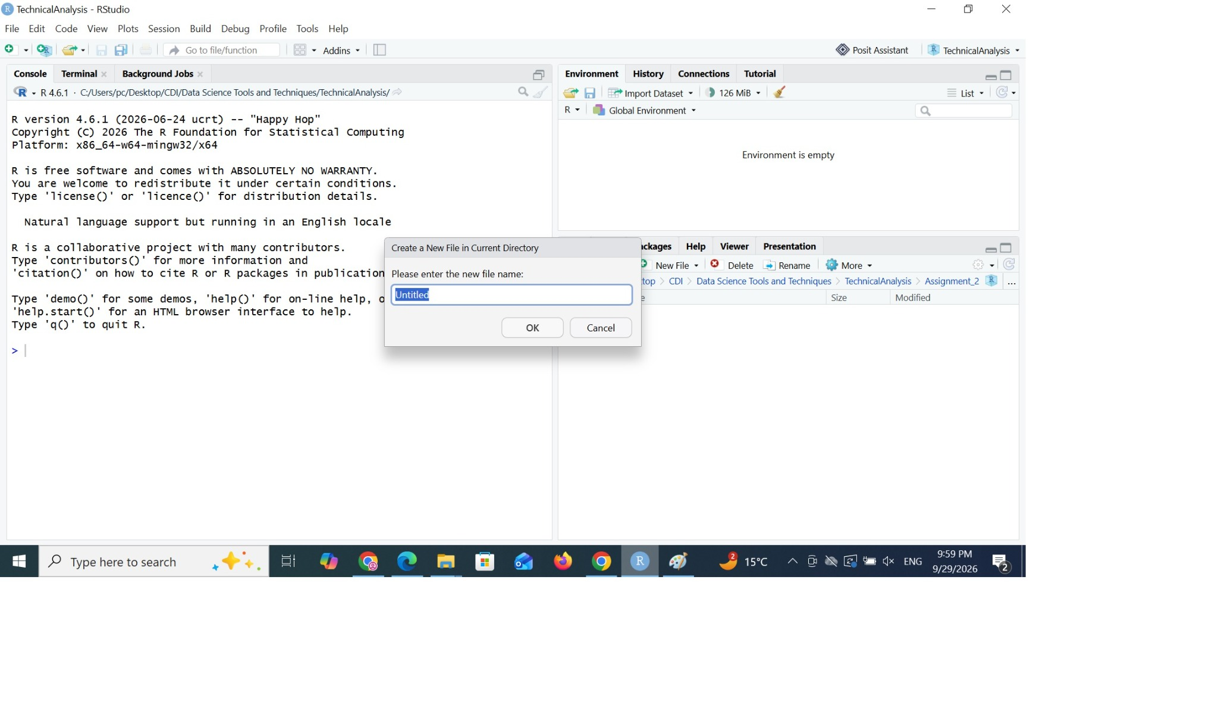
Figure 7. Creating the Assignment_2 folder.

6. Portfolio File
A text file named portfolio.txt was created with one stock symbol per line. The portfolio contains AAPL, MSFT, GOOGL, AMZN, and TSLA.
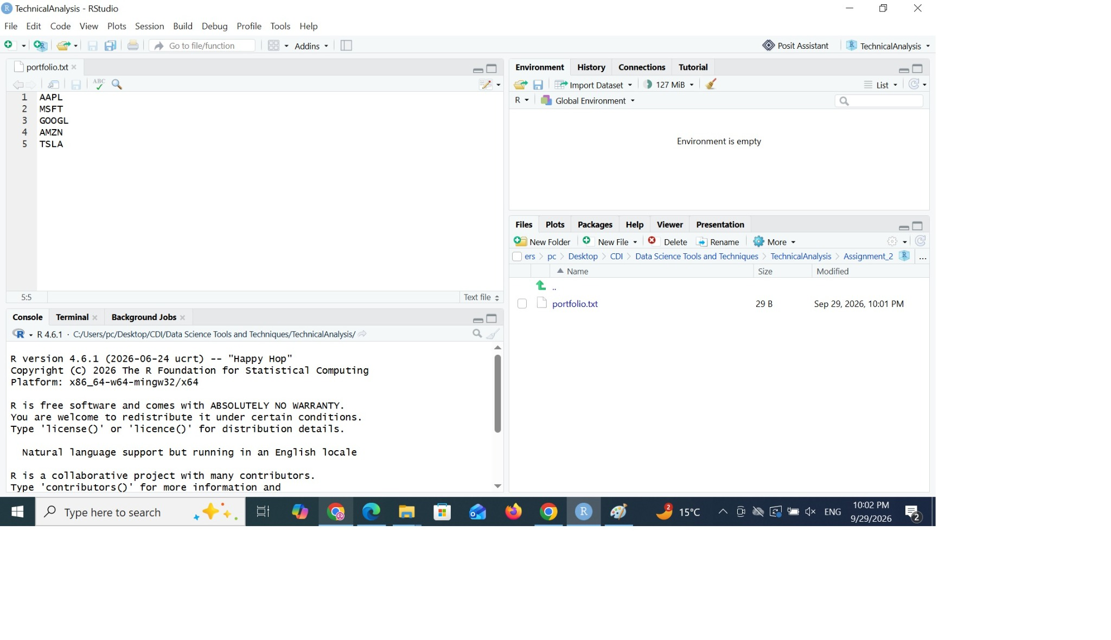
Figure 8. portfolio.txt with five stock symbols.

7. R Script and Stock Data Import
The R script reads portfolio.txt and uses quantmod to retrieve historical stock data for every symbol. The imported data are retained separately for the individual stocks.
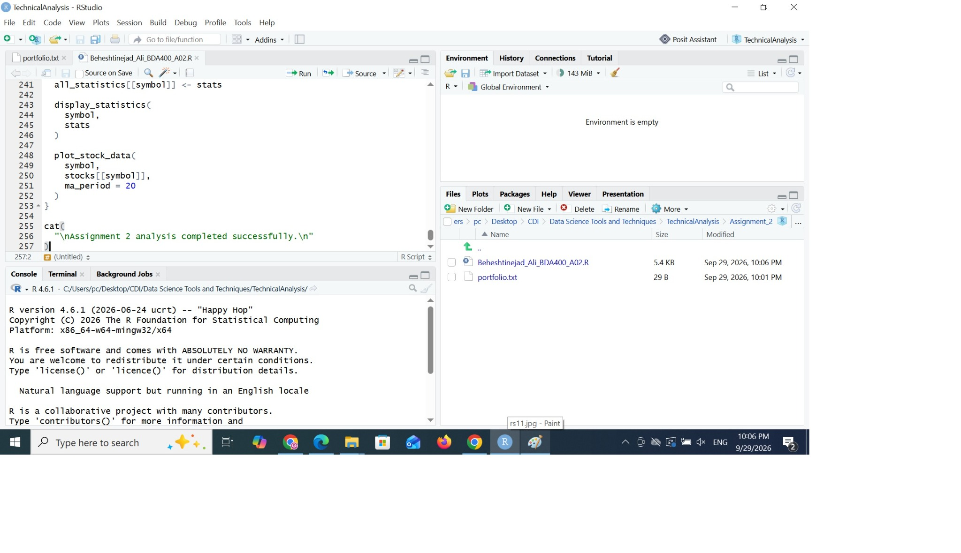
Figure 9. Assignment 2 R script in RStudio.
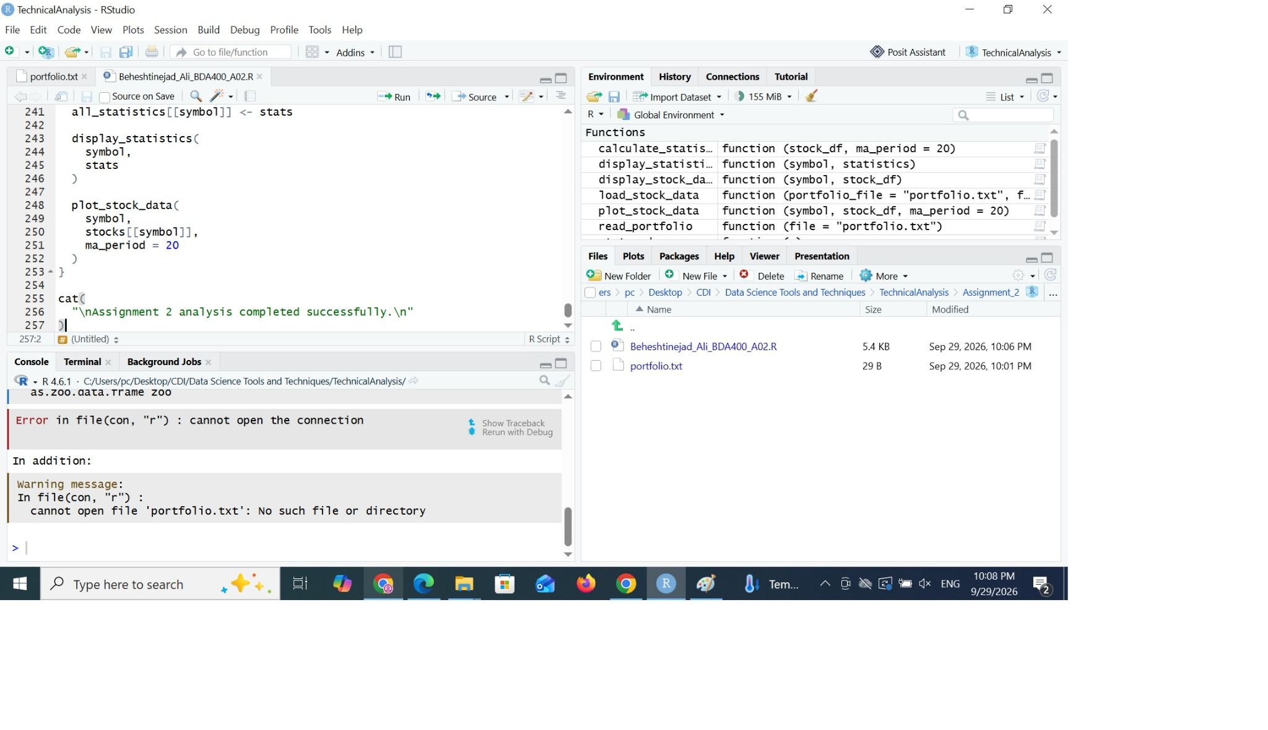
Figure 10. Functions and imported stock objects in the RStudio environment.

8. Basic Statistics
The script computes the required basic statistics for the stock data: 20-day moving average, mean, mode, median, and standard deviation. The calculated values are stored in a structured object and displayed in the Console.
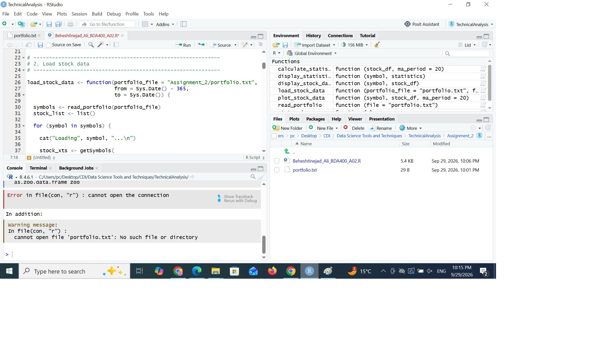
Figure 11. Statistics-related code and execution in RStudio.

9. Data Display and Visualization
The script displays the calculated statistics and produces a stock-price visualization with a 20-day moving average. The final execution completed successfully for all five portfolio symbols.
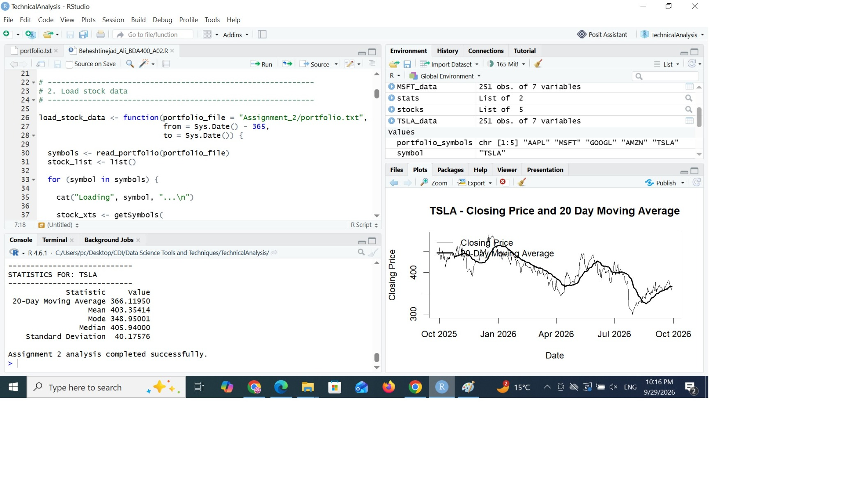
Figure 12. Successful final execution showing TSLA statistics, stock objects, and visualization.

10. GitHub Repository
The required public GitHub repository is named TechnicalAnalysis. The Assignment_2 subdirectory contains the assignment files, and the repository is available at https://github.com/abeheshtinejad57/TechnicalAnalysis.

11. Conclusion
The preliminary technical-analysis environment was configured successfully. R and RStudio are installed, the required packages are available, the portfolio file is configured, stock data are imported, required statistics are calculated, and the output and visualization execute successfully.
12. GitHub Upload Verification
The screenshot below verifies that the TechnicalAnalysis repository and Assignment_2 subdirectory were created on GitHub and that the initial R script and portfolio.txt were uploaded.
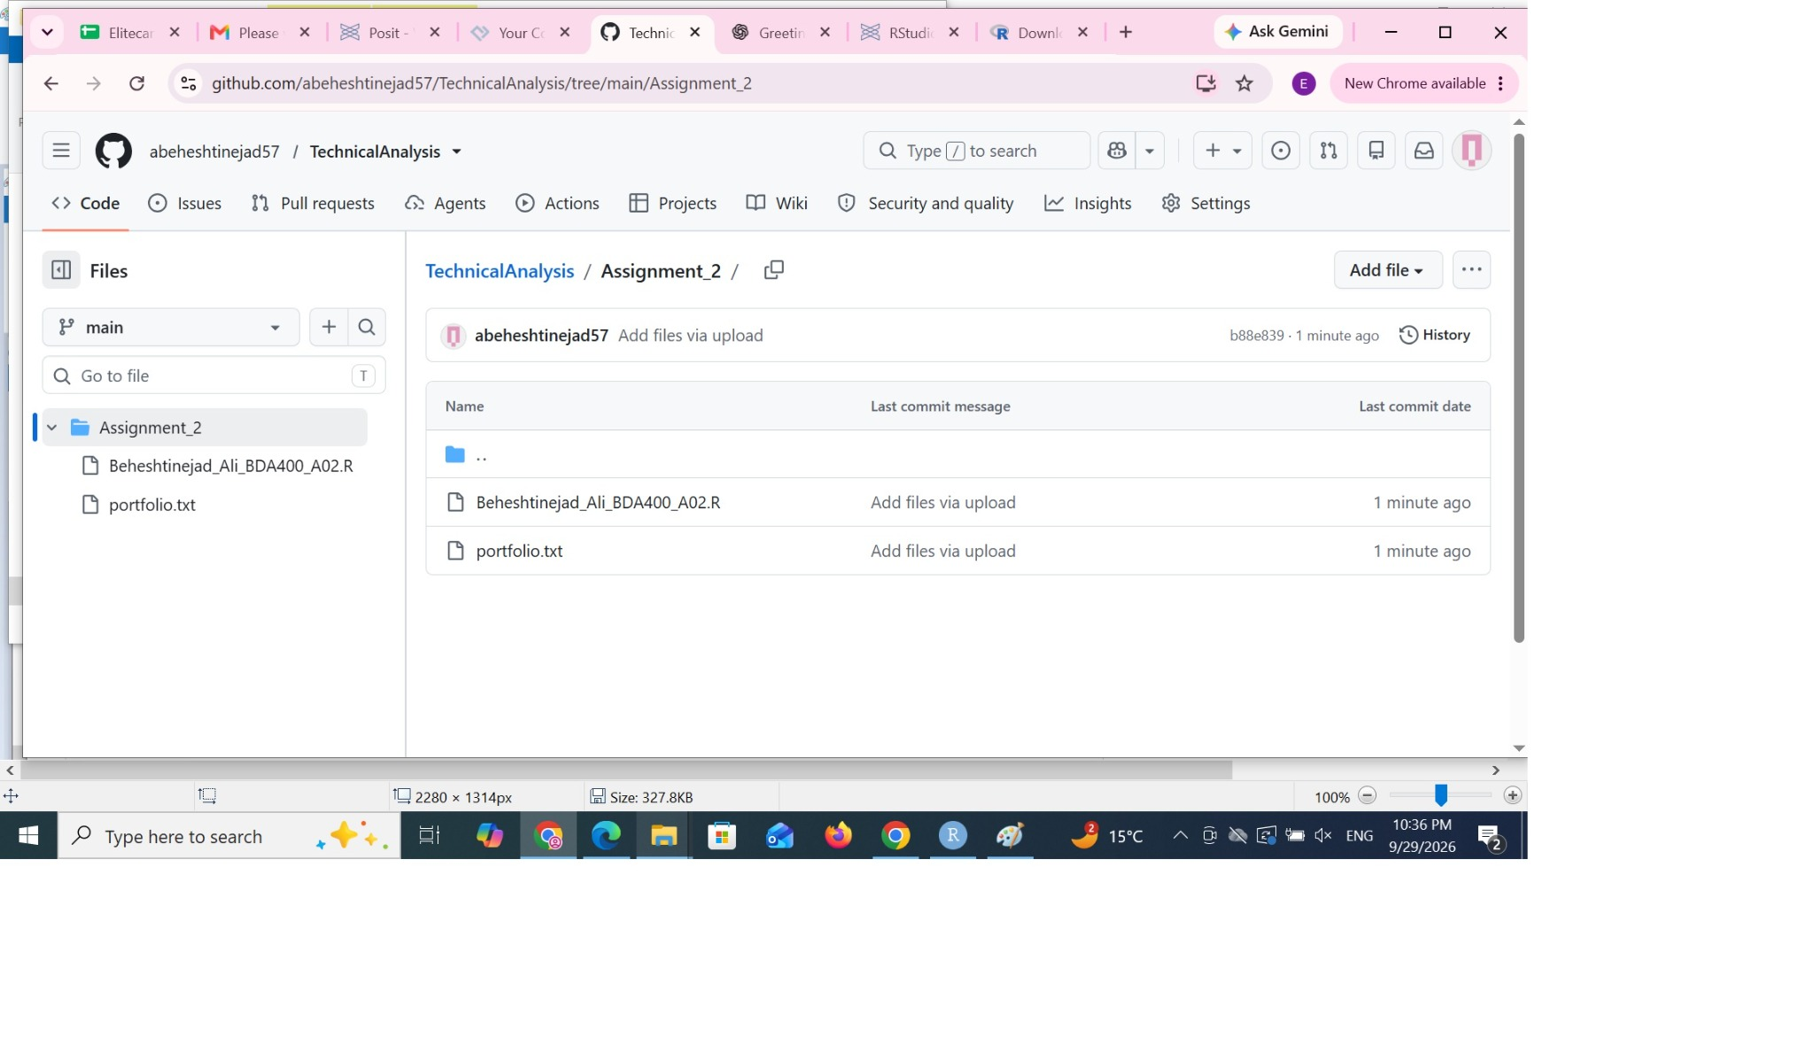
Figure 13. GitHub TechnicalAnalysis/Assignment_2 repository folder.

