CprE 381, Computer Organization and

Assembly-Level Programming

Lab 2 Report

Student Name Austin Beinder_________________________________________

Submit a typeset pdf version of this on Canvas by the due date. Refer to the highlighted language in the lab document for the context of the following questions.

[Part 2 (a)] Draw the interface description (i.e., the “symbol” or high-level blackbox) for the MIPS register file. Which ports do you think are necessary, and how wide (in bits) do they need to be?
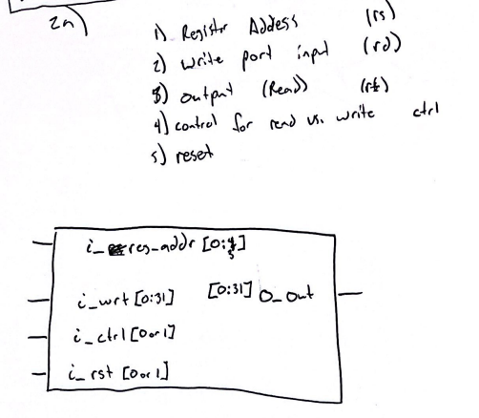
i_CLK [0 or 1]
I think the register address needs to be 5 bits wide, that the data input should be 32 bits, the output should be 32 bits, the read vs write and rst should both be 1 bit. The clock is also neccesary and should be 1 bit. I think the design is asynchronous because it happens sequentially.

[Part 2 (b)] Create an N-bit register using this flip-flop as your basis.
See RegFil/reg.vhd

[Part 2 (c)] Waveform.
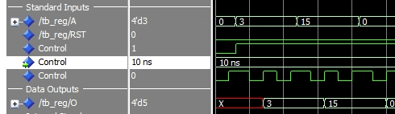
[Part 2 (d)] What type of decoder would be required by the MIPS register file and why?
In order to control the mips register file you would need a 5 to 32 bit decoder. This is because the decoder would be used to control the write enable pins on all of the registers, and there would need to be 5 bits in order to specify 32 possible locations.
[Part 2 (e)] Waveform.
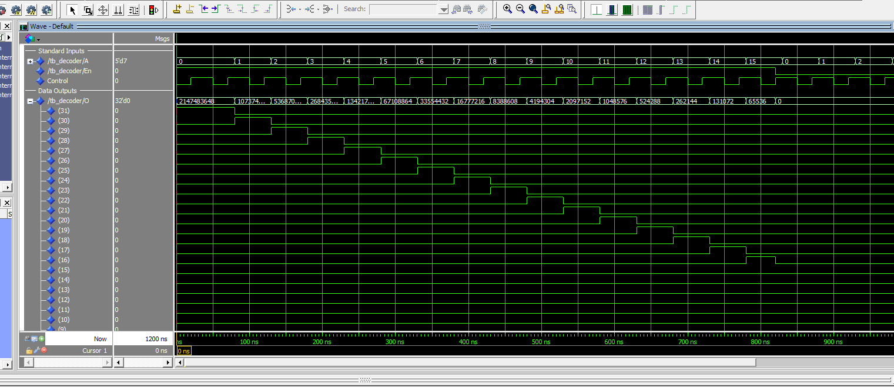
[Part 2 (f)] In your write-up, describe and defend the design you intend on implementing for the next part.
I plan to make a 32bit 32:1 multiplexer via a structural approach. I think this is the best idea as it provides the most intuition for how it will physically work, and I also don’t know how to do anything else.
[Part 2 (g)] Waveform.
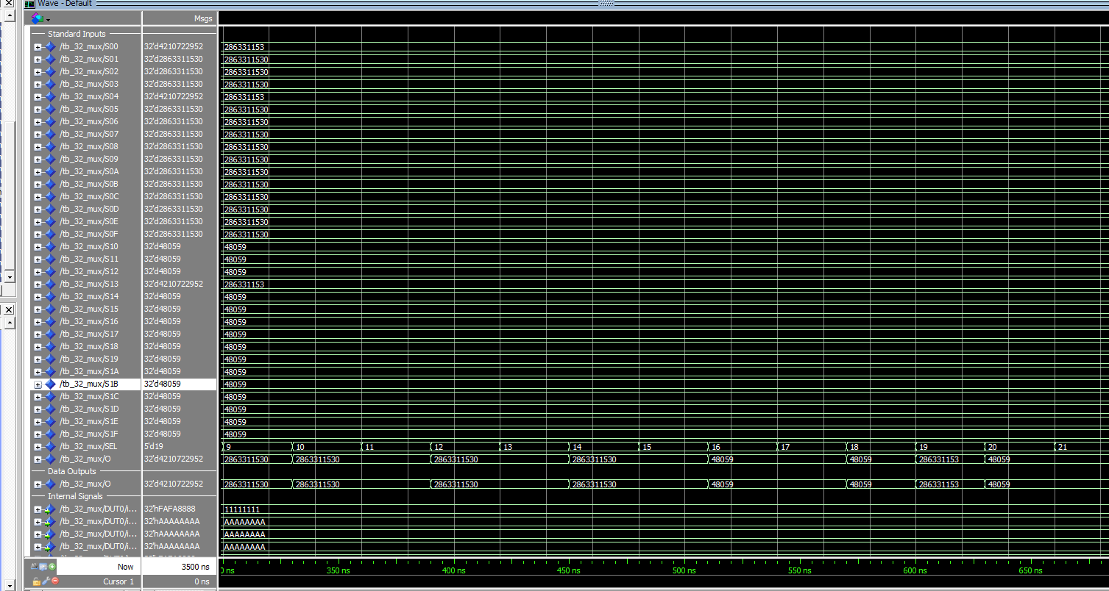

[Part 2 (h)] Draw a (simplified) schematic (i.e., components within the high-level blackbox) for the MIPS register file, using the same top-level interface ports as in your solution describe above and using only the register, decoder, and mux VHDL components you have created.
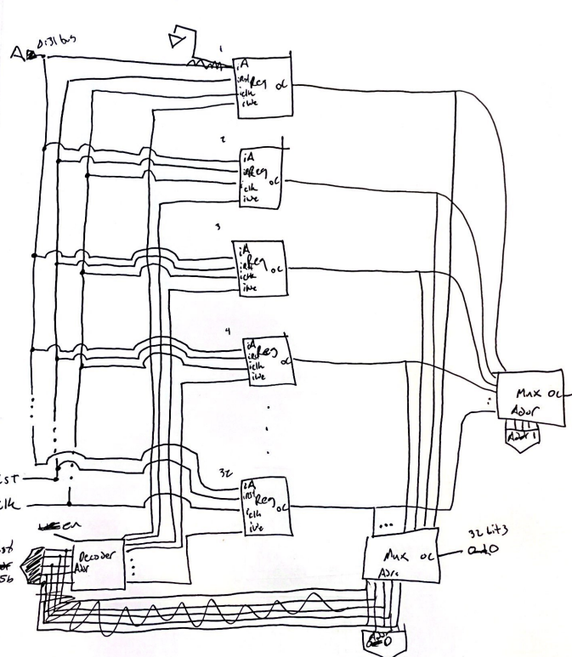

[Part 2 (i)] Waveform.
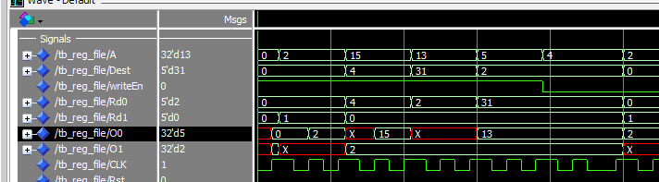
[Part 3 (b)] Draw a symbol for this MIPS-like datapath.
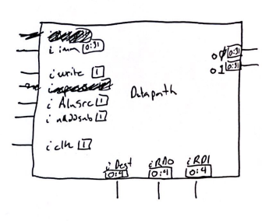

[Part 3 (c)] Draw a schematic of the simplified MIPS processor datapath consisting only of the component described in part (a) and the register file from problem (1).

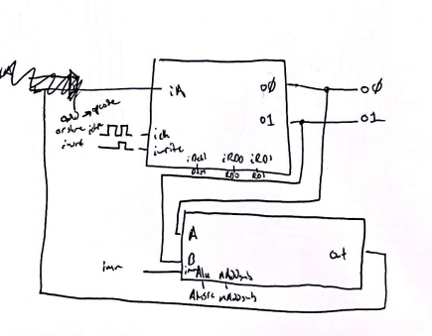
Reg File
Add Sub w/ Imm

[Part 3 (d)] Include in your report waveform screenshots that demonstrate your properly functioning design. Annotate what the final register file state should be.

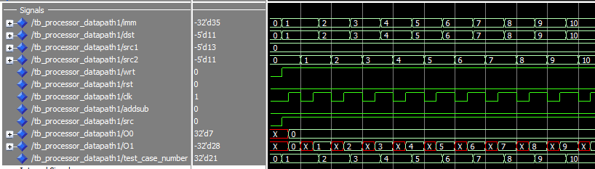

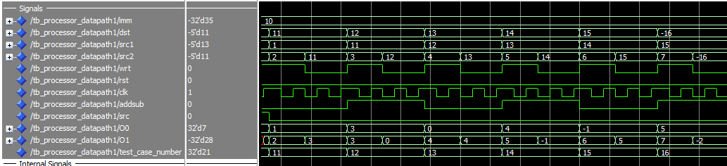

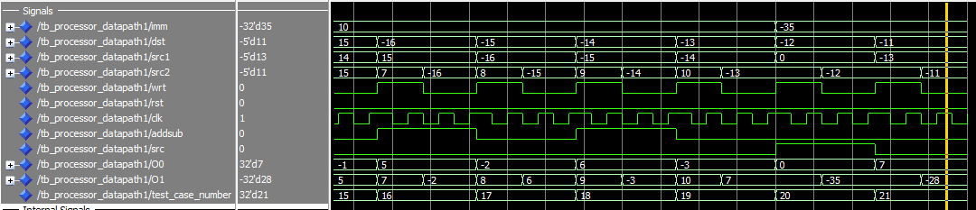

The final value should be -35 + 7 which is -28, which is observed in the bottom right of the output graph.

[Part 4 (a)] Read through the mem.vhd file, and based on your understanding of the VHDL implementation, provide a 2-3 sentence description of each of the individual ports (both generic and regular).
Data width: How many bits does a register store?

Addr_width: How many bits can we use to address registers?

clk: The clock signal is used to clock the registers and
instruct them to move to the next position. Clock is a standard input
in most processes that deal with memory.

addr: The addr port dictates what address we wish to talk to. Similar to
the reg file it will dictate where we store or retrieve data to.

data: If we are trying to write data to the memory, this is the data we are
passing in.

we: This is a write enable pin. If we wish to write to a register, it must be enabled.
Versus if we want to read from a register but not write it will not be enabled.

q: This is the data output of the memory. 1 clock cycle after setting an addr, this
port should read the contents of that address.

[Part 4 (c)] Waveforms.
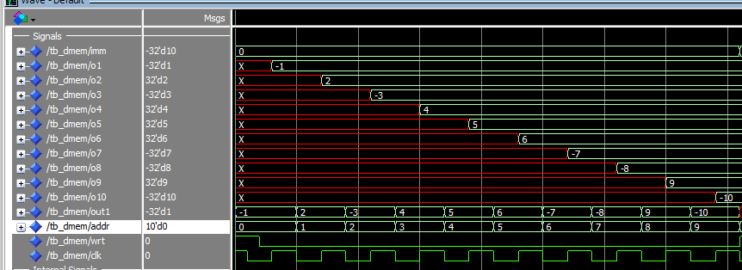
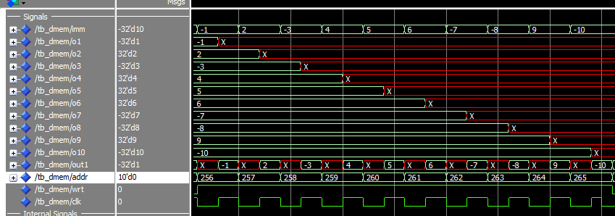
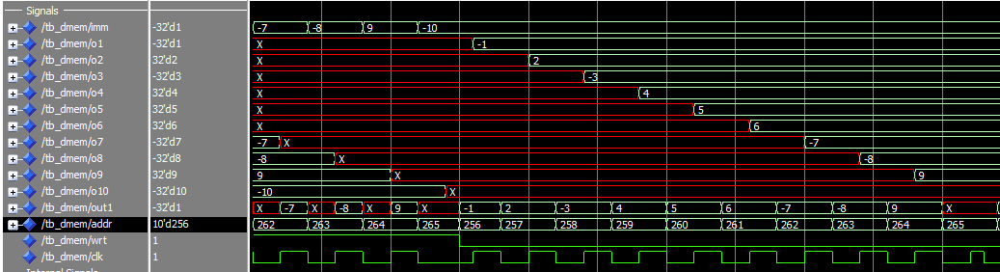

[Part 5 (a)] What are the MIPS instructions that require some value to be sign extended? What are the MIPS instructions that require some value to be zero extended?

What instructions require some value to be sign extended?
addi
slti
lb-8bit
lh-16bit

What instructions need to be zero extended?
addiu
sltiu
lbu
lhu

[Part 5 (b)] what are the different 16-bit to 32-bit “extender” components that would be required by a MIPS processor implementation?
What are the different extender components that would be
required by a MIPS processor?
You would need an extender that can either sign or zero extend,
and you would need a version that could do so for either 8
or 16 bit inputs.
[Part 5 (d)] Waveform.

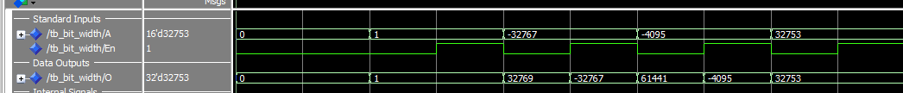

[Part 6 (a)] what control signals will need to be added to the simple processor from part 2? How do these control signals correspond to the ports on the mem.vhd component analyzed in part 3?

In addition to the control signals last time (write on registers, alusrc, naddsub, rst), we will also need write on memory, use memory or alu, signed or unsigned, and divide by 4 control bits.

The write on memory bit is used to control the write enable pin on the memory.

[Part 6 (b)] Draw a schematic of a simplified MIPS processor consisting only of the base components used in part 2, the extender component described in part 4, and the data memory from part 3.

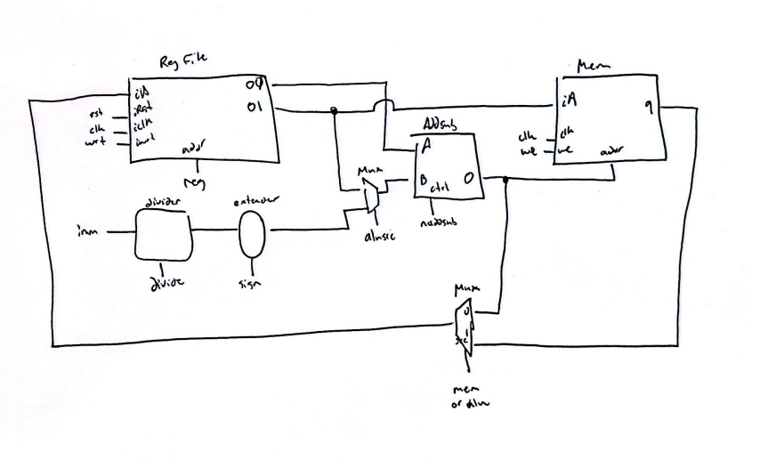

[Part 6 (c)] Waveform.
