COMP 3004 - Iteration # 1  
Team Project: Magic Realm  
Instructor: Jean-Pierre Corriveau  
Due Date: Tuesday, Feb 24th 2015  
Team 17: Abe Fehr, Nataly Slewa, Nathan Barton

*

File: **modelsTeam17.pdf**File Description: Includes your use cases and corresponding unbound UCMs

**Use cases**

|  |  |  |
| --- | --- | --- |
| UC-01 | Create Game | Traceability |
| Summary | Player begins a new Magic Realm game |  |
| External Actors | Server |  |
| Triggering Event | Player creates game |  |
| Pre-Conditions | Magic Realm program is open, displaying main menu |  |
| Main Sequence | 1. Player creates a new Magic Realm game 2. When new game is created, game board is generated in Server 3. Player must create a character based on the options shown on the lobby screen 4. Player distributes 5 free Victory points: Gold, Fame, Notoriety, Treasure and Spell 5. Player enters character’s name 6. Player begins and views game board |  |
| Result | Player is now in game |  |
| Post-Condition | Player is no longer in the lobby screen and is now viewing game board screen. |  |

|  |  |  |
| --- | --- | --- |
| UC-02 | Join Game | Traceability |
| Summary | Player can join an existing Magic Realm game |  |
| External Actors | Server, Player |  |
| Triggering Event | Player joins an existing game |  |
| Pre-Conditions | Magic Realm program is open and a new game is running on the Server | UC-01 |
| Main Sequence | 1. New player joins an existing game 2. New player enters IP address of desired game 3. Server allows new Player to enter game lobby 4. New player creates character, initializes character’s Victory points 5. New player enters game and views game board |  |
| Result | New player is now in existing game in the Server |  |
| Post-Condition | New player no longer in the lobby screen and is now viewing game board screen with existing Players |  |

(To help with the Unbound UCMS)

|  |  |  |
| --- | --- | --- |
| **ID** | **Responsibility** | **Use Case Steps** |
| **RESP-01** | Player creates new Magic Realm Game | UC-01-1 |
| **RESP-02** | Player selects Character | UC-01-3 |
| **RESP-03** | Player enters character’s name | UC-01-5, UC-02-4 |
| **RESP-04** | Player enters character’s initial VP (Victory Points) distribution | UC-01-4, UC-02-4 |
| **RESP-05** | Player joins game | UC-01-6, UC-02-5 |
| **RESP-06** | Server is running and displays game board | UC-01-2 |
| **RESP-07** | Server allows new players to join existing game | UC-02-3 |
| **RESP-08** | Player enters IP address of game server | UC-02-2 |
| **RESP-09** | Server allows new Player to enter game lobby | UC-02-3 |
|  |  |  |

**Unbound Use Case Maps**

**UC-01: Creating a new game**

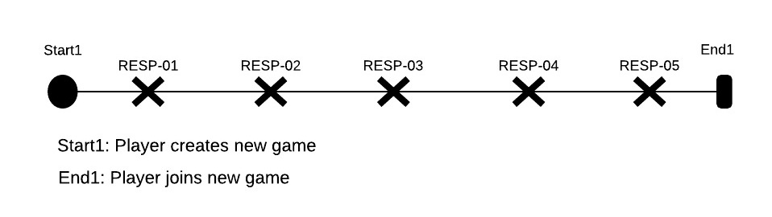

**UC-02: Joining an existing game**

