

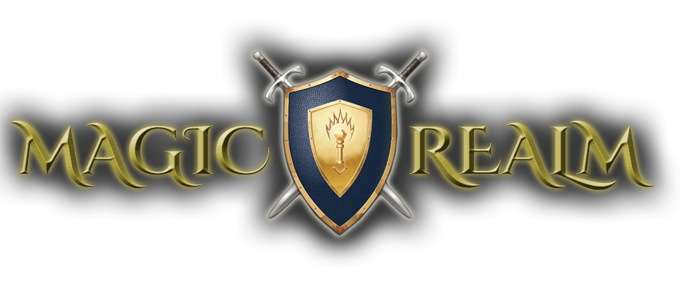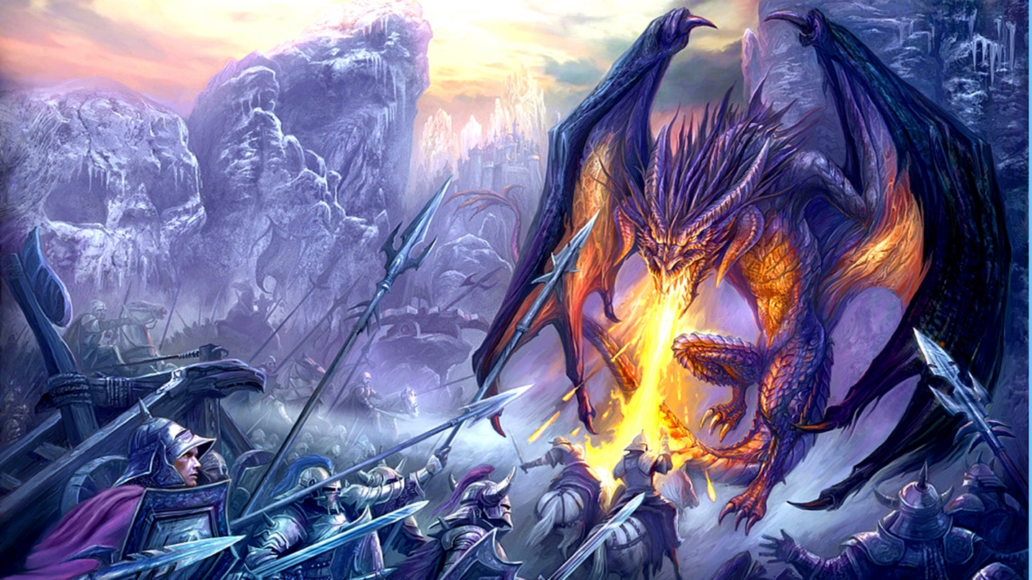

Based on Magic Realm by Avalon Hills

COMP 3004 - Team 17



April 8, 2015

Project completed by:

Abe Fehr, Nataly Slewa, Nathan Barton

Table of Contents

1 Introduction 2

1.1 Purpose 2

1.2 Definitions 2

1.2.1 Table 2

2 Game Rules 3

Table 2.1 3

3 Requirements 3

3.1 Assumptions 4

Table 3.1.1 4

3.2 Functional Requirements 4

4 Use Cases 5

4.1 Use Case Diagram 5

4.2 Use Cases 5

4.3 Responsibilities 6

4.3.1 - Table 6

5 Design Decisions 6

5.1 Decisions 6

5.1.1 - Table 6

5.2 Structural Model 7

Diagram 7

# 1 Introduction

Welcome to the Magic Realm. Magic Realm is a complex board game designed by [blah]. Magic realm is a fantasy adventure, hex-tile, turn-based game that is filled with monsters and treasures. Choose between any 6 heroes. All of which have different skills and weapons. Combat against monsters and collect all the treasure.

## 1.1 Purpose

The purpose of the game is to [blah blah blah blah]. This project aims to [blah blah blah blah].

## 1.2 Definitions

These definitions are based on what is given in the 3rd edition rules of the Magic Realm

### 1.2.1 Table

|  |  |
| --- | --- |
| Term | Definition |
| Attention Chit | The combat chit which has the character symbol on one side and is blank on the other. |
| Cave Clearing | A clearing that is in a cave. |
| Caves Tile | Any tile with at least one cave on it, in which treasure sites can appear. |
| Character | One of the 16 adventurer types that can be played by a player. Described on the character cards. |
| Chit | The smallest square counters, including combat chits, sound chits, warning chits, site chits, Lost City and Lost Castle chits, Monster Roll, Day (Turn), weather chits, visitor chits, and number chits. |
| Counter | Any game piece other than the hex tiles, character cards, and chits. |
| Denizen | A monster or native of the Magic Realm. |
| Mountain Clearing | A clearing that has ridges drawn around it on a mountain tile; not every clearing on a mountain tile is a mountain clearing. |
| Mountain Tile | A tile with at least one mountain clearing in which treasure sites can appear. Also includes the Deep Woods tile (even though there are no mountains in it) to round out the 5 Mountain tiles, along with the 5 Cave tiles, in which treasure sites can appear. |
| Player | A person who plays one of the characters. A distinction between the character and the player is made in some rules. |
| Tiles | The hexagonal Map Tiles (or “hex tiles”) show the terrain of the Magic Realm.The green side of each tile is the front or “normal” side. |
| Wood Clearing | Any clearing that is not a cave or mountain clearing. |

# 2 Game Rules

Below you will find all the official game rules as per presented in the 3rd edition rules of the Magic Realm rules. Each rule is identified by its rule ID. These ID’s are used as identifiers with respect to the game requirement traceability. The game rules presented are reflected to what has been implemented in our iteration.

### Table 2.1

|  |  |
| --- | --- |
| Game Rule ID | Description |
| GR-01 | Each player plays the part of one character in the game. He controls that character’s pieces and uses that character’s counter to represent him on the map. |
| GR-02 | The characters start the game in the same clearings with the Dwellings and move from clearing to clearing following the roadways. |
| GR-03 | The clearings are connected by four kinds of roadways: black underground "tunnels", light brown “open roads”, dark brown “hidden paths” and grey-speckled black “secret passages” |
| GR-03 | The character card provides a quick reference to the character. The front of the card names and pictures him, and shows the symbol that identifies all of his personal pieces. The back summarizes his qualities and lists the items he starts the game with. Each character is explained indetail in the List of Characters. The List of Characters explains each character, and his Character card summarizes his qualities. |
| GR-04 | The character's combat chits are the twelve chits that show his sym­bol on one side and either Move, Hide, Attack or Block on the other side. He plays these chits to do actions in the game. The values on each chit define its qualities. |
| GR-05 | Magic Realmusing the 20 map tiles. The map chits in each tile indicate the special places in that tile, and the game pieces on the Treasure Set Up Card define what each special place contains. |
| GR-06 | Each player plays the part of one character in the game. He controls that character’s pieces and uses that character’s character counter to represent him on the map |
| GR-07 | Victory Points are calculated by comparing the characters’ Fame, Notoriety, Gold, Great Treasures, and Spells with the Victory Requirements recorded at the beginning of the game. |
| GR-08 | The player secretly chooses the Dwelling where he will start the game. |
| GR-09 | The player records the re­quirements he needs to win the game in his Victory Requirements box. |
| GR-10 | Each character gets one turn per game day.  He plays the game by doing activities when he takes his turn. |
| GR-11 | A character, hired leader, or controlled monster uses the Hide activity to try to hide. To record a Hide activity. |

# 3 Requirements

In this section, you will find all the features that were implemented in our version of Magic Realm. Each requirement contains its own unique ID, requirement description and where in the game rules it may be traced back to. There is also an assumption’s table, which clearly indicates all the assumptions that we made for all our functional requirements.

## 3.1 Assumptions

Assumptions are a fairly important step in software development because it may make clear of any misunderstandings (of the requirements) that may occur during the development. Assumptions many of the functional requirements that we will consider will trace to this list of assumptions. In Table 3.1.1, you will find the assumption ids, the assumption description as well as the justification.

### Table 3.1.1

|  |  |  |
| --- | --- | --- |
| Assumption ID | Assumption Description | Justification |
| A-01 | The first player to start the game gets first pick on which character they would like to play. | No two players can have the same character. |
| A-02 | Some characters can pick any dwelling to start from. | Only the Dwarf and the Captain can start from different dwellings. All the other characters begin at the Inn |
| A-03 | Any player can exit at any point, and the game may still continue. |  |
| A-04 | The system allows for players to play together from separate machines. | A game can still be played if players decide to play on different machines. |
| A-05 | All players begin with 5 Victory Points | These Victory points can be distributed between Gold, Fame Notoriety, Treasure and Spell points. |
| A-06 | Player cannot create character without first distributing all 5 Victory Points | All 5 Victory points must be used in order for a player to be able to create a character. |
| A-07 | Once the game starts, no other players can join | The game can have 1-6 players, but players cannot join the server once a game has begun. |
| A-08 | The game displays the character’s status | Players can be able to keep track of their characters’ status |
| A-09 | Players wish to know the current phase of the game. | There are several phases during game play that affect different characters, players should be able to see the current phase of the game they are playing. |
| A-10 | The players can chat in the lobby (before the game starts) | This is an additional feature, Players can chat in the lobby while they wait for other Players. |

3.2 Functional Requirements

Functional requirements define what behaviour and functionality that is implemented in our software. […]   
Table 3.1

|  |  |  |
| --- | --- | --- |
| Functional Requirement ID | Functional Requirement | Traceability |
| FR-01 |  |  |
| FR-02 | Players choose one character from a list of characters | GR-01, A-01 |
| FR-03 | Player can choose (depending on the character) which dwelling they would like to start at | GR-08,A-02 |
| FR-04 | The host player may start the session when desired amount of participants have joined the game | A-04 |
| FR-05 | Each player has 5 Victory Points which they can distribute as they wish. | GR-07, A-05 |
| FR-06 | Player can move their character to desired location |  |
| FR-07 | Player can choose to hide their character |  |
| FR-08 |  |  |

# 4 Use Cases

[A use case depicts a scenario, the system’s interactions from “actors”, and the paths of events that may follow. In the case of Magic Realm, the external actors include the player and the system]

## 4.1 Use Case Diagram

[The following diagram corresponds diagram corresponds to the use cases in Section 4.2. Actors are depicted as stick figures. Ellipses represent use cases, dashed arrows with an <<include>> stereotype represent an “includes” relationship, and regular lines represent association. ]

## 4.2 Use Cases

[Use Cases here represent the….]

|  |  |  |
| --- | --- | --- |
| Use Case ID | Name | Use Case Description |
| UC-01 | Player selects a character | Actors:  Triggering Event:  Pre-Conditions:  Main Sequence:  Post-Condition(s):  Resulting Event:  Alternative Scenarios:  Traceability: |
| UC-02 | Player creates a game | Actors:  Triggering Event:  Pre-Conditions:  Main Sequence:  Post-Condition(s):  Resulting Event:  Alternative Scenarios:  Traceability: |
| UC-03 | Player plays their turns | Actors:  Triggering Event:  Pre-Conditions:  Main Sequence:  Post-Condition(s):  Resulting Event:  Alternative Scenarios:  Traceability: |
| UC-04 | Player joins a game | Actors:  Triggering Event:  Pre-Conditions:  Main Sequence:  Post-Condition(s):  Resulting Event:  Alternative Scenarios:  Traceability: |
|  |  |  |

## 4.3 Responsibilities

[These responsibilities are derived from the use cases above, and they are used with the use case maps which will be presented below. The use cases from which they come from are shown in the right-most column. ]

### 4.3.1 - Table

The table shown below represents all the responsibilities that come with the Use Cases we analyzed for Magic Realm. Responsibility ID contains the unique ID for each responsibility, while […]

|  |  |  |
| --- | --- | --- |
| Responsibility ID | Responsibility Description | Use Case(s) |
| RESP-01 |  |  |
| RESP-02 |  |  |
| RESP-03 |  |  |
| RESP-04 |  |  |

# 5 Design Decisions

[This section documents design decisions that have been taken with respect to classes and objects chosen from the system. Included is a UML diagram in Section 5.2]

## 5.1 Decisions

### 5.1.1 - Table

## 5.2 Structural Model

### Diagram